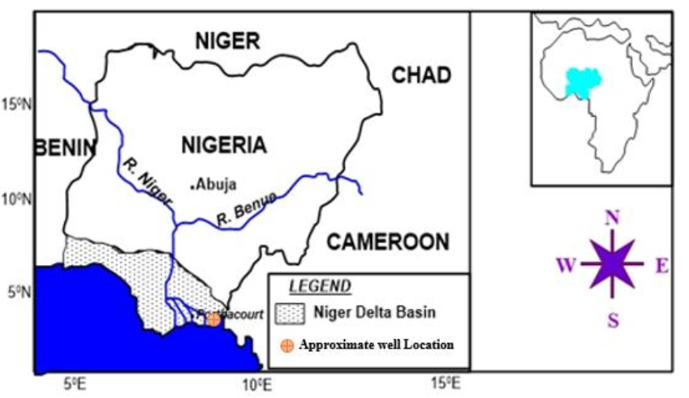

Figure 1 Map of Nigeria, showing the study area. Source: modified after Agyingi *et al*. (2012).

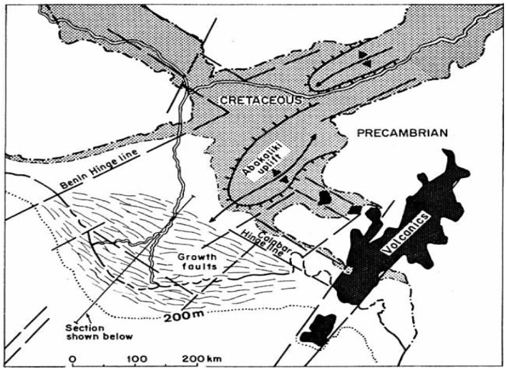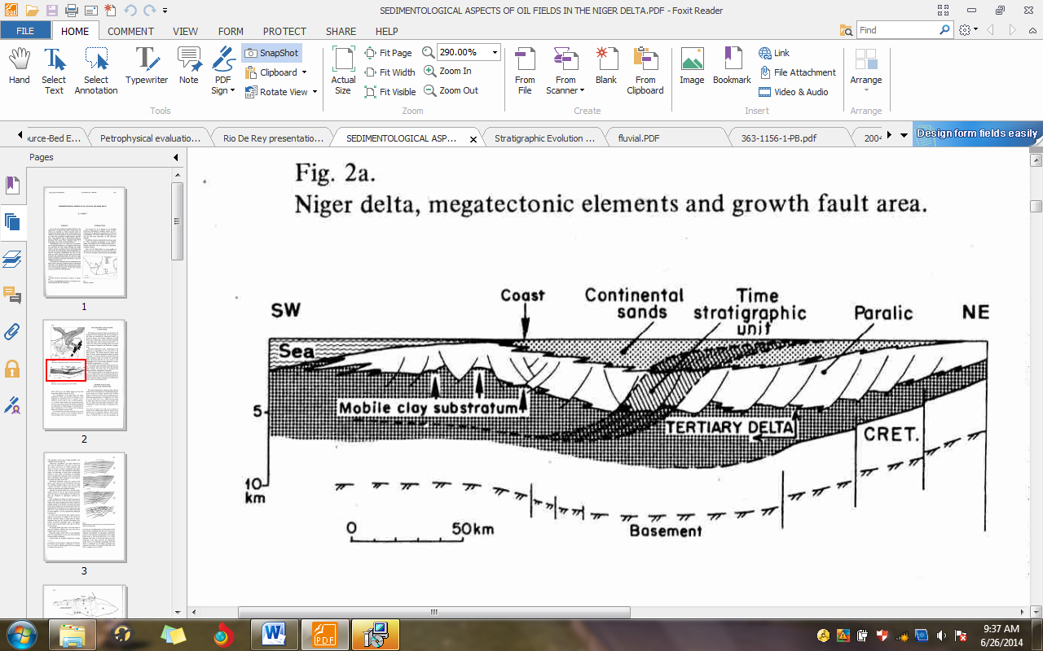

**B**

**A**

Figure 2 A. Niger Delta, mega-tectonic elements and growth fault area (Weber, 1971); B. Schematic section of the Niger Delta Basin perpendicular to the coastline (Weber, 1971).

Figure 3 Stratigraphic column of the East Niger Delta Basin (Doust and Omatsola, 1990).