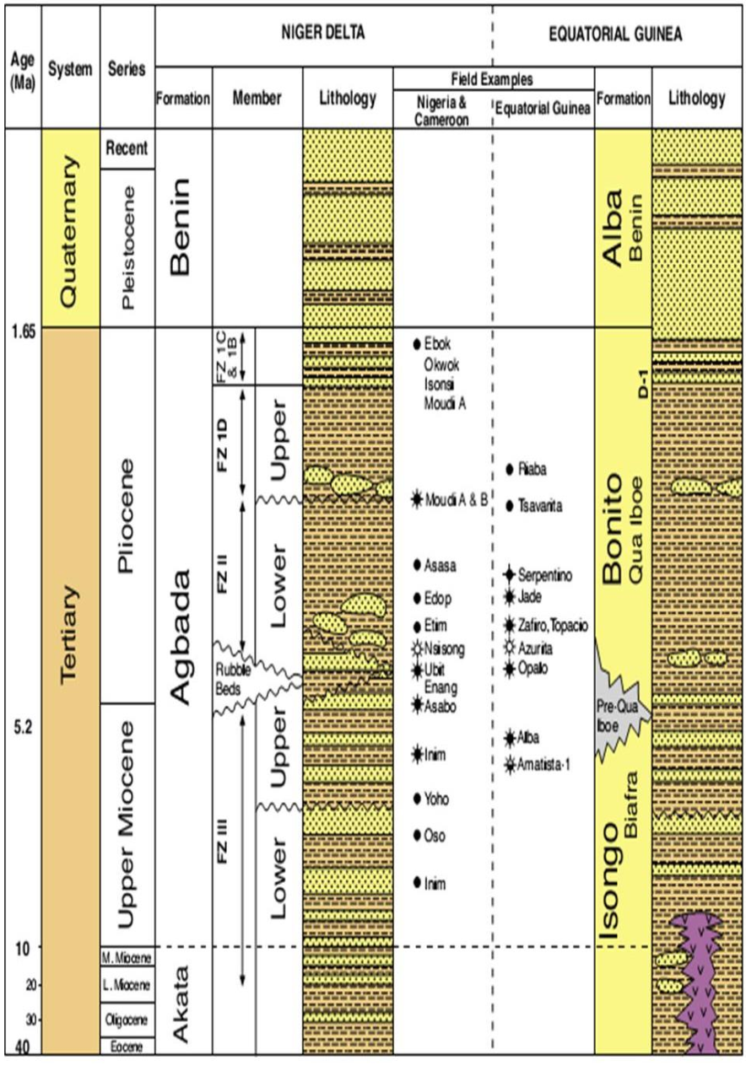

Figure 3 Stratigraphic column of the East Niger Delta Basin (Doust and Omatsola, 1990).

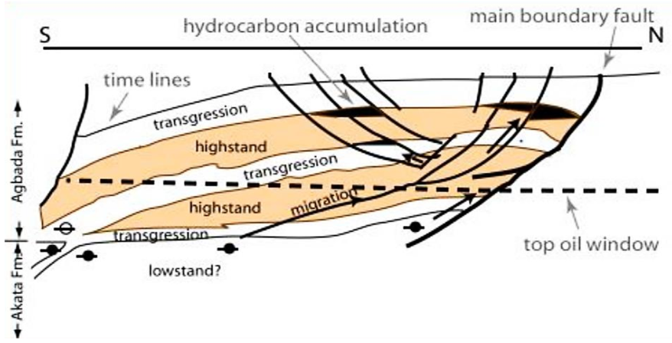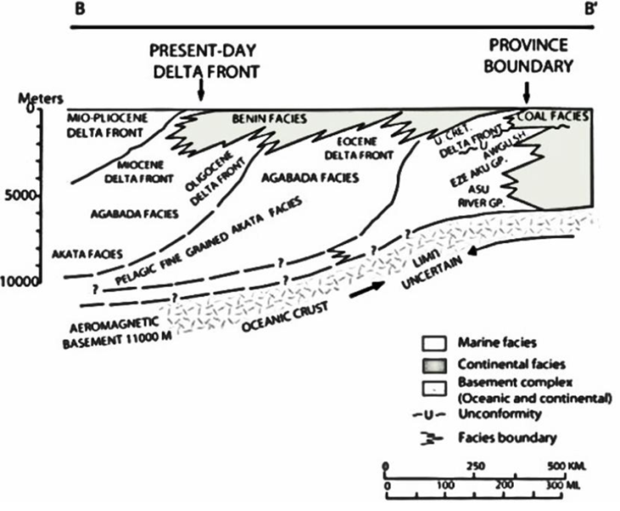

Figure 4 Geological cross section showing stratigraphic units of the Niger Delta (Michele et al., 1999).

Figure 5 Sequence stratigraphic model for the central portion of the Niger Delta showing the relation of source rock, migration pathways and hydrocarbon traps related to growth faults (Stacher, 1995).

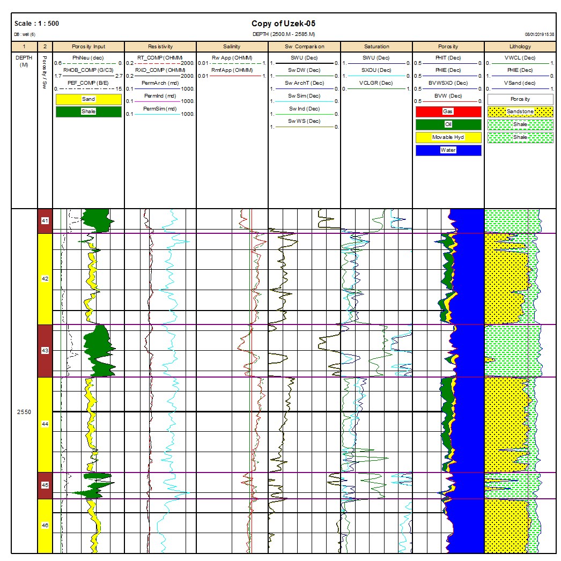

**WELL UK-05**

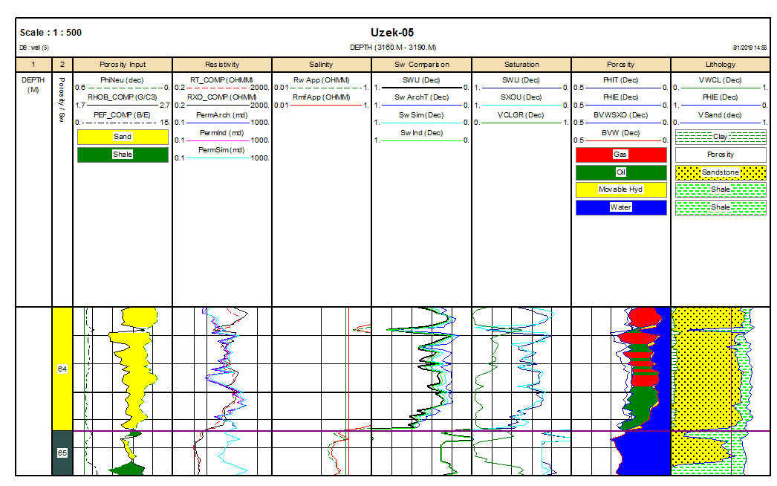

**WELL UK-05**

**B**

**A**

**Oil**

**Gas**

Figure 6 A. Wireline log for Well UK-05 with interpreted lithology showing alternation of sands and shales with the fluids saturating the reservoirs being gas, oil and water; B. Wireline log for Well UK-05 with interpreted lithology showing alternation of sands and shales with the fluids saturating the reservoirs being gas, oil and water.

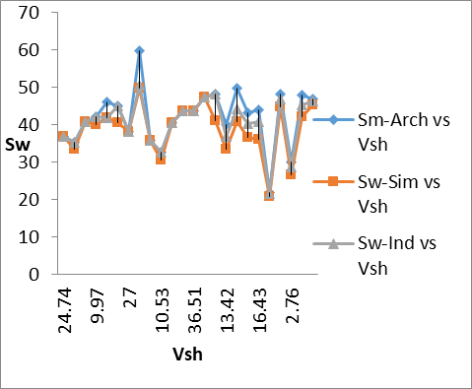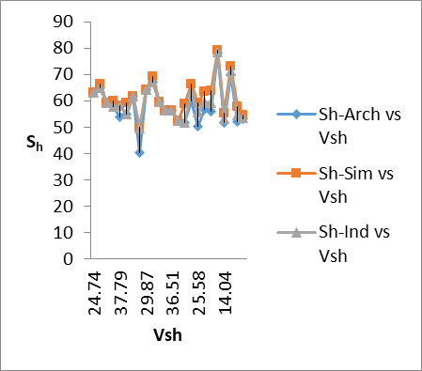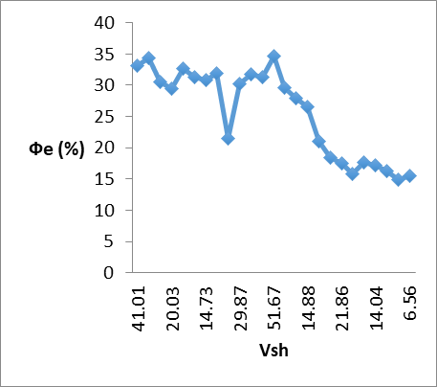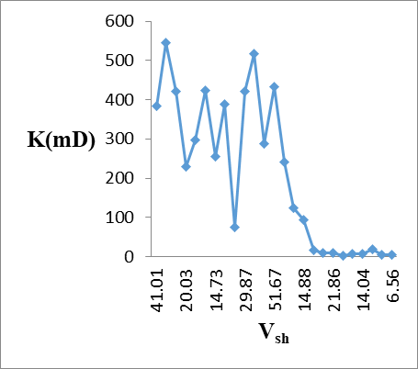

A

B

C

D

Figure 7 A. Influence of shale on water saturation; B. Influence of shale on hydrocarbon saturation; C. Relationship between shale volume and permeability; D. Shale effect on effective porosity.