Supplementary material
Biomass model and water balance application for watershed drought analysis

APPLICATION OF WEIGHTS FOR EACH VARIABLE OF THE FOREST BIOMASS MODEL
- Topography
Source: Martins et al. (2009) and Iverson (1994)
Data: SRTM project data Farr et al. (2007)
Table 1 - Reclassification and weights of slope classes for study region
Slope Class | Weights
0 - 10 % | 12
10 – 20 % | 10
> 20 % | 8
Source: Authors
Table 2 - Reclassification and weights of altimetry classes for study region
Altimetry Class | Weights
0-15 m | 8
15 – 50 m | 11
50 – 750 m | 13
750 – 1000 m | 12
1000 – 1500 m | 11
> 1500 m | 7
Source: Authors
- Soils
Source: Martins et al. (2009) and Iverson (1994)
Data: Instituto Brasileiro de Geografia e Estatística
Table 3 - Reclassification and weights of soil type classes for study region
Soil Class | Weights
Fértil, textura média-fina a média-grossa | 12
Fértil, textura fina ou grossa | 10
Não -fértil | 6
Source: Authors
Table 4 - Reclassification and weights of fertility classes for study region
Fertility Class | Weights
Média a alta. | 13
Baixa a média. | 11
Média a muito baixa | 10
Baixa | 9
Baixa a muito baixa | 8
Muito baixa. | 7
Source: Authors
- Rainfall
Source: Martins et al. (2009) and Iverson (1994)
Data: Tropical Rainfall Measuring Mission (TRMM)
Table 5 - Reclassification and weights of precipitation classes for study region
Precipitation Class | Weights
800 – 1000 mm/ano | 10
1000 – 1200 mm/ano | 11
1200-1600 mm/ano | 13
1600-2000 mm/ano | 16
2000- 2400 mm/ano | 19
2400-2800 mm/ano | 22
2800-3200 mm/ano | 25
3200-3600 mm/ano | 22
>3600 mm/ano | 19
Source: Authors
- Weck's Modified Climate Index
Source: Martins et al. (2009) and Iverson (1994)
Data: IBGE (2019) and CRESESB (2000)
Table 6 - Reclassification and weights of WMCI classes for study region
WMCI Class | Weights
50-100 | 2
100-150 | 3
150-200 | 4
200-250 | 5
250-300 | 6
300-350 | 7
350-400 | 8
400-450 | 9
450-500 | 10
Source: Authors

ESTIMATED VALUES OF VOLUME, CARBON BIOMASS PER BIOM
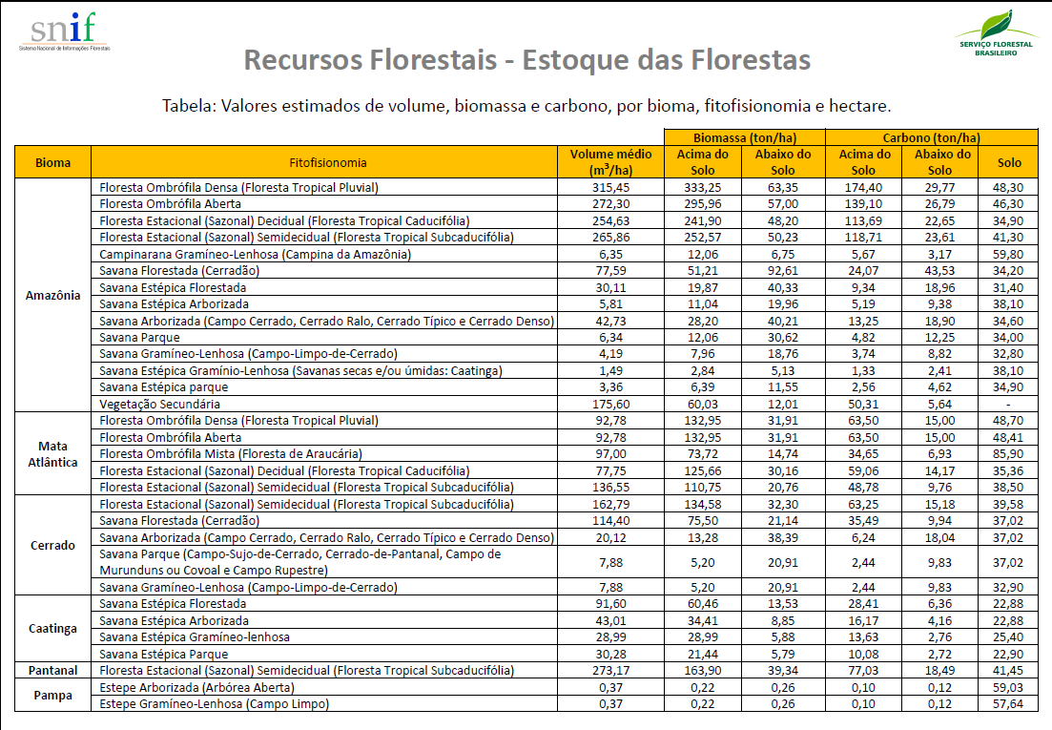
Fonte: SNIF (2020)

References
CRESESB. ATLAS Solarimétrico do Brasil. Recife: Universidade Federalde Pernambuco, 2000.
FARR, T. G. et al. The Shuttle Radar Topography Mission. Reviews of Geophysics, v. 45, n. 2, p. 1–33, 2007. Disponível em: <http://doi.wiley.com/10.1029/2005RG000183>.
IBGE. Dados vetoriais. Disponível em: <https://www.ibge.gov.br/geociencias-novoportal/informacoes-ambientais/climatolo gia /15817-clima.html?=&t=downloads>. Acesso em: 22 jul. 2020.
IVERSON, L. R. ET AL. Use of GIS for estimating potential and actual forest biomass for continental south and Southeast Asia. Effects of land-use change on atmospheric CO concentrations. Berlin: Springer-Verlag, 1994. .
MARTINS, O. S. et al. Estimativa da densidade de biomassa potencial com uso de SIG no Estado de São Paulo. 1. ed. São Paulo: Imprensa Oficial do Estado de São Paulo Secretaria. Secretaria do Meio Ambiente, 2009.
SNIF. Estoque das Florestas - Referências - Metadados. Disponível em: <http://snif.florestal.gov.br/pt-br/estoques-das-florestas/627-metadados?tipo=tableau&modal=1>.

