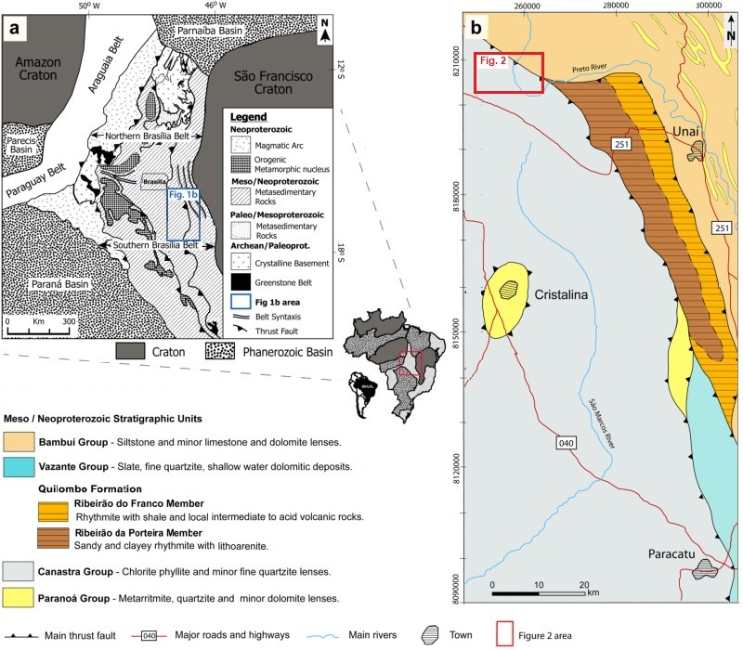

Figure 1 Schematic geologic maps showing: A. Location of the study area in South America, relative to the main cratons and in the Brasília Fold Belt, the blue polygon outlines the area of Figure 1B; and B. Location study area in the southern Brasília Belt, the red polygon outlines the area of Figure 2 (modified from Dardenne 2000 and Campos et al. 2021).

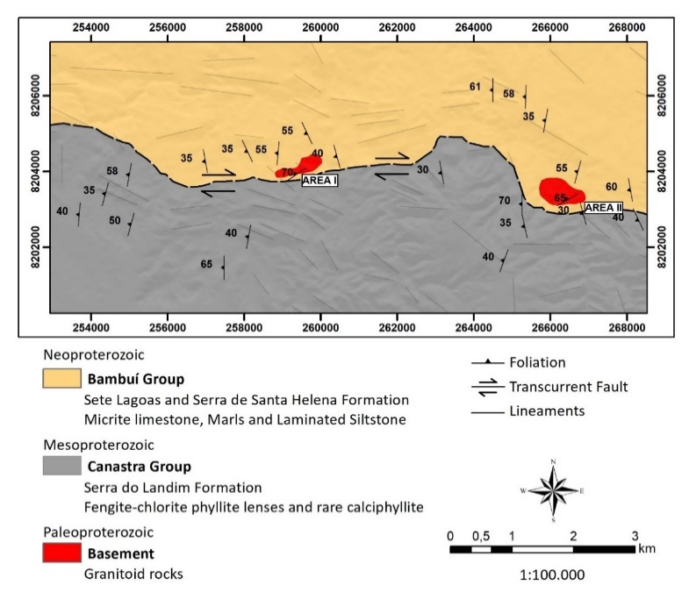
Figure 2 Simplified geological map of the study area.

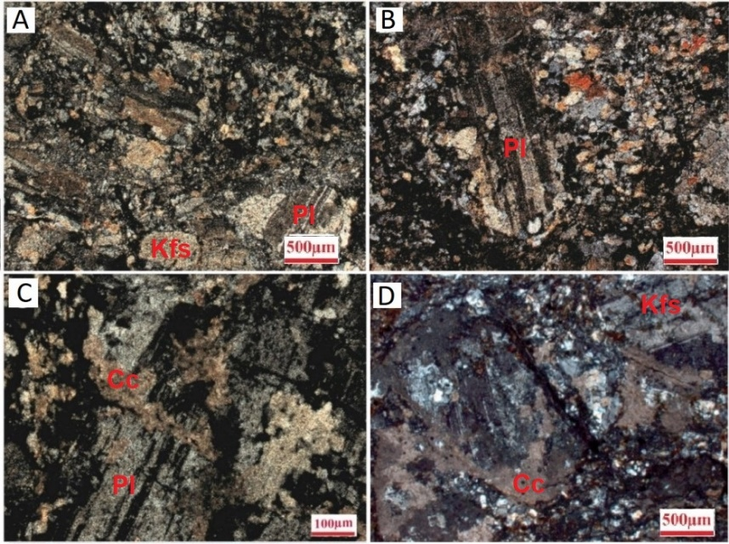
Figure 3 Representative petrographic features of tonalite and granodiorite from Area I and II: A. and B. General aspects showing inequigranular porphyritic texture, composed of plagioclase phenocrysts and matrix composed of quartz and K-feldspars; C. and D. Plagioclase crystals replaced by calcite.

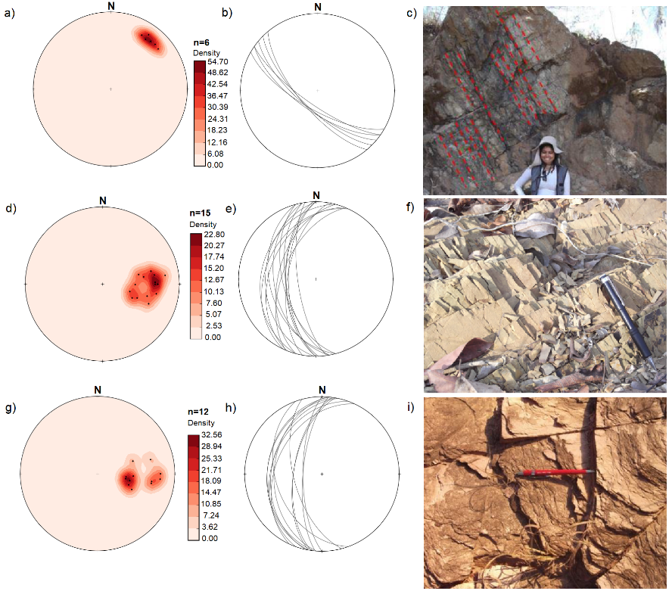
Figure 4 Poles of granitoid foliation plotted on Schmidt-Lambert stereogram, lower hemisphere: A. Points and isofrequency; B. Lines; C. Outcrop of basement rock in Area II. Poles of foliation of the Bambuí rocks plotted on Schmidt-Lambert stereogram, lower hemisphere: D. Points and isofrequency; E. Lines; F. Siltstone of the Bambuí Group, showing the pervasive spaced cleavages., of the Poles of Canastra Group rocks foliation plotted on Schmidt-Lambert stereogram, lower hemisphere; G. Points and isofrequency; H. Points; I. Weathered chlorite phyllite from the Canastra Group.

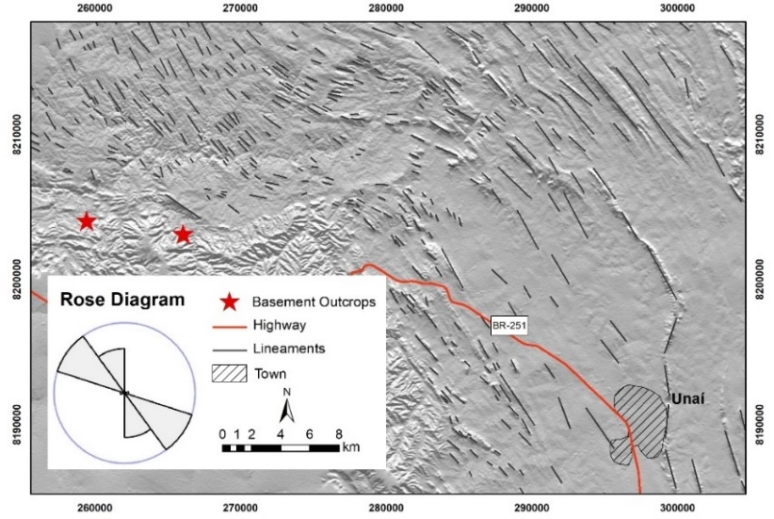
Figure 5 Regional structural map. The rose diagram indicates the preferential direction of the lineaments.

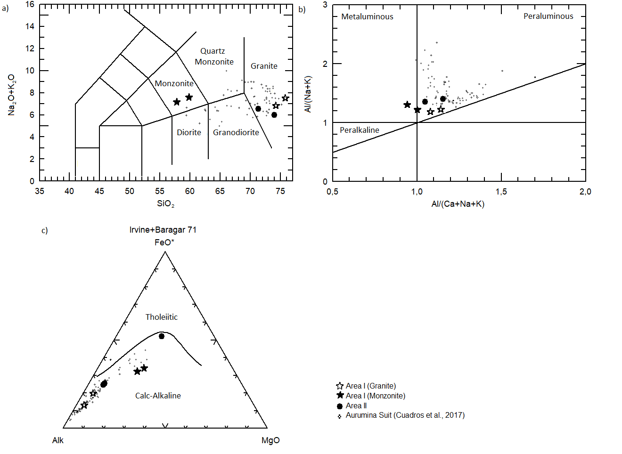
Figure 6 A. TAS diagram (Cox et al. 1979) showing the classification of the rock based on the percentage of silica versus total alkalis; B. Diagram for classification of rock in relation to saturation in alumina; C. AFM diagram (Irvine & Baragar 1971). * Area I, • Area II and ∙ Suite Aurumina.

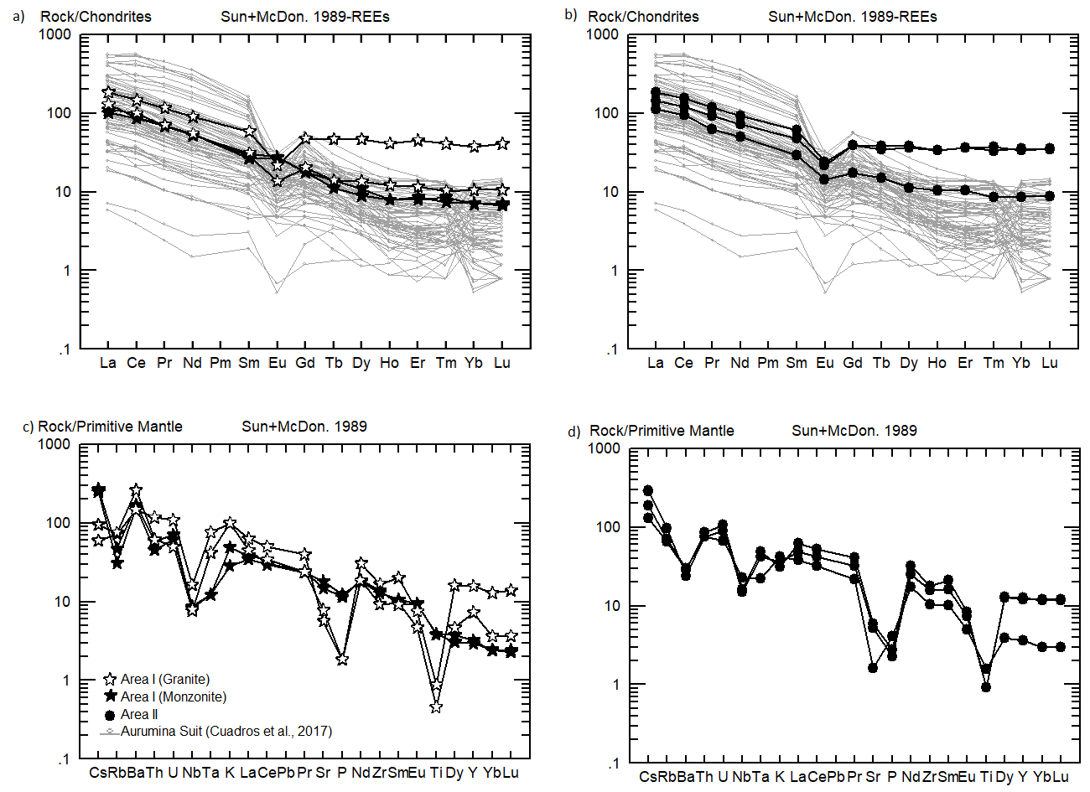
Figure 7 Distribution pattern of Rare Earth Elements normalized to chondrite: A. Area I and B. Area II. Multi-element diagram: C. Area I and D. Area II (Sun & McDonough 1989).

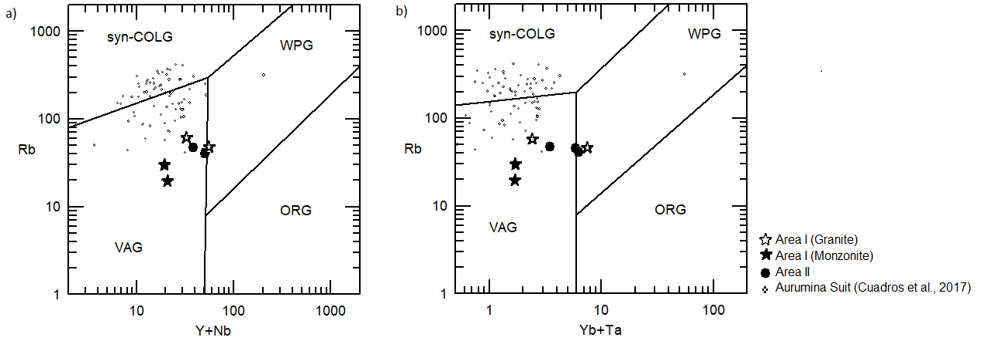
Figure 8 Geotectonic discrimination diagrams after Pearce et al. (1984): A. Y+Nb versus Rb; B. Yb/Ta versus Rb. Syn-Colg - Collision Granite; WPG - Within Plate Granite; ORG - Ocean Ridge Granite; VAG - Volcanic Arc Granite. * Area I, • Area II and ∙ Suite Aurumina.

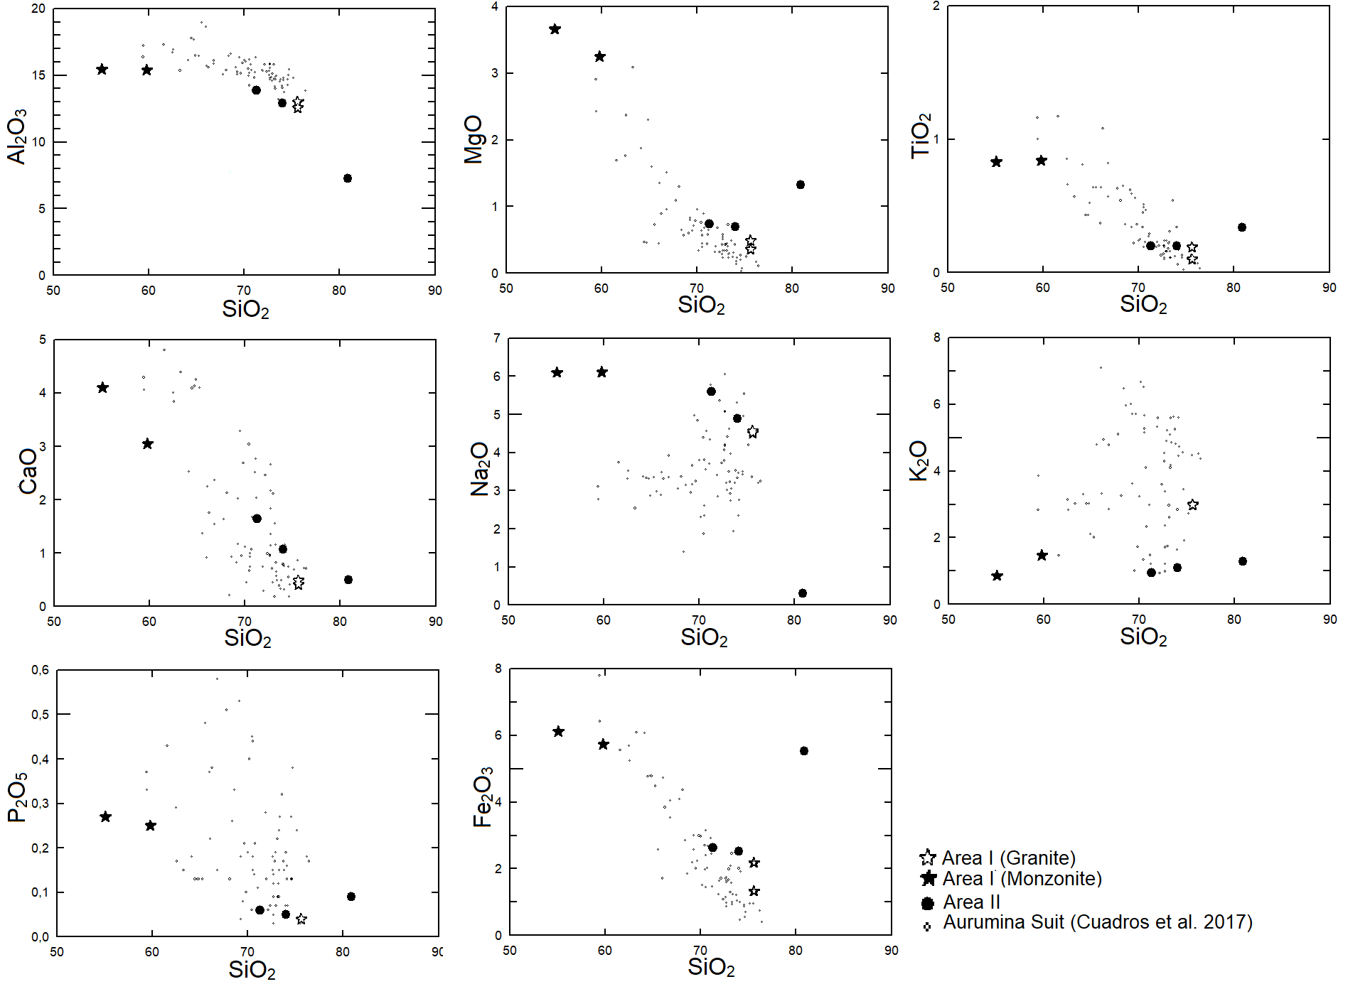
Figure 9 Geochemical features of the analyzed samples from Areas I and II and data from Cuadros et al. (2017). * Area I, • Area II and ∙ Suite Aurumina.

Figure 10 Images of scanning electron microscopy – SEM: A. Area I sample; and B. Sample from Area II. Spots made in the center of the zircon grains.

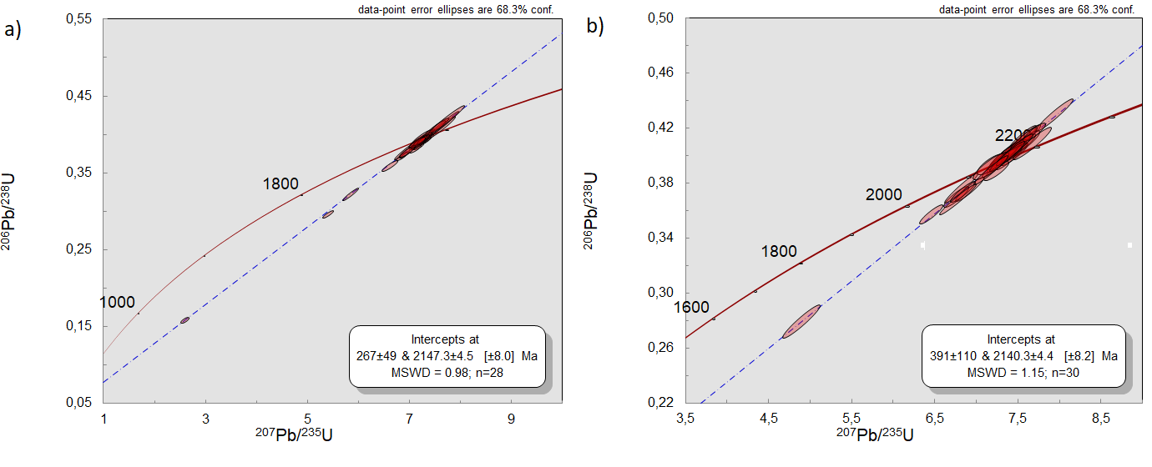
Figure 11 Ages of tonalite and granodiorite rocks of the Areas I and II obtained from the discordant curves: A. Area I sample; and B. Sample from Area II.

