Type of the paper (Research paper)
Sensitivity Analysis of SWAT Model at Brantas Watershed, East Java Indonesia
Abstract. Brantas Watershed and Its Tributaries (Approximately 14,103 km²) play an essential role to supply water for About 30% of East Java province populations. Management of water resources in this watershed has become a challenging issue. The conformity of modelling processes and result to mimic the existing hydrological processes is still in question. This study aims to analyse sensitive parameters of the SWAT (Soil & Water Assessment Tool) model on the significant watershed. The hydrological processes are observed monthly and annually. Sensitivity analysis using the SWAT-CUP tool show 18 sensitive parameters. The nine (9) parameters have a sensitivity level of more than 50%. The four (4) correlated to the runoff generation and water movement in the soil layer. Then, eight (8) parameters correlated to baseflow calculation. Simulation results illustrate the strong effect of climate change (especially rainfall) on water yield and sedimentation.
Keywords: Sensitivity, Analysis, SWAT-CUP, SUFI, Brantas, East Java.
- Introduction
Brantas watershed (Figure.1) covers an area of approximately 14,103 km², equivalent to 30% of East Java Province area (approximately 47,075.35 km²). The main river length of Brantas reaches 320 km (Kementrian PUPR, 2010).
This watershed area is composed of 19 Regencies (District) and Cities areas. The Brantas areas cover the administrative regency/city of Malang, Kediri, Blitar, Nganjuk, Batu, Blitar, Tulungangung, Trenggalek, Jombang, Mojokerto, Sidoardjo and Surabaya. The population in the Brantas watershed was around 16.2 million in 2010 (census) and around 16.9 million in 2015 (Projection) (BPS Jatim, 2014). About 30% of the East Java population have occupied the watershed land resources for residential use, agricultural, urban and city facilities, road network, tourism site, plantation, industry, and other social-cultural and economic activities. The Brantas river network and its tributaries supply water for residential use, gearing the industry, electricity source, drainage, irrigating the agricultural field, and tourism activities (JICA, 2019). About 60% of the agricultural product of the province come from the Brantas tributaries. Major reservoirs or Dam have been constructed on the Brantas tributaries, i.e., D1 (Sengguruh reservoir), D2 (Sutami), D3 (Lahor), D4 (Selorejo), D5 (Lodoyo), D6 (Wlingi), D7 (Wonrorejo), D8 (Waru Turi), D9 (Menturus), D10 (Gunungsari), D11 (Gubeng), and D12 (Jagir Dams) (Figure1).
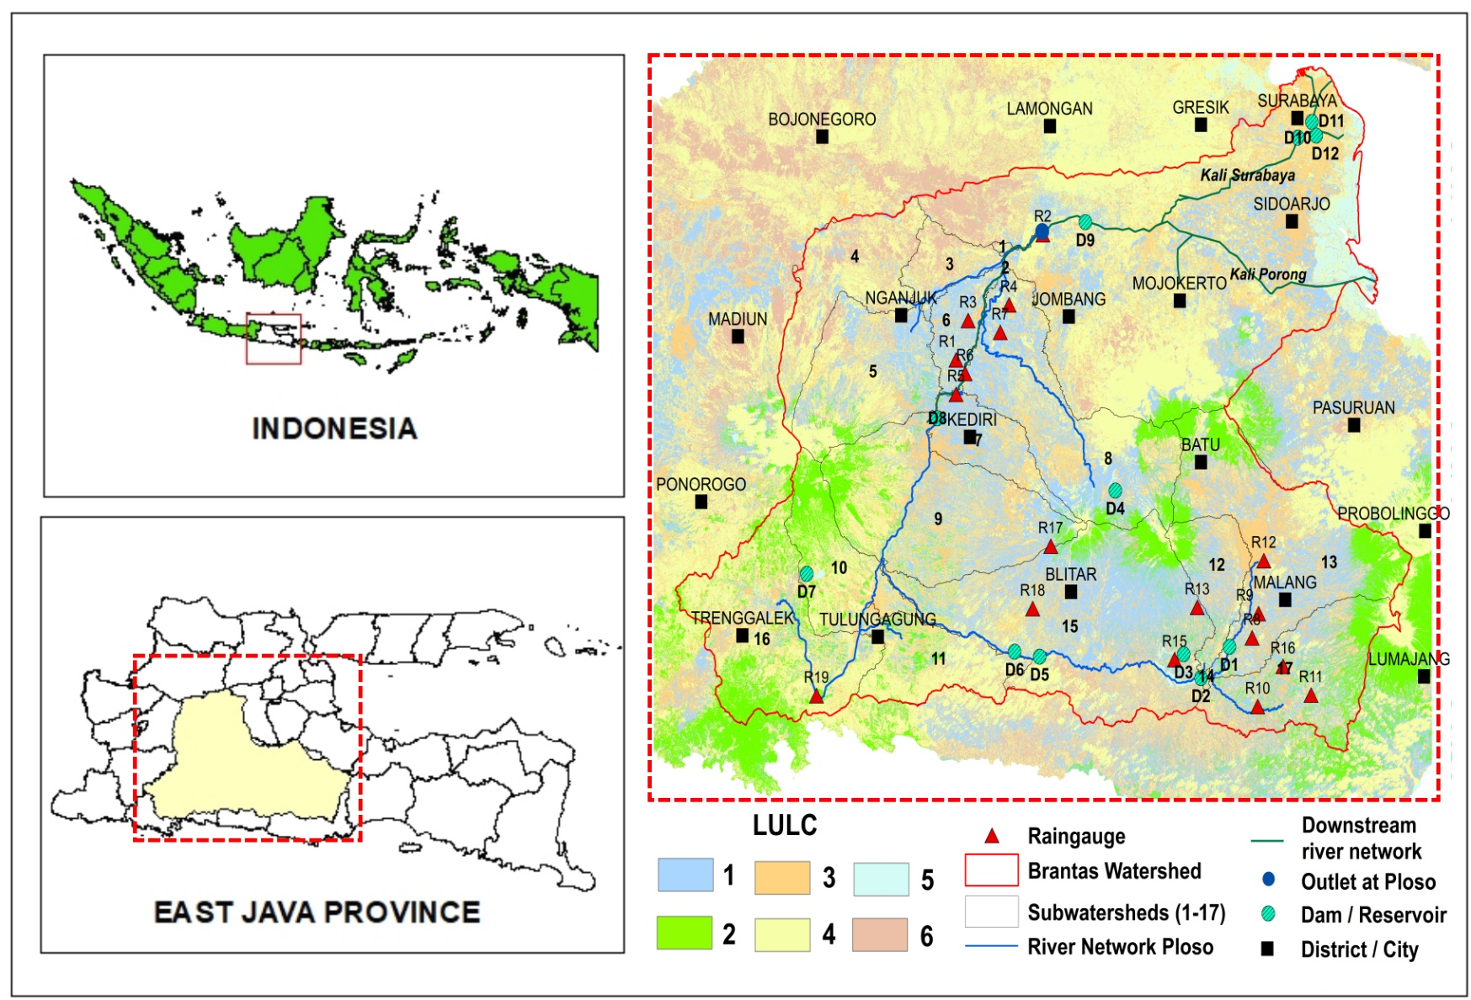
Figure. 1. Study site
The complexity of the watershed ecosystem requires a model to simplify the explanation in the watershed system. SWAT (Soil & Water Assessment Tool) models provide reliable features in analysing this complex watershed. Several studies using SWAT models by (Joseph, Preetha and Narasimhan, 2021); (Liu et al., 2021), and (Rani and Sreekesh, 2021) have succeeded in analysing their watershed hydrological systems. Modelling this complex system of the watershed and using limited data available are challenging issues. How to reduce the system’s complexity so that the essential hydrological processes are modelled? How to adjust the parameter’s value in the model with the limited data constraint. Thirdly, how to justify and explain that modelling processes and results can mimic the real phenomenons questioned.
This study aims to analyse the SWAT model’s sensitive parameters using SWAT-CUP Tool and SUFI (Sequential Uncertainty Fitting) algorithm (Abbaspour, 2015). Sensitivity analysis was conducted by following the previous publication (Arnold et al., 2012; Moreira, Schwamback and Rigo, 2018; Brighenti et al., 2019). The hydrological processes are modelled at the monthly level. The study was conducted in Brantas Watershed in East Java Province, Indonesia.
The SWAT model (Krysanova and Arnold, 2008) has more comprehensive equations and features. SWAT can calculate the discharge, erosion, sediment, and nutrient-related hydrological processes. The SWAT model is based on the concept of HRU (Hydrological Response Unit) to calculate the hydrological processes spatially distributed (Arnold et al., 2012). The vertical components of water balance are calculated for each HRU. Then the runoff, sediment and nutrient are accumulated from HRUs to each sub-basin. The horizontal movement of water, nutrient and sediment from each sub-basin to the watershed outlet is calculated using the transfers function (Arnold et al., 2012).
Many researchers around the world have used SWAT to study the impact of land use and land cover change, and climate change on hydrological processes, for example, the works by (Lamichhane and Shakya, 2019) in Nepal (Spruce et al., 2018) in Mekong river basin (section: Thailand). A similar study was conducted by (Marie Mireille et al., 2019) in Kenya.
- Methodology
2.1 Input data
This study use flow measurement located at Ploso. Then, from Ploso as an Outlet, the boundary of the sub-watershed is delineated. The sub-watershed area covers an area of 8,844.26 km² (Figure 1). The inputs for SWAT are digital elevation model (DEM), land cover, soil characteristics, climate variables (rainfall, temperature, solar radiation, relative wind speed and humidity), and land management practice. All of the input data is necessary to be formatted in raster.
The DEM (Digital elevation model) is derived from DEMNAS (BIG, 2018). The DEMNAS is the Digital Elevation Model source at the National Scale provided by the Indonesian Agency of Geospatial Information or Badan Informasi Geospatial (BIG). The DEMNAS (BIG, 2018) has a spatial resolution of 8.3m x 8.3m, and it is sufficiently excellent for watershed delineation. In this case, the DEMNAS is used to determine the sub-watershed boundary and derive the river network. Figure 2 visualised the Digital elevation model (DEM), soil type layer, land cover in the Years 2001, and land cover in the year 2015 of the Ploso sub-watershed. The altitude on the watershed varies from 17 to 3,653 m above sea level (Figure. 2a).

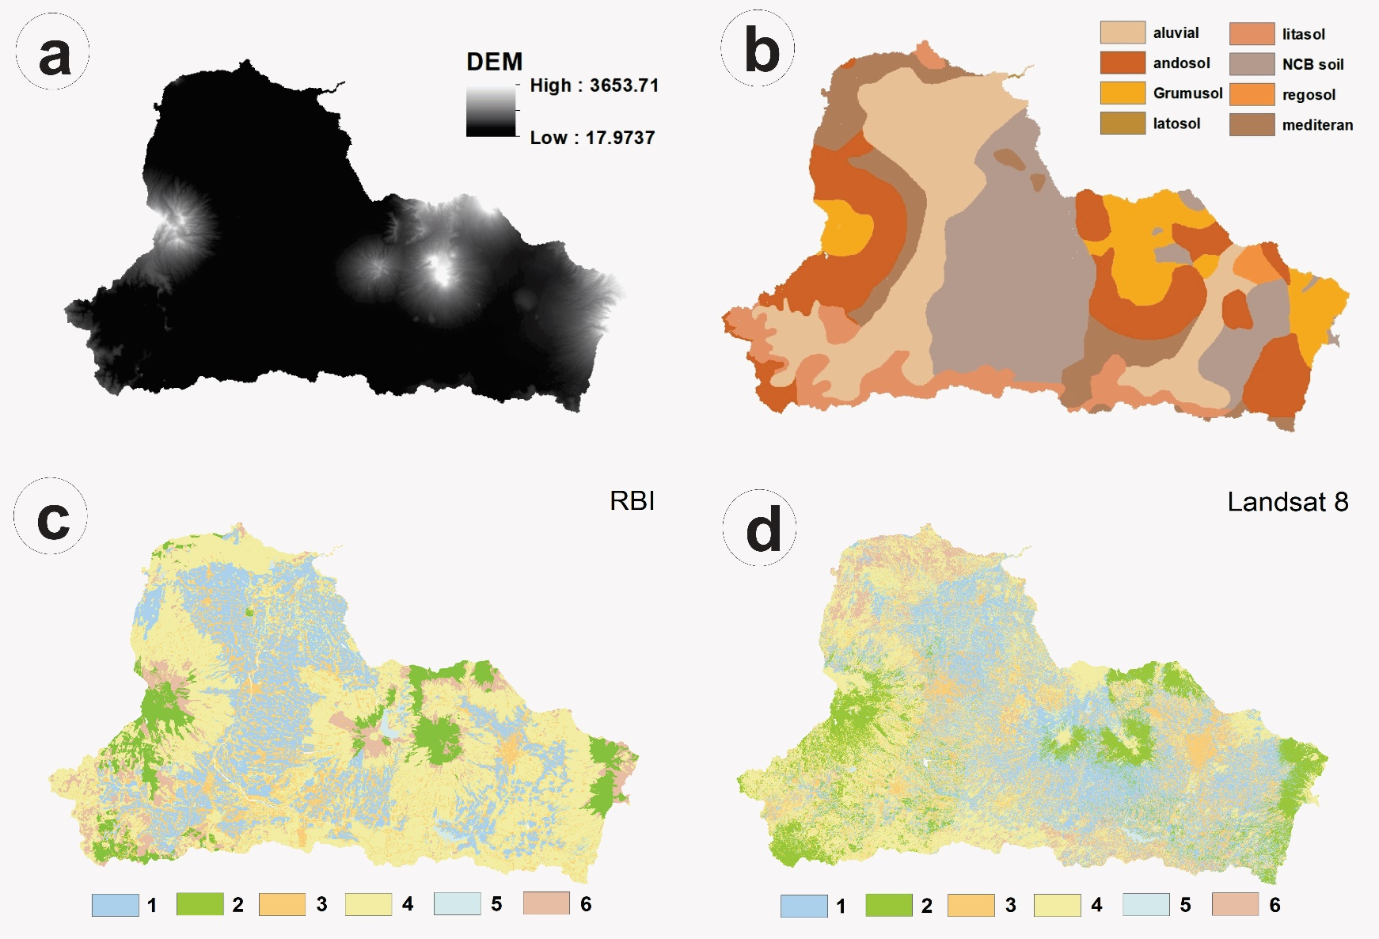
Figure 2 Input data: (a) Altitude (mm), (b) Soil Type, (c) Land cover 2001, (d) Land cover 2015, (1) Irrigated paddy, (2) Forest-Plantation, (3) Settlement or pavement area, (4) heterogeneous agriculture land, (5) Shrubs land.

Soil layer is obtained from national soil layer map (Balitbang Pertanian, 2014). The major soil type class on the watershed include: aluvial (24.5%), andosol (19.5%), grumosol (9.8%), latosol (0.02%), litosol (8.4%), regosol (10.4%) , MCB soil (0.9%), mediteran (26.5%). The slope derived from DEM. Slope classification follows the provisions of the Indonesian Ministry of Forestry, namely 0 - 8% (10.6%), 8 - 15% (26.1%), 15 - 25% (36.3%), 25 - 40% (15.7%), and > 40% (11.3%).
This study covers the period from 1996 to 2015. This study uses two editions of Land use (LU) and land Cover (LC) maps. The first map is a clip from the RBI (Rupa Bumi Indonesia) digital maps (BIG, 2018). The RBI map was produced during the year 2000-2001. The second map clip from the classified Landsat-8 Image. The available time series data were divided into periods 1 (1996-2005) and 2 (2006-2015). The model is run according to the period. The RBI represented the LULC for the first period. In comparison, Landsat represents the LULC for the second period (Figures. 2c and 2d). LULC in Brantas from 2001 to 2015 experienced significant changes. The change is marked by increasing irrigated paddy fields (+ 21,24%) and forests-plantation areas (+42.44%). The land occupied for urban or pavement areas is also increased by +26.36% from the beginning. Contrary, the increase of LULC class above is compensated by the decrease in agricultural land (non-irrigated area) by -30.87% from the beginning (Table 1).
Table 1. LULC Change in Ploso sub-watershed
LULC | Area (km²) |  |  |  | Change (%)
 | RBI | (%) | Landsat-8 | (%)
Paddy filed | 2,134.72 | 24.73 | 2,588.28 | 29.98 | 21.25
Heteregeneous agriculture land | 3,746.27 | 43.40 | 2,589.9 | 30.00 | -30.87
Settlement or Pavement | 1,415.25 | 16.40 | 1,788.35 | 20.72 | 26.36
Forest-plantation | 707.93 | 8.20 | 1,008.4 | 11.68 | 42.44
Shrubland | 581.21 | 6.73 | 606.93 | 7.03 | 4.42
Water bodies | 46.78 | 0.54 | 50.30 | 0.58 | 7.52

Rainfall data were obtained from 19 measurement sites (Table 2). The location of the rainfall measurement site are presented in Figure.1 (R1 to R19). The recording period for all the climate variables ranges from 1996 to 2015 (20 years). The discharge data is obtained from existing AWLR (Automatic Water Level Recorder) located on the outlet of this watershed
Table 2. Rainfall Stations
No | Station | Latitude | Longitude | Elevation
1 | Dingin | -7.6697 | 112.059 | 54
2 | Kedungrejo | -7.4665 | 112.226 | 34
3 | Kertosono | -7.6059 | 112.082 | 44
4 | Ktr Cab. Perak | -7.5806 | 112.161 | 45
5 | Minggiran | -7.7256 | 112.059 | 59
6 | Papar | -7.6918 | 112.077 | 55
7 | Wonomarto | -7.6251 | 112.145 | 73
8 | Blambangan | -8.118 | 112.633 | 444
9 | Bululawang | -8.0786 | 112.646 | 402
10 | Clumprit | -8.2292 | 112.645 | 329
11 | Dampit | -8.21 | 112.748 | 414
12 | Kedung Kandang | -7.9929 | 112.656 | 438
13 | Ngajum | -8.069 | 112.527 | 449
14 | Sumber Pucung | -8.3895 | 112.676 | 308
15 | Sitiarjo | -8.1538 | 112.483 | 20
16 | Turen | -8.1639 | 112.694 | 391
17 | Kalibadak | -7.9708 | 112.243 | 562
18 | Pojok_Dadapan | -8.0721 | 112.208 | 243
19 | Besuki | -8.2141 | 111.79 | 89

First, the discharge and rainfall data are obtained from the public offices of the water management and watershed authorities. The climate data (i.e., rainfall, temperature, solar radiation, wind speed and humidity) were obtained from the nearby climatological stations. In this study, ArcSWAT 2012 is used as the primary tool for the hydrological analysis, while GIS software visualises the maps.
Table 3. Description of model input
Data Type | Source | Description
DEM (Digital elevation model) | Geospatial Information Agency of Indonesia  http://tides.big.go.id/DEMNAS/Jawa.php | Resolution 8,3 m
Digital soil layer | Soil Research Institute, 1998 Bogor, Indonesia | Scale 1:250.000
Land use - land cover layer | Rupa Bumi Indonesia https://tanahair.indonesia.go.id/)  Intepretation of landsat 8 | Scale 1:250.000 (satellite image)
Climate /meteorological data series | Meteorology and Climatology Geophysical Agency of Banyuwangi | 1996-2015 (20 years)
Daily rainfall data | Dingin, KedungRejo, Kertosono, Ktr Cab.Perak, Minggiran, Papar, Wonomarto, Blambangan, bululawang, clumprit, dampit, Kedung kandang, ngajum, sumber pucung, sitiarjo, turen, kalibadak, Pojok_dadapan, and Besuki Stations. | 1996-2015  (20 years)

2.2 Procedure
The general procedure of the modelling task consists of (1) Watershed delineation and HRU determination, (2) Writing table and climate data input, (3) creation of model output, (4) Calibration and validation. This step consists of sensitivity analysis and evaluation model performance for calibration and validation periods, and the final step (5) is conducting the model simulation, water balance and sediment yield analysis. Figure 3 present the flowchart of the research procedure.
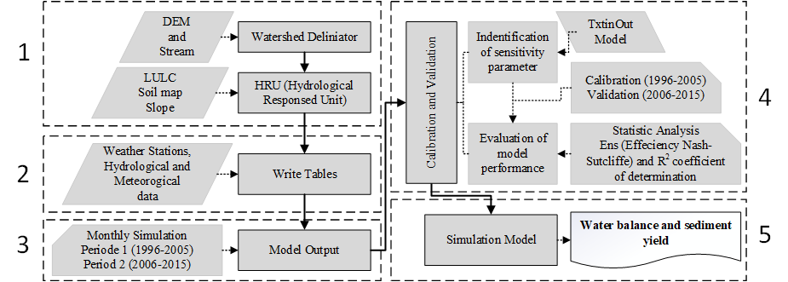
Figure 3. Procedure
Watershed delineation and HRU processing.
In this case, the ArcSWAT module fills the sink to determine the flow direction and flow accumulation from the input DEM (DEMNAS). Then, the result uses to create the stream network, outlet, and sub-basin. The arcSWAT will delineate the boundary of the watershed. Furthermore, the ARcSWAT produce HRUs (hydrological response unit). HRU was constructed from 3 layers, overlay among land use (land cover), soil type, and slope classes. Finally, the HRU was determined using a 10% threshold.
Climate input (WritingTables).
The SWAT-weather database (Weather Generator) is used to calculate 14 necessary parameters. Seven (7) parameters depend on rainfall data, and the other seven (7) parameters are adjusted for climate data (Table 4). Each parameter is then used for updating the SWAT database. The model will automatically calculate according to available data.
Table 4a. Parameter dependent on rainfall data
No | Parameter | Description
1 | PCPMM | The average amount of precipitation falling in a month (mm/day),
2 | PCPSTD | The standard deviation for daily precipitation in a month (mm/day),
3 | PCPSKW | The skew coefficient for daily precipitation in a month,
4 | PR_W1 | Probability of a wet day following a dry day in the month,
5 | PR_W2 | Probability of a wet day following a wet day in the month,
6 | PCPD | The average number of days of precipitation in a month (days),
7 | RAINHHMX | Maximum of 0.5-hour rainfall in the entire period of record for the month (mm).
Source: Arnold et al. (2012)
Table 4b. Parameter determined from climate data
No | Parameter | Description
1 | TMPMX | Average maximum air temperature for a month (°C)
2 | TMPMN | Average minimum air temperature for month (°C),
3 | TMPSTDMX | The standard deviation for maximum air temperature in the month (°C),
4 | TMPSTDMN | The standard deviation for minimum air temperature in the month (°C),
5 | SOLARAV | Average daily solar radiation in month (MJ/day/m2),
6 | DEWPT | Average dew point temperature in month (°C),
7 | WNDAV | Average wind speed in month (m/s).
Source: Arnold et al. (2012)
SWAT Output.
Simulation results are read through the SWAT output menu. The model provides three types of output, i.e. (output.Rch: Flow_out) for calculated flow (in m³/s) and The “TxtInOut folder (output.std)” to visualise the calculated water balance result. Calibration is set for periods 1996 to 2005, and validation starts from 2006 to 2018 using flow data from the model. The model is tested on the two periods through the SWAT GUI (graphical user interface).
The SWAT CUP module uses to evaluate model performance. In this case, the SUFI-2 (Sequential Uncertainty Fitting) is explored to fit the parameter value during calibration and validation. Calibration and validation follow the procedure as published by Abbaspour (2015). Water balance is calculated for monthly and annual intervals. About 33 parameters are selected for sensitivity analysis by 500 iterations. Table 5 show the 18 selected parameters. In this case, the r (multiples) and v (replace) procedures, as published by Abbaspour (2015), were used to find optimal parameter values.
Table 5. The estimated parameter value for calculating flow
No. | Parameter Input | Parameter Description | Range Parameter
1 | SMFMX.bsn | Maximum melt rate for snow during the year (occurs in the summer) | 0-20
2 | CH_N1.sub | Manning’s “n” value for the tributary channels | 0.01-30
3 | CH_L1.sub | The most extended channel length in the subbasin. | 0.05-20
4 | SL_SUBBSN.hru | Average slope length (m) | 10-150
5 | SMFMN.bsn | Minimum melt rate for snow during the year (occurs on winter solstice) | 0-20
6 | GW_SPYLD.gw | Specific yield of the shallow aquifer (m³/m³) | 0 – 0.4
7 | ESCO.bsn | Plant uptake compensation factor | 0 – 1
8 | CH_W1.sub | The average width of tributary channels (m) | 1 to 1000
9 | LAT_TTIME.hru | Lateral flow travel time | 0-180
10 | GW_REVAP.gw | Groundwater revap coefficient | 0.02-0.2
11 | GW_DELAY.gw | Groundwater delay (days) | 0 – 500
12 | GW_QMN.gw | Threshold depth of water in the shallow aquifer required for return flow to occur (mm) | 0 – 5000
13 | REVAP_MN.gw | Threshold depth of water in the shallow aquifer for revap to occur (mm) | 0 -500
14 | RCHARG_DP.gw | Deep aquifer percolation fraction | 0-1
15 | SOL_AWC.sol | Available water capacity of the soil layer (mm H2O /mm soil) | 0 – 1
16 | SOL_BD.sol | Moist bulk density (g/cm3 @ Mg/m³) | 0.9 to 2.5
17 | CANMX.hru | Maximum canopy storage. | 0 to 100
18 | SOL_K.sol | Saturated hydraulic conductivity(mm/hour) | 0 to 2000
Source: Arnold et al. (2012)
The model performance was evaluated by two statistical tests, i.e., Nash-Sutcliffe Efficiency (NSE) and determination coefficient (R²). Moriasi et al.(2007) stated that NSE values range between −∞ to 1, NSE = 1 is the optimal value. NSE values between 0.0 and 1.0 are generally seen as an acceptable model performance, while NSE ≤ 0.0 indicates that model performance is unacceptable. The value of R² describes the correlation between observed and calculated (estimated) values. The higher value indicates a low error variant. R² = 0 shows no correlation between the observed and calculated values, whereas R² = 1 shows the strong correlation between observed and calculated values (Table 6).
Table. 6 Classification of statistical indices
NSE | R² | Classification
0.75 < NSE ≤ 1.00 | 0.75 < R² ≤ 1.00 | Very good
0.60 < NSE ≤ 0.75 | 0.60 < R² ≤ 0.75 | Good
0.36 < NSE ≤ 0.60 | 0.50 < R² ≤ 0.60 | Satisfactory
0.00 < NSE ≤ 0.36 | 0.25 < R² ≤ 0.50 | Bad
NSE ≤ 0.00 | R² ≤ 0.25 | Inappropriate
Source: Moriasi et al.(2007)
Water balance and sediment yield are calculated during the simulation periods. The optimal parameter values are obtained from calibration, and validation is then used to run SWAT to calculate water balance and sediment yield at the location of interest.
- Result And Discussion
3.1 Initial Calibration
Figure 4 show the initial calibration result of SWAT to calculate flow at Ploso Outlet (Subbasin 1 in Model). The NSE and R² obtained are 0.05 and 0.01, respectively. Figure 4 indicated that seasonal variation of a rainfall event is followed by seasonal variation in flow (discharge). It is shown (in Figure 4) that the dot-line (calculated flow) start from zero and increase linearly by a slope, which is not correlated both to the observed flow nor rainfall series. Therefore, it is necessary to search which parameters may be adjusted to mimic the observed flow and respond to the rainfall variation.

Figure. 4. Initial calibration result for a period (Monthly 1996-2005) (Source: Own analysis)
3.2 Sensitivity Analysis
As listed in table 5, parameters values are evaluated through iteration processes on the SWAT CUP module. Figure 5 show the best-fitted result of parameter values. The “t-Stat” value (in Figure 5) indicates the sensitivity of the parameter. The zero (0) of the “t-Stat” value shows the most sensitive parameter. Furthermore, the “P-Value” visualise how the strength of such parameter contributes to the flow calculation. The “P-Value” that is close to one (1) signifier is the most determinant parameter. Therefore, the change in calculated flow is more significant by changing or manipulating this parameter’s value (Abbaspour, 2015).
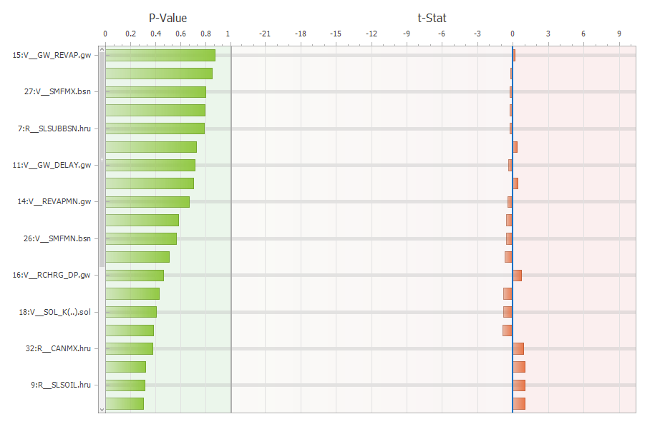
Figure. 5. Sensitive parameters (Source: own SWAT CUP analysis)
As presented in Figure 5, the sensitivity result is obtained after 10x simulation processes and is treated with 500 iterations for each simulation. Finally, table 7 presents the fitted 18 parameters that perform more sensitive to produce runoff for the Ploso sub-watershed. It is noted that 9 parameters are more sensitives ( >50% sensitivity) than other parameters. These include ( GW_REVAP, ESCO, SMFMX, SOL_AWC, SLSUBBSN, CH_N1, GW_DELAY, CH_L1, dan REVAPMN). The four (4) parameters (ESCO, SOL-AWC, SOL_BD, and SOL_K) correlated to the soil layer’s runoff generation and water movement. Then, eight (8) parameters (i.e., GW_REVAP, SMFMX, GW_DELAY, REVAPMN, SMFMN, GW_SPYLD, RCHRG_DP, and GWQMN) correlated to baseflow calculation (Brighenti et al., 2019).
Table 7. The fitted value of each parameter
No | Parameter Name | t-Stat | P-Value | Fitted
1 | V__GW_REVAP.gw | 0.16 | 0.87 | 0.06
2 | V__ESCO.hru | -0.19 | 0.85 | 0.13
3 | V__SMFMX.bsn | -0.26 | 0.80 | 15.09
4 | R__SOL_AWC.sol | -0.26 | 0.79 | 1.03
5 | R__SLSUBBSN.hru | -0.27 | 0.79 | 22.25
6 | R__CH_N1.sub | 0.35 | 0.73 | 1.31
7 | V__GW_DELAY.gw | -0.37 | 0.72 | 0.57
8 | R__CH_L1.sub | 0.38 | 0.70 | 87.93
9 | V__REVAPMN.gw | -0.43 | 0.67 | 66.90
10 | R__SOL_BD.sol | -0.55 | 0.59 | 1.62
11 | V__SMFMN.bsn | -0.58 | 0.56 | 4.10
12 | V__GW_SPYLD.gw | -0.66 | 0.51 | 0.17
13 | V__RCHRG_DP.gw | 0.73 | 0.46 | 0.51
14 | R__CH_W1.sub | -0.79 | 0.43 | 219.02
15 | V__SOL_K.sol | -0.83 | 0.41 | 1120.90
16 | R__LAT_TTIME.hru | -0.87 | 0.38 | 47.24
17 | R__CANMX.hru | 0.88 | 0.38 | 78.4
18 | V__GWQMN.gw | 0.99 | 0.32 | 3863.88
Other parameters such as CH_N1, CH_L1, CH_W1, LAT_TIME influence the properties and velocity of flow at the main river channel. Specific parameters related to the groundwater (gw) significantly influence the streamflow calculation. For example, the parameter “GW_REVAP.gw” is gradually modified from 0.02 to 0.06 to increase the baseflow level until the vegetation root zone is reached. The increasing value of “GW_REVAP.gw” normalised the calculation of potential evapotranspiration. The root zone will be saturated, then less or no water will infiltrate the soil and increase the production of runOff. Therefore, the REVAPMN parameter value should be reduced from 750 to 66.9 to increase water until the root zone. In this case, the parameter “GW_REVAP.gw” has 87% sensitivity, and the REVAPMN parameter got 67% sensitivity.
Moreover, reducing the value of “GW_DELAY.gw” from 31 to 0.57 will accelerate the filling-time of the aquifer zone. Furthermore, increasing the value of “GW_SPYLD.gw” from 0.003 to 0.27 done the balanced ratio between water volume and rock material in the unsaturated zone. The “GWQMN.gw” value increased from 1000 to 3863.88 to compensate for other groundwater parameters and reversely permit water flow in the unsaturated zone. The “RCHRG_DP” is adjusted from 0.05 to 0.51 to recharge the deep aquifer from the root zone through percolation.
Moreover, parameters describing soil properties are adjusted to maintain water content at a certain level in the soil layer ( for example, SOL_AWC from 0.11 to 1.03, SOL_BD from 1.1 to 1.62 SOL_K from 5.4 to 1120.90 ). Also, related parameters for describing HRU, Basin and Sub-basin are optimised; for example, the ESCO value is set up from 0.95 to 0.13 to reduce evaporation level. SL-SUBBSN is adjusted from 91.46 to 22.25; LAT_TTIME is increased from 0 to 47.24 (Table 8). All adjustments of these parameters values, therefore, increase the model performance in calculating flow.
3.3 Hydrograph Results
Figure. 6 shows the observed and calculated hydrograph of monthly flow for calibration periods from 1996 to 2005. The calibration produce NSE = 0.66 and R² = 0,67. The calculated flow pattern is more adjusted and follows the fluctuation of observed flow and rainfall events.

Figure. 6. Hydrograph of monthly flow (for calibration periods 1996-2005) (source: own analysis).
Figure 7 visualised the simulated and observed hydrograph of monthly flow during the validation periods from 2006 to 2015. The validation processes produce NSE and R² = 0.55 and 0.56, respectively.

Figure. 7. Hydrograph of monthly flow for the validation period (from 2006-2015) (source: own analysis)
3.4 Hydrological Simulation of The SWAT Model
Figure 8 illustrates an overview of the annual SWAT simulation. We can divide the result into three periods. The average annual rainfall series divided into 3 segment(1st red line = 3,009.9 mm/yr, 2nd red line = 1,860.1 mm/yr, and 3rd red line = 3,946.3 mm/yr). Similarly, we can divide the average annual sediment yield into 3 segment (1st black-line = 1,547.7 ton/ha/yr, 2nd = 890.4 ton/ha/yr, and 3rd = 3,600.0 ton/ha/yr). Finally, the average annual water yield was divided into three segments (first greenline =2,481.8 mm/yr, second = 1,413.7 mm/yr, third = 3,522.0 mm/yr). It is noted that the distribution of water yield and sediment follows the fluctuation of rainfall.

Figure. 8 Resume of the SWAT Model Simulation (source: own analysis)
The previous studies have reported that the abundance of rainfall in segment 3 ( from 2014 to 2015) caused flood events in four districts on the Brantas watershed (Erlina, 2018) and increased sediment concentration by 60.50%. The sediments deposit propagated by a flood event, reducing the capacity in 6 large reservoirs (2005-2006) in the Brantas (Kementrian PUPR, 2010).
- Conclusion
Sensitivity analysis of the SWAT model using the SWAT-CUP tool was conducted in Brantas Watershed. The results show that 18 parameters are sensitives. The nine (9) parameters have a sensitivity level of 50% (GW_REVAP, ESCO, SMFMX, SOL_AWC, SLSUBBSN, CH_N1, GW_DELAY, CH_L1, and REVAPMN). The four (4) parameters (ESCO, SOL-AWC, SOL_BD, and SOL_K) correlated to the soil layer’s runoff generation and water movement. Then, eight (8) parameters (GW_REVAP, SMFMX, GW_DELAY, REVAPMN, SMFMN, GW_SPYLD, RCHRG_DP, and GWQMN) correlated to baseflow calculation. The model simulation illustrates that rainfall and land cover changes drive the hydrological processes, producing more water yield and sediment in the Brantas watershed.
- Acknowledgements
This article’s publication is supported by a Reworking “Skripsi” Grant from the Research Institute (LP2M), University of Jember, 2019 - 2020.
- References
Abbaspour, K. (2015) ‘SWAT-CUP Calibration and uncertainty programs’, in User Manual. Eawag Aquatuc Research. doi: 10.1007/s00402-009-1032-4.
Arnold, J. G. et al. (2012) ‘Swat: Model Use, Calibration, and Validation’, American Society of Agricultural and Biological Engineers, 55(4), pp. 1491–1508.
Balitbang Pertanian (2014) Peta tanah dengan skala 1:50.000, Indonesian Agency for Agricultural Research and Development. Available at: http://balittanah.litbang.pertanian.go.id/ind/.
BIG (2018) Seamless Digital Elevation Model (DEM) dan Batimetri Nasional, Badan Informasi Geospasial. Available at: http://tides.big.go.id/DEMNAS/ (Accessed: 12 January 2019).
BPS Jatim (2014) Proyeksi Penduduk Jawa Timur 2010 - 2020. Surabaya. Available at: https://jatim.bps.go.id.
Brighenti, T. M. et al. (2019) ‘Two calibration methods for modeling streamflow and suspended sediment with the swat model’, Ecological Engineering, 127(May 2018), pp. 103–113. doi: 10.1016/j.ecoleng.2018.11.007.
Erlina (2018) ‘Analisis Banjir Dan Sedimentasi Wilayah Sungai Brantas (Tinjaun Terhadap Metode Pengendalian)’, Jurnal Teknik Sipil, XIII(1), pp. 1–14. Available at: https://jurnal.ucy.ac.id/index.php/teknik_sipil/article/view/245.
JICA (2019) The Republic of Indonesia, the project for assessing and integrating climate change impacts into the water resources management plans for Brantas and Musi river basins : water resources management plan : final report ; Volume-II. - Main Report. Japan. Available at: https://openjicareport.jica.go.jp/619/619/619_108_12353090.html.
Joseph, N., Preetha, P. P. and Narasimhan, B. (2021) ‘Assessment of environmental flow requirements using a coupled surface water-groundwater model and a flow health tool: A case study of Son river in the Ganga basin’, Ecological Indicators, 121, p. 107110. doi: 10.1016/j.ecolind.2020.107110.
Kementerian PUPR (2010) Pengelolaan sumber daya air wilayah sungai bengawan solo. Jakarta.
KRYSANOVA, V. and ARNOLD, J. G. (2008) ‘Advances in ecohydrological modelling with SWAT—a review’, Hydrological Sciences Journal, 53(5), pp. 939–947. doi: 10.1623/hysj.53.5.939.
Lamichhane and Shakya (2019) ‘Integrated Assessment of Climate Change and Land Use Change Impacts on Hydrology in the Kathmandu Valley Watershed, Central Nepal’, Water, 11(10), p. 2059. doi: 10.3390/w11102059.
Liu, Z. et al. (2021) ‘Identifying climate change impacts on surface water supply in the southern Central Valley, California’, Science of the Total Environment, 759(xxxx), p. 143429. doi: 10.1016/j.scitotenv.2020.143429.
Marie Mireille, N. et al. (2019) ‘Analysis of Land Use Change and Its Impact on the Hydrology of Kakia and Esamburmbur Sub-Watersheds of Narok County, Kenya’, Hydrology, 6(4), p. 86. doi: 10.3390/hydrology6040086.
Moreira, L. L., Schwamback, D. and Rigo, D. (2018) ‘Sensitivity analysis of the Soil and Water Assessment Tools (SWAT) model in streamflow modeling in a rural river basin’, Revista Ambiente e Agua, 13(6), pp. 1–12. doi: 10.4136/1980-993X.
Moriasi, D. N. et al. (2007) ‘Model Evaluation Guidelines For Systematic Quantification Of Accuracy In Watershed Simulations’, American Society of Agricultural and Biological Engineers, 50(3), pp. 885–900.
Rani, S. and Sreekesh, S. (2021) ‘Flow regime changes under future climate and land cover scenarios in the Upper Beas basin of Himalaya using SWAT model’, International Journal of Environmental Studies, 78(3), pp. 382–397. doi: 10.1080/00207233.2020.1811574.
Spruce, J. et al. (2018) ‘Developing Land Use Land Cover Maps for the Lower Mekong Basin to Aid Hydrologic Modeling and Basin Planning’, Remote Sensing, 10(12), p. 1910. doi: 10.3390/rs10121910.

