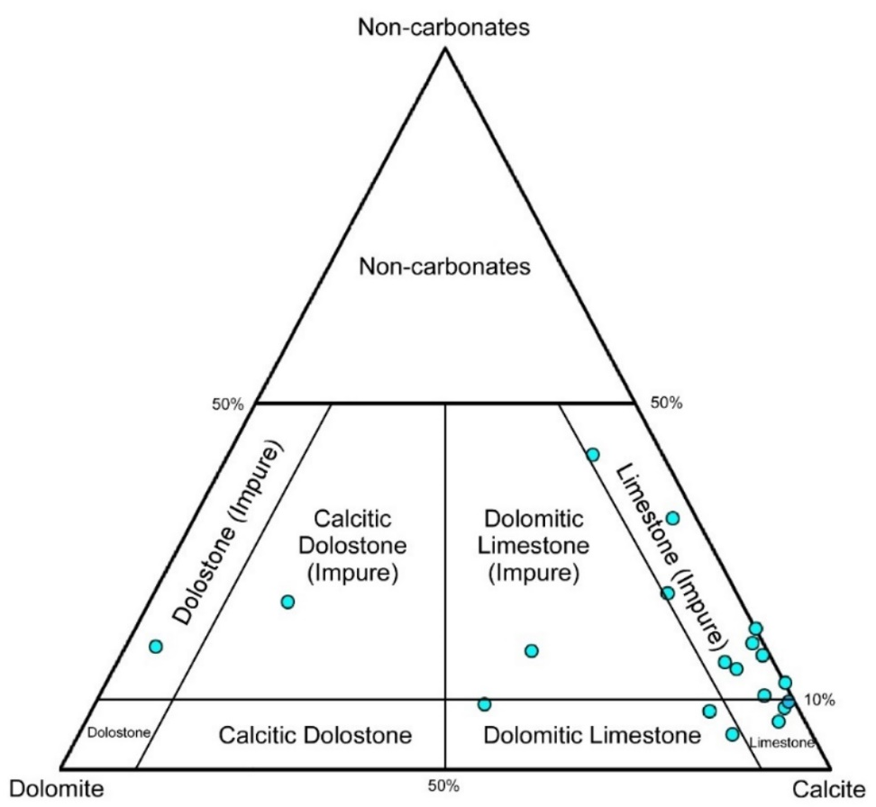
Figure 1: Compositional ternary diagram of carbonates from Cotinguiba Formation, considering Gianni (2000) terminology. Data based on X-ray diffraction.

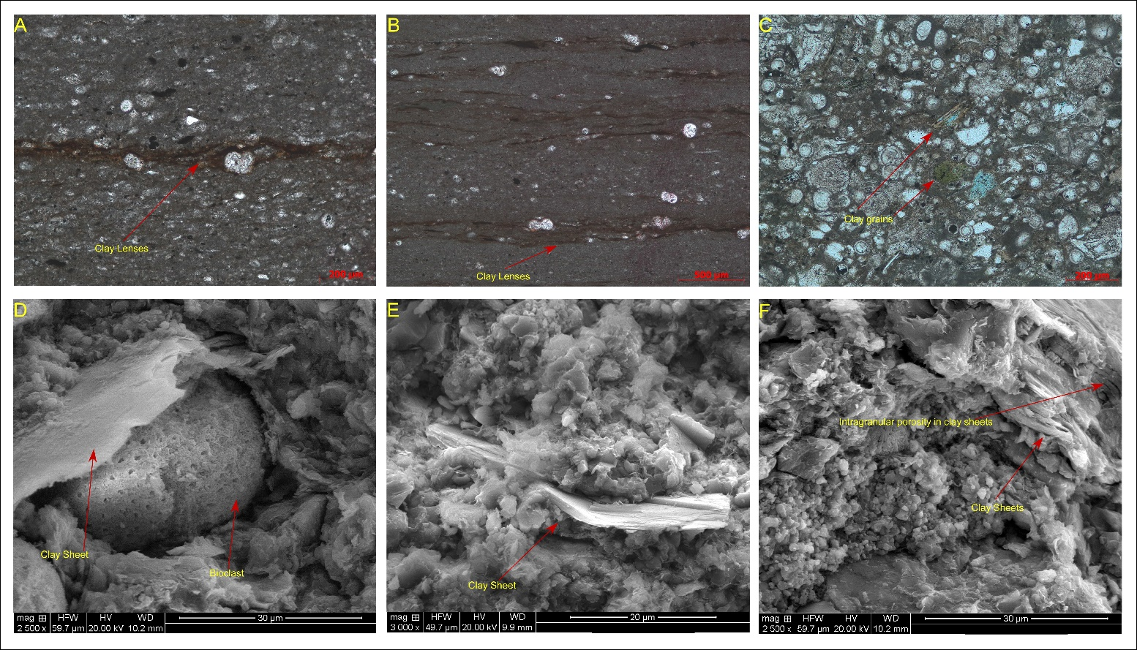
Figure 2: Different occurrences of clays in the carbonates. A) Photomicrography in parallel nicols, clay films covering bioclasts. B) Photomicrography in parallel nicols, clay lenses disseminated in the matrix forming lamination. C) Photomicrography in parallel nicols, with detailed view of clay grains. D) SEM image of clay sheets covering bioclasts. E) SEM image clay sheets in the micrite. F) SEM image clay sheets with intragranular porosity.

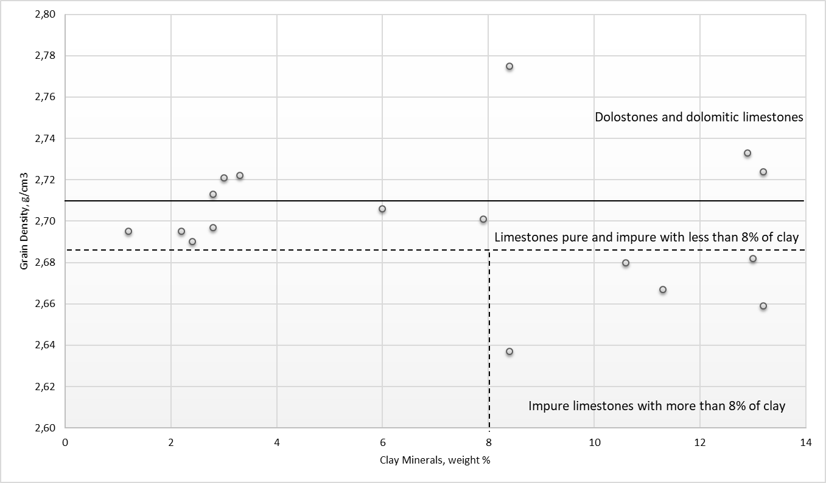
Figure 3: Relationship between grain density and clay mineral content. Presenting separation between dolostones and dolomitic limestones with densities higher than 2.71 g/cm³; pure limestones and impure limestone with less than 8% of clay and density ranging 2.69 and 2.71 g/cm³ impure limestone with more than 8% of clay and density ranging 2.64 and 2.69 g/cm³.

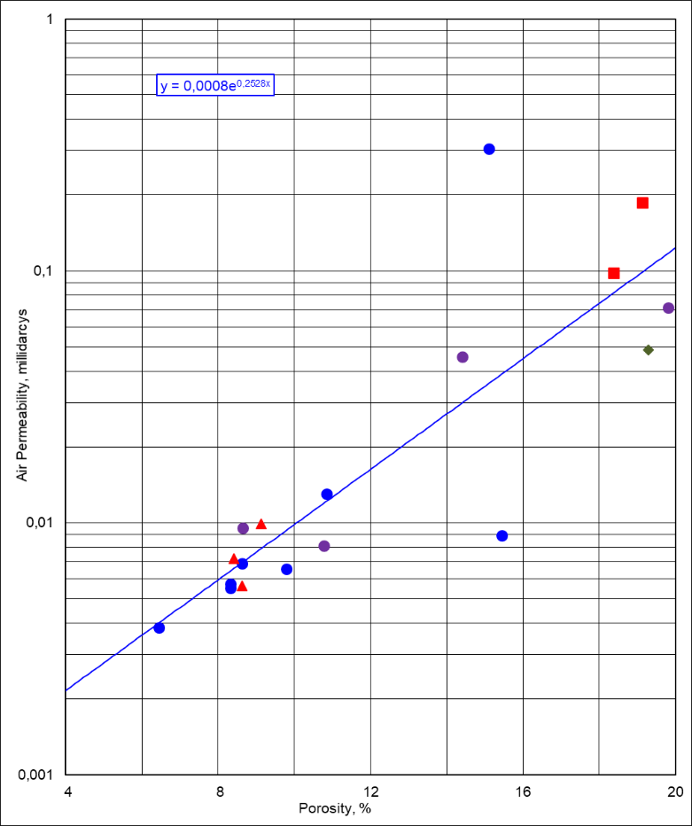
Figure 4: Cross plot between porosity (%) and permeability (mD). Limestone, Impure Limestone, Dolomitic limestone, Impure dolostone.

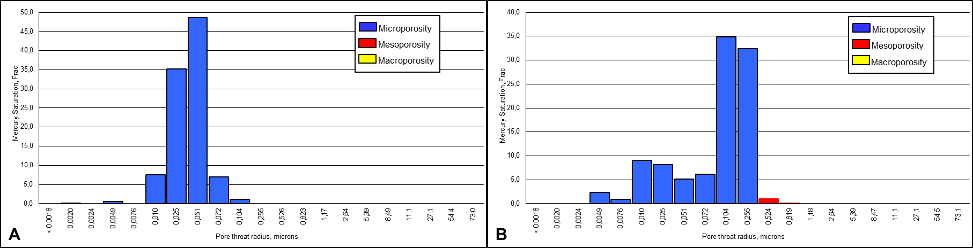
Figure 5: A) Histogram from limestone with 100% microporosity. B) Histogram from limestone with 99% microporosity and 1% mesoporosity.

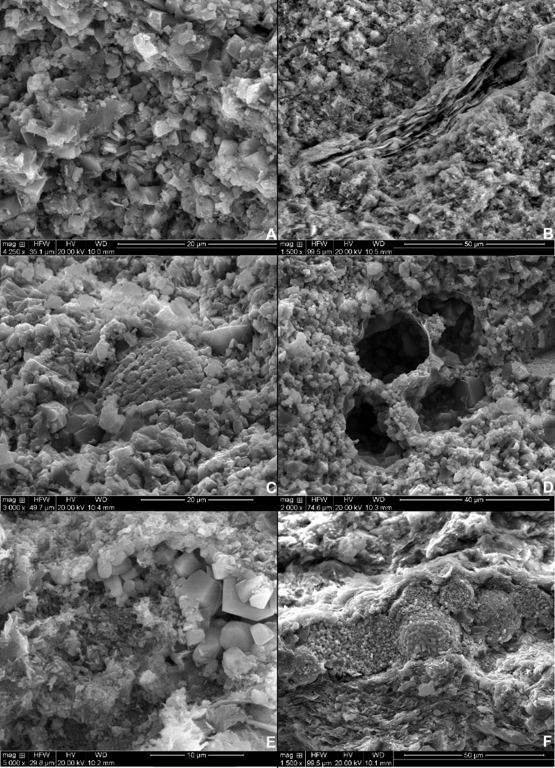
Figure 6: SEM images with evidence of micropores. A) Porous matrix. B) Porous matrix with clay lenses with intragranular pores. C) Porous bioclast. D) Porous bioclasts with intragranular porosity. E) Calcite cement with intercrystalline pores. F) Framboidal pyrite cement with intercrystalline pores.

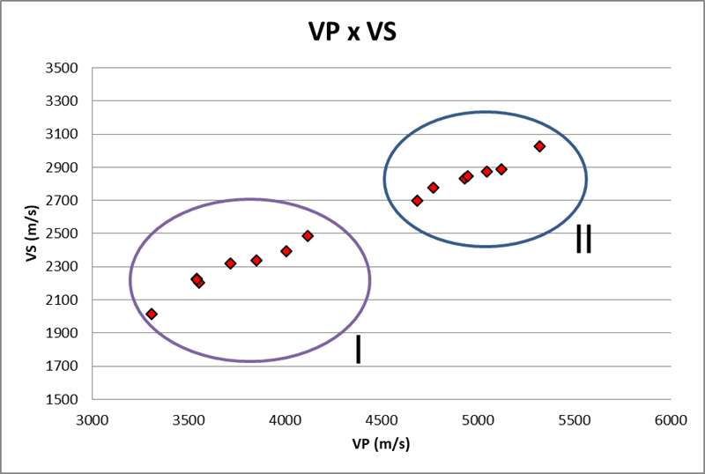
Figure 7: Graph Vp x Vs1 with separation of two identified groups.

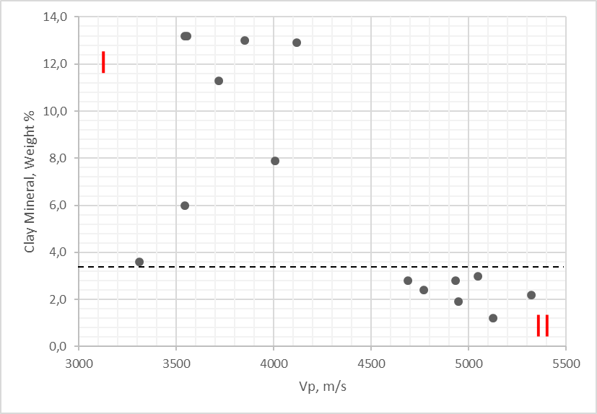
Figure 8: Relationship between clay mineral content and Vp, with separation of two identified groups.

