**Interaction Between Surface and Underground Waters of the Itapemirim**

**and Itabapoana River Basins in the Southern part of the**

**State of Espírito Santo, Southeastern Brazil**

Interação Entre as Águas Superficiais e Subterrâneas nas Bacias dos Rios Itapemirim e Itabapoana no Sul do Estado do Espírito Santo, Sudeste do Brasil

**Abstract**

The Itapemirim River basin and part of the Itabapoana River basin are located in the southern area of the State of Espírito Santo, covering 26 municipalities. The knowledge of the hydrogeological characteristics of these basins provides information on the groundwater potential and the behavior of the river base flow during dry seasons. The objective of this study is to assess the relationship between surface and underground waters from the analysis of hydrograph units and information from tubular well logs. The Itabapoana River basin had the highest flow rates with mean specific capacity was 1415.1 m3/h/m. Itapemirim River basin wells yielded 0.6941 m3/h/m. The percentage of underground discharge in relation to the total discharge exceeded 60% during all seasons in both basins.

**Keywords:** Aquifers; Base flow; Groundwater Management

**Resumo**

As bacias hidrográficas dos rios Itapemirim e parte da bacia do rio Itabapoana localizam-se no extremo sul do estado do Espírito Santo, abrangendo 26 municípios. O conhecimento da hidrogeologia dessas bacias, fornecem informações sobre o potencial hídrico subterrâneo e sobre o comportamento do fluxo de base dos rios, em períodos de estiagem. O objetivo do trabalho é de avaliar a relação entre águas superficiais e subterrâneas a partir das análises de hidrogramas unitários e das informações de um cadastro de poços tubulares. O percentual do deflúvio subterrâneo com relação ao deflúvio total, apresentou valores superiores a 60% para todas as estações do ano em ambas as bacias. Os poços de maiores vazões são os perfurados na bacia do rio Itabapoana, onde a capacidade específica média é de 1415,1 m3/h/m, contra valores de 0,6941 m3/h/m, dos poços perfurados na bacia do rio Itapemirim.

**Palavras-chave**: Aquíferos; Fluxo de Base; Gestão de Águas Subterrâneas

1 Introduction

The surface and underground waters must be considered as unique and inseparable natural resources that promote continuous interaction between superficial discharge and aquifers in the composition of the hydrological cycle. However, increasing human population and humans’ natural predisposition to promote a better quality of life have demanded a more efficient management and planning of water resources. These actions should primarily aid the reasonable use of water resources not only now but also in the future, for the benefit of both humanity and the ecosystems that depend on them.

Groundwater has had a conspicuous importance as a source of domestic, agricultural and industrial water supply in Brazil and worldwide (Hirata et al. 2010), not only because of the increasing costs of water treatment and other factors that limit the use of superficial waters, but also because of the better understood advantages in using groundwater (Gonçalves 2001). A detailed study of the hydrographic basin hydrogeology can provide information on groundwater potential, being directly associated with the understanding of the base flow behavior (Alencar et al. 2006; Bicudo et al. 2011).

The study of the relationships between surface and underground waters should not separate one from the other, and any modification in one of these water resources can generate momentary or even irreversible transformations in the other. State of Espírito Santo is constituted by twelve hydrographic basins. The basins of the Itapemirim and Itabapoana rivers are located in the southern part of the state, and are greatly relevant to many environmental, social and economic aspects. Severe droughts can make surface reservoirs insufficient to comply with such water demands. Most of the Itapemirim and Itabapoana river basins overlie crystalline rocks and their potential as aquifers should be investigated as alternative for water supply (Gonçalves et al. 2005).

The adoption of the hydrographic basin as a planning unit makes a systemic and integrated vision possible, because of the clear delimitation and natural interdependence of climatic, hydrological, geological and ecologic processes (Hao et al. 2018). Having this concept in mind, we describe and interpret in this paper the arrangements, hydric potential and availability of the aquifers of the Itapemirim and Itabapoana hydrographic basins, considering the contributions of both surface and underground waters.

2 Methodology and Data Acquisition

The methodology adopted in this study makes use of the following parameters: rainfall seasonality, base flow in rivers e hydrogeological typologies.

In periods of water recession, associated with rainfall seasonality, the systems or hydrogeological units should be greatly responsible for the maintenance of the base discharges of the water courses in the region (Gonçalves et al. 2005). This aspect will help distinguish hydrogeological typologies with more or less capacity of water transmission from the aquifers to the water courses.

It is also considered that the results obtained by production tests in wells are insufficient to measure the real aquifer potentialities and such results only indicate the capacity of water extraction by means of tubular wells, disregarding the parcel available for a sustainable exploitation (Correa & Melo, 2014; Costa & Bacellar, 2010; Fitts 2015).

Hydraulic equilibrium is considered to exist between the incoming water flow and the outgoing volumes in aquifer systems (Blom et al. 2017). Thus, by knowing how much is returned from groundwater to the rivers, it is possible to determine in the proportion groundwater that participates in the total superficial flow rate. Also allows the determination of the underground unit flow rate, these being equivalent to the capacity of underground storage of the basin in question (Gonçalves et al. 2019).

The study of the capacity of underground storage of a hydrographic basin is carried out on the basis of the discharge during the period of water depletion or recession (Maréchal et al. 2020), which begins in April and lasts until the end of September in the study area. Depletion or recession means the decrease of water stored in the basin aquifer systems. Thus they denoting the water course regime during periods of rainfall deficit. These parameters and their correlations were studied by means of hydrographs.

For the preparation of hydrograph units and the quantification of surface and underground components of the flow rates for the rivers of the study area, the data from four fluviometric stations located in the axes of the Itapemirim and Itabapoana rivers were used. It was observed that the fluvial regime of such rivers is well characterized, highlighting a recession period (April to September) and a flooding period (October to April), (Espirito Santo 2007).

The regulation of the base flows does not exclusively depend on the stored water resources – it also depend on the discharge of these resources to water courses. Such discharges are conditioned to the difference of hydraulic charges between underground deposits and fluvial channels for the displacement of water between the media (Bonsor et al. 2017; Killian et al. 2019). The relationship between the hydraulic charge and the transported flow rate is generally named recession curve. The recession curve characterizes the recession period of the basin aquifers by the decrease in stored water (Bernard-Jannin et al. 2016).

Due to the hydrogeological conditions of the study area, where the rocks permeability is low, the Maillet formula was used to resolve the recession curve (Gonçalves et al. 2005). The recession curve is adjusted to an expression such as the Maillet equation:

$Q=Q_{0}. e^{\left(-α t\right)}$ (1)

where:

$Q_{t}$ = flow rate at instant t in m3/s;

= flow rate at the initial depletion instant in m3/s;

α = recession coefficient;

t = period from the beginning of depletion in days;

e = base of Napierian logarithms (2.71828).

Taking the logarithmic form, the expression of the recession coefficient (α) results in:

$α=\frac{\log{Q_{0}-\log{Q_{t}}}}{0.4343 t}$ (2)

The recession coefficient of a hydrographic basin is the inverse function of the size, the storage coefficient and the Darcy permeability coefficient of the aquifer systems. Therefore, the higher the size and hydrodynamic parameters of the basin aquifers, the lower the value of the recession coefficient (Castany, 1967). The storage capacity is given by the expression:

$V= \frac{Q_{0}}{α}$ (3)

As α is calculated in days from the depletion curve, the storage capacity is given by:

$V=\frac{86400 Q_{0} }{α}$ (4)

This expression yields the groundwater volume above the base level stored at instant $t_{0}$.

By means of this expression 4 and the hydrographs drawn using daily discharge data, it was possible to obtain the recession coefficients of some segments upstream the basins of the Itapemirim and Itabapoana rivers, Table 1.

Table 1 – Data from fluviometric stations

|  |  |  |  |  |
| --- | --- | --- | --- | --- |
| Code | Station | River | Drainage Area (Km2) | Recession Coefficients (days) |
| 57450000 | Rive | Itapemirim | 2218 | 90 |
| 57580000 | Usina Paineiras | Itapemirim | 5167 | 65 |
| 57770000 | São José dos Calçados | Calçado | 144 | 81 |
| 57880000 | Mimoso do Sul | Muqui do Sul | 369 | 88 |

In the Itapemirim and Itabapoana river basins, 51 and 37 deep tubular well were registered, respectively. The transmissivity values (T) were obtained by pumping tests and resulting maximum and recovery flow rate values, interpreted by the method Cooper e Jacob (1946). It was performed in 15 tabular wells drilled in the Itapemirim river basin and 9 wells in the Itabapoana river basin. For the hydrogeological study of the Itapemirim and Itabapoana hydrographic basins, fluviometric and pluviometric data available on the Agência Nacional de Águas (ANA) on the site, by request, where a time series data distributed from the 1930’s to 2018 can be obtained for the southern part of the State of Espírito Santo. Data from transverse profiles (depth versus section width) at the fluviometric stations were also used. The profiles show the river cross section at fluviometric stations. It was possible to analyze the processes affecting the river during the time series by considering width and depth variations, whether erosion or deposition of sediments took place in its bottom. Hypsometry and declivity maps for the Itaperirim and Itabapoana river basins were produced using SIG ArcGIS® version 10.2.2.

**3 Results and Discussion**

The Itapemirim River Basin, Figure 1 drains a total area of 6,014 km2 encompassing 17 municipalities - 16 in the State of Espírito Santo (ES) and one in the State of Minas Gerais (MG) – with a population of almost 500,000 inhabitants.

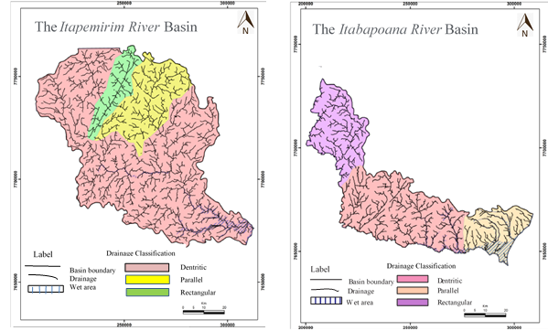

Figure 1 – The hydrographic basins of the Itapemirim and Itabapoana rivers, modified fron, CPRM (1997).

The Itapemirim River headwaters are located in the Lajinha municipality (MG). The river runs for ca. 320 km from west to east, reaching Itapemirim (ES).

The Itabapoana River Basin, Figure 1 drains an area of 4,875 km2 in the states of Minas Gerais, Espírito Santo and Rio de Janeiro, encompassing 18 municipalities whose total population reaches 652,000 inhabitants (IBGE 2019). The headwaters of the Itabapoana River are located in the Caparaó Ridge, in the Alto Caparaó municipality (MG) close to the Bandeira Peak.

**3.1 Hydrogeology**

The definition of the hydrogeological units was based on the characteristics of the litho-structural units identified in the study area, and, according to the behavior of the water conducing medium, these units can be characterized as aquifers. A proposal and systematization of the aquifer systems and their relationship with the lithostratigraphic units are presented in Table 2.

Table 2 – Aquifer systems of the Itapemirim and Itabapoana river basins.

|  |  |
| --- | --- |
| Lithology | Aquifer system |
| Granites, granitoids, gneisses | Granitic-Gneissic |
| Fine- to coarse-grained sands in coastal bars | Coastal Deposits |
| Fine- to coarse-grained sandstones, argillites | Barreiras |
| Alluvial and colluvial deposits | Undifferentiated Detrital Covers |
| Quartzites, metagranites | Metasedimentary |

The values of the hydrodynamic parameters that characterize the registered wells are listed in Table 3; in Figure 2 the map of hydrogeological domains is presented. Due to the lithological and structural complexity, the hydrogeological behavior in the study area is also very complex.

Table 3 – Wells of the aquifer systems of the Itapemirim and Itabapoana river basins.

|  |  |  |  |  |  |  |
| --- | --- | --- | --- | --- | --- | --- |
| Tabular wells | N.W. | Depth (m) | Q (m3/h) | Q/s (m3/h/m) | S.L. (m) | D.L. (m) |
| Itapemirim Basin | 51 | 20.00  77.49  150.00 | 1.15  10.66  27.72 | 0.0360  0.6941  7.9200 | 1.00  8.02  38.00 | 5.00  44.15  95.72 |
| Itabapoana Basin | 37 | 16.00  72.20  300.00 | 0.79  10.26  32.69 | 0.0136  1.4151  6.5000 | 0.10  3.48  10.60 | 3.00  34.97  102.00 |
| 20.00- Minimum Value //77,49-Mean value //150,00-Maximum value; N. W. Number of Wells/ Q = Flow rate / Q/s = Specific Flow rate / S.L. Static Level / D.L. Dynamic Level | | | | | | |

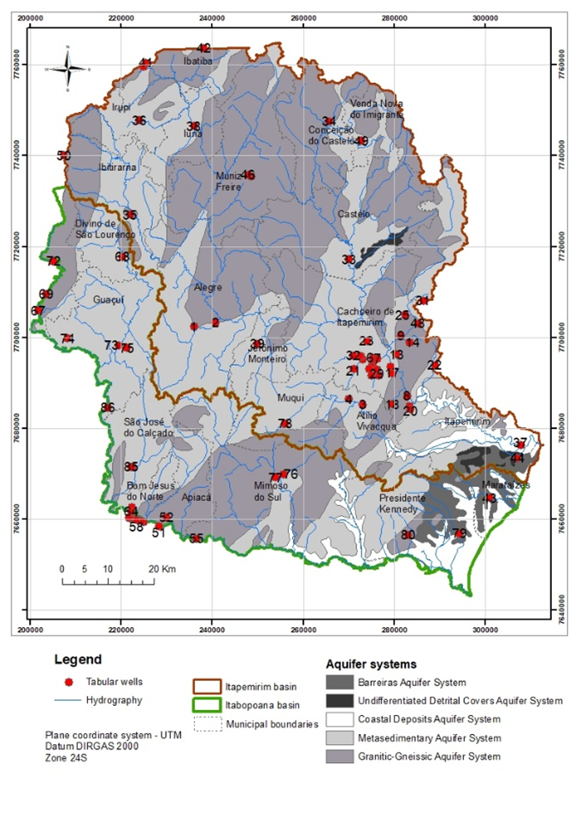

Figure 2 – Aquifer systems of the Itapemirim and Itabapoana river basins

For descriptive purposes, the groundwater occurrences were grouped according rock types and open structures in the following aquifer categories: aquifers in fractured rocks and aquifers in granular rocks. Regarding the aquifers by granular porosity, the groundwater storage takes place by means of pores or interstices in the rock. These aquifers are represented by the Tertiary-Quaternary covers and Recent alluvial deposits.

The aquifer medium of the fractured rocks is very weak when it comes to water storage and production and is dependent on the presence of joints, fractures, and the extension and lithology of the overlying weathering mantle (Maharjan & Donavan, 2016). In the recharge of the aquifer system of crystalline terrains, the main regenerating agent of the groundwater resources is the surface hydrographic system that, acting in the zones of fracture-drainage coincidence, can ensure a constant recharge via alluvial deposits during periods of greater rainfall (Ohmer et al. 2017).

3.2 The Aquifer Systems

3.2.1 Granitic-Gneissic Aquifer System

This system is mainly represented by granites, gneisses, migmatites, granitoids, and charnockites. The aquifers are discontinuous, anisotropic, heterogeneous, fractured, either free or semi-confined by the altered rock. These aquifers present double porosity, with groundwater circulation and storage in discontinuities created by rock fracturing (fracture porosity) and interstices in the weathering mantle (interstitial porosity), (Le et al. 2018). In these aquifers the fracture porosity makes them more permeable and the interstice porosity more capable of groundwater storage. Due to the high local rainfall and the presence of a thick regolith, the underground recharge is potentialized. The transmissivity values obtained for eight wells drilled in these aquifers varied from 0.10 to 12.00 m2/day, with a mean value of 3.99 m2/day, and median of 2.20 m2/day. The conductivity values varied from 0.01 to 0.04 m/day, with a mean value of 0.02 m/day.

3.2.2 Undifferentiated Detrital Covers Aquifer System

It is regionally verified in this system, despite the predominantly clayey-sandy lithology, a regular share of rainwater acting as an intermediate element in the water transmission to subjacent fissures. These Quaternary (Q) and Tertiary-Quaternary (T) covers almost always overlie rocks. They are mainly represented by sandy-clayey sediments, which are locally residual or show little transport.

3.2.3 Coastal Deposits Aquifer System

The coastal deposit aquifers are limited to the region of the Itapemirim River mouth and in general are not expressive in the basin. The sediments are composed of poorly sorted fine- to coarse-grained sands with a silty to clayey matrix. These aquifers are free, shallow, usually brackish, and of restricted use. The existing catchments are shallow wells known as cacimbas and ponteiras, which exploit the surficial water levels for domestic supply.

3.2.4 Metasedimentary Aquifer System

These aquifers are constituted by quartzitic metasediments of different ages and stratigraphic positions. They are favored by good groundwater storage and circulation conditions, which are improved when brittle structures (faults, fractures) are associated with them. Their occur as discontinuous linear bodies of varied thicknesses. These aquifers are fractured, discontinuous, anisotropic, heterogeneous, and free. The mean transmissivity value obtained for these rocks using the data from four wells is 210 m2/day, with a maximum value of 610 m2/day, a minimum value of 85 m2/day, and a storage coefficient varying between 10-2 and 10-5.

3.2.5 The Barreiras Aquifer System

The Barreiras Aquifer is porous, free, locally semi-confined, and of large spatial distribution. Porosity and permeability are in general good. It is composed of alluvial and fluvial sediments in a complex association of permeable/impervious strata (Araí, 2006; Nunes et al. 2011). The great heterogeneity results from the discontinuity of the aquifers (lenticular geometry) associated with permeability barriers caused by more argillaceous facies. This lithological association affects the permeability-porosity characteristics of the layers. The analysis of the hydraulic characteristics of the Barreiras Aquifer (Furrier et al. 2006) indicates great heterogeneity of this underground source throughout its ample area of occurrence. The recharge of the Barreiras Aquifer is fundamentally rainwater falling on outcropping areas. During flooding periods, there is also the contribution from rivers. The thickness of the package varies a lot, once the basement crops out in some points, from a few meters to 150 m in the coastal region, with mean values of 60 m, estimated from tabular well logs. The mean transmissivity value obtained from eight wells was 162.54 m2/day, a maximum value of 289 m2/day, a minimum value of 95 m2/day, and a storage coefficient varying between 10-2 and 10-5. Due to the ample facies variation, this aquifer system is free, with characteristic heterogeneity and anisotropy (Obodovskyi et al. 2020). The thicknesses of these covers are not exactly known, but they may not reach more than 40 m, with a mean value of ca. 15 m. Thicknesses around 2 m may occur, which leads to an increased hydrogeological interest to the zones of higher potential. The system recharge is exclusively by means of direct infiltration of rainwater falling directly on the occurrences. Thirty-eight dug wells and 17 headwaters were registered in the Itapemirim River Basin. In the Itabapoana River Basin 22 dug wells and 31 headwaters were registered, the depths of these wells varying between 5.50 m (minimum) and 22.30 m (maximum), with a mean value of 12.63 m. the static levels vary from 4.20 m (minimum) to 20.60 m (maximum), with a mean value of 9.83 m.

3.3 Hydrology of the Itapemirim River Basin

To the north, the Itapemirim River Basin borders the State of Minas Gerais, corresponding to ca. 50% of the area. The geomorphology is very rugged, modeled on geological formations of remobilized fold belts. In the southern part of the basin, sedimentary deposits, the majority of which belonging to the Barreiras Formation, predominate. Considering the geology and the geomorphology, the basin is dominated by two regimes that influence the flow rate behavior. The first, to the north of the basin, is characterized by altitudes varying from 900 to 2,900 m (Figure 3a) and declivities from 20 to 45% (undulated to strongly undulated) (Figure 3b). The second is characterized by altitudes varying from 0 to 450 m and declivities from 3 to 8% (smoothly undulated). In the first, the surface flow rate is more constant and free, once the high altitudes, the high declivities, and the geological formation favor these conditions.

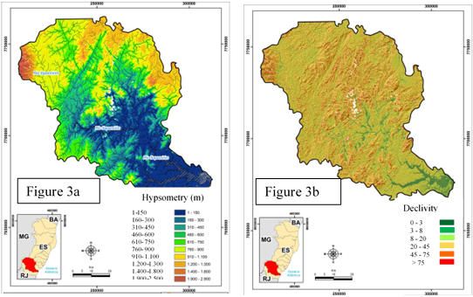

Figure 3 – Itapemirim River Basin: Hypsometry (a) and Declivity (b).

The historical series of the fluviometric data were collected in the stations from 1940 to 2018. The monthly mean flow rate values, considering the sum of all flow rate values during a month, seem to accompany the rainfall seasonality, (Espirito Santo 2007). A drop in the values is observed from April to October (Figures 4a, 4b and 5a, 5b).

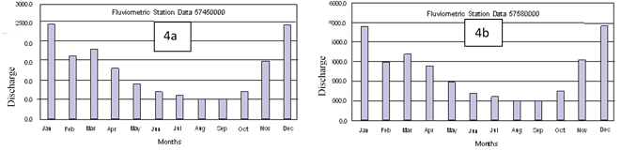

Figures 4a and 4b – Monthly flow rates recorded in the fluviometric stations.

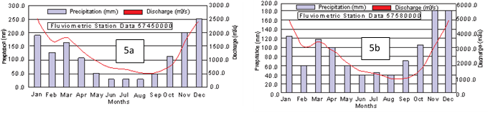

Figures 5a and 5b – Relationship between rainfall data and monthly flow rates recorded in

pluviometric and fluviometric stations

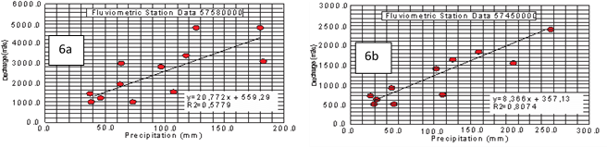

Figures 6a and 6b – Dispersion diagrams of rainfall and flow rate data, recorded in

pluviometric and fluviometric stations

The correlation between the pluviometric and fluviometric data generates a data dispersion diagram, whose linear regression equation shows a monthly flow rate independent of rainfall – Figures 6a and 6b.

In Figures 7a and 7b the percentages of underground discharge are displayed in relation to the total discharges in the Itapemirim River basin, reaching very high values, greater than 60%, in both fluviometric stations, independently of the time of the year. The underground discharge or specific capacity expresses the capacity of the aquifer to recover per km2, characterizing the potentiality of the aquifers of the sub-basin. Within this concept, it was observed that the contributions of the waters drained to the Itapemirim River decrease from up- to downstream. In this basin, the drilled wells have an average specific capacity of 0.6941 m3/h/m.



Figures 7a and 7b – Itapemirim River hydrographs

3.4 Hydrology of the Itabapoana River Basin

The Itabapoana River Basin, is divided in two different geomorphological domains, the first from the centermost portion to the north, composed by the Differentiated Fold Belts of altitudes varying from 900 to 2,000 m, Figure 8a, and declivities from 20 to 45% (strongly undulated) and from 8 to 20% (undulated), Figure 8b. The second domain, in the southern part of the basin, is constituted by the sedimentary deposits of the Barreiras Formation. In these terrains, altitudes from 500 to 0 m and declivities from 3 to 8% (smoothly undulated) predominate.

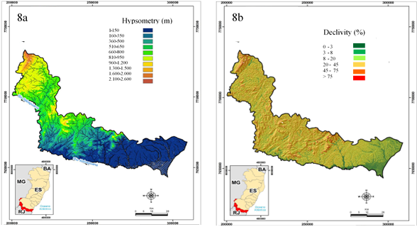

Figure 8 – Itabapoana River Basin: Hypsometry (a) and Declivity (b)..

In the historical series of fluviometric data obtained from stations 57770000 and 55880000, it is observed that for the monthly mean values, the sum of all flow rate values obtained during the month, there is a tendency of dropping from April to October. From November to January rises in the flow rates are recorded in the fluviometric stations, Figure 9a and 9b.

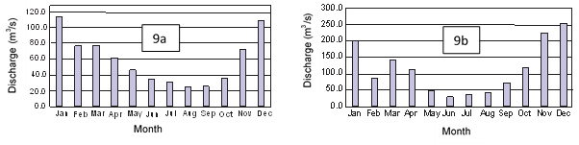

Figures 9a and 9b – Monthly flow rates recorded in the fluviometric stations.

The graphs of Figures 10a and 10b follow the same regimes of variations of the values presented for the pluviometric data, with drops in the flow rate from the second trimester, and beginning of the rise in the flow rate in beginning of the last trimester of the year. The graphs of Figures 11a and 11b show a correlation between these flow rate data and rainfall.

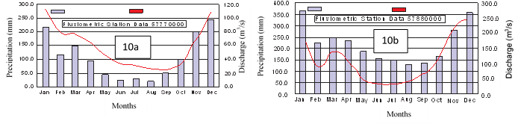

Figure 10a and 10b – Relationship between rainfall and monthly flow rate data.

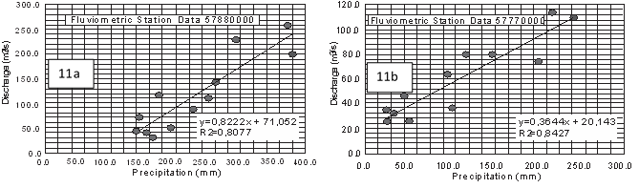

Figures 11a and 11b – Dispersion diagrams of rainfall and flow rate data, recorded in the pluviometric and fluviometric stations.

The correlation between the pluviometric and fluviometric data, considering the sum of the rainfall (mm) and flow rate (m³/s) during a month, generating a mean value for the months of the year within the time series interval, shows that in both stations there are flow rate values that do not depend on rainfall. The correlation between the pluviometric (2141016) and fluviometric (57770000) stations localized in São José dos Calçados produced a data dispersion diagram whose linear regression equation points to a flow rate value of 20 m³/s per month. For the pluviometric (2141015) and fluviometric (57880000) stations localized in Mimoso do Sul, the data dispersion diagram whose linear regression equation points to a flow rate value of 71 m³/s per month, (Figures 11a and 11b). In other words, in both stations, during the drought period, the flow rate accumulated in the month reaches that value.

Figures 12a and 12b show that the percentages of underground discharges in relation to the total discharges are very high in the Itabapoana River sub-basin, exceeding 63.57% in the fluviometric station 57770000 and 72.76% in the fluviometric station 57880000, independently of the time of the year. As observed in the Itapemirim River basin, contributions of the waters drained to the Itabapoana River decrease from up- to downstream. In this basin, the drilled wells have an average specific capacity of 1415.1 m3/h/m.

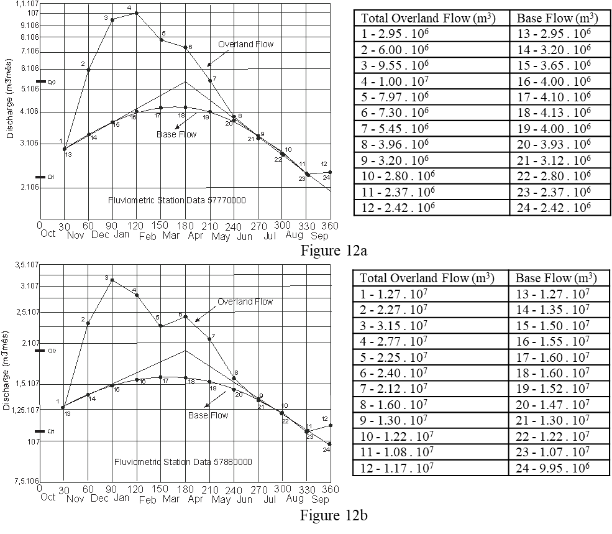

Figures 12a and 12b – Itabapoana River hydrographs.

4 Conclusions

For the whole study area, the predominant recharge is via rainfall that infiltrates surface formations connected to fractures, and also contributions from water courses that cross fractured gneisses and granites. However, the rugged morphology does not favor infiltration, but the surface flow rate. The flow tends to the topographic lows where the perennial water courses drain the system. The natural outlets are headwaters in contact with poorly permeable strata of the crystalline basement, yielding weak flow rates.

The Itapemirim River Basin is characterized by aquifer zones of variable productivity. The wells that produce the highest flow rates are those drilled in metasedimentary rock aquifers, followed by coastal deposit aquifers. The wells that yield the low flow rates are those drilled in the granitic-gneissic aquifer system.

It is concluded that there is an important correlation between the geological, geomorphological and hydrologic conditioning factors in a hydrogeological environment in which medium to low mean porosities usually predominate, which reduces the infiltration in the Itapemirim River Basin.

The groundwater storage capacity is significant, considering that both basins are mostly constituted by fissured aquifers. However, these aquifers are overlain by a relatively thick weathering mantle and are also associated with a considerable hydrographic net, a fact that results from the permeable nature of the weathered covers.

**5 References**

Alencar, D.B.S., Silva, C.L., Oliveira, C.A.S. 2006, ‘Influência da Precipitação no Escoamento Superficial em uma Microbacia Hidrográfica do Distrito Federal’ *Engenharia Agrícola*, vol. 26, pp. 103-12.

Arai, M. 2006, ‘A grande elevação eustática do Mioceno e sua influência na origem do Grupo Barreiras’, *Geologia USP Série Científica*, vol. 6, pp. 1-6. http://dx.doi.org/10.5327/S1519-874X2006000300002

Bernard-Jannin, L., Brito, D., Sun, X., Jauch, E., Neves, R., Sauvage, S., Pérez, J.M.S. 2016, ‘Spatially distributed modelling of surface water-groundwater exchanges during overbank flood events – a case study at the Garonne River’, *Advances in Water Resources*, vol. 94, pp. 146-59. https://doi-org/10.1016/j.advwatres.2016.05.008

Bicudo, C.E.M., Tundisi, J.G., Scheuenstuhl, M.C.B. 2011, ‘*Águas do Brasil: análises estratégicas’*, São Paulo: Academia Brasileira de Ciências, Rio de Janeiro, Brasil.

Blom, A., Arkesteijn, L., Chavarrías, V., Viparelli, E. 2017, ‘The equilibrium alluvial river under variable flow and its channel-forming discharge’, *Journal of Geophysical Research: Earth Surface*, vol. 122, pp. 1924-48. https://doi.org/10.1002/2017JF004213

Bonsor, H.C., MacDonald, A.M., Ahmed, K.M. 2017, ‘Hydrogeological typologies of the Indo-Gangetic basin alluvial aquifer, South Asia’, *Hydrogeology Journal*, vol. 25, pp. 1377-406. https://doi-org/10.1007/s10040-017-1550-z

Castany, G. 1967, ‘Traité pratique des eaux souterraines’, Paris, France.

Cooper, H.H., Jacob, C.E. 1946, ‘A generalized graphical method for evaluating formation constants and summarizing well field history’, *American Geophysical Union*, vol. 27, pp. 526-34.

Correa, S.W., Mello, C.R. 2014, ‘Determinação e separação do escoamento superficial direto do escoamento base na sub-bacia Paraopeba, Rio Ribeirão da Ajuda, mediante os métodos de Barnes e dos filtros de Eckhardt’, *Congresso Brasileiro de Engenharia Agrícola,* Campo Grande, Brasil.

Costa, F.M., Bacellar, L.A.P. 2010, ‘Caracterização Hidrogeológica de Aquíferos a Partir do Fluxo de Base’, *Revista Brasileira de Recursos Hídricos*, vol. 15, pp. 173-83. https://doi.org/10.21168/rbrh.v15n3.p173-183

CPRM – vide Companhia de Pesquisa e Recursos Minerais.

Companhia de Pesquisa e Recursos Minerais 1997, *Folha Cachoeiro do Itapemirim SF 24 Z-V-A.* Serviço Geológico do Brasil.

Espírito Santo 2007, Resolução CERH nº 017, de 19 de março de 2007. Conselho Estadual de Recursos Hídricos. Vitória, Brasil.

Fitts, C.R. 2015, ‘*Águas Subterrâneas’*, Elsevier, Rio de Janeiro

Furrier, M., Araújo, M.E., Meneses, L.F. 2006, ‘Geomorfologia e Tectônica da Formação Barreiras no Estado da Paraíba’, *Geologia USP Série Científica*, vol. 6, pp. 61-70. http://dx.doi.org/10.5327/S1519-874X2006000300008

Gonçalves, J.A.C. 2001, ‘Contribuição à Hidrogeologia e Hidroquímica do Leste da Zona da Mata de Minas Gerais e Extremo Noroeste do Estado do Rio de Janeiro’. Master Thesis, Univesidade Federal de Ouro Preto.

Gonçalves, J.A.C., Scudino, P.C.B., Sobreira, F.G. 2005, ‘Reservas Renováveis e Caracterização dos Aquíferos Fissurais do Leste da Zona da Mata de Minas Gerais e Adjacências’, *Geologia USP Série Científica*, vol. 5, pp. 19-27. https://doi.org/10.5327/S1519-874X2005000100002

Gonçalves, J.A.C., Almeida, M.S.L., Ferreira, M.A.M., Paiva, B.L.F. 2019, ‘Disponibilidade de águas superficiais e subterrâneas na bacia do Rio do Peixe – Itabira-MG’, *Research, Society and Development*, vol. 8, pp. 1-17. http://dx.doi.org/10.33448/rsd-v8i12.1904

Hao, A., Zhang, Y., Zhang, E. 2018, ‘Review: Groundwater resources and related environmental issues in China’, *Hydrogeology Journal*, vol. 26, pp. 1325–37. https://doi-org/10.1007/s10040-018-1787-1

Hirata, R., Zoby, J.L.G., Oliveira, F.R. 2010, *‘Água Subterrânea: Reserva Estratégica ou Emergencial’*. Instituto de Botânica, São Paulo, Brasil.

IBGE - vide Instituto Brasileiro de Geografia e Estatística.

Instituto Brasileiro de Geografia e Estatística 2019, *Folhas Topográficas,* Rio de Janeiro, Brasil.

Killian, C.D., Asquith, W.H., Barlow, J.R.B. 2019, ‘Characterizing groundwater and surface-water interaction using hydrograph-separation techniques and groundwater-level data throughout the Mississippi Delta, USA’, *Hydrogeology Journal*, vol. 27, pp. 2167-79. https://doi-org/10.1007/s10040-019-01981-6

Le, T.B., Crosato, A., Uijttewaal, W.S.J. 2018, ‘Long-term morphological developments of river channels separated by a longitudinal training wall’, *Advances in Water Resources*, vol. 113, pp. 73-85. https://doi.org/10.1016/j.advwatres.2018.01.007

Maharjan, M., Donovan, J.J. 2016, ‘Groundwater response to serial stream stage fluctuations in shallow unconfined alluvial aquifers along a regulated stream’, *Hydrogeology Journal*, vol. 24, pp. 2003-15. http://dx.doi.org/10.1007/s10040-016-1443-6

Maréchal, J., Bouzit, M., Rinaudo, J., Moiroux, F., Desprats, J., Caballero, Y. 2020, ‘Mapping Economic Feasibility of Managed Aquifer Recharge’, *Water*, vol. 12, no. 680, pp. 1-13. https://doi.org/10.3390/w12030680

Nunes, F.C., Silva, E.F., Boas, G.S.V. 2011, ‘Grupo Barreiras: Características, Gênese e Evidências de Neotectonismo’, *Boletim de Pesquisa e Desenvolvimento 194*. Centro Nacional de Pequisa de Solos, Ministério da Agricultura, Pecuária e Abastecimento.

Obodovskyi, O., Habel, M., Szatten, D., Rozlach, Z., Babiński, Z., Maerker, M. 2020, ‘Assessment of the Dnieper Alluvial Riverbed Stability Affected by Intervention Discharge Downstream of Kaniv Dam’, *Water*, vol. 12, no. 1104, pp. 1-17. https://doi.org/10.3390/w12041104

Ohmer, M., Liesch, T., Goeppert, N., Goldscheider, N. 2017, ‘On the optimal selection of interpolation methods for groundwater contouring: An example of propagation of uncertainty regarding inter-aquifer Exchange’, *Advances in Water Resources*, vol. 109, pp. 121-32. https://doi.org/10.1016/j.advwatres.2017.08.016