Land Use and Occupation Analysis of the Municipality of Itarema-CE based on Landsat Multispectral Data
Análise de Uso e Ocupação do Solo do Município de Itarema-CE com Base em Dados Multiespectrais Landsat

Abstract
This work investigated the process of land use and occupation in the municipality of Itarema. It is located in the geographic coordinates of Latitude (S) 2º 55' 13" and Longitude (W) 39º 54' 54 in the northern region of the state of Ceará, with an area of 720.7 km² IPECE (2017) in the semi-arid region. The objective of this study was to analyze the sand-time changes in land use and cover in the municipality of Itarema for the period from 2000 to 2020, from Landsat series orbital remote sensing data to evaluate the evolutionary behavior of the landscape. The methodology used was the literary review. Technical procedures related to orbital images of the Landsat5-8 series were applied, with recording scenes 2000 and 2020. Imaging treatment was performed with preprocessing, and RGB 542 was processed for Landsat 5 and RGB 654 for Landsat 8 in ENVI 4.3. The classification supervised in the SCP - Semi-Automatic Plug-in was performed by the MAX-VER method and seven types of use were considered, and the post-processing with image enhancement was performed. The Software used was QGIS 3.16, on a scale of 1:150,000 km. The results point to a significant change in the typology of dense vegetation from 52.84% in (2000) to a reduction of 25.71% in (2020), followed by the increase in degraded areas from 7.47% in (2000) to 16.03% in (2020). Final considerations, we highlight the importance of remote sensing in observations of landscape evolution and in the interpretation of the typology of use, supported by the change in the PIB profile of the municipality.

Keywords: Remote Sensing; Semiarid; Landscape

Resumo
Este trabalho investigou o processo de uso e ocupação do solo no município de Itarema. O mesmo está situado nas coordenadas geográficas de Latitude (S) 2º 55' 13" e Longitude (W) 39º 54' 54 na região norte do estado do Ceará, com área de 720,7 km² IPECE (2017) no semiárido. Objetivou-se, analisar as alterações espaço-temporal de uso e cobertura do solo no município de Itarema para o período de 2000 a 2020, a partir de dados de sensoriamento remoto orbital da série Landsat, visando avaliar o comportamento evolutivo da paisagem. Utilizou-se como metodologia a revisão literária. Aplicou-se procedimentos técnicos vinculados a imagens orbitais da série Landsat5-8, com registro de cenas 2000 e 2020. Realizou-se o tratamento de imagem com pré-processamento, e o processamento dos RGB 542 para o Landsat 5 e RGB 654 para o Landsat 8 no ENVI 4.3. Realizou-se a classificação supervisionada no SCP – Semi-Automatic Plugin pelo método MAX-VER e considerou-se sete tipologias de uso, realizou-se o pós-processamento com realce de imagem. O Software utilizado foi o QGIS 3.16, na escala de 1:150.000 km. Os resultados apontam para uma alteração significativa na tipologia da vegetação densa de 52,84% em (2000) para um redução de 25,71% em (2020), seguida pelo aumento de áreas degradada de 7,47% em (2000) para 16,03% em (2020). Considerações finais, destaca-se a importância do sensoriamento remoto nas observações de evolução da paisagem e na interpretação da tipologia de uso, subsidiada pela mudança no perfil do PIB do município.

Palavras-chave: Sensoriamento remoto; Semiárido; Paisagem

Introduction
The process of land use and occupation by communities modifies the dynamics of semi-arid environments and landscapes. The population distribution of the municipality and its relationship between rural and urban communities, associated with the economic profile, enables a spatial dynamics of the territory, configuring specific spatial processes of use.
The benefit of the soil is related to several economic processes existing in the municipalities, in the region and in the territories, among them, mineral extractivism, agriculture, industry and the service sector. In this context, soil becomes an object of political, economic and social interest, and is valued in view of its socio-environmental characteristics.
Santos & Oliveira (2012 p. 23) exposed that the northeastern coast, with the arrival of European invaders, became the target of intense greed and as their domains advanced, interest in invaded lands became greater. For FEPOINCE (2022) the Brazilian Northeast was the first frontier of resistance to attacks by the colonizers.
The intensity of the spatial modification of the landscape arises with the arrival of the "Europeans" to the lands of the Americas. However, it is worth noting that the degree of modification of landscapes varied over time and space, being linked at first to the conditions of survival of communities and territories.
The occupation of the soil emerged from the dynamics of the region itself, given the relationship between the indigenous "Tremembé people" and the Europeans in their penetration by the coast under the continent. Itarema, an area of this study, arose from the disaggregation of the municipality of origin, Acaraú, before law no. 11,2008/1985. A relevant aspect is about the origin of the name Itarema which in Tupi means stone of unpleasant smell.
According to Soares et al (2014) the use and occupation of land in Itarema, is characterized by the subsistence culture of beans, corn and cassava, in addition to monoculture cotton, sugarcane, cashew nuts and various fruits, especially coconut.
For Kelting (2009) in the coastal watershed, where the municipality of Itarema is inserted, the way of appropriation of the landscape by society occurs with the use of extractive agro pastoral practices, inherited by the first inhabitants of the area, the Indians. Where it suggests its influence on soil appropriation processes.
For Roque et al (2017) the expression "use of soil" can be understood as the way in which space is being occupied by man, whether for the housing, industrial, cultivation or deforested area character. It is understood that the analyses of the types of use of landscapes are related to the need to know the spatial organization of geographical phenomena.
For Leite & Rosa (2012) knowledge and monitoring of land use and occupation is paramount for understanding the patterns of space organization, once its trends can be analyzed. Thus, it validates the importance of analyzing the spatial behavior of landscapes through remote sensing techniques as a crucial factor in the process of territorial organization.
According to Rodrigues et al (2021) remote sensing is a technique that allows the extracting of information through the use of satellite images. Such techniques can be used in several applications, such as the development of maps of land use and occupation, determination of vegetation indices (NDVI, EVI, SAVI, etc.), environmental zoning, and mapping of water resources, planning and management of watersheds.
The use of images in the process of mapping soil use according to Augusto (2016) have a great potential for applicability in the environmental theme, the products obtained through remote sensing technology, such as radar images and multispectral images of the optical region, have been extremely used in recent years. In this aspect it is worth mentioning the Landsat series, which since the 1970s provides data for various studies.
The objective of this study was to analyze the space-temporal alterations of land use and cover in the municipality of Itarema on the west coast of the State of Ceará for the period from 2000 to 2020, based on remote orbital sensing data from the Landsat series, aiming to evaluate the evolutionary behavior of the landscape.
1.1 Literature Review
According to Antunes el at (2017), information on the identification and characterization of land use and land cover history in deforested areas is necessary to verify the main factors responsible for the occurrence of this phenomenon and to evaluate the environmental implications. In summary, this record is the heritage of landscape changes through the insertion of human activities over time and space, which can be identified through satellites.
According to Brito et al (2017) the use of satellite images constitute a very reliable and economically viable alternative for monitoring pastures cultivated in Brazil apud (Ferreira et al., 2012; Sano et al.,2010). Thus, to allow knowing the nuances existing in the land cover, for this, it had the orbital images of the Landsat series 5 and 8, because it has a high relevance in the process of identification of the types of use in relation to land cover.
Thus, corroborating the thought of Milk & Pink (2012) use, occupation and land cover can be synthesized through maps. These indicate the spatial distribution of the typologies of anthropic action that may be by homogeneous patterns. In this respect, remote sensing is an important auxiliary tool and essential to carry out spatial mapping processes.
Ribeiro el at (2019) sees that remote sensing is an indispensable tool with regard to the view of the earth's surface; satellite images allow the extraction of information with precision in relation to the use and cover of the ground. However, it retains the proper proportions, this image processing followed by a spatial analysis needs to follow a methodological ordering.
It describes Medeiros (2019) that through the digital processing of satellite images, which provided an ease in obtaining and manipulating matrix data that prove possible degradation and increase of urban areas. The technical and operational knowledge of the GIS is relevant to adequately visualize spatial analysis.

Methodology and Data
For the research, a bibliographic research was initially carried out based on: Kelting (2009), Leite & Rosa (2012), IBGE Land Use Technician Manual (2013), IPECE (2017), and IBGE (2021). These literary bases subsidize the interpretation of the landscape from the space-time modification of the series under analysis from 2000 to 2020. The method used consists of systemic analysis of the landscape.
2.1 Location of the Study Area
The municipality of Itarema figure 02 is located between the geographic coordinates of Latitude (S) 2º 55' 13" and Longitude (W) 39º 54' 54", positioned north of the State of Ceará. Making geographical boundary with the Atlantic Ocean to the North, to the east with the municipality of Amontada and to the West and South with the municipality of Acaraú. It has a territorial area of 720.7 km², with an average altitude of 20 m. It is located in the administrative region of the North Coast IPECE (2017).
Figure 02: Spatial location of the Municipality of Itarema - Ceará.
Source: Prepared by the authors (2022).
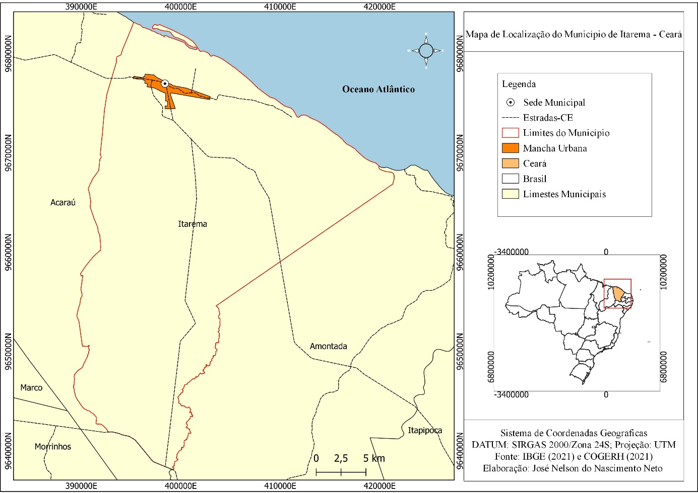
Among its natural characteristics, its inclusion in the semi-arid environment according to resolution no. 115 of November 23, 2017 and No. 107 of July 27, 2017 of SUDENE (2017). In addition to this natural condition, the general characteristics of the environment are presented below table 01.
Watershed | Coast
Climate | Tropical warm semi-arid soft and tropical semi-arid hot.
Relief | River plain relief, coastal plain and pre-coastal trays.
Vegetation | Open and dense shrubby caatinga, mixed forest Dicotillo and perennial, paludosa maritime and palmaceous.
Watershed | Marine quartz sands, flat sols, soldic, yellow-red podzolic, solonchak and solodized solonetz.

Table 01: Natural characterization of the area of the municipality of Itarema-CE.
Source: IPECE (2017).

The municipality of Itarema consists of the following districts, being Amofala, Carvoeiro, Juritianha, Olhos D'Água, Patos, Santa Fe and Santo Antônio annexed by state law no. 6990, of 12-23-1963, according to IBGE (2022). It is observed that among one of the economic characteristics the insertion of the coconut production industry in the region influenced the demographic and landscape alteration according to Cavalcante (2016).
2.2 Operational Technical Procedures
Data were obtained from consultations of Landsat 5/TM (Thematic Mapper) and 8/OLI (Operational Land Imager) in the 20-year time horizon for the operational operational procedure of the study. Access was linked to the Earth Explorer: USGS (United States Geological Survey) website and the image catalogue were consulted through Landsat Collection 1. Filters were used to choose scenes with a percentage of clouds below 30%. The scenes collected were from the dry season, from August to the 2000 scene and September for the 2020 scene.
The pre-processing of images consisted of the projection to the coordinate system between WGS 84/UTM ZONA 24 N, for SIRGAS 2000/ZONA 24 S, in order to keep the entire database co-recorded, being the orbit/point of the bands that record the scenes, Path 218 and Row 62. The RGB (Red, Green, and Blue) was produced in the software ENVI 4.5, where it was for the scene 2000, Landsat 5-TM the RGB 542. And for Scene 2020, Landsat 8-OLI employed the RGB 654.
The processing of data and spatial information took place through the Geographic Information System (GIS), using the open source QGIS 3.16 software. The image clipping was processed with the overlap between the vector layer (polygonal of the municipality of Itarema) on the Raster base of scenes RGB 542 and RGB 654 of Landsat 5 and 8, of spatial resolution of 30 m. In table 01 and 02, you can learn some of the features about the Landsat 5 and 8 series.

Sensor | Spectral Bands | Spectral resolution | Spatial resolution
TM (Thematic Mapper) | B1 Blue | 0.45-0.52 μm | 30 m
 | B2 Green | 0.52-0.60 μm
 | B3 Red | 0.63-0,69 μm
 | B4 Near infrared | 0.76-0.90 μm
 | B5 Medium infrared | 1.55-1.75 μm
 | B6 Thermal infrared | 10.4-12.5 μm | 120 m
 | B7 Medium infrared | 2.08-2.35 μm | 30 m
Temporal  Resolution | Imaged Area | Res. Radiometric
16 days | 185 km | 8 bits

Table 01: Features of the Landsat 5 series.
Source: EMBRAPA (2022).

Sensor | Spectral Bands | Spectral resolution | Spatial resolution
OLI (Operational Land Imager) | B1 Costal | 0.433 - 0.453 µm | 30 m
 | B2 Blue | 0.450 - 0.515 µm
 | B3 Green | 0.525 - 0.600 µm
 | B4 Red | 0.630 - 0.680 µm
 | B5 Near infrared | 0.845 - 0.885 µm
 | B6 Medium infrared | 1.560 - 1.660 µm
 | B7 Medium infrared | 2.100 - 2.300 µm
 | B8 Panchromatic | 0.500 - 0.680 µm | 15 m
 | B9 Cirrus | 1.360 - 1.390 µm | 30 m
Temporal Resolution | Imaged Area | Res. Radiometric
16 days | 185 km | 12 bits
Table 02: Features of the Landsat 8 series.
Source: EMBRAPA (2022).

The supervised classification of land use and cover was based on the method corresponding to max-VER (Maximum-Likelihood) pixel by pixel, aiming to order the reading of the image to the operational algorithm of the technique of classification by typology of the form ordering in class types, of which it was decided to identify seven typologies. The IBGE Technical Manual of Land Use (2013) was used as support.
The classifier used is inserted in the SCP tool - Semi-Automatic Classification Plug-in, where a category of classes was created to interpret the reading of the RGB image of the scenes (2000 and 2020), later classified the RGB of the Scenes by the categories identified, being: Urban Area, Dunes/ Sand, Water, Dense Vegetation, Open Vegetation, Exposed Soil and Degraded Area.
Post-processing consists of contrast enhancement of products generated from the handling of the histogram of images. Followed by the adequacy of the mapping scale of 1: 250,000, to represent the maps of use and ground cover of the scenes 2000 and 2020 to understand the evolution of the landscape by the typology of use of the form.
The methodological procedure shown in Figure 01 consists in the conception of the central idea of the map to be represented followed by the operational dynamics of decision-making, before the following steps: orbital image acquisition, orbital image reprojection, digital processing, and classification by MAX-VER method and having as final product the map of use and soil cover.

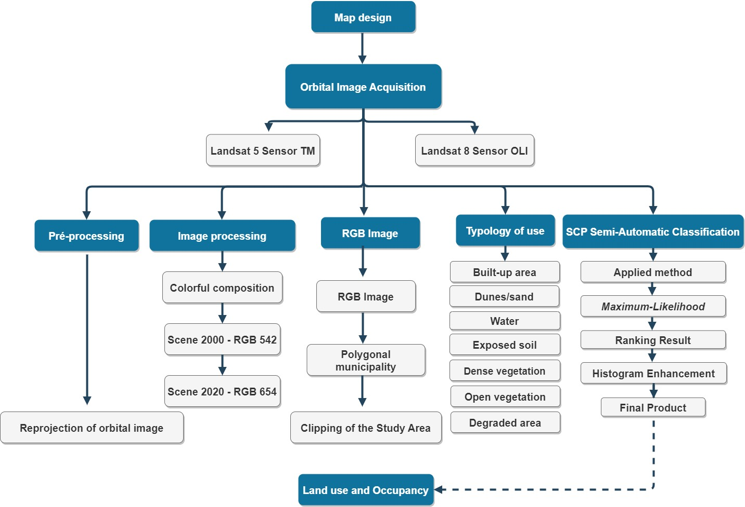
Figure 01: Methodological flowchart of soil cover, municipality of Itarema-CE.
Organization: Prepared by the authors.

For the measurement of the sample data, the IBGE data source (2000 and 2021) of the population registered and estimated was taken into account. And for the GDP of the municipality, IBGE data (2000 and 2019) were considered. This information will be detailed throughout the manuscript. The statistical basis applied consists of considering the sample value, applying the subdivision between the groups to know the percentage relationship, being Percentage Value = n (variable) *100/Total. It is worth mentioning that in this study, the site check-list in of the assigned typologies was not performed.

Results

To understand the behavior of land use and occupation, we took into account the relationship between population dynamics, observed in table 01 below, and the reading of the landscape before the typology.
Description  Population  Total | Census de 1991 | Census de 2000 | Census de 2010 | 2021*
 | 25.548 | 30.347 | 37.471 | 42.595
Urban | 7.719 | 9.901 | 15.938 | S/I
Rural | 17.829 | 20.446 | 21.533 | S/I
Table 01: Resident population of the municipality of Itarema - CE
Source: IPECE (2017) and IBGE (2021). Legend: * Esteemed; S/I = No information.

The population distribution is presented in graph 01 below; it shows the spatialization of the data over the time-space of the study area.
Figure 01: Population distribution over time from 1991 to 2021.
Source: IPECE (2017) and IBGE (2021).

It was verified according to graph 01, that there was a significant change in the resident population, from 25,548,000 inhabitants of the IBGE census (1991), to 42,595,000 inhabitants according to estimated IBGE data (2021), representing a difference of 17,047,000 inhabitants, 40.02% over three decades. Subsequently, it is estimated that this demographic evolution alters the behavior of the typology of the form of land use and cover as predispose d'it to the comparison between the maps. This situation suggests that with the arrival of the coconut production industry in the region, this rural population has migrated to the urban space of the municipality.
The following is possible to verify in Figure 03 the behavior of the typology of the form of land use and occupation of the municipality of Itarema-CE, for the recording of the Scene of the year 2000, for the Landsat 5-TM image classification.

Figure 03: Land Use and Coverage Map of the Municipality of Itarema-CE, in 2000.
Organization: Authors (2022).

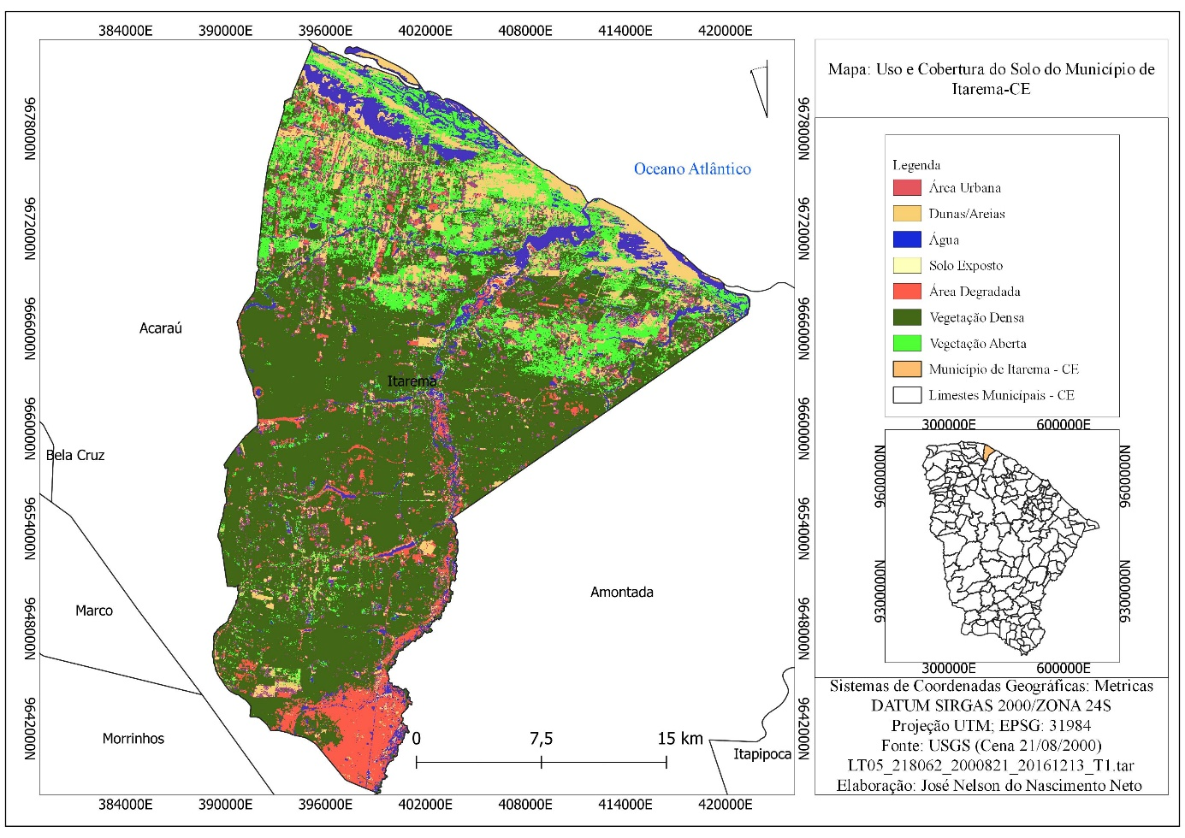

Based on the map of land use and occupation, it is verified that the dynamics of the landscape began to change as population density was distributed among the environments, the existence of specific processes such as extractivism and agriculture has its roots in traditional habits, such as indigenous ones.
In the map shown in Figure 03, seven typologies were identified for Scene 21/08/2000 of the Landsat 5 TM sensor series. The remote sensing procedure took into account the socio-environmental context of the coastal semi-arid environment, and was based on the IBGE technical manual (2013). The following is figure 04 of the land use and occupation map for Cena 2020, in the municipality of Itarema.

Figure 04: Land Use and Coverage Map of the Municipality of Itarema-CE, in 2020.
Organization: Authors (2022).

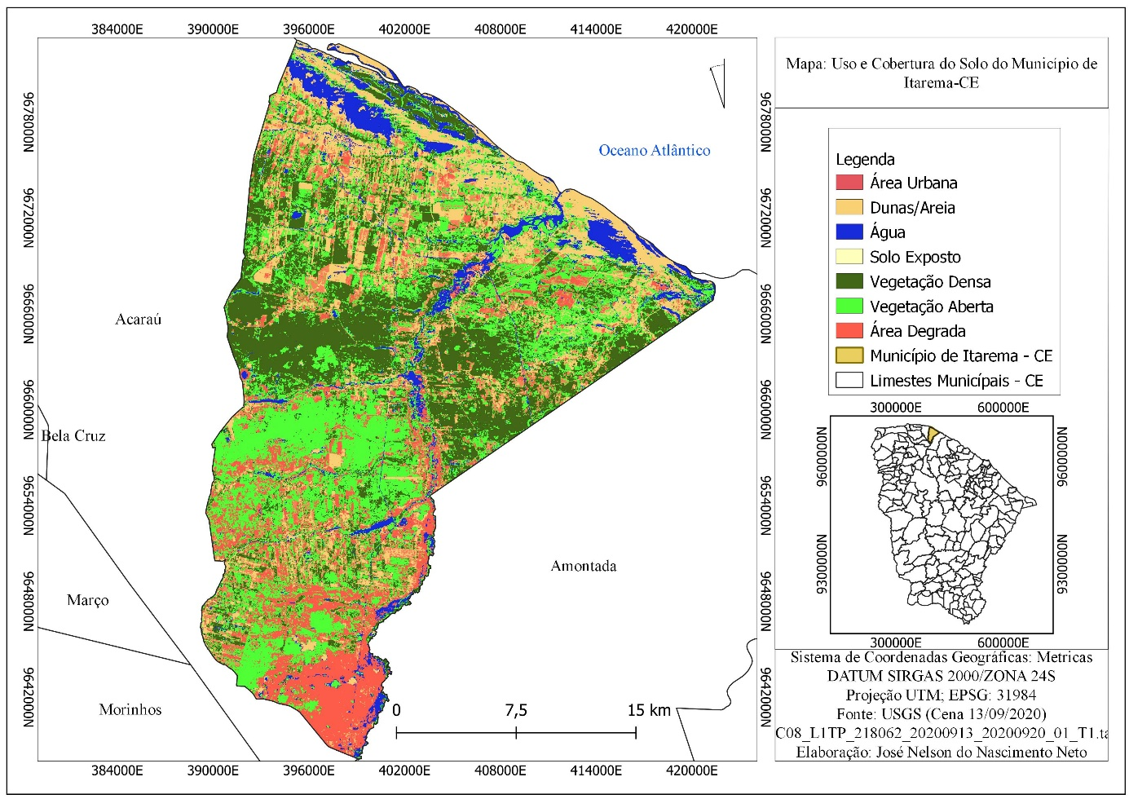

The 2020 scene, observed in The Landsat 8 AREA OF THE LANDSAT 8 OLI sensor, indicates a greater expansion of the area related to the exposed soil. These classes are represented between Scenes 2000 and 2020 in table 02 below.

CLASS/AREA | Cena 21/08/2000 |  | Cena 13/09/2020
 | Área (km²) | (%) | Área (km²) | (%)
Built-up area | 10,64 | 1,47 | 28,64 | 3,97
Dunes | 47,93 | 6,65 | 55,14 | 7,65
Degraded Area | 53,85 | 7,47 | 115,42 | 16,03
Exposed Soil | 51,26 | 7,11 | 53,41 | 7,41
Open Vegetation | 114,83 | 15,94 | 229,33 | 31,85
Dense Vegetation | 380,46 | 52,84 | 185,15 | 25,71
Water | 61,00 | 8,47 | 50,00 | 6,94
Total | 719,97 | 100 | 719,97 | 100
Table 02: Relationship of land use and cover and area of the municipality of Itarema - CE
Organization: Authors (2022).

There was a change in landscape behavior as recorded in the usage classes. The typology observed via remote sensing procedure was based on the recording of physiognomic behavior recorded in August and September in Scenes 2000 and 2020, situating the dry season of the state of Ceará.
The water class recorded a small change of 1.53%. In the coastal basin, rivers have dendritic physiognomic behavior. In relation to the urban area, its variation was from 1.47% to 3.97% registering a change in urban spot. . This change corresponds to 32.62% according to the IBGE census from (2000) to 42.53% according to the IBGE census of (2010), evidencing a growth in its urbanization process of the municipality, as can be seen in graph 02 below. The inside circle represents the record of scene 2000 and the circle outside the 2020 scene.

Graph 02: Spatial distribution of land use and occupation data scenes 2000-2020.
Organization: Authors (2022).

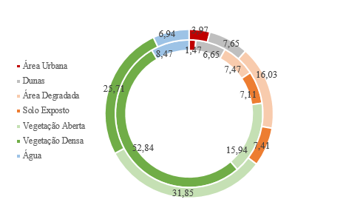

In the dense vegetation class, it was recorded 52.84% in 2000 compared to 25.71% in 2020. It is suggested that the strong reduction in this class is due to the evolution of secondary activities presented in graph 02. For the open vegetation class, 2000 represented 15.94% while 2020 increased to 31.85%. In coastal environments, suggests Lima & Medeiros (2006) apud Moro el at (2015) the threats to conservation are more intense. This intense modification observed in the products corroborates the great occupation that occurs along the coastal/coastal regions in our country.
The classes of exposed soil and degraded areas together reached about 23.44% of altered areas in the 2020 record. In the degraded area class, 7.47% was observed in 2000 and 16.03% in 2020, with growth in physiognomic alteration. For the exposed soil, the records are 7.11% in the 2000 scene and 7.41 in 2020. The exposed soil class does not alter its physiognomic behavior because it is a natural condition of the landscape, something that is common in the semi-arid climate.
The population distribution of Itarema, in 30,347,000 inhabitants for the IBGE census (2000), is subdivided into about 20,446,000 inhabitants 67.37% living in the rural area in relation to 9,901,000 inhabitants 32.62% located in the urban area. Given the absence of the 2020 census record, we considered the estimated data of the population of 2021 with about 45,595,000 inhabitants according to IBGE (2021). For analysis and understanding of the landscape, the dynamics of the municipality's GDP according to table 03 and graph 03 below were taken into account.
Year | Agricultural  R$ | Industry  R$ | Services  R$ | Year | Agricultural  R$ | Industry  R$ | Services  R$
2019 | 42.623,33 | 217.297,65 | 162.060,36 | 2009 | 29.325,00 | 37.364,00 | 65.281,00
2018 | 61.769,27 | 354.464,58 | 151.285,41 | 2008 | 29.320,00 | 59.671,00 | 58.227,00
2017 | 59.786,29 | 339,640,46 | 142.622,06 | 2007 | 20.576,00 | 62.900,00 | 46.431,00
2016 | 48.642,97 | 115.279,33 | 131.208,09 | 2006 | 28.128,00 | 61.362,00 | 40.671,00
2015 | 49.827,29 | 85.922,65 | 122.266,44 | 2005 | 19.638,00 | 42.819,00 | 33.046,00
2014 | 49.020,01 | 90.132,91 | 114.370,26 | 2004 | 24.462,00 | 33.559,00 | 27.356,00
2013 | 35.222,00 | 110.763,00 | 100.248,00 | 2003 | 19.999,00 | 30.378,00 | 25.706,00
2012 | 34.665,00 | 54.658,00 | 87.358,00 | 2002 | 15.923,00 | 20.622,00 | 21.936,00
2011 | 41.404,00 | 51.912,00 | 81.640,00 | 2001 | 15.342,00 | 19.002,00 | 27.025,00
2010 | 27.191,00 | 48.477,00 | 75.799,00 | 2000 | 15.195,00 | 15.992,00 | 23.363,00
Table 03: GDP of the Municipality of Itarema-CE.
Source: IBGE (2019).

This market value representation corresponds to price change over time. And it suggests the sectoral interrelationship in the whole of the municipal PIB, so as to influence the process of landscape change in the local context. It retains the appropriate proportions, the PIB influence on the aspect of land use and occupation in the municipality. In addition, it is possible to check in graph 03 the spatial expression of the percentage data.

Figure 03: GDP share among the various sectors in the municipality of Itarema-CE.
Source: IBGE (2019).

The socioeconomic profile of the municipality represented in PIB indicates a change in the typology of land use, corroborating what was presented in the maps of use and occupation. Table 03 shows a price variation between the various sectors, in order to induce a spatial and economic dynamics of the territory. In this analysis, there was a reduction in the agricultural sector from 2000 to 2019, from 27.85% in 2000 to 10.10% in 2019, with a variation of 17.75% between two decades.
The tertiary data represented in Graph 03 indicate a percentage change over the reporting period, from 42.82% in 2000 to 38.40% in 2019, a reduction in the sector, however, with an increase in the price acquired over time and space from R$ 23,363,000 to R$ 162,060,000. Respectively, this variation in relation to the market price corresponds to the economic dynamics in the municipality.
Studies using remote sensing performed by SEMACE (2016) showed the existence of thirteen classes: in addition to the classes represented in this study, are the technogenic alterations, aquaculture/salt pans, sandy sediment, mud texture sediment, anthropized vegetation with culture/reforestation, anthropized vegetation with irregular pattern and ocean, and the largest class with 46.91% of natural vegetation followed by 19.18% in anthropized vegetation was recorded.
In summary, it is suggested that the change of landscape, comes from the process of land use and appropriation before the historical and cultural aspect of a community, of a region. Such analysis was possible through the spatial-temporal reading of the spectral signature of the radiated object and before the spatial resolution of 30 m of the pixel that make up the image of the recorded scenes, thus, it is the response to the behavior of a type of vegetation cover before an economic, social and political context of use.

Conclusion
Remote sensing is consolidated as an important tool for the process of soil use analysis, as it serves as an instrument for the production of information essential to the planning and organization of the territory. It is noteworthy that among the limitations of this study, it consisted of the non-verification of check-list in the field, due to the operational and technical difficulties resulting from the context of sanitary restriction of the covid-19 pandemic (SARS-Cov-2).
Changes in land use and cover in the municipality of Itarema-CE between 2000 and 2020 were evaluated from Landsat 5-8 data. The most modified area corresponds to the dense vegetation class with a variation of 52.84% in (2000) versus 25.71% in (2020). It is inferred that this change can be induced by the economic behavior of the municipality, which ranged from 27.85% in (2000) to 10.10% in (2019) a reason that possibly justifies the degrowth of the agricultural sector.
The significant changes in landscape units were observed in view of the percentage data measured between the scenes via pixel-by-pixel supervised classification. In summary, it was observed that the evolution of the landscape is a natural consequence of the demographic dynamics of the municipality followed by the socioeconomic profile.
It is suggested as a possible future research the analysis of the use of units of permanent preservation areas and areas of integral protection for the municipality in question, justified by the need to monitor the process of economic growth of the municipalities in relation to vulnerable areas. Finally, it is noteworthy that the evolution of the landscapes recorded throughout the analysis period indicated significant changes in all classes identified.

Acknowledgments
Please, edit the acknowledgments in the final version of the manuscript.

References

ANTUNES, J.F.G.; LEFT, J.C. D.M.; LYDIA, S.B. et al. Dynamics of land use and land cover in the micro regions of Sinos and Alto Teles Pires in Norte Mato Grosso. Annais of the XVIII Brazilian Symposium on Remote Sensing - SBSR. May 28-31, 2017, INPE, Santos-São Paulo, 2017. ISBN: 987-85-17-00088-1.
AUGUSTO, R.C; The mapping of landscapes and the Geosystemic perspective as subsidies to environmental planning. Tamoios Magazine, v.12,n.(2016). DOI: 10.12957/tamoios.2016.22644
BRAZIL. Itarema Municipality. Portal of the Brazilian Government. IBGE, 2022. Available in: <https://cidades.ibge.gov.br/brasil/ce/itarema/panorama> Accessed: 21 Jan. 2022.
BRAZIL. Itarema Municipality. Portal of the Brazilian Government. IBGE, 2022. Available in >https://cidades.ibge.gov.br/brasil/ce/itarema/historico< Access on 07 Jan. 2022. BRASIL. New Delimitation of the Semiarid. SUDENE, 2017. Available in: >http://antigo.sudene.gov.br/delimitacao-do-semiarido> Accessed: 21 Jan. 2022.
BRAZIL. New Semi-arid Delimitation: Resolution No. 150/2021. SUDENE. Available from: >https://www.in.gov.br/web/dou/-/resolucao-condel/sudene-n-150-de-13-de-dezembro-de-2021-370970623> Accessed: 21 Jan. 2022.
BRITO, J.L.S.; ROSA, R.; SILVA, M. K. A. Mapping of degraded areas occupied with pastures in the Triangle Mineiro - MG. Annais of the XVIII Brazilian Symposium on Remote Sensing - SBSR. May 28-31, 2017, INPE, Santos-São Paulo, 2017. ISBN: 987-85-17-00088-1.
CEARÁ, CEARÁ. State Government. Itarema Municipal Profile. IPECE, Fortaleza. Available at: <https://www.ipece.ce.gov.br/wp-content/uploads/sites/45/2018/09/Itarema_2017.pdf>Accessed: 21 Jan. 2022.
CAVALCANTE, L. V.; The spatial circuits of coconut production on the west coast of Ceará.Caminhos de Geografia Uberlândia, v17,n57,p41-58, mar/2016.
FEPOINCE. Federation of indigenous peoples and organizations of Ceará. 2022. Available at: >https://www.fepoince.org/povos-ind%C3%ADgenas-no-cear%C3%A1< Accessed: 14 Feb. 2022.
IBGE. Technical Manual of Land Use.3° Ed. Rio de Janeiro, 2013.
KELTING, F.M. S. The climate and landscape of the Coastal-State Watershed of Ceará. B.goiano.geogr, Goiânia, v. 29, n. 2, p. 83-99, Jul./Dez, 2009.
MILK, E. F.; ROSA, R. Analysis of Land Use, Occupation and Land Cover in the Ant River Basin, Tocantins. OBSERVATORIUM: Electronic Journal of Geography, v4, n12, p90-102, Dec.2012.
ROQUE, D.C; RIEGEL, R.P;; QUEVEDO, D.M. Geotechnologies: Methodology for mapping land use and occupation. Annais of the IX Geotechnical Engineering Seminar of Rio Grande do Sul, 27 and 28 April 2017, Caxias do Sul-RS.
RODRIGUES, L.G; MEIRELES, A.C.M; OLIVEIRA, C. W. Use of remote sensing for analysis of land use and occupation in the irrigated floodplains of Sousa-PB. Irrigate, Botucatu, Special Edition -Inovagri, v. 1, n. 4, p. 722-729, December, 2021. ISSN 1808-8546 (ONLINE) 1808-3765 (CD-ROM)
RIBEIRO, J. K.; BARROS, R. O.; LIMA, E.C. Land use and occupation through geoprocessing techniques in the city of Sobral-CE. Sobral's House of Geography Magazine. v21,n2.2019. ISSN: 2316-8056
SANTOS, M.G; OLIVEIRA, M, L, V. de. The territorialization of the Tremembé Indians: Conflicts and Resistances in Itarema-Ceará. Revista da Casa da Geografia de Sobral (RCGS), Sobral-CE, v. 14, n. 1, p. 27-43, 2012. www.uvanet.br/rcgs
SOARES, V. L; MEDEIROS, C.N; ALBUQUERQUE, E, L, S. Geoprocessing applied to the mapping of the forms of land use and occupation in the municipality of Itarema, Ceará. Annais VI Ibero-American Congreso de Estudios Territoriales y Ambientales. São Paulo, September 8-12, 2014. ISBN: 978-85-7506-232-6
SEMACE. Re-examination and Updating of the Mapping of the Ecological-Economic Zoning Project of Ceará- Coastal Zone and Coastal Conservation Units: Final Report of Land Use and Cover Mapping. Fortaleza, 2016.
MORO, M, F; MACEDO, M, B; MOURA-FÉ, M, M et al. Vegetation, phytoecological units and landscape diversity of the state of Ceará. SciELO, July-Sep 2015 Available at:>https://doi.org/10.1590/2175-7860201566305> Accessed:26 Jan. 2022
MEDEIROS, R.B.; ALVES, L.B.; SILVA, C.A.; Land use and land cover: a multitemporal analysis of the Anhumas Stream watershed, Bonito/MS. Annais does XVIII Brazilian Symposium on Applied Physical Geography. 11-15 June 2019.

