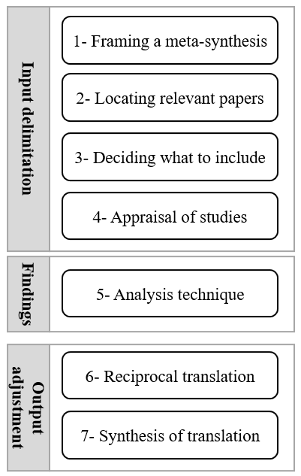

Fig. 1. Meta-synthesis Process (Walsh & Down, 2005)

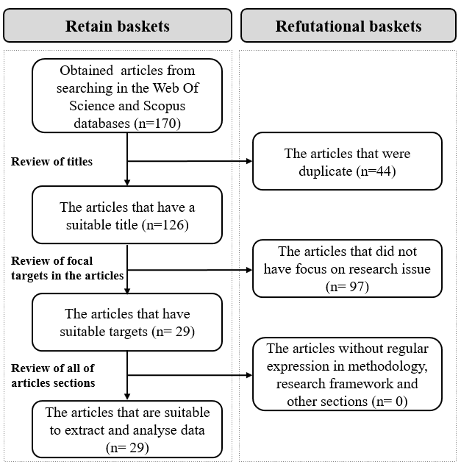

Fig. 2: literature review structure

Source: research findings

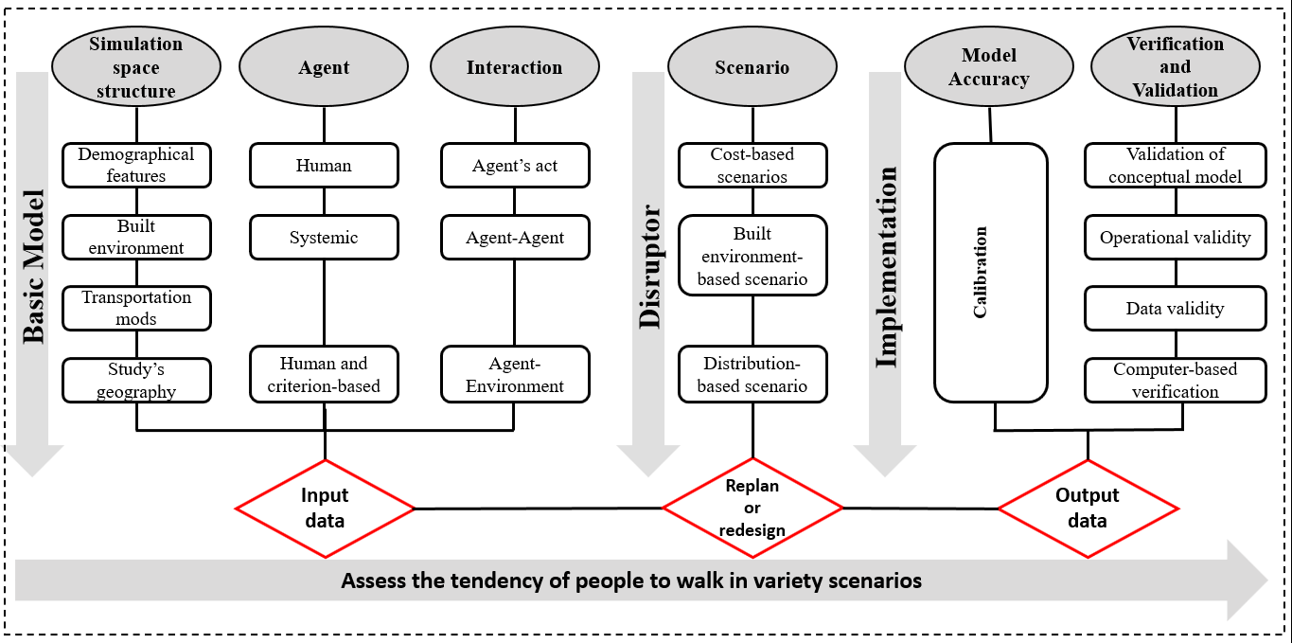

Fig. 3- The comprehensive framework to apply ABM to investigate the influence of urban policies on people’s tendency to walk