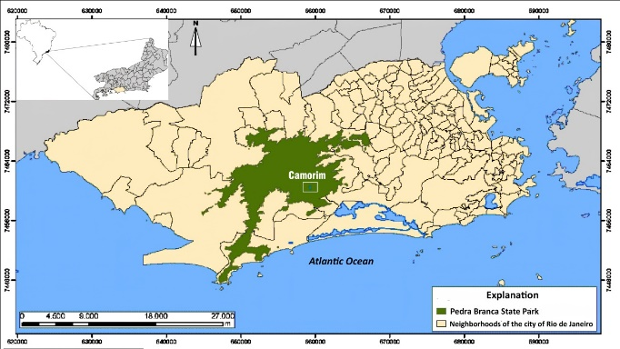
Figure 1 Location of the Camorim dam inside the Pedra Branca State Park, in Rio de Janeiro city.

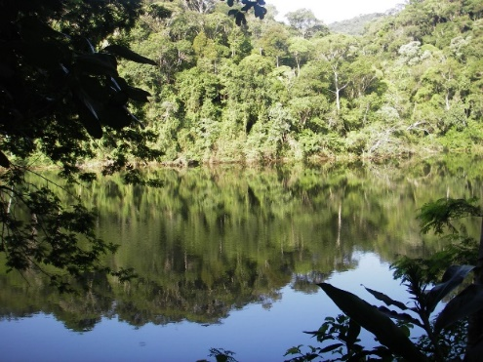
Figure 2 Camorim dam, seen from the retaining wall: water mirror and forest.

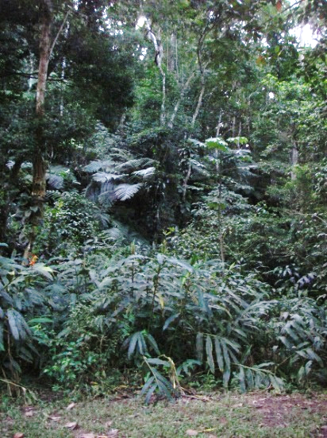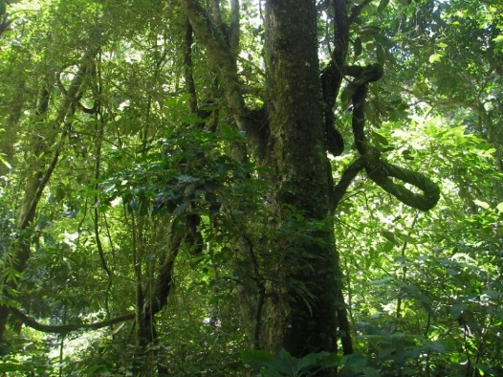
Figure 3 Aspects of the Atlantic Forest low and high vegetation around the dam.

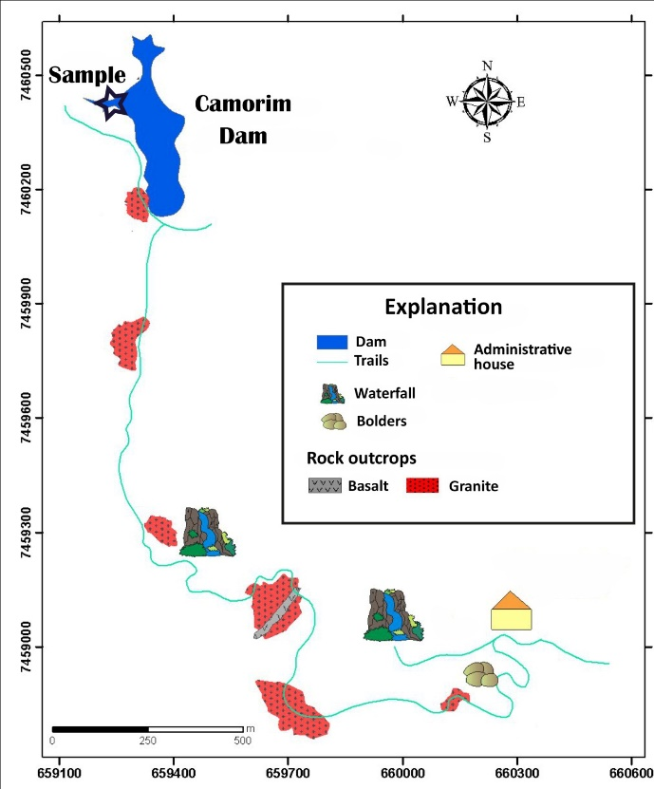
Figure 4 Location of the collected core at the Camorim dam.

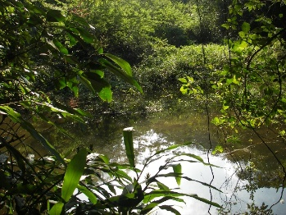
Figure 5 Core’s withdrawal location.

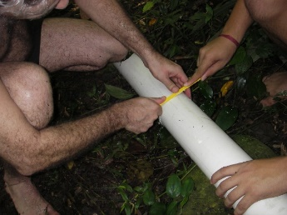
Figure 6 Core conditioning for transport.
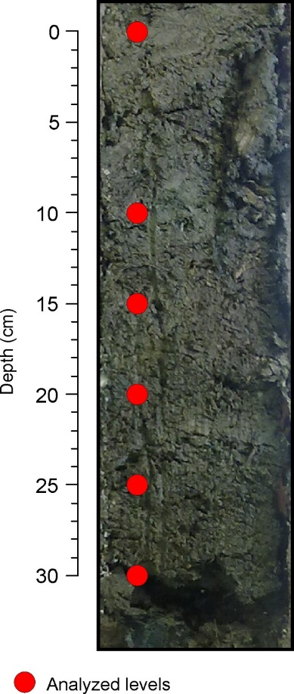
Figure 7 Core internal aspect and the levels for sample extraction.

