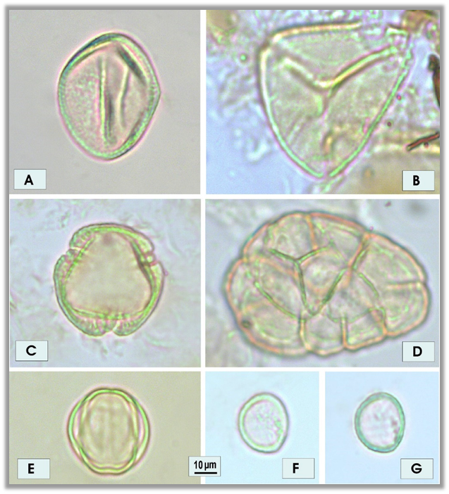
Figure 8 Examples of pollen grains characteristic of forest (A, B) and forest pioneers (C-G). A - Araceae, B - Myrcia pollen type, C - Alchornea, D - Anadenanthera pollen type, E - Melastomataceae pollen type, F - Piper, surface and colpus, G - Piper, optical cut.

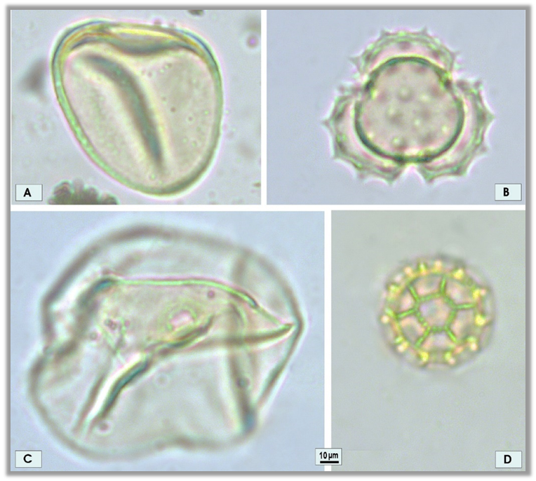
Figure 9 Examples of campo characteristic pollen grains. A - Cyperaceae, B - Artemisia pollen type, C - Bambusa, D - Gomphrena.

