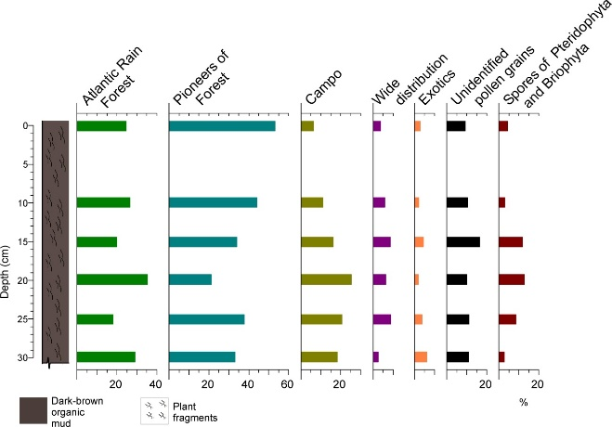
Figure 10 Relative frequency (%) diagram of palynomorphs according to the established groups for the Camorim dam core.

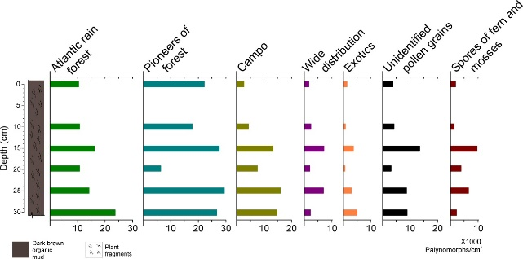
Figure 11 Concentration diagram of palynomorphs/cm³ according to the established groups for the Camorim dam core.

