The influences of forest fires on the
repellency, mineralogy and thermogravimetry of soils in a mountainous area of the Atlantic Forest
biome - the study case of São Pedro da Serra, Rio de Janeiro (Brazil).

Abstract
Landscapes are systems undergoing constant transformation, associated with different forms of environmental disturbances. Among these disturbances are fires, which depending on the magnitude and frequency can have effects with different severities. In the district of São Pedro da Serra in the municipality of Nova Friburgo, located in the mountain region of the state of Rio de Janeiro, Brazil, controlled burning is often used to prepare areas for farming. However, in certain cases of atmospheric conditions, type of vegetation and soil moisture levels, among others, these fires can escape control. This study reports the analysis through X-ray diffractometry and thermogravimetric analysis of the characteristics of the soils in two distinct areas Area 1 (Benfica) and Area 2 (Bocaina), in the same pedological regime within the Macaé de Cima Environmental Protection Area. These two areas were affected by forest fires in different periods. We also sought to identify the severity of these fires, for which purpose we collected undeformed soil samples from depths of 0-5, 5-10, 10-15, 15-20 and 20-25 cm. The data obtained showed that the mineralogy of the sand fraction was homogeneous, but the clay fraction in Area 2, unlike Area 1, was characterized by the presence of smectite and goethite. Fire tended to have the greatest impact on the top 5 cm of soil, possibly related to the hydrophobic characteristics, which are not directly linked to the timing of the fires, but rather to their magnitudes.

Introduction.

Fire has always been a natural element in the environment, subject to a variety of climatic factors, such as lightening, rainfall, drought, temperature and winds, as well as accumulation of dead biomass. In the preindustrial period, these were the main factors determining the occurrence and severity of forest fires. However, in the past 300 years, anthropic actions have been the main cause of these fires. (JUSTINO et al., 2021).
In Brazil, controlled burning and forest fires are concentrated in the dry season, especially during prolonged droughts as well as in previously deforested areas in regions of transition between the Cerrado (savanna) and Amazon biomes. Most of the controlled burning is for the purpose of preparing and maintaining agricultural areas, renewal of pastures, suppression of litter and elimination of pests and diseases (NELSON & MORELLI, 2021).
Data from satellite monitoring collected as part of the Burn-off Program (Programa Queimadas) show that between June 1998 and May 2022, the average number of active fire hotspots detected in Brazil was 219,414. The highest values were found in September, August and October 2007 (141,220; 91,085; 67,228 respectively). After a period of reduction, since 2018 the number of active fire hotspots has been increasing in all months of the year (INPE, 2022).
In the Atlantic Forest biome, natural fires were a recurring feature in the initial millenniums of the Holocene epoch. However, some 13 thousand years ago, humans began to inhabit this Forest, using slash and burn agriculture to produce food (DEAN, 1996). This type of farming persists in many tropical areas, making it important to understand the effects of fire on the soil (THOMAZ & FACHIN, 2014; FACHIN et al., 2021). In the district of São Pedro da Serra, despite the establishment of the Macaé de Cima Environmental Protection Area in 2001, slash and burn agriculture is still common in some areas.
Errors in preparation of firebreaks or changes in the wind intensity and direction can cause these controlled fires to spread to areas with greater volume of biomass, resulting in more intense and often uncontrolled fires (BERTOLINO, 2021; MATTOS et al., 2022)
The occurrence of fires is related to three basic factors: fuel (biomass), oxidizer (O₂) and source of ignition. Although natural factors such as lightning strikes are sources of ignition of many fires, in the tropics most fires are caused by humans (CAMPANHARO et al., 2021). Two parameters are fundamental to diagnose the effects of fire: intensity and severity (LOZANO & JIMÉNEZ-PINILLA, 2013). Severity is defined as the consequences generated by fire on the environment, while intensity is the speed with which energy is released (PAUSAS, 2012). The correlation between intensity and severity allows understanding the magnitude of fire (KEELEY, 2009).
The intensity of fire can be classified according to the color of the ashes and litter, composed of leaves and branches that fall from trees. When combustion is incomplete, the ashes are dark colored and it is possible to find fragments of preserved organic matter in the burned area. In turn, after complete combustion, the ashes have silvery or white color, and contain a high percentage of minerals, since the organic matter is degraded by the high temperature (MATAIX-SOLERA & GUERRERO, 2007).
Moreno and Oechel (1989) classified fire intensity through the size of branches that fall on the ground during burning. During more intense combustion, the branches that fall are larger than in cases of less intense fire.
The severity of fire can be analyzed according to the classification proposed by Hungerford (1996), as low, moderate or high. Areas subject to fires with low or moderate severity typically have unaltered mineral soil, while in areas subject to high severity fires, the soil can turn orange or reddish.
Fires with low or moderate severity leave partially consumed or carbonized wood. In turn, fires with high severity totally consume and carbonize the wood fragments. It is also important to consider the influence of fire on the temperature of the soil during burning, which can also be classified according to the fire severity and temperature. From the surface to depth of 1 cm, the soil temperature is< 50º C (low severity), between 100 and 200 ºC (moderate severity), and> 250 ºC (high severity), with the other temperature ranges denoting intermediate levels. The propagation of heat from fire with moderate severity can be lethal to the organisms in the soil to a depth of 3 to 5 cm, and from 9 to 16 cm in case of high severity (HUNGERFORD, 1996).
Moisture is another factor determining the thermal variation. According to De Bano. (1979), in dry soils, the transmission of heat occurs by conduction and convection of the hot gases through the pores in the soil. In contrast, soils with high moisture have high capacity to absorb heat through vaporization of water. This is a problem in the case of tropical soils. The temperature declines exponentially with increasing depth, so the effect of fires mainly occurs in the topmost layer (MATAIX-SOLERA & GUERRERO, 2007).
The alterations of soils caused by fire can be direct, due to the action of heat on the organic component, or indirect, via the elimination of plant cover. In both cases, the vulnerability to water erosion increases (NOGUEIRA, 2014.
Fire also affects the water repellency of the soil. Indeed, this is one of the properties affected the most by combustion. Repellency is related to the difficulty of moistening the soil (aggregates) with water, normally associated with the coating of soil particles with hydrophobic organic substances. According to De Bano (2000), the effect of fire on repellency only started to be studied in the 1960s. Until then, it was believed that the effect of fire on the capacity for infiltration was associated with the loss of protection of the canopy or the presence of ashes on the soil surface, reducing its porosity. More recently, it has been verified that hydrophobia is associated with the formation or precipitation of substance produced during the burning of organic matter in the soil, forming a coating of the aggregates and preventing infiltration by water (DEBANO, 2000; DOERR et al., 1996; SHAKESBY & DOERR, 2006). According to Vogelmann et al. (2010), the organic substances responsible for repellency can totally or partially cover the particles, aggregates and pore walls, resulting in different degrees of soil hydrophobicity. The hydrophobicity can also be associated with the soil moisture, the presence of some species of fungi, the granulometric composition, pH level and occurrence of fires.
Various factors alter the soil hydrophobicity to a greater or lesser degree, such as temperature, type and quantity of organic matter and textural differences.
It is hard to understand the behavior of repellency associated with temperature. According to De Bano (2000), there is little change in the soil up to a temperature of 175ºC. Hotter temperatures (between 175ºC and 200ºC) result in strong repellency, but this repellency is destroyed between 280 ºC and 480 ºc. Other researchers have reported similar results (GARCIA-CORONA et al., 2004; DOERR et al., 2005; THOMAZ, 2008).
Further according to De Bano (2000), greater coating of the mineral soil particles occurs at low temperatures and during short heating periods. In contrast, in areas subject to longer heating periods with higher temperatures, the organic substances responsible for hydrophobicity are destroyed, so the soil repellency is weak or disappears. Experiments conducted by Jordan (2011) demonstrated that fires with low severity do not affect soil hydrophobicity. Temperatures in the range of 200-250ºC are necessary for repellency to occur.
Various researchers have also demonstrated that fire modifies the soil texture. Fachin et al. (2021) reported that submission of clay to fire compresses the phyllosilicates, leading to modification of the color and reduction of the clay content. Furthermore, the iron oxides can undergo alterations (goethite can be transformed into magnetite and hematite), and fires reaching temperatures hotter than 400 ºC, or recurring fires can raise the content of sand in the soil.
Studies conducted by Merat (2014), Mattos (2015) and Pereira (2016) in São Pedro da Serra showed that in the region the process of transforming the soil properties is intrinsically related to the magnitude of the flames. In this case, the magnitude can be measured according to the temperature attained by the fire.
The objective of this study is to analyze the influences of forest fires on the repellency, mineralogy and thermogravimetry of the soil.

Materials and methods

Pedological and geological settings
The area studied is located in São Pedro da Serra, the seventh district of the Nova Friburgo City, in the mountain region of the state of Rio de Janeiro (geographic coordinates 22º 19’ 07” S and 42º 19’ 50”W). It is contained in the sub-basin of the São Pedro River, in the Rio Bonito watershed, and is within the Macaé de Cima Environmental Protection Area (APA) (Figure 1)
I do suggest modify municipality of Nova Friburgo by Nova Friburgo city
Figure 1 – Location of the study area.
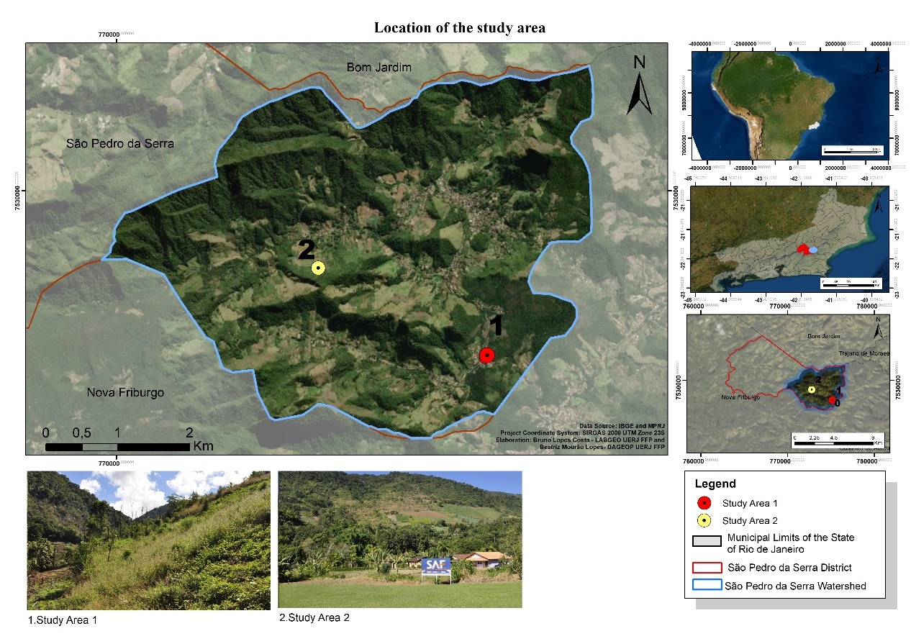
Source: Authors.
The climate in the region according to the Köppen classification is approximate to temperate mesothermal- Cfb (always humid, with mild summers). The atmospheric phenomena acting in the region are in general the same as those affecting the entire state of Rio de Janeiro:Tropical Instability Waves (TIW);Atlantic Tropical Air Mass (ATM); and South Atlantic Convergence Zone (SACZ) (INEA, 2014).
The region is inserted in the Ribeira Belt, a strip having complex lithological and structural features, with predominance of different types of metamorphic rocks such as gneisses, migmatites, quartzites,mica-schists and philites, as well as secondaryintrusive rocks such as granite and syenite, integrated with the Paraíba do Sul Complex –São Fidélis Unit (ROSS, 1985).

The metamorphism in the region gave origin to rocks like gneiss composed of garnet, biotite, sillimanite, feldspar, and quartz, with anathetic pockets and veins, formed in situ or injected, with granitic composition. Also present are intercalations of calcsilicate and quartzite rocks. Varieties with cordierite and sillimanite (kinzigite) having transitional contacts with garnet, biotite, gneiss and horizons of graphite schists are also common. Besides the paraderived rocks, characteristic of this unit, various granite pulses also occur, forming granite bodies, with highlight on Sana and Nova Friburgo granite and suites such as foliated leucogranites, besides various philonic intrusions of leucogranites and pegmatites (INEA, 2014).
The pedological base of the rugged mountainous relief of the study area is formed by litholic neosols, red-yellow latosols andhaplic cambisols (CARVALHO FILHO & LUMBRERAS). Merat (2014), describing the soil profiles in the area, identified the presence of primary minerals, indicating low weathering degree.

Field collections and laboratory analysis
In the study region, we selected two areas (Area 1 and Area 2) where fires had occurred that consumed part of the vegetation. The data were obtained through field work, where it was possible to observe and describe the landscapes and collect the soil samples for later analysis in the laboratory.
For general characterization of the soil, a profile was opened in each area halfway up a hillside. Area 1 is located at coordinates22º 20’ 04.17”S and 42º 19’ 43.02”W, at altitude of 711 meters above sea level, with a slope of 33º. In turn, Area 2 is located at coordinates 22º 19’ 26.09”S and 42º 21’ 05.88”W , at altitude of 854 meters above sea level, with slope of 31º. After opening the weathering profiles, the soil horizons were described with the support of pedological material, according to the method of EMBRAPA (2006).
The laboratory analyses were performed with deformed soil samples, where there is no concern for maintaining the structure of the soil body. The samples were collected between July 20-25, 2017 according to the method proposed by Santos et al. (2013). After opening and characterizing the soil profiles (each one 150 cm long), samples were collected at depths of 0-5, 5-10, 10-15, 15-20 and 20-25 cm using a trench system with compound samples. A total of 15 trenches were opened with depth of 40 cm on each of the hillsides. From each trench, aliquots of approximately 300 g were collected from each of the 5 depths. The granulometry was measured by the pipette method (TEIXEIRA et al., 2017). The deformed samples were homogenized and separated into aliquots of approximately 2 kg.

In Area 1, the fire had occurred during the start of spring, but there was no reliable information about the reason for the burning. In contrast, in Area 2 the fire had occurred in the winter, when according to the local farmers a fire used to clear a field to plant beans escaped control due to high winds, and reached an area with denser vegetation, classified as an event with high magnitude.
The soil samples were separated into the sand and clay fractions to enable identification of the minerals present in each fraction. The minerals of the coarse and fine sand fraction were identified with a Leica EZ4 stereomicroscope. During this step, a magnet was used to determine the presence of magnetic minerals in the soil samples.
X-ray diffractometry (XRD) was used to precisely determine the minerals present in the clay fraction. This method is based on examination of the peaks of the resulting diffractograms, with application of Bragg’s law.
The mineralogical characterization of the sand and clay fractions was performed by X-ray diffractometry (XRD). The diffractograms were obtained by determination of the interplanar spacing based on the powder method, utilizing a Bruker D4 Endeavor® diffractometer under the following operating conditions: Co Kα radiation (35 kV/40 mA); and goniometer speed of 0.02o (2θ) per scan with 1 second for each scan, collected from 4 to 80º (2θ). The qualitative interpretation of the spectra was based on comparison with the standards contained in the PDF02 database (ICDD, 2006), with the Bruker Diffrac Plus software.
The characterization of the water repellency degree of the samples was carried out according to the technique described by King (1981). This technique is based on two methods, in both of which the samples must be in the form of air-dried fine soil. The first method consists of determining the molarity of ethanol droplets (or MED), where two droplets (40 μL) of an aqueous solution of ethanol with known concentration are applied, and the time interval necessary for the droplets to be absorbed by the soil is counted. This procedure is intended for concentrations varying between 0 and 5 mol l ⁻¹ , with intervals of 0.2 mol l ^{-1 .}. The repellency is represented by the molarity of the ethanol solution as of which the droplets penetrate the surface of the sample in less than 10 seconds.
The second method consists of measuring the water drop penetration time (or DP), where the time is counted for two drops (40 μL) to penetrate the soil sample.
The differential thermogravimetric analysis. were carried out at the Center for Mineral Technology (CETEM) of Rio de Janeiro Federal University (UFRJ). According to this method, the mass of the sample is recorded continually while the temperature is gradually increased.
The analytic device consists of a thermobalance (i.e., an instrument that enables continuous weighing of the sample while it is being subjected to varying temperature), an oven, sample support, temperature sensor, oven temperature programmer, and temperature control and recording system (DENARI & CAVALHEIRO, 2012).
For performance of analyses thermogravimetr (TGA) and differential thermogravimetr (DTG), small samples of the clay fraction were macerated, placed in the thermobalance and submitted to a temperature variation of 0 ºC to 1000 ºC

Results and Discussion
Repellency

By the water drop penetration time (WD) method, no repellency was observed in any of the samples from the five depths studied in Area 1, since the water drops placed on the samples were immediately absorbed, characterizing the severity as insignificant. In contrast, for Area 2, repellency was observed in the sample from the topmost soil layer (0-5 cm), in which the water drop was absorbed in 28 seconds, classified as low severity For the samples from the other four depths, the repellency severity was classified as insignificant (Table 1).

Table 1:Severity of the fire in the soils of areas 1 and 2
 | Area 1 |  | Area 2
Depth  cm | Severity  MED | Severity  WD | Severity  MED | Severity  WD
0-5 | Low | Not significant | moderate | Low
5-10 | Low | Not significant | Low | Not significant
10-15 | Low | Not significant | Low | Not significant
15-20 | Low | Not significant | Low | Not significant
15-20 | Low | Not significant | Low | Not significant
20-25 | Low | Not significant | Low | Not significant

According to the molarity of ethanol droplets (MED) method, the sample from the topmost layer of Area 1 was classified as having low severity, while the sample from the same depth of Area 2 was classified as having moderate severity. The other samples were classified as having low severity.
The repellency results according to the WD and MED methods indicated that the sample from the 0-5 cm layer of Area 2 had a hydrophobic characteristic. Therefore, even though the fire in Area 2 occurred earlier than that of Area 1, the effects of the burning on the water repellency capacity remained present in the topmost layer, while the soil submitted to fire more recently had lost its hydrophobicity or never had this characteristic.
These results suggest the fire event had higher magnitude in Area 2. When the fire temperature exceeds 200ºC, the organic matter is consumed, generating whitish ashes that can contain hydrophobic substances, forming an impermeable layer, which depending on the slope angle can promote loss of sediments through water erosion (MATAIX-SOLERA & GUERRERO 2007).
The insignificant repellency of the samples from the other layers does not mean this never existed. The soil hydrophobicity tends to present variable responses over time, because due to the characteristics of the soil and material that was burned, the repellency can occur only for a short period after the fire or last for long periods (CELIS et al., 2013).

Mineralogy

Areas 1 and 2 have homogeneous mineralogy of the sand fraction, which can be attributed to the lithology of the entire region, characterized by the presence of granites and gneisses.
The predominant minerals found in the coarse sand fraction were quartz, feldspar, muscovite and biotite, with the occurrence of garnet and orthoclase at some depths. In the fine sand fraction, phlogopite - (KMg₃(AlSi₃O₁₀(F,OH)) – was the preponderant mineral in all the soil samples, together with the occurrence of lower quantities of muscovite and quartz.
A hand magnet test was conducted of the sandy samples to try to identify magnetic minerals, such as ilmenite and magnetite, since these minerals are often found in soils submitted to temperatures higher than 500 ºC. However, no magnetic minerals were found in the soil samples from any of the depths studied in the two areas.
The analysis of the clay fraction was performed by X-ray diffractometry. This indicated that the mineralogical compositions of the soil in Area 1 consists of the occurrence of kaolinite (Ca), gibbsite (Gb), muscovite (Mu), microline (Mi) and quartz (Qz)
Quartz (SiO₂) is among the minerals that are most resistant to weathering due to its chemical composition. It is commonly found in the earth’s crust. Muscovite is a phyllosilicate with chemical composition (KAl₂Si₃AlO₁₀(OH,F)₂) and monoclinic crystallography. Its occurrence is associated with pneumatolytic, hydrothermal and metamorphic processes. Microcline (KAlSi₃O₈) is a technosilicate mineral commonly found in plutonic rocks, with triclinic crystallography, constituting the most common variant of alkali feldspar. Kaolinite is a clay mineral with chemical composition Al₂Si₂O₅(OH)₄, and like muscovite, it has monoclinic crystallography. Its occurrence is associated with alterations to silicates such as feldspars and feldspathoids during chemical and hydrothermal weathering. Gibbsite is an aluminum hydroxide - Al(OH)_{3 –} withmonoclinic crystallographic composition. Its occurrence is related to weathering processes with intense leaching, especially in regions with tropical climate.(Figure 2)

Figure 2 –Overlapping X-ray diffractograms of the clay soil fraction in Area 1. Co Ka radiation (35 kV/40 mA). – Kln – kaolinite, Gbs –gibbsite, Ms – muscovite, Mc – microcline, Qz – quartz.
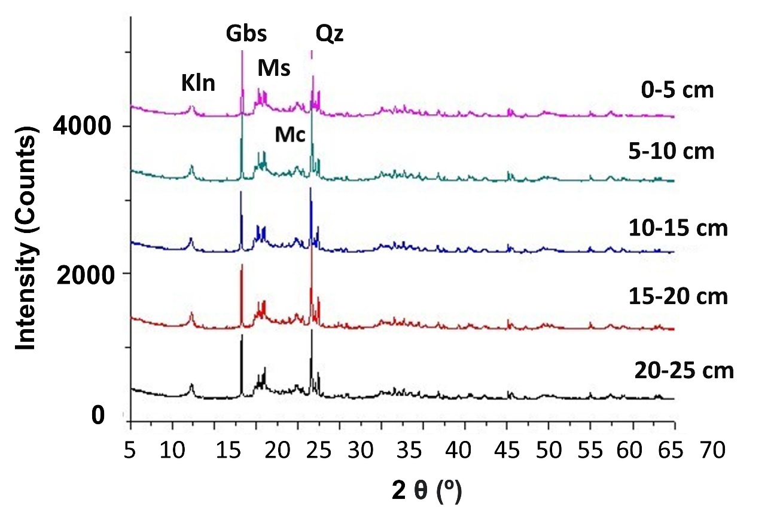

Source: Author.
The clay fraction from Area 2 contained the same minerals as that fraction from Area 1, plus the presence of goethite (Go). Goethite is an iron oxide - FeO (OH) – with orthorhombic crystallographic composition.
No transformation was detected of goethite into minerals with magnetic properties, which can occur in soils exposed to temperatures higher than 500°C. This mineral was found, with different intensities, in both the 0-5 and 20-25 cm layers (Figure 3). Kaolinite is also destroyed due amorphization in temperatures higher than 500 ºC. This is another indicative that the temperatures did not reach these values.

Figure 3 – Overlapping X-ray diffractograms of the clay soil fraction in Area 2. Co Ka radiation (35 kV/40 mA). – Kln – kaolinite, Gbs – gibbsite, Ms – muscovite, Mc – microcline, Qz – quartz, Gth – goethite.
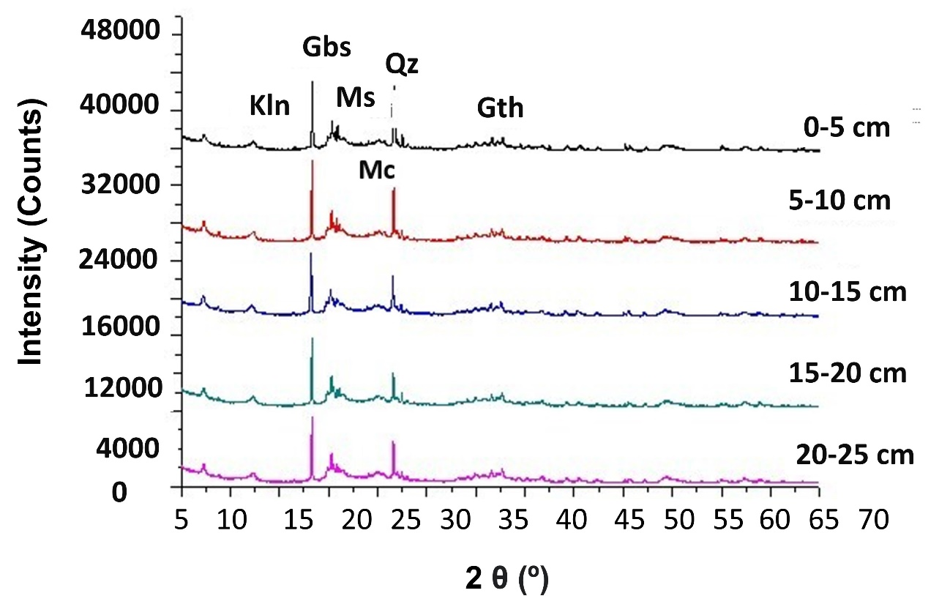

Source: Author.

For transformation of goethite into magnetite to occur, there must be complete vaporization of the water present in the mineral, which happens at around 450°C. Organic matter is another important factor for this transformation to take place. Since in Area 2 the fire resulted from the burning of litter in a field to plant beans that spread out of control due to high winds, reaching regions with more complex vegetation, the organic matter found in the soil tended to be less than would be found in an area with forest plant cover. This might have been another factor hindering the magnetization of the iron oxides at the collection site. This does not rule out the existence of magnetic minerals at the site. Mattos (2015), also studying São Pedro da Serra, in an area with more voluminous arboreal contribution that was affected by a fire with strong intensity observed the presence of magnetite in the clay fraction in the 0-5 cm layer.
The overlapping diffractograms of the 0-5 cm soil layer of the two areas studied enables the identification of differences in the mineralogical composition of the two environments. It is likely that the absence of smectite and goethite in Area 1 is not related to the fire intensity, but rather to the weathering and pedogenesis processes of each area (Figure 4).

Figure 4 – Overlapping X-ray diffractograms of the clay soil fraction in Areas 1 and 2. Co Ka radiation (35 kV/40 mA). – Kln – kaolinite, Gbs – gibbsite, Ms – muscovite, Mc – microcline, Qz – quartz, Gth – goethite.

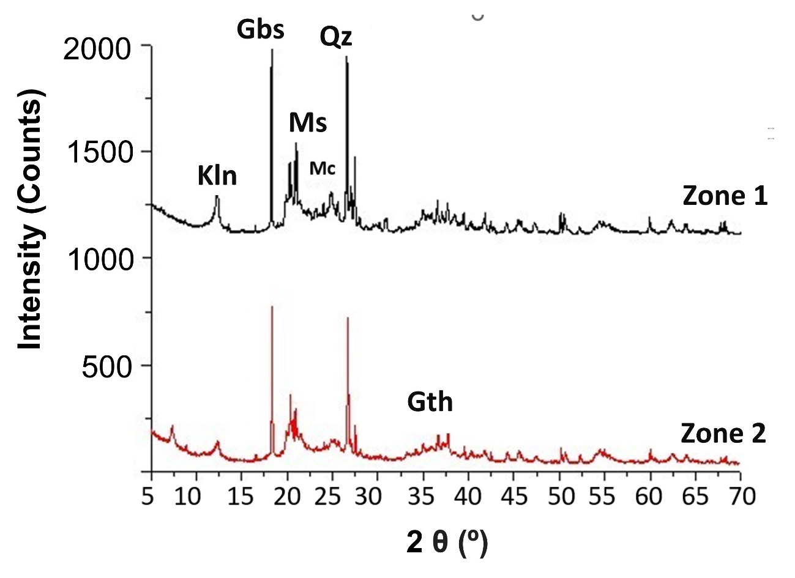Source: Author.

The fact of not finding the presence of magmatic minerals in the soil samples analyzed does not mean the fires in the two areas had low intensity. According to Fontes and Weed (1991), the temperature increase in the soil does not have a direct cause-effect relationship with the magnetization of iron oxides, since it is not uncommon to find magnetite or maghemite at depths not altered by fire, showing that other factors can influence the occurrence of magnetic minerals.
Work carried out by Mattos (2018) and Mattos et al (2022) in the district of São Pedro da Serra showed that the action of fire in the soil can cause differences in the mineralogical composition according to depth. The two areas studied in this work are located in the same lithological region and with the same soil typology, which suggests that the occurrence of different minerals, especially goethite, may be related to the severity of fires.

Characterization by TGA/DTG

The TGA/DTG data show similar results in relation to the five soil depths studied. However, by comparing the results of each layer, it is possible to note that the samples in Area 2 had greater mass loss with rising temperature.
In Area 1, the mass loss in the five layers taken together was approximately 18%. For example, in the 0-5 cm layer, four energy release and mass loss events were recorded. The first occurred at around 80 °C, with mass loss of 2.92%. The second was at 280°C, corresponding to a loss of 7.11%. The third was at about 480 °C, corresponding to the greatest mass loss, 7.41%. This event was associated with the vaporization of the water present in the mineral structure. The final event was at 870°C, with a mass loss of 2.85%. In the other layers, the values were very similar. However, the only depth at which losses greater than 7% occurred was the topsoil (0-5 cm), while in the other layers the mass loss of both the second and third events was near 6.6%.(Figure 5)

Figure 5 – Area 1 soil TGA/DTG curves.

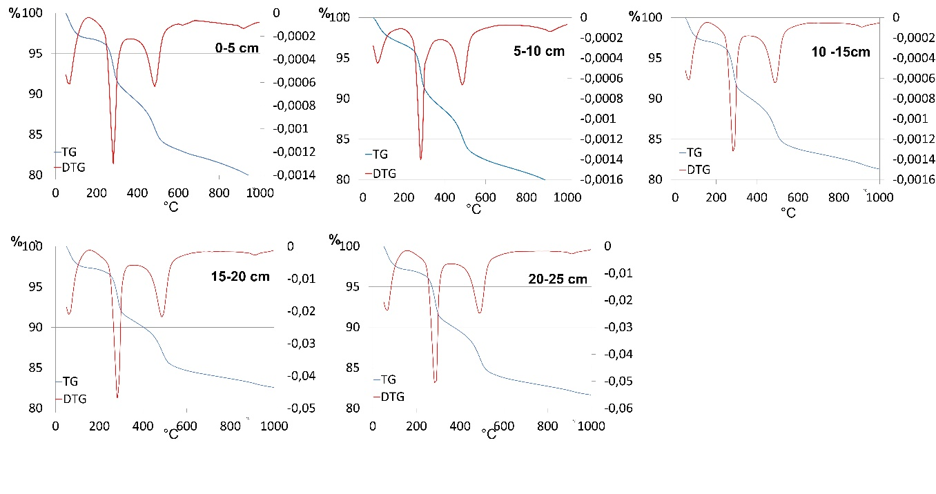
Source: Author.
In Area 2, the mass loss of the minerals was approximately 30% at all depths. There also were four energy release events observed. However, the values found in the 0-5 cm layer differed slightly from the others. For example, in the topsoil layer, the first three events were not as drastic. At 80ºC the loss was 5.86%; at 280°C it was 10.6%; and at 480°C it was 7.18%. At the other depths, there were only small alterations in the mass loss values in the same temperature intervals. The greatest mass loss occurred at 870°C, and was greater in the topmost layer (7%) in comparison with the other layers (approximately 4.5%) (Figures 6).

Figure 6 – Area 2 soil TGA/DTG curves.
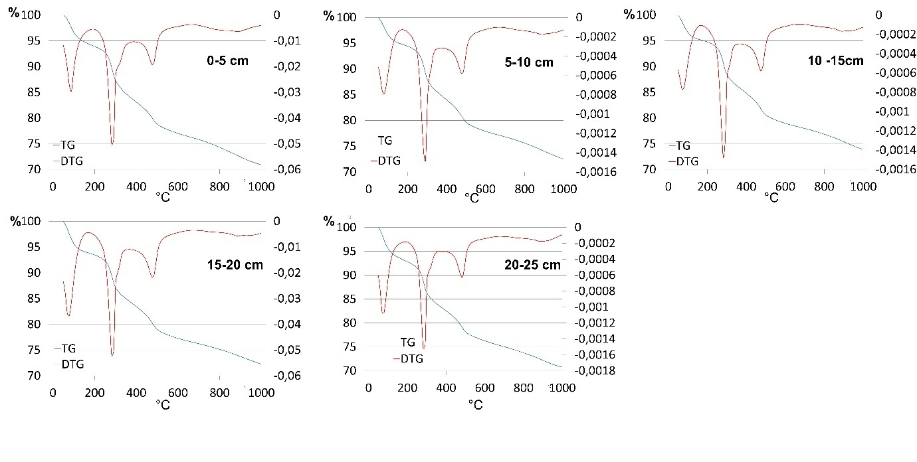
Source: Author.

The soil samples from Area 2 needed less energy for mass loss to occur, as indicated by the fact that in this area, the greatest mass losses occurred between 250 and 300°C, while in Area 1, the greatest losses happened between 450 and 500°C. These results can indicate a more severe fire in Area 2, since the minerals had already undergone transformations in their properties, so that it was not necessary to reach higher temperatures to alter the mass. However, further studies are required to corroborate this hypothesis.

Final Considerations

The data obtained indicated that the forest fires in the two areas had severities that differed according to the combustion magnitude, which in turn was associated with various factors, such as atmospheric variables, land use, soil moisture and type of vegetation. The vestiges in landscapes left by fires are important elements to understand the dynamics of fire. However, it is necessary to analyze different environmental subsystems to reach more definitive findings regarding fire severity.
Area 1, affected by fire more recently, still has some visible elements that facilitated the identification of the consequences of burning. In turn, in Area 2 it was possible to find recovered vegetation, with the occurrence of repellency in the 0-5 cm. layer. This area also differed from Area 1 by the occurrence of goethite in the soil’s clay fraction, and also a lesser need to expend energy for mass loss of the soil particles analyzed by thermogravimetry.
The differences found in the 0-5 cm layer in comparison with the other horizons indicated that fire only affected the first few centimeters of the soil. Only at the 0-5 cm depth were results found that differed from the other layers, which had homogeneous results.

Acknowledgment

This research was funded by the Research Support Foundation of the State of Rio de Janeiro (FAPERJ), process, E-26/111.897/2021 and Support Program for the purchase or maintenance of Equipment and small renovations (PROINFRA/UERJ) n1/ 2021.

References

BERTOLINO, A.V.F.A. Repercussões da agricultura de corte e queima na hidrologia e na erosão –São Pedro da Serra /Nova Friburgo (RJ). In: VILLAS BOAS, H.G.;MATTOS, C.P. (Ed.) 20 anos da Área de Proteção de Macaé de Cima: trajetórias e caminhos na pesquisa ambiental. p. 173-220, 2021
CAMPANHARO. W. A. et al., Padrões e impactos dos incêndios florestais nos biomas brasileiros. In: SETZER, A. W.; FERREIRA, N. J. (Org). Queimadas e incêndios Florestais. Mediante monitoramento orbital. São Paulo: Oficina de Textos, 2021. 296p.
CARVALHO FILHO, A., LUMBRERAS, J.F.; ANTOS, R.D. Os solos do estado do Rio de Janeiro. Brasília: CPRM; Embrapa-Solos, 2000.
CELIS, R.; JORDAN, A.; ZAVALA, M, A. Efectos del fuego en las propiedades biológicas, físicas y químicas del suelo. In: BENTO-ÇONÇALVES, A.; VIEIRA, A. Grandes incêndios florestais, erosão, degradação e medidas de recuperação dos solos. Universidad de Sevilla: Sevilla, 2013. 291p.
COUTO, E. G.; CHIG, L. A.; CUNHA, C. N. Estudo sobre o impacto do fogo na disponibilidade de nutrientes, no banco de sementes e na biota de solos da RPPN SESC Pantanal. SESC, Departamento Nacional: Rio de Janeiro, 2006. 56p.
DE BANO, L. et al. Effects of burning on Chaparral soils: I - Soil Nitrogen. Soil Science Society America Journal, Madison, v. 43, n. 3, p. 504-509, 1979.
DE BANO, L.F. Water repellency in soils: a historical overview. Journal of Hydrology, n 231-232, p.4-32, 2000.
DEAN, W. A ferro e fogo: a história e a devastação da Mata Atlântica brasileira. 1. ed. São Paulo: Cia. das Letras, 1996. 484 p.
DENARI, G. B.; CAVALHEIRO, E. T. Princípios e aplicações de análise térmica. São Carlos: IQSC, 2012. 40p.
DOERR, S.H., DOUGLAS, P., EVANS, R.C., MORLEY, C.P., MULLINGER, N.J., BRYANT., R., SHAKESBY, R.A. Effects of heating and post-heating equilibration times on soil water repellency. Australian Journal os Soil Research, 43, 261-267. 2005.
DOERR, S.H.; SHAKESBY, R.A.;WALSH, R.P.D. Soil hydrophobicity variations with depth and particle size fraction in burned and unburned Eucalyptus globulus and Pinus pinaster forest terrain in tha Águeda Basin, Portugal, Catena, 27, 25-47, 1996.
EMBRAPA. Manual de procedimentos de coleta de amostras em áreas agrícolas para análise da qualidade ambiental: solo, água e sedimentos. Embrapa Meio Ambiente: Jaguariúna, 2006. 169p.
FACHIN, P. A.; THOMAZ, EDIVALDO L. Variations of temperature on soil in the slash-and-burn agriculture. In: 8th International Conference on Fire Effects on Soil Properties, 2021, Guarapuava. Anais do 8th International Conference on Fire Effects on Soil Properties, 2021.
FONTES, M.P.F.; WEED, S.B.. Iron oxides in selected Brazilian Oxisols. I. Mineralogy. Soil Science Society of America Journal, 1991. 55: 1143-1149.
GARCIA-CORONA, R. BENITO, E., DE BLAS, E. e VARELA, M.E. Effects of properties related to its hydrological behavior in tho north-western. Spanish soil. International Journal of Wildland Fire, n 13(2), p.195-199. 2004.
HUNGERFORD, R. D. Soils. Fire in Ecosystem Management Notes: Unit II-I. USDA Forest Service, National Advanced Resource Technology Center, Marana, Arizona, 1996. p. 668 – 673.
International Centre for Diffraction Data (ICDD). (Database), edited by Kabekkodu, S. International Centre for Diffraction Data, Newtown Square, PA, USA, 2014
INEA. APA Estadual de Macaé de Cima. Plano de Manejo – Zoneamento. Rio de Janeiro: INEA, 2014. 99p.
INPE – Instituto Nacional de Pesquisas Espaciais. SIAM – Sistema de Monitoramento e Alertas para Queimadas. Programa Queimadas. INEPE, 2022. Available in : https://queimadas.dgi.inpe.br/queimadas/portal-static/estatisticas_estados/.Access in: 19 Oct. 2022.
JUSTINO, F. et al. Paleofogo e potencial impacto das mudanças climáticas na incidência de queimadas. In: SETZER, A. W.; FERREIRA, N. J. (Org). Queimadas e incêndios Florestais. Mediante monitoramento orbital. São Paulo: Oficina de Textos, 2021. 296p.
KING, P. M. Comparision of methods for measuring severity of water repellence of sandy soils and assessment of some factors that affect its measurement. Aust. J. Soil Res., v. 19, p. 275-285, 1981
LOZANO E, JIMÉNEZ-PINILLA P. 2013. Intensidad y severidad del fuego. Red Temática Nacional Efectos de los Incendios Forestales sobre los Suelos (FUEGORED). Ficha técnica FGR2013/01.
MATAIX- SOLERA, J.; GUERRERO, C. (Ed.). Incendios Forestales, Suelos y Erosion Hídrica. Caja Mediterrâneo, CEMACAM Font Roja-Alcoi. Alicante, 2007.
MATTOS, B. S. Análise da composição física e mineralógica de solos sob distintas intensidade do fogo em São Pedro da Serra, 7° Distrito de Nova Friburgo, RJ (Monografia de pós graduação) DEGEO – UERJ/FFP. São Gonçalo, 2015. 84p.
MATTOS, B. S. A severidade dos incêndios e sua influência nas propriedades físicas, químicas e mineralógicas do solo em São Pedro da Serra – Nova Friburgo/RJ (Dissertação de Mestrado) DEGEO – UERJ/FFP. São Gonçalo. 100p.
MATTOS, B. S.; BERTOLINO, A. V. F. A. ; BERTOLINO, L. C. . A influência do fogo nas propriedades de um solo sob manejo de agricultura de corte e queima em ambiente serrano no bioma de Mata Atlântica. Revista Sociedade & Natureza, UFU Online, , v. 34, p. 1 - 14, 31 mar. 2022.

MERAT, G. S. Análise da transformação da paisagem sob utilização de coivara em biomas de mata atlântica – Estação experimental de pesquisa de erosão em São Pedro da Serra – Nova Friburgo/RJ. (Dissertação de mestrado). DEGEO - UERJ/FFP: São Gonçalo, 2014. P.113
MORENO, J. M.; OECHEL, W. C. A simple method for estimating fire intensity after a burn in California chaparral. Acta Oecologia/Oecologia Plantarum, v.10, n. 4, p. 57-68, 1989.
NELSON, A. W. S; MORELLI. O Programa queimados do INPE. In:SETZER, A. W.; FERREIRA, N. J. Queimadas e incêndios Florestais mediante monitoramento orbital. São Paulo: Oficina de Textos, 2021. 296p.
NOGUEIRA, C. C. F. Efeito do fogo controlado em propriedades químicas do solo em áreas de montanha sob coberto de matos: o caso de Aveleda, Parque Natural de Montesinho. (Dissertação de mestrado) Escola Superior Agrária de Bragança: Bragança, 2014. 71 p.
PAUSAS, J.G. Incendios Forestales. Editorial Catarata CSIC. Madrid, 2012. 128 p.
PEREIRA, I. S. L. Paisagem e fogo: dinâmicas hidrológicas e erosivas em agricultura tradicional de corte e queima - São Pedro da Serra/RJ; Dissertação (Mestrado em GEOGRAFIA) - Universidade do Estado do Rio de Janeiro, Fundação de Amparo a Pesquisa do Estado do Rio de Janeiro, 2016.
ROSS J. L. S. Relevo Brasileiro: uma nova proposta de classificação. Revista do Departamento de Geografia, v. 4, p. 25-39, 1985.
SANTOS, R. D.; LEMOS, R, C.; SANTOS, H. G., KER, J. K.; ANJOS, L. H. C. Manual de descrição e coleta de solo no campo. 6ª ed. Viçosa: SBCS, 2013. 88 p.
SHAKESBY, R. A.; DOERR, S. H. Wildfire as a hydrological and geomorphological agente. Earth-Sci. Rev., v. 74, p. 269-307, 2006.
VOGELMANN, E. D. et al. Water repellency in soils of humid subtropical climate of Rio Grande do Sul, Brazil. Soil and Tillage research, Volume 110, Issue 1, September, 2010, Pages 126-133.
TEIXEIRA, P. C; DONAGEMMA, G. K.; FONTANA, A; TEIXEIRA, W. G. Manual de métodos de análise de solo. 3. ed. revi. e ampl. – Brasília, DF: Embrapa, 2017. 574
THOMAZ, E. L.; FACHIN, P. A. Effects of heating on soil physical properties by using realistic peak temperature gradients. Geoderma, v. 230, p. 243-249,2014.
THOMAZ, E.L. Efeito da temperatura na repelência de água no solo: ensaios de laboratório Revista Brasileira de Recursos Hídricos, vol.13, n 1, p. 57-64, 2008.

The mineralogical characterization was carried out by Consulting the database of UNESP, available at: <http://www.rc.unesp.br/museudpm/banco>.

