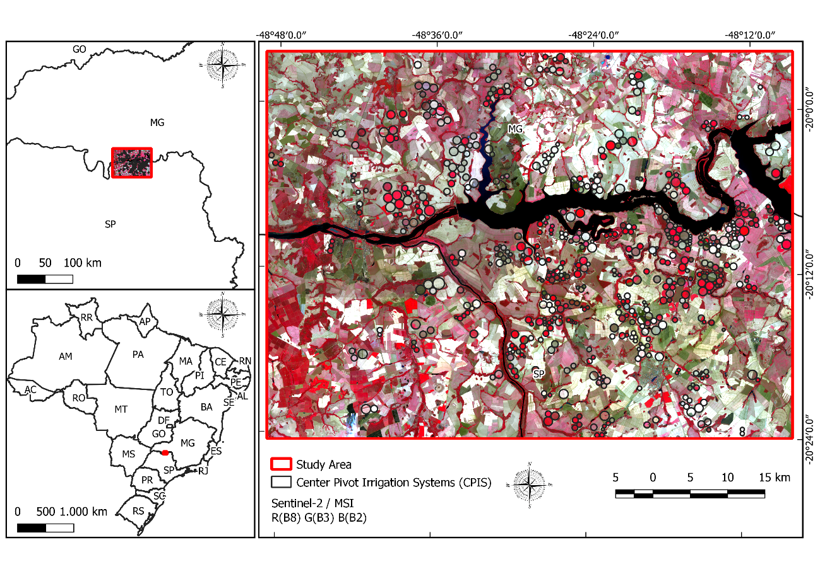
Figure 1 Location map of the study area.

