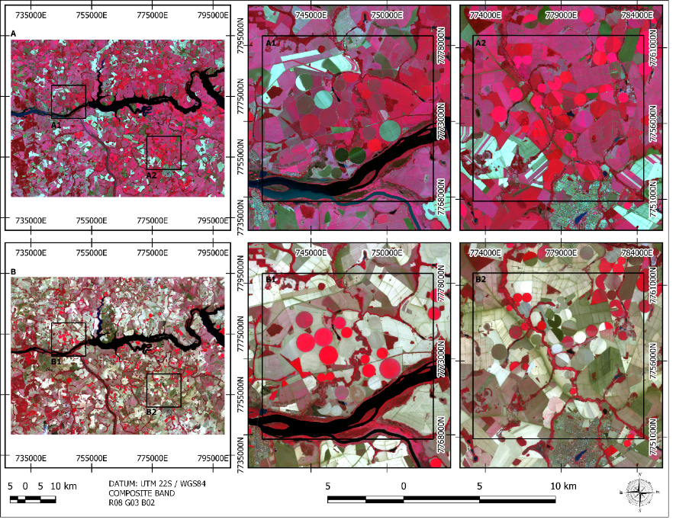
Figure 2 Sentinel-2 images from the two different periods: (A) final of rainy period (May 2020) and zoomed areas (A1 and A2), (B) dry period (September 2020) and zoomed areas (B1 and B2). The red areas represent the photosynthetically active regions.

