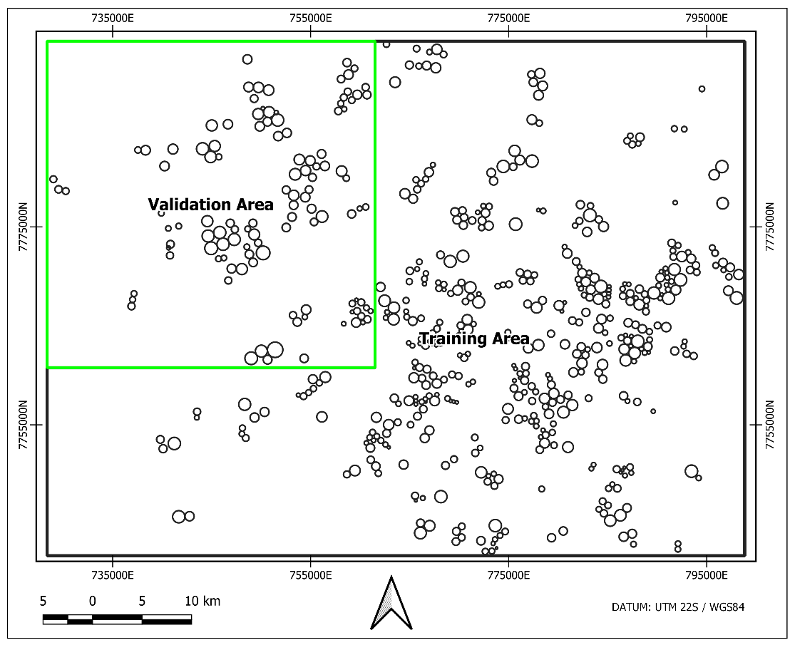
Figure 3 Training and Validation area and CPIS ground truth mapping.

