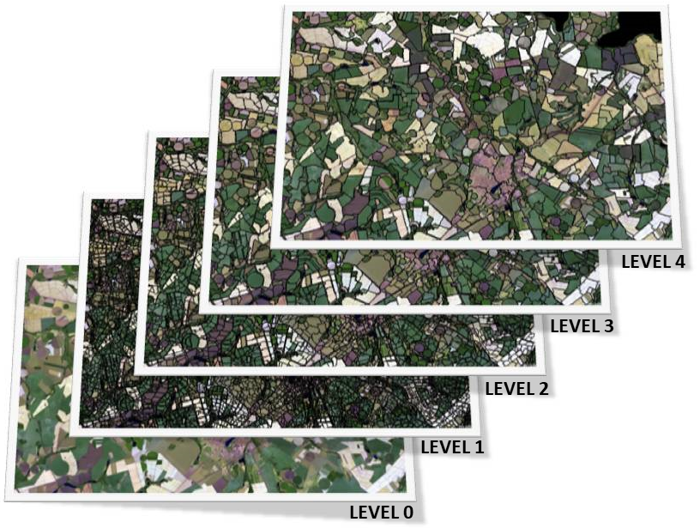
Figure 4 Multiresolution segmentation and hierarchical net between levels of segmentation.

