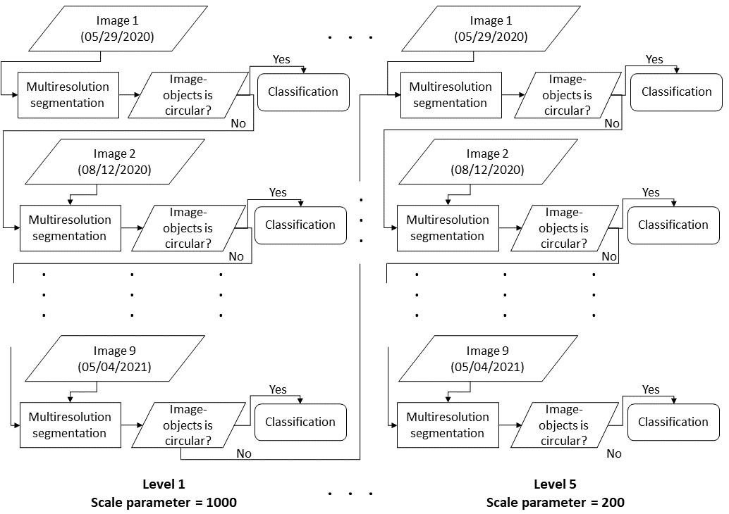
Figure 5 Multiresolution segmentation and classification sequence process beginning at scale parameter 1000 and finishing at scale parameter 200.

