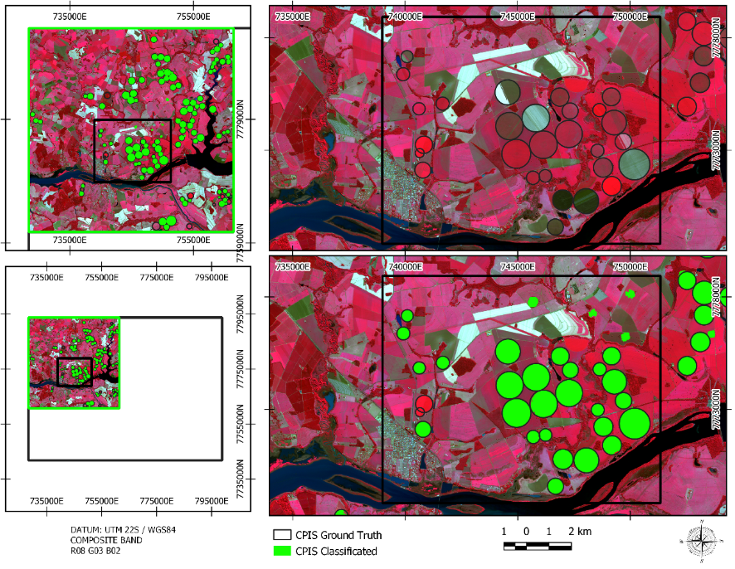
Figure 6 Detail of validation area showing classification result.

