NASALITY TRIGGERED BY /ɲ/ IN TWO PORTUGUESE VARIETIES OF SAO TOME AND PRINCIPE
NASALIDADE ENGATILHADA POR /ɲ/ EM DUAS VARIEDADES DO PORTUGUÊS DE SÃO TOMÉ E PRÍNCIPE

Amanda Macedo Balduino

Recebido em: 27 de agosto de 2020 | Aceito em: 26 de outubro de 2020

ABSTRACT:
This study describes and analyzes the nasality triggered by /ɲ/ in the Portuguese spoken in São Tomé (PST) and in the Portuguese spoken in Príncipe (PP). PST and PP are Portuguese varieties from São Tomé and Príncipe (STP) that present particular linguistic characteristics. Considering the context of linguistic contact into which PST and PP are inserted, we aim to (i) propose a phonological analysis of nasality triggered by /ɲ/ in PST and PP, and (ii) investigate the presence of ambisyllabic structures. Based on Autosegmental Phonology (Goldsmith 1976; 1990) as the phonological theory and laboratory phonology (Ohala, 1995) as the methodology and considering the phonotactic analysis of vowels, we observed that nasality can be triggered by /ɲ/, a nasal consonant that occupies an ambisyllabic structure. Thus, the palatal nasal nasalizes left contiguous vowels in stressed and unstressed syllables. This nasalization process is possible because /ɲ/ is in coda, resulting in a CVN syllable structure and triggering tautosyllabic nasality. Even though it is optional, the nasality triggered by /ɲ/ occurs independently of the vowel quality and the word stress, as described for BP (Wetzels, 1997).
KEYWORDS: Portuguese; São Tomé and Príncipe; Nasality; Vowel Inventory.

RESUMO:
Este estudo descreve e analisa a nasalidade desencadeada por /ɲ/ no português falado em São Tomé (PST) e no português falado em Príncipe (PP). O PST e o PP são variedades da língua portuguesa de São Tomé e Príncipe (STP) que apresentam características linguísticas específicas. Considerando o contexto de contato linguístico no qual o PST e o PP estão inseridos, pretendemos, portanto, (i) descrever a nasalidade engatilhada por /ɲ/ para o PST e o PP e (ii) investigar a presença de estruturas ambissilábicas acionadas por /ɲ/. Com base na Fonologia Autosegmental (Goldsmith 1976; 1990), como teoria, e na fonolgoia de laboratório (Ohala, 1995) enquanto aporte metodológico, observamos, a partir da análise fonotática das vogais, que a nasalidade vocálica pode ser engatilhada por /ɲ/, uma consoante nasal de estrutura ambissilábica. Assim, a nasal palatal nasaliza as vogais contíguas a sua esquerda, mesmo em sílabas tônicas. Esse processo de nasalização é possível por /ɲ/ estar em coda, resultando em uma estrutura de silábica do tipo CVN e desencadeando, por isso, nasalidade tautossilábica. Mesmo sendo opcional, a nasalidade engatilhada por /ɲ/ ocorre de modo independente à qualidade da vogal e ao acento lexical, como descrito para o PB (Wetzels, 1997).
PALAVRAS-CHAVE: Português; São Tomé e Príncipe; Nasalidade; Inventário Vocálico.

Introduction
The aim of this paper is to discuss the status of nasality triggered by the palatal nasal /ɲ/ in two varieties of Portuguese spoken in São Tomé and Príncipe: Santomean Portuguese (PST) and Principean Portuguese (PP). We analyze the phonotactic behavior of vowels in a phonetic environment that could or could not trigger nasality and discuss whether nasality triggered by /ɲ/ suggests ambisyllabic structures in these varieties. Although the existence of nasalized vowels in PST and PP may be the result of a phenomenon of nasality (see Balduino, 2018), the phonological role of /ɲ/ in nasalization was not considered in works such as Balduino (2018) and Araujo and Balduino (2019). In this study, we aim to fill some gaps related to the description of nasality in these varieties by analyzing phonological environments capable of conditioning nasality. Thus, we consider, through the phonotactic behavior of target segments, whether word stress, vowel quality, and/or syllable structure can determine this phenomenon.
Even though PST and PP are varieties widely spoken and transmitted as a mother language in São Tomé and Príncipe, there are few descriptive studies on these varieties. In the literature, recent studies such as those of Gonçalves (2010, 2016), Figueiredo (2010), Christofoletti (2013), Agostinho (2016), Bouchard (2017), Brandão et al. (2017), Balduino. Bandeiras and Freitas (2017), Balduino (2018; 2019), Braga (2018), Nascimento (2018a; 2018b), Passos (2018), Araujo and Balduino (2019), Gomes (2019), Gomes, Alves and Fernandes (2019), Santiago and Agostinho (2020), Agostinho, Soares and Mendes (2020), Vieira and Balduino (2020), and Santiago et al. (to be published) can be cited. Most of these works have aimed to describe PST. There are, however, few studies on PP (see Agostinho 2016; Balduino 2018, 2019; Araujo; Balduino 2019; Santiago 2019; Agostinho; Soares; Mendes 2020; Santiago et al. to be published). Therefore, this study is justified for it contributes with a description and a phonological analysis of these varieties, thus expanding the literature on nasality and linguistic analysis of PST and PP.
In the following section we discuss the current situation of Portuguese in São Tomé and Príncipe. Then, in the second section, we provide a background on nasalization in different varieties of Portuguese and an overview of the vowel inventory in PST and PP. We then present in section 4 the methodology adopted. In section 5 we discuss nasality triggered by /ɲ/. Finally, the sixth section presents the most important findings.

Santomean Portuguese (PST) and Princepense Portuguese (PP)
The Democratic Republic of São Tome and Principe (STP) is located in the Gulf of Guinea, western coast of Africa. STP is one of the nine countries where Portuguese is considered an official language since 1975. Besides Portuguese, there are other languages spoken in the archipelago, considered as national languages. These languages are autochthonous to the Islands and correspond to Portuguese-based Creole languages, namely Santome (código ISO 639-3: CRI), Lung’Ie (ISO 639-3: PRE) and Angolar (ISO 639-3: AOA) (Ferraz, 1979; Maurer 2009; Hagemeijer 2009; Agostinho 2015; Bandeira 2017). Kabuverdianu (ISO 639-3: KEA), a transplanted language from Cape Verde, is also spoken in Sao Tome Island and in Principe Island. The coexistence of these languages provides a multilingual environment with a frequent contact among them. Consequently, this may result in structural variations which affect all languages, including Portuguese.
The multilingual linguistic situation of STP is a result from the colonization process. Colonized and settled by Portugal for centuries (from the 16th to the 20th century), STP had socio-historical conditions necessary to provide a proper environment for the origin of creole languages. That is, there was a huge diversity of African languages spoken by slaves who met Portuguese-language speakers (colonizers) in a context that demanded communication. Thus, the contact among different ethnic groups resulted, in general terms, in the development of new languages. Such varieties were widely used by the population that lived in the islands. Children acquired them as their native language. As a result, other languages are still spoken in STP besides Portuguese as a heritage from the colonization period.
Despite being a legacy of the European colonization, Portuguese – in the way which is spoken in STP – has changed (Bouchard, 2017). Thus, to assume Portuguese spoken in STP as the same language spoken in Portugal would be an inaccuracy, since it has some linguistic variations compared to the European Portuguese (EP), which is a standard variety in STP. This is the case of diphthongs, for example. According to Christofoletti (2013):

“(…) it was found the uniqueness of the phonetic- phonological system of PVS, because, unlike the PE, considered prestigious in the country, PVS performs the monophthongization of diphthongs (…)”. (Christofoletti, 2013: VIII)

The Portuguese spoken in São Tomé and Príncipe has recently received some attention (Gonçalves 2010, 2016; Figueiredo 2010; Christofoletti, 2013; Agostinho 2016; Bouchard, 2017; Brandão et al., 2017; Balduino; Bandeira; Freitas, 2017; Balduino, 2018, 2019; Braga, 2018, Gomes, 2019; Nascimento, 2018; Passos, 2018; Araujo; Balduino, 2019; Gomes; Alves; Fernandes 2019; Santiago; Agostinho, 2020). Nevertheless, even taking into account these studies, there are still few works on the African varieties of Portuguese. According to Hagemeijer (2016), Portuguese varieties from São Tomé and Príncipe, Guinea Bissau and Cape Verde are less described and have recently been object of academic studies. There is still an imbalance between the areas: areas such as syntax and morphosyntax have been privileged, while areas of phonetics and phonology have been disfavored (Santiago and Agostinho, 2020, p. 40). One of the aims of this paper is to contribute with the description of vowel inventory and vowel nasality, phenomena observed in Portuguese varieties spoken in STP.
Different varieties of Portuguese spoken in STP have distinct structures compared to European (EP) and Brazilian Portuguese (BP), such as the production of diphthongs (Christofoletti, 2013), rhotics (Agostinho, 2016; Bouchard, 2017; Brandão et al., 2017; Brandão; Paula, 2018; Agostinho; Soares; Mendes, 2020), vowels (Gomes, 2018; Rocha and Nascimento, 2018; Santiago, 2019; Santiago et al., to be published), and different phonological processes (Balduino; Bandeiras; Freitas, 2017; Balduino, 2018, 2019; Braga, 2018; Nascimento, 2018; Araujo; Balduino, 2019; Balduino; Vieira, 2020; Vieira; Balduino, 2020). Thus, we aim here to discuss the status of nasality triggered by /ɲ/ in two urban varieties: the Portuguese spoken in the city of São Tomé (PST) and the Portuguese spoken in the city of Santo Antonio, Príncipe Island, (PP). Based on studies such as Balduino (2018) and Araujo and Balduino (2019), we propose a phonological analysis of oral and nasalized vowels by investigating the possibility of nasalization trigged by the nasal palatal /ɲ/.
The division between PST and PP is justified not only by the geographic distance between the islands, since the island of Príncipe is 160 kilometers away from the city of São Tomé, but also by a distinct and singular linguistic ecology of each variety. PST coexists with Santome and Angolar, however PP is in contact mainly with Lung'Ie and Kabuverdianu.
These languages have similar phonological systems. However, some differences can be observed (see Bandeira, 2017). Santome, Lung’Ie, and Angolar have seven oral vowels /i, e, ɛ, a, ɔ, o, u/, but only Lung’Ie and Angolar have long vowels: /ii, ee, ɛɛ, aa, ɔɔ, oo, uu/ (see Agostinho, 2015; Bandeira, 2017). According to Ferraz (1979) and Maurer (2009), Santome and Lung'Ie have phonemic nasal vowels. However, Balduino et al. (2015) showed that nasality is a result of nasal spreading. Thus, there is no nasal vowel in the phonological system of Santome and Lung’Ie: nasality is due to a phonological process that results in five nasalized vowels [ĩ, ẽ, ɐ̃, õ, ũ]. In addition, Agostinho, Balduino and Araujo (2020) pointed out some particular characteristics in Lung'Ie nasality which are not reported in the literature on Santome and Angolar phonology. The authors showed that the epenthetic vowel [i] in pretonic syllables is optionally nasalized if followed by /ɲ/, an ambisyllabic consonant: “The solely identified case in which the unstressed vowel incorporates the nasalization of a nasal consonant occurs with pre-vocalization” (Agostinho; Balduino; Araujo, 2020, p. 20). Moreover, [ɲ] can also trigger progressive nasality in Lung’Ie (Agostinho; Balduino; Araujo, 2020). For Angolar, Bandeira (2017) stated that all seven vowels can be phonetically nasalized in stressed syllables preceded by a nasal consonant contained in the following syllable: [ĩ, ẽ, ɛ̃, ɐ̃, ɔ̃, õ, ũ]. Kabuverdianu, in turn, have eight oral vowels /i, e, ɛ, a, ɐ, ɔ, o, u/ and five nasalized vowels [ĩ, ẽ, ɐ̃, õ, ũ] (Quint, 2000; Freitas; Bandeira, 2020, p. 16).
Although all the languages mentioned above do not have phonological nasal vowels, nasality seems to manifest itself in different ways in each of them. Angolar, for example, is the only language that has seven nasalized vowels (Bandeira, 2017). In turn, only in Lung’Ie there is an epenthetic vowel [i] nasalized in pretonic syllables (Agostinho, Balduino and Araujo, 2020). In Santome and Angolar, [ɲ] is known to spread nasality exclusively to stress syllables (Bandeira, 2017). Considering that even small differences can be relevant in a contact situation, we analyzed PST and PP separately. In addition, there is the affirmation of an ethnic identity in different cultural translations and social customs of Santomean and Principean citizens (see Nascimento, 2008), which is reinforced by the political autonomy status of the Príncipe Island. Such facts could provide distinct structural analyses for each variety, thus justifying the individual analysis we conduct in this study.
In summary, PST and PP are varieties of Portuguese that compose a wide set that includes EP, BP, and other varieties of Portuguese. In the following section, we present a general overview of the vowel inventory of PST and PP. For this, we are guided by previous studies on the analysis of the vowel system of such varieties.

The Vowel Inventory in PST and PP

In PST and PP there are seven oral vowels, as Table 1 shows (cf. Christofoletti; Araujo, 2018; Santiago, 2019; Santiago et al., to be published).

Table 1. Stressed Vowels in PST and PP.
 | [coronal] | [dorsal] | [dorsal]
High | I |  | u
Mid-High | E |  | o
Mid-Low | ɛ |  | ɔ
Low |  | A

Stressed vowels in PST and PP can be systematized in [coronal] segments (such as [i, e, ɛ]) and in [dorsal] segments (such as [a, ɔ, o, u]). However, in pretonic (see 1) and non-final posttonic syllables (see (2)), the inventory shown in Table 1 is reduced, since the opposition between [e, ɛ] and [o, ɔ] is canceled. Thus, we only identified five vowels, [i, e, a, o, u] in non-final unstressed syllables (cf. Christofoletti and Araujo, 2018; Gomes, 2018; Nascimento, 2018a, 2018b; Santiago et al., to be published).
In pretonic syllables, different phonological processes targeting mid vowels are identified in PST and PP. Nascimento (2018a) and Santiago et al. (to be published) describe phenomena such as vowel harmony and vowel raising in both varieties, demonstrating that pretonic syllables favor vowel neutralization, as shown in (1) and (2).

(1) a. precoce [pɾeˈkɔsɪ] ~ [pɾɛˈkɔsɪ] ‘precocious’
b. obobo [oboˈbɔ] ~ [ɔbɔˈbɔ] ‘obobo’

(2) a. sofá [soˈfa] ~ [suˈfa] ‘couch’
b. menina [meˈninɐ] ~ [miˈninɐ] ‘girl’

In (1.a), we notice that the variation in precoce [pɾeˈkɔsɪ] ~ [pɾɛˈkɔsɪ] ‘precocious’ indicates neutralization of [coronal] vowels: [e] ~ [ɛ]. Conversely, obobo [oboˈbɔ] ~ [ɔbɔˈbɔ] (1.b) exemplifies neutralization of [dorsal] vowels: [o] ~ [ɔ] (Santiago et al., to be published). According to Santiago et al. (to be published), PP presents [ATR] harmony. This phenomenon occurs because of the agreement of the [ATR] feature between pretonic and stressed vowels. Therefore, vowel harmony in PP demonstrates certain types of constraints on triggers and targets: (i) triggers must be stressed, (ii) targets are only upper-mid vowels [e, o] in pretonic syllables, and (iii) harmony is applied for the feature [ATR]. Nascimento (2018), conversely, attests a different type of height harmony in PST, which is triggered by stressed vowels for the feature [high]: menino [miˈninʊ] ~ [meˈninʊ] ‘boy,’ mosquito [muʃˈkitʊ] ~ [moʃˈkitʊ] ‘mosquito.’ The production of [i] and [u] by raising most likely occurs in a phonetic environment where a high vowel (homorganic or not) is in the contiguous syllable (cf. Rocha; Nascimento, 2018). Such fact suggests a phonological assimilation for the harmonic feature [high], which operates over a string of different segments in PST (cf. Rocha, 2018). Although the data examined by Rocha and Nascimento (2018) indicate that high stressed vowels favor the raising of pretonics, it does not explain data such as sofá [suˈfa] observed by Santiago et al. (to be published). Thus, it is possible that raising is not motivated by vowel harmony in PST and PP (Santiago et al., to be published; Balduino, to be published).
The examples in (2.a) and (2.b) show that [e] can be neutralized into [i], and [o] can be neutralized into [u] without phonological assimilation of harmonic features in pretonic syllables (Santiago et al., to be published). In PP, Santiago et al. (to be published) analyzes vowel raising as a process that affects upper-mid vowels in pretonic and non-final posttonic syllables, being characterized by the elimination of the height opposition between [e] ~ [i] and [o] ~ [u]. This result is also related to PST (Christofoletti, 2013; Gomes, 2018; Christofoletti; Araujo, 2018; Nascimento, 2018). In addition, non-final [e] and [o] in posttonic syllables are often deleted in PST and PP (Balduino, to be published). The deletion of mid vowels in non-final posttonic syllables is a productive phenomenon in PST, as in chácara [ˈʃakɾɐ] ~ [ˈʃakaɾɐ] ‘farm’ and abóbora [a.ˈbɔbɾɐ] ~ [a.ˈbɔbuɾɐ] ‘pumpkin.’ This process is widely implemented when vocalic deletion results in a grammatical cluster usually composed by an obstruent (p, b, d, t, k, g, f, v) and a liquid (l, ɾ) (Gomes, 2018, p. 169).
Finally, posttonic syllables in word-final position eliminate the opposition between mid and high vowels, resulting in a subsystem of only three vowels [ɐ, ɪ, ʊ] (Balduino, to be published). In addition to the reduction of word-final unstressed vowels, [ɪ] and [ʊ] can also suffer vowel devoicing into [ɪ̥] and [ʊ̥], respectively (Santiago et al., to be published). In PP, this phenomenon is marked by the loss of vowel voicing, as well as of most acoustic properties of the vowel, such as its regular formative structure. Moreover, not only the unstressed position is a necessary condition for the occurrence of devoicing, but also the voiceless quality of the contiguous consonant in onset seems to favor it (see Meneses, 2017). In PST, this process also occurs and is also attested in pretonic syllables (see Balduino, to be published). Finally, [a] is observed in posttonic syllables in word-final position in PST and PP (Balduino, to be published), indicating that [a] reduction is not mandatory in these varieties.
To describe PST and PP vowel inventory, a distinction between stressed and unstressed vowels is needed, since vowel quality is intrinsically related to word stress, a fact also observed in varieties such as BP and EP (see Câmara Jr., 1970; Mateus; D’Andrade, 2000). Furthermore, different phenomena are shared among those varieties. The raising of mid vowels in unstressed syllables, for example, is a common process in PST and PP, and also in EP and some varieties of BP. Differently from EP and similarly as some varieties of BP, however, phenomena such as vowel harmony suggest that mid vowels have a high number of occurrences of opening in pretonic syllables. The lower-mid vowels [ɛ] and [ɔ] are attested in the pretonic inventory of PST and PP.
Deletion of unstressed vowels is also common in all Portuguese varieties considered. In EP, the deletion of unstressed vowels is a productive process that affects unstressed vowels. In BP, on the contrary, this phenomenon is observed, but it is not as productive as vowel neutralizations (Mateus; D’Andrade, 2000; Gomes, 2018). In PST and PP, both processes seem to be productive, but it is necessary to analyze these phenomena expanding the data before we can propose categorical generalizations, which is a matter for future studies. So far, we have noticed that although PST and PP are in contact with different languages, both share the same vowel inventory.
Table 2 shows the overall inventory of vowels. The highlighted segments correspond to phonetic realizations that emerge in the unstressed inventory as an outcome of phonological phenomena discussed in this paper.
Table 2. Unstressed Vowels in PST and PP

Pretonic |  |  | Posttonic |  |  | Word-Final Posttonic
i |  | u | i |  | u | ɪ, ɪ̥ |  | ʊ, ʊ̥
e |  | o | e |  | o
ɛ |  | ɔ |  |  |  |  | ɐ
 | a |  |  | a |  |  | a

In this section, we showed that the vowel inventory of PST and PP is composed by seven oral vowels: [i, e, ɛ, a, ɔ, o, u]. In unstressed syllables, these vowels are common targets of neutralization and deletion processes in PST and PP. These phenomena affect mainly mid vowels, which are often modified by raising, lowering, devoicing, or even deletion. In the following section we present a brief theoretical summary on nasality in the Portuguese language considering varieties such as EP, BP, PST, and PP.

Processes of Nasality in Portuguese

Vowel nasality is a synchronic phonological process in European and Brazilian Portuguese. Although this phenomenon has been discussed according to different theoretical proposals, two main hypothesis should be highlighted: monophonemic and biphonemic. The monophonemic hypothesis (Ludtke, 1933; Leite, 1974; Medeiros, 2007) assumes [nasal] vowels as phonological segments. For this reason, the nasality identified in Portuguese vowels is interpreted as intrinsic. On the contrary, the biphonemic hypothesis supports the lack of phonological nasal vowels in Portuguese, since nasality is believed to be the result of an assimilation process trigged by a nasal consonant inside a vowel + nasal consonant /VN/ sequence (Câmara Jr., 1953, 1970; Moraes; Wetzels, 1992; Wetzels, 1997; Mateus; D'Andrade, 2000).
The second hypothesis is usually discussed in accordance with non-linear theories. Autosegmental Phonology, for example, explains the coarticulatory character of nasalized vowels based on (i) spreading of features and (ii) temporality of the syllable (Moraes; Wetzels, 1992; Wetzels, 1997; Mateus; D'Andrade, 2000; Balduino, 2018; Araujo; Balduino, 2019). The nasal consonant is responsible for spreading its [nasal] feature to the adjacent vowel regressively, which then becomes nasalized. After the vowel assimilates the nasal feature, two outcomes are possible: the nasal consonant may be deleted or may remain in the word. Deletion depends on the position of the nasal consonant in the syllable. If the nasal consonant is in coda, the vowel immediately on the left is nasalized and only after that the nasal segment is deleted. In this case, [+nasal] vowels (ṼN) become longer than [-nasal] vowels (V). This could occur because nasalized vowels would correspond to the temporal unit of the vowel sound plus the temporal unit of the deleted nasal consonant. In this paper, we call this phenomenon as tautosyllabic nasality, representing nasalized vowels as ṼN, where V can be replaced by any oral vowel and N corresponds to a nasal consonant in coda.
Conversely, nasality trigged by a nasal onset does not result in a longer duration in nasalized vowels, as the nasal segment is not deleted. In opposition to tautosyllabic nasality, this process is optional and the nasal consonant in onset does not always spread its nasality to the vowel immediately on its left. Generally, in BP and EP, this process is obligatory if the target vowel is in a stressed syllable, as the first [a] in cama [ˈkɐ̃.ma] ‘bed,’ but it is optional in unstressed syllables, as in camada [ka.ˈma.da] ~ [kɐ̃.ˈma.da] ‘tier’ (Miguel, 2006, p. 187). Even though this nasalization phenomenon is also regressive, the nature of the process is distinctive from tautosyllabic nasality: it is promoted by a consonant in onset. We call this phenomenon heterosyllabic nasality, representing nasalized vowels as Ṽ.N.
Nasality in PST and PP has been studied by Balduino (2018), and Araujo and Balduino (2019). Based on the duration and the formants of nasal (ṽN), nasalized (ṽ.N) and oral (V) segments, Araujo and Balduino (2019) related both nasalization processes in PST and PP: tautosyllabic nasality, triggered by a nasal coda, and heterosyllabic nasality, promoted by a nasal onset. According to the authors, both processes are coarticulatory in nature and arise from a regressive dissemination of the [+nasal] feature onto the previous oral vowel. However, while tautosyllabic nasality is compulsory, results in lexical contrast, and causes the deletion of the nasal coda – resulting in a longer ṽN than V (48% for PST and 60% for PP) –, heterosyllabic nasality is not applied to pretonic syllables, is optional in stressed syllables, and always keeps the nasal consonant in onset (Araujo; Balduino, 2019, p. 41).
In addition to tautosyllabic and heterosyllabic nasality, there is a third process of nasalization in EP and BP which is triggered by the palatal nasal consonant. For Wetzels (1997), the palatal nasal occupies an ambisyllabic structure since it is simultaneously associated with onset and coda positions in a syllable. According to this reasoning, the palatal nasal always nasalizes its left contiguous vowel in PB and PE. Because /ɲ/ is in coda, characterizing a CVC syllable structure, tautosyllabic nasality is triggered. The nasalization process in these cases is mandatorily implemented, occurring independently of the vowel quality and the word stress (Wetzels, 1997). Even though Araujo and Balduino (2019) proposed a general analysis for nasalized vowels, there is no mention to the behavior of vowel nasalization triggered by the palatal nasal in their study. To expand the studies on vowel nasality in Portuguese, we aim to examine vowel nasality triggered by the palatal nasal in PST and PP. In the following section, we present the methods and the corpus considered for achieving such objective.

Methodological and Theoretical Aspects

This study is based on a corpus collected during fieldwork conducted in the cities of São Tomé, capital of São Tomé and Príncipe, and Santo Antonio, capital of the Príncipe Island, in October and November of 2016 and January and February of 2019. The corpus comprises 31 lexical items (31 for PST and 31 PP) and oral vowels or nasalized vowels trigged by the palatal nasal. The words were recorded inside carrier sentences such as Eu falo X baixinho (I say X softly), where X was replaced for the target item. All words were repeated three times by each speaker and the first round of repetition was discarded. We recorded three female speakers for each variety, resulting in 62 occurrences per informant (or 186 occurrences per variety). Additional information about speakers can be verified in Table 3.

Table 3 - Speakers of PST and PP.
PST |  |  |  | PP
Sex | Age | Education Level | L1 | Sex | Age | Education Level | L1
Female | 19 | High | Portuguese | Female | 16 | High | Portuguese
Female | 18 | High | Portuguese | Female | 18 | High | Portuguese
Female | 18 | High | Portuguese | Female | 20 | High | Portuguese

The corpus obtained by controlled methods created random segmental and suprasegmental contexts for obtaining the linguistic variable in evidence. Thus, we analyzed the data using Laboratory Phonology (Ohala, 1995). Laboratory Phonology (Ohala, 1995) is a methodological approach which incorporates the techniques of phonetics. In this way, experimental methods can be developed to empirically prove the results obtained and monitor the data more assertively. In this study, this has been done by using the software Praat (Boersma; Weenink 2015). This tool is widely used for acoustic analyses and focuses on the analysis of speech and its sound properties such as sound waves, formants, spectrograms, length in milliseconds, intonation, and other characteristics of phones or phonemes. In fact, the many possibilities offered by praat make it an interesting and necessary software to measure the target segments of this study.
Using the software Praat (Boersma; Weenick 2015), we analyzed the spectrogram of each occurrence. We observed nasalization considering sound environment, such as segments co-articulated to the nasalized vowel, and the direction of nasal spreading, verifying the possibility of a progressive spread of the [nasal] feature of /ɲ/. Additionally, we also examined some suprasegmental factors, such as syllable stress. The occurrence of words collected through carrier sentences was then compared with items extracted from semi-spontaneous speech data. The data collected by sociolinguistic interviews were fundamental for analysis of oral vowels and examination of data carrying /ɲ/ in uncontrolled speech.
Figure 1 shows a spectrogram of [ɲ]. Acoustically, nasals have formant patterns similar to vowels, but with less intensity. Besides, the articulation of nasal consonants also produces anti-formants in the vocal tract (Zampaulo, 2019, p. 38). The analysis of the spectrogram of the nasal palatal was important to identify items in which the nasal was actually produced. Then, we used the transition into vowel formants as the main acoustic clue to establish the production of [ɲ]. Distinctly from [n] and [m], [ɲ] shows a long transition period into neighboring vowels (Zampaulo, 2019, p. 38), as shown in Figure 1 by the first and the second formant transition (F1 and F2, respectively). Such clue was fundamental to distinguish cases in which the nasal was not produced or performed as a glide [j]. Although the F2 movement of [j] is similar as that of [ɲ], the palatal nasal shows a low intensity in its central portion. This region, in the spectrogram, would correspond to oral airflow blocking. Finally, if there was production of [nj], the nasal murmur would present a distinct acoustic configuration: in addition to the shorter duration of [n], the transition of the formants is also distinct, especially for F2 (see Vieira, 2017).

Figure 1- Wave Form and Spectrogram of [ɲ] – banha [ˈbɐ̃ɲɐ] ‘lard.’
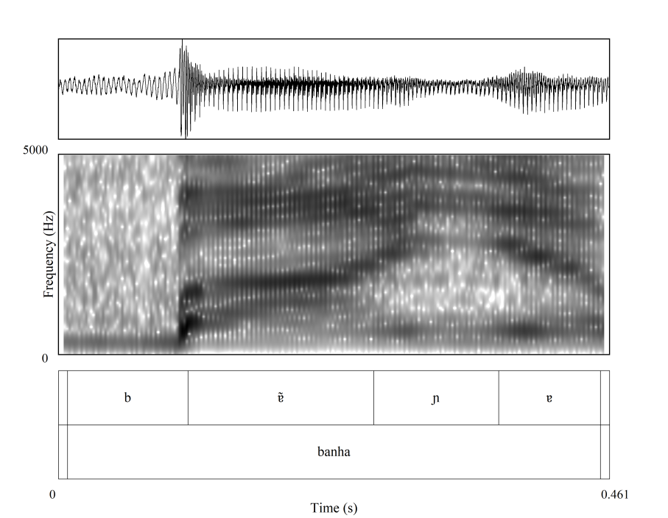

The results obtained by the acoustic study were reviewed according to phonological theories such as Autosegmental Phonology (Goldsmith, 1976, 1990; Moraes; Wetzels, 1992; Wetzels, 1997).

Analysis: nasality in PST and PP

In this section, we discuss nasality triggered by the palatal nasal in PST and PP. The process is described based on controlled speech. Such speech material allowed us to examine the phenomenon considering sound environment, domain, trigger, and the consequences of these linguistic factors on nasalization processes in the varieties spoken in STP.

Nasalized Vowels: /ɲ/ as a trigger
PST and PP have five nasalized vowels [ĩ, ẽ, ɐ̃, õ, ũ] identified in stressed and unstressed syllables, as in (1) and (2), respectively.

a. [ĩ] linda [ˈlĩdɐ] ‘pretty’
b. [ẽ] tempo [ˈtẽpʊ] ‘number’
c. [ɐ̃] canto [ˈkɐ̃tʊ] ‘lamp’
d. [õ] longe [ˈlõʒɪ] ‘pumpkin’
e. [ũ] junto [ˈʒũtʊ] ‘comma’

a. [ĩ] pintado [pĩˈtadʊ] ‘pintado’
b. [ẽ] tentar [tẽˈtaɾ] ‘to try’
c. [ɐ̃] anterior [ɐ̃teɾiˈoɾ] ‘before’
d. [õ] bondade [bõˈdadɪ] ‘goodness’
e. [ũ] untar [ũˈtaɾ] ‘to grease’

We have argued that nasality is not an inherent phonological property of the vowel in PST and PP, but instead nasality results from a coarticulatory phenomenon (see Balduino, 2018; Araujo; Balduino, 2019). Vowel nasality in both varieties is triggered by adjacency to a nasal consonant of Portuguese - /m/ and /n/ - that may be associated with a tautosyllabic coda (see example in 3) or with an onset of a different syllable (see example in 4).

- a. cantar /kaNtaR/ [kɐ̃.ˈtaɾ] ~ [kɐ̃n.ˈtaɾ] ‘to sing’
b. lanche /laNʃe/ [ˈlɐ̃.ʃɪ] ~ [ˈlɐ̃n.ʃɪ] ‘snack’

- a. cama /kama/ [ˈkɐ̃.mɐ] ~ [ˈka.mɐ] ‘bed’
b. tema /tema/ [ˈtẽ.mɐ] ~ [ˈte.mɐ] ‘theme’
c. banana /banana/ [ba.ˈna.nɐ], *[bɐ̃.ˈna.nɐ] ‘banana’
d. caneta /kaneta/ [ka.ˈne.tɐ], *[kɐ̃.ˈne.tɐ] ‘pen’
The tautosyllabic nasality in (1), (2) and (3) occurs regardless of word stress. However, heterosyllabic nasality is determined by stress, since the phenomenon cannot be produced if the target is in unstressed syllables, as in (4). Nasality is not purely an accidental process, but it is implemented under segmental or suprasegmental constraints in PST and PP.
Based on 372 occurrences of words with palatal nasal (186 for each variety), we observed that /ɲ/, in the same way as /m/ and /n/, triggers nasality in PST and PP. Initially, vowel nasality was established from hearing. Then, some acoustic cues were evaluated: (i) duration, since nasalized vowels, in general, are longer than oral vowels (see Araujo and Balduino, 2019), (ii) in cases where [ɲ] is not observed, it is possible to verify the presence of a nasal murmur similar to [n], and (iii) the F1 of an oral [a] tends to be lower than [ɐ̃]. Examples are given in (5).

- a. banho /baɲo/ [ˈbɐ̃ɲʊ] ~ [ˈbaɲʊ] ‘shower’
b. unha /uɲa/ [ˈũɲɐ] ~ [ˈuɲɐ] ‘nail’
c. ganhar /gaɲaR/ [gɐ̃ˈɲaɾ] ~ [gaˈɲaɾ] ‘to win’
d. dinheiro /diɲeRo/ [dĩˈɲeɾʊ] ~ [diˈɲeɾʊ] ‘money’
e. canhoto /kaɲoto/ [kɐ̃ˈɲotʊ] ~ [kaˈɲotʊ] ‘left-handed’

The nasality is triggered by /ɲ/ in stressed (see 5.a–b) and unstressed targets (see 5.c-e). It indicates that this phenomenon is more similar to tautosyllabic than to heterosyllabic nasality since unstressed syllables are the domain of the phenomenon. In addition, data in (4) allow us to conjecture the possibility of /ɲ/ being in coda in PST and PP. As heterosyllabic nasality is not implemented in unstressed syllables in both varieties, if the palatal nasal were associated only to the onset, words such as ganhar [gɐ̃ˈɲaɾ] ‘to win’ (5.c) and dinheiro [dĩˈɲeɾʊ] ‘money’ (5.d), produced with the nasalized unstressed vowels ([ɐ̃] and [ĩ]), would be ungrammatical. In case /ɲ/ is only in onset, the expected outcome of data in (5.c) and (5.d) would be unstressed oral vowels: ganhar [gaˈɲaɾ] ‘to win’ and dinheiro [diˈɲeɾʊ] ‘money,’ which are possible but not unique occurrences.
Figure 2, based on Wetzels’ (1997) analysis for BP, shows the ambisyllabic behavior of /ɲ/ using the tree notation for syllable structure. The vowel [ɐ̃] of words such as canhoto [kɐ̃.ˈɲo.tʊ] ‘left-handed’ is nasalized because of the ambisyllabicity [ɲ]. Thus, [ɲ] is associated to the onset and also to the coda, resulting in a first closed syllable [kɐ̃ɲ] (CVN) and in a second open syllable [ɲo] (NV).

Figure 2 - Tree representation of /ɲ/ in the word canhoto [kɐ̃.ˈɲo.tʊ] ‘left-handed.’
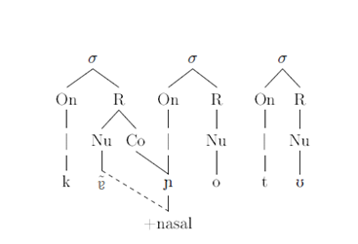
Author's elaboration based on the proposal of Wetzels (1997).

In PST and PP, nasality triggered by /ɲ/ is a result of a coarticulatory phenomenon, as has been suggested by studies on nasality triggered by /m/ and /n/ (see Balduino, 2018; Araujo; Balduino, 2019). For this reason, the feature [+nasal] or [-nasal] is not an inherent phonological property to the vowel in both varieties. As well as other nasal consonants in PST and PP, the process triggered by /ɲ/ is conditioned by the coarticulation between the vowel and the nasal consonant. This coarticulation normally happens because of the articulatory movement involved in the speech production of /ɲ/, since producing a nasal consonant requires velum lowering, palatal vellum port opening, and allowing airflow through the nose and the mouth (Styler, 2008, p. 9).
According to Styler (2008, p. 9), given that the tongue and the velum can move independently, it is more anatomically efficient to decouple the two gestures, beginning the velar gesture earlier and outside of the boundaries of the nasal consonant. This coarticulation is such that in CVN/CVɲ/CV.m/Cv.n structures the velum may be lowered before the vowel has been fully produced, nasalizing the previous vowel (Styler, 2008, p. 9). Even though velum lowering is common in PST and PP, it is not a compulsory movement and nasality is more recurrent according to the proximity between the nasal consonant and the target vowel. Thus, despite this optionality, nasality is more likely to occur in tautosyllabic structures. On the contrary, if the target vowel and the nasal trigger are in different syllables, stress determines nasalization.
Regardless of the point of articulation of the nasal consonant that triggers nasality, as well as whether the phenomenon is tautosyllabic or heterosyllabic, nasality is anticipatory in PST and PP. The nasal assimilation is regressive. No lexical items such as in (6) are identified. Additionally, the nasality triggered by the palatal nasal is not obligatory. This is a distinct behavior from BP, whose nasality is always attested if triggered by /ɲ/ (see Wetzels, 1997; Collischonn; Wetzels, 2017).

- a. banho /baɲo/ [ˈba.ɲʊ] ~ [ˈbɐ̃.ɲʊ̃] ‘shower’
b. unha /uɲa/ [ˈũɲɐ] ~ [ˈuɲɐ] ‘nail’
c. ganhar /gaɲaR/ [gɐ̃ˈɲaɾ] ~ [gaˈɲaɾ] ‘to win’

As already pointed out, distinctly from /m/ and /n/, the palatal nasal seems to show a distinct phonotactic behavior in both varieties: ambisyllabicity. This is not an inherent characteristic to these varieties, since /ɲ/ has been analyzed as a consonant associated simultaneously with a coda and an onset in Brazilian Portuguese (cf. Wetzels, 1997; Collischonn; Wetzels, 2017).
PST and PP are varieties whose syllable coda can be /l, R, N, S/ and present diverse phonetic productions (see Balduino, 2019; Vieira; Balduino, 2020). An evidence supporting the ambisyllabicity of /ɲ/ is that words carrying [ɲ] are only observed word-medially and do not occur in sequences comprising coda /l, R, N, S/ + /ɲ/ or /l/ (see 7).

- a. banho /baɲo/ *[ˈbaɫ.ɲʊ] ‘shower’
b. unha /uɲa/ *[ˈuɾ.ɲɐ] ‘nail’
c. ganhar /gaɲaR/ *[gɐs.ˈɲaɾ] ‘to win’

The absence of words such as *[ˈbaɫ.ɲʊ], *[ˈuɾ.ɲɐ] and *[gɐs.ˈɲaɾ] in (7) suggests that the coda is already filled by /ɲ/. Other nasal consonants, /m/ and /n/, do not suffer this same constraint. They are identified in words such as in (8), in which nasal consonants are in onset regardless of the previous coda being filled or not.

- a. palma /palma/ [ˈpaɫmɐ] ‘palm’
b. palmeira /palmeRa/ [paɫˈmeɾɐ] ‘Palm tree’
c. carne /kaRne/ [ˈkaɾnɪ] ‘meat’

Still regarding the ambisyllabicity of /ɲ/, we observed some outputs carrying [j] as a consequence of a phenomenon of vocalization. These examples suggest that the trigger consonant /ɲ/ can be produced as [j] after spreading its nasal feature (see 9).
- a. banho /baɲo/ [bɐ̃ˈjʊ] ‘shower’
b. unha /uɲa/ [ˈũjɐ] ‘nail’
c. vergonha /vergoɲa/ [veɾˈgõjɐ] ‘shame’

In (9), /ɲ/ may or may not be produced since the vocalization of /ɲ/ into [j] is also possible. Figure 3 shows this phenomenon by the spectrogram of [j].
Figure 3 - Wave Form and Spectrogram of [j] – galinha [gaˈlĩj̃ɐ] ‘chicken.’
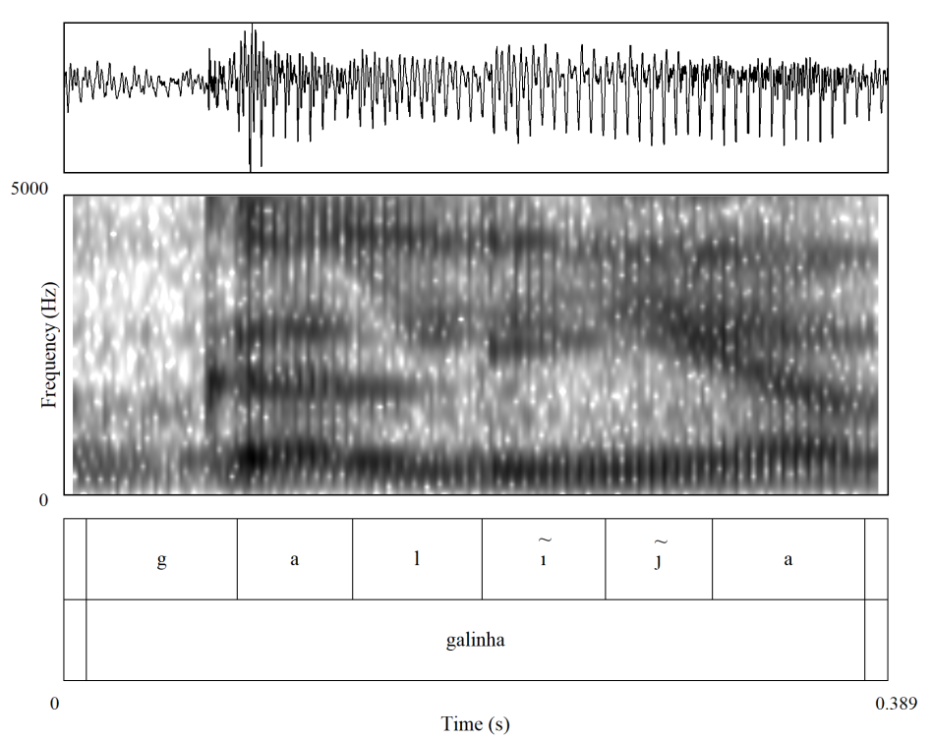
Figure 3 shows a spectrogram of galinha [gaˈlĩj̃ɐ] ‘chicken.’ Different from the spectrogram of [ɲ], there is not a long transition period into neighboring vowels and the consonant since [ɲ] is produced as [j]. Thus, the expected transition between F1 and F2 is replaced for the maintenance of these formants, since [i] and [j] have similar F1 and F2 values.

When a coronal glide [j] is performed, the syllable structure is preserved by maintaining the onset, and the target vowel of nasality remains nasalized. The palatal nasal regressively nasalizes to the preceded vowel and is subsequently vocalized, losing its consonantal features associated to the onset. Even when /ɲ/ is produced as [j], nasalization may be possible, as nasality spreading occurs before vocalization. Therefore, /ɲ/ can be vocalized in onset and even deleted of the coda after the assimilation of nasality by the target vowel, as in (9). If /ɲ/ were only in onset, the nasal deletion would be impossible. Words with /m/ and /n/ in onset preserve the nasal consonant and phonological processes such as deletion and vocalization are not identified: cama [ˈkɐ̃mɐ] ~ [ˈkamɐ], but *[ˈkɐ̃ɐ], *[ˈkɐ̃jɐ] ‘bed’.
Figure 3 shows an example in which a nasal palatal is vocalized, but we cannot notice a nasal murmur. Figure 4, however, shows an example where the vocalization of /ɲ/ is accompanied by the production of [n]. Occurrences as this, although less frequent, allow us to think about the hypothesis that /ɲ/ [nj] may be a possible result of weakening of /ɲ/ in PST. In PP, data as these were not observed.

Figure 4 - Wave Form and Spectrogram of [nj] – senhor [sẽˈnjo] ‘chicken’.
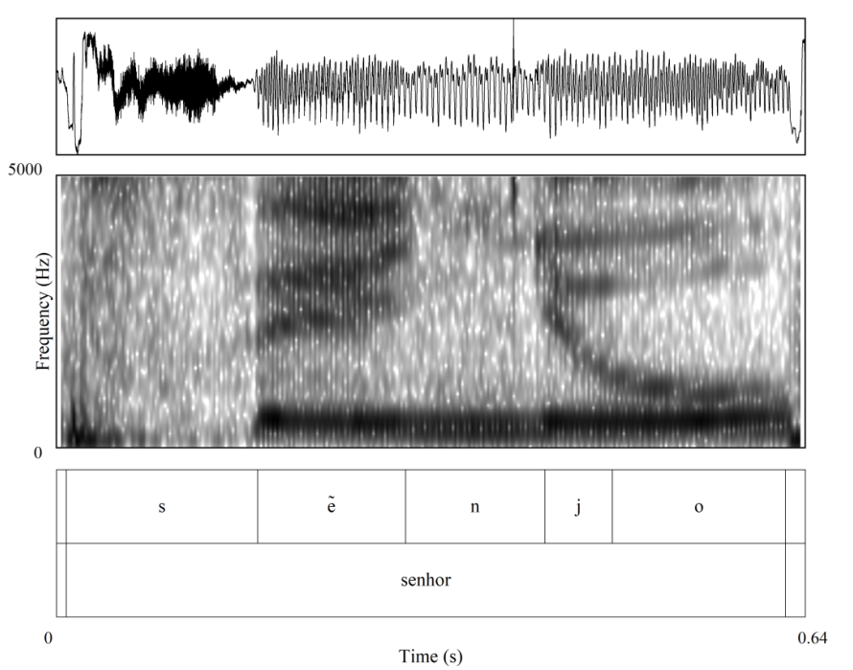
Based on the features of the palatal nasal, it is possible to understand /ɲ/ [j] as a consequence of the disassociation of the consonantal features (or c-place) of /ɲ/. The palatal nasal is usually understood as a complex segment, presenting in its structure a primary and secondary articulation (see Matzenauer, 1996), both associated with two temporal units (xx) (see Wetzels, 1997; Collischonn; Wetzels, 2017), as Figure 5 shows.
Figure 5 - The Geometrical Organization of /ɲ/.
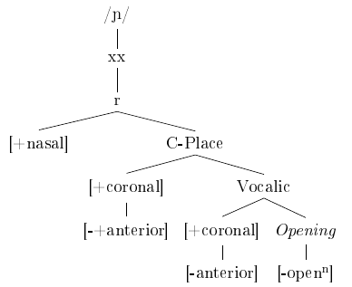
Author's elaboration based on the proposal of Collischonn; Wetzels (2017).
Due to the complex structure of /ɲ/, the geometrical organization of the palatal nasal features implies a simultaneous association with a primary consonantal node and a secondary vowel node (see Clements; Hume, 1995). It occurs in such a way as to favor the production of [j], as the features of vowels comprise the secondary node. During the vocalization of /ɲ/, the complex articulation that characterizes the palatal nasal is undone. Then, the palatal nasal has the c-place node disassociated and lose its consonantal features - except for the [nasal] feature, which can be associated with the vowel of the preceded nucleus. As a result, [j] is produced (see Figure 5). In case of [nj] output, c-place is disassociated from v-place, but it does not lose its consonantal features, resulting in [n]. The secondary articulation is thus divided into two: one consonantal, generating [n], and another vocalic, resulting in [j].

Figure 5- The Geometrical Organization of [j].
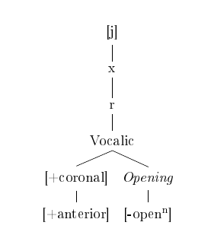

Author's elaboration based on the proposal of Collischonn; Wetzels (2017).

In this paper we observed that /ɲ/ behaves in some respects differently from /m,n/. Even though all nasal consonants in PST and PP trigger nasality, when triggered by /ɲ/ the phenomenon is similar to tautosyllabic nasality and is not conditioned by the stressed syllable as heterosyllabic nasality. Considering the multilingual context in which PST and PP are spoken, we noted that nasality in these varieties can be similar phonologically to the nasality in local languages. In Lung’Ie and Santome, for example, a regressive nasalization of the vowel preceded by [ɲ] is also possible (Bandeira 2017; Agostinho, 2015; Agostinho; Balduino; Araujo, 2020). According to Bandeira (2017) and Agostinho, Balduino and Araujo (2020), in cases of nasality the ambisyllabic consonant may or may not spread its nasal feature to the preceded vowel, as also occurs in PST and PP. The differences were, however, established mainly in relation to the phonetic aspects, as Table 4 shows.

Table 4 - Nasality triggered by /ɲ/ in Lung’Ie, Santome, Angolar, PST, and PP: similarities and differences.
Lung’Ie | Santome | Angolar | PST | PP
(Agostinho, 2015; Agostinho, Balduino and Araujo, 2020) | (Bandeira, 2017) | (Bandeira, 2017)
Stressed syllables as domain | Stressed syllables as domain | Stressed syllables as domain | Stressed and unstressed syllables as domain | Stressed and unstressed syllables as domain
Optional | Optional | Optional | Optional | Optional
Regressive and progressive spreading of [nasal] | Regressive spreading of [nasal] | Regressive spreading of [nasal] | Regressive spreading of [nasal] | Regressive spreading of [nasal]
[i, e, a, o, u] as targets | [i, e, a, o, u] as targets | [i, e, ɛ, a, ɔ, o, u] as targets | [i, e, a, o, u] as targets | [i, e, a, o, u] as targets
[ĩ, ẽ, ɐ̃, õ, ũ] as output | [ĩ, ẽ, ɐ̃, õ, ũ] as output | [ĩ, ẽ, ɛ̃, ɐ̃, ɔ̃, õ, ũ] as output | [ĩ, ẽ, ɐ̃, õ, ũ] as output | [ĩ, ẽ, ɐ̃, õ, ũ] as output
------ | ------ | ------ | /ɲ/ [j] | /ɲ/ [j]
 |  |  |  | /ɲ/ [nj]

As Table 4 shows, although in Lung'Ie the nasality triggered by /ɲ/ is regressive and progressive, in PST and PP we observe only regressive nasality. In addition, the process is optional in unstressed syllables, which is not feasible in local languages. Contrasting PST with PP, the only difference was the production of [nj] as a /ɲ/ allophone in PST. Thus, it is possible that aspects related to linguistic contact play a role in the way nasality is implemented in PST and PP. Although this factor is not part of the scope of this paper, it should be further considered in future studies on nasality in PST and PP.
To summarize, PST and PP have different processes of nasalization. Similar as EP and BP, the data of PST and PP show that the palatal nasal occupies an ambisyllabic structure and is simultaneously associated with onset and coda positions in a syllable. Thus, the palatal nasal can nasalize left contiguous vowels, whether or not in stressed syllables. It is possible because /ɲ/ is in the coda, resulting in a CVN syllable structure and triggering tautosyllabic nasality. Thus, even though it is optional, the nasality triggered by /ɲ/ occurs independently from the vowel quality and the word stress, as described for BP (Wetzels, 1997; Collischonn and Wetzels, 2017).

Final Remarks
Portuguese – in the way spoken in STP – has changed (Bouchard, 2017; Agostinho; Soares; Mendes, 2020). Thus, to assume Portuguese spoken in STP as the same language as that spoken in Portugal is inaccurate, since it presents some linguistic variations compared to the European Portuguese (EP), which is the variety officially propagated by local education institutions and educational materials in STP. PST and PP are new varieties of Portuguese. They share structures with other Portuguese varieties, such as EP and BP, but also have their own characteristics. This is the case of vowel nasality triggered by /ɲ/. The data indicate that /ɲ/ triggers nasalization and occupies two positions in different syllables: coda and onset. Such ambisyllabic behavior enables nasality promoted by /ɲ/ to occur in unstressed syllables, which is only possible for tautosyllabic nasality. Besides nasality, we observe that the vowel inventory of PST and PP comprises seven oral vowels: [i, e, ɛ, a, ɔ, o, u]. However, these vowels are common targets of neutralization and deletion processes in unstressed syllables. These phenomena mainly affect mid vowels, which are often deleted or modified by raising, vowel harmony, and devoicing. The results presented in this paper are still preliminary and a wide scope of analysis of these phenomena remains open for PST and PP.

References
AGOSTINHO, A. L; BALDUINO, A.M; ARAUJO, G. A de. Nasalization processes in Lung’Ie. Alfa, v.64. ISSN 1981-5794, 2020.
AGOSTINHO, A. L. Róticos em contexto intervocálico no Português da Ilha do Príncipe: fonologia e educação. In: IX ENCONTRO DA ABECS. Brasília, Universidade de Brasília, 28-30 de novembro, 2016.
______. Fonologia e Método Pedagógico do lung'Ie. São Paulo: USP, 2015. Tese (Doutorado em Filologia e Língua Portuguesa), Faculdade de Filosofia Letras e Ciências Humanas, Universidade de São Paulo, São Paulo, 2015.
ARAUJO, G. A. d; BALDUINO, A. M. Nasalização Vocálica no Português Urbano de São Tomé e Príncipe. Diacrítica, v. 33, n. 2, p. 41-68, 2019. DOI: :https://doi.org/10.21814/diacritica.256
BALDUINO, A.M. Processos Fonológicos no português de São Tomé e Príncipe: USP, Em elaboração. Tese (Doutorado em Filologia e Língua Portuguesa), Faculdade de Filosofia, Letras e Ciências Humanas, Universidade de São Paulo, São Paulo, To be published.
BALDUINO, A.M; VIEIRA, N. M. T. Distribuição da lateral /l/ em coda no português santomense. Estudos Linguísticos, v. 49, n. 2, p. 594-615, 2020. DOI: https://doi.org/10.21165/el.v49i2.2490. Acesso em 20 jul. 2020.
BALDUINO, A.M. Apagamento de /R/ e /S/ em coda no Português Principense. PAPIA, v. 29, n. 1, p. 25-39, 2019.
______. A nasalidade vocálica no português falado em São Tomé e Príncipe: USP, 2018. Dissertação (Mestrado em Filologia e Língua Portuguesa), Faculdade de Filosofia, Letras e Ciências Humanas, Universidade de São Paulo, São Paulo, 2018.
BALDUINO, A.M; BANDEIRA, M.; FREITAS, S. Os processos de elisão e degeminação no português de São Tomé e Príncipe. Filologia e Linguística Portuguesa, v. 19, n. 1, p. 163-197, 1 dez. 2017.
BANDEIRA, M. Recontrução fonológica e lexical do protocrioulo do Golfo da Guiné. São Paulo: USP, 2017. Tese (Doutorado em Filologia e Língua Portuguesa), Faculdade de Filosofia, Letras e Ciências Humanas, Universidade de São Paulo, São Paulo, 2017.
BOUCHARD, M. Linguistic Variation and change in the Portuguese of São Tomé. New York: UNY. Thesis (Doctor in Philosophy) of the Department of Linguistics, New York University, 2017.
BRAGA, G. Prosódia do português de São Tomé: o contorno entoacional das sentenças declarativas neutras. São Paulo: USP, 2018. Dissertação (Mestrado em Filologia e Língua Portuguesa), Faculdade de Filosofia, Letras e Ciências Humanas, Universidade de São Paulo, São Paulo, 2018.
BRANDÃO, S.F.; PESSANHA, D. B.; PONTES, S. de P.; CORREA, M. O. Róticos na variedade urbana do Português de São Tomé. Papia Revista Brasileira de Estudos do Contato Linguístico, v. 27, p. 293-315, 2017.
CÂMARA Jr, J. M. Problemas de linguística descritiva. Rio de Janeiro: Editora Vozes, 1971.
______. Estrutura da Língua Portuguesa. Rio de Janeiro: Editora Vozes, 1970.
______. Para o Estudo da Fonêmica Portuguesa. Rio de Janeiro: Editora Vozes, 1953.
CLEMENTS, Nick; HUME, Elizabeth. The internal organization of speech sounds. In: GOLDSMITH, Jonh. (Ed.). The handbook of phonological theory. Cambridge: Cambridge/ Massachusetts Blackwell, 1995.
CHRISTOFOLETTI, A. Ditongos no português de São Tomé e Príncipe. São Paulo: USP, 2013. Dissertação (Mestrado em Letras), Faculdade de Filosofia, Letras e Ciências Humanas, Universidade de São Paulo, São Paulo, 2013.
CHRISTOFOLETTI, A.; ARAUJO, G. Vogais e Ditongos no Português Vernacular de São Tomé e Príncipe. In.: OLIVEIRA, M. S. D.; ARAUJO, G. A. (orgs.). O Português na África Atlântica. São Paulo: Humanitas/ Fapesp, 2018, p. 258-296.
COLLISCHONN; G. WETZELS, L. Syllable Structure. In.: WETZELS, L.; COSTA, J.; MENUZZI, S. (eds.). The Handbook of Portuguese Linguistics. Oxford: Wiley Blackwell, 2017, p. 86-106.
FERRAZ, L. I. The creole of São Thome. Johannesburg: Witwatersrand University Press, 1979.
FIGUEIREDO, C. A concordância plural variável no sintagma nominal do português reestruturado da comunidade de Almoxarife, São Tomé. Macau: UM, 2010. Tese (Doutorado em Linguística), Faculdade de Ciências Sociais e Humanas, Universidade de Macau, Macau, 2010.
FREITAS, S.; BANDEIRA, M. Aspectos fonológicos dos crioulos de base lexical portuguesa da Alta Guiné. Revista Estudos Linguísticos, Belo Horizonte, Ahead of Print. Disponível em: http://www.periodicos.letras.ufmg.br/index.php/relin/article/view/16910/0. 2020.
GOLDSMITH, J. A. Autossegmental Phonology. Massachusetts: MIT Working Papers in Linguistics, 1976.
______. Syllable Structure. In.: GOLDSMITH, J. Autosegmental and metrical phonology. Nova Jersey: Wiley-Blackwell Publishing, 1990, p.103-140.
GOMES, D. K. Vogais no contexto postônico medial no Português de São Tomé. In.: BRANDÃO, S. F. (org.). Duas variedades africanas do Português: variáveis fonético-fonológicas e morfossintáticas. São Paulo: Blucher, 2018, p. 159-176.
GOMES, D. K.; ALVES, S. S.; FERNANDES, T. C. R. O apagamento da vogal postônica medial na norma urbana de São Tomé: uma análise sociolinguistica sobre a redução de proparoxítonos. Prolíngua (JOÃO PESSOA), v. 14, p. 109-119, 2019.
GONÇALVES, R. Propriedade de Subcategorização verbal no português de S. Tomé. Lisboa: UL, 2010. Dissertação (Mestrado em Linguística), Faculdade de Letras, Universidade de Lisboa, Lisboa, 2010.
______ Construções ditransitivas no português de São Tomé. Lisboa: UL, 2016. Tese (Doutorado em Linguística), Faculdade de Letras, Universidade de Lisboa, Lisboa, 2016.
GONÇALVES, R.; HAGEMEIJER, T. O português num contexto multilingue: o caso de São Tomé e Príncipe. Revista Científica da Universidade Eduardo Mondlane: Série Letras e Ciências Sociais, v. 1, n. 1, p. 87-107, 2015.
HAGEMEIJER, T. Initial vowel agglutination in the Gulf of Guinea creoles. In.: ABOH, E.; SMITH, N. (eds.). Complex processes in new languages. Amsterdam/Filadélﬁa: John Benjamins Publishing Company, 2009, p. 29-50.
______. The Gulf of Guinea creoles: genetic and typological relations. Journal of Pidgin and Creole Languages, v. 26, n. 1, p. 111-154, 2011.
______. From creoles to Portuguese: Language shift in São Tomé and Príncipe. In.: LÓPEZ, L.; GONÇALVES, P.; AVELAR, J. (eds.). The Portuguese language continuum in Africa and Brazil. Amsterdam/Philadelphia: John Benjamins, 2018, p. 169-184.
INSTITUTO NACIONAL DE ESTATÍSTICA (INE). 2011. São Tomé e Príncipe em Números. São Tomé: 2001. Disponível em: http://http://www.ine.st/2012.html
MATEUS, M. H.; D’ANDRADE, E. The Phonology of Portuguese. Oxford: Oxford linguistics, 2000.
MATZENAUER, C. L. H.. Introdução à Teoria Fonológica. In.: BISOL, L. (org.). Introdução a estudos de fonologia do português brasileiro. Porto Alegre: EDIPUCRS, 1996, p. 47-62.
MAURER, P. Principense Grammar texts, and vocabulary of the afro-portuguese creole of the island of Príncipe, Gulf of Guinea. London: Battlebridge Publications, 2009.
MENESES, F. Uma visão Dinâmica dos Processos de Apagamento de Vogais no Português Brasileiro. Campinas: UNICAMP, 2017. Tese (Doutorado em Linguística), Instituto de Estudos da Linguagem, Universidade Estadual de Campinas, Campinas, 2017.
NASCIMENTO, F. M. V. Vogais em contexto postônico medial no português de São Tomé. In.: BRANDÃO, S. F. (org.). Duas variedades africanas do Português: variáveis fonético-fonológicas e morfossintáticas. São Paulo: Blucher, 2018, p. 119-158.
______. O sistema vocálico do português de São Tomé e o comportamento das vogais médias em contexto pretônico. Rio de Janeiro: UFRJ, 2018. Tese (Doutorado em Letras Vernáculas), Faculdade de Letras, Universidade Federal do Rio de Janeiro, Rio de Janeiro, 2018
MORAES, J.; L. Wetzels. Sobre a duração dos segmentos vocálicos nasais e nasalizados em português: um exercício de fonologia experimental. Cadernos de Estudos Linguísticos, v. 23, p. 153-166, 1992.
PASSOS, R. O ditongo /ei/ na fala de São Tomé. In.: BRANDÃO, S. F. (org.). Duas variedades africanas do Português: variáveis fonético-fonológicas e morfossintáticas. São Paulo: Blucher, 2018, p. 177-200, 2018.
QUINT, N. Grammaire de la Langue Cap-Verdienne. Paris: L’Harmattan, 2000a.
SANTIAGO, A. M.; BALDUINO, A. M.; AGOSTINHO, A. L.; SOARES, E. C. As Vogais no Português do Príncipe. In: HAGEMEIJER, Tjerk; Oliveira; SANTOS, Márcia; FIGUEIREDO, Carlos (Orgs.). O Português na África Atlântica. v. 2. To be published.
SANTIAGO, A. M.. As vogais do português do Príncipe. Trabalho de conclusão de curso defendido na Universidade Federal de Santa Catarina, 2019.
SANTIAGO; A; AGOSTINHO, A. L. Situação linguística do português em São Tomé e Príncipe. Revista Digital dos Programas de Pós-Graduação em Letras do Departamento de Letras e Artes da UEFS Feira de Santana, v. 21, n. 1, p. 39-61, janeiro-abril de 2020. DOI: http://dx.doi.org/10.13102/cl.v21i1.4970.
STYLER, W. 2008. On the acoustical and perceptual features of vowel nasality. Colorado: UC, 2008. Thesis (Doctor in Philosophy) of the Department of Linguistics, University of Colorado, Colorado, 2008.
VIEIRA, N.; BALDUINO, A. M. Apagamento de /R, S, l/ na coda no português de São Tomé: convergência linguística? PAPIA, v. 30, n. 1, p. 7-33, 2020.
VIEIRA, M. G. Estudo acústico e aerodinâmico das consoantes nasais do português brasileiro: variedade de Florianópolis. 2017. Tese (Doutorado em Linguística), Universidade Federal de Santa Catarina, Florianópolis, 2017.
WETZELS, W. L. The lexical representation of nasality in Brazilian Portuguese. Probus, v. 9, p. 01-4, 1997.
ZAMPAULO, A. Palatal Sound Change in the Romance Languages - Synchronic and Diachronic Perspectives. Oxford: Oxford Studies in Diachronic and Historical Linguistics, 2019.

Doutoranda do Departamento de Letras Clássicas e Vernáculas da Universidade de São Paulo.
FAPESP (2017/26595-1).
According to Bandeira (2017), Santome, Lung’Ie and Angolar emerged form The Proto-Creole of Gulf of Guinea (PGG), a protolanguage developed in STP during the first phase of its colonization, a period during which socio-historical, geographical, and demographic conditions were positive to creolization (Bandeira, 2017, p. 118). The consolidation of different groups of PGG speakers led to the emergence of three distinct daughter languages in STP. Lung’Ie is a language used on the Príncipe Island. The fugitive slaves, in turn, formed a maroon community, distancing themselves from the capital and building their own community where the Angolar language emerged. Santome or Forro, spoken in the capital, is the third daughter language of PGG in STP (see Bandeira, 2017). Finally, Fa d’Ambô is the forth daughter language of PGG. It is spoken on the Ano Bom Island, an islet of the Republic of Equatorial Guinea (RGE).
PVS – used by the author as Vernacular Portuguese of São Tomé.
“Ademais, foi constatada a singularidade do sistema fonético-fonológico dessa variedade africana de português, pois, diferente da norma europeia, considerada de prestígio no país, o pvs realiza a monotongação dos ditongos (...)”(Christofoletti, 2013: VIII).
This proposal is based on the variety of Kabuverdianu spoken in Santiago. We have no knowledge of works dedicated to the variety spoken in STP. Therefore, there may be differences underlying the Santiago variety and the varieties of Kabuverdianu spoken in STP. For comparative purposes, we will only observe nasality in Santome, Lung’Ie and Angolar.
Words recorded: Amanhecer - ‘to dawn;’ Apanhar – ‘to catch;’ Banho – ‘shower;’ Banheira – ‘bathtube;’ Banha – ‘lard;’ Caminho – ‘path;’ Conhecimento ‘knowledge;’ Cozinhar – ‘to cook;’ Cunhado – ‘brother in-law;’ Desenho – ‘drawing;’ Desenhar – ‘to draw;’ Dinheiro – ‘money;’ Engenharia – ‘engineering;’ Focinho – ‘snout;’ Galinha – ‘chicken;’ Galinheiro – ‘hennery;’ Ganhar – ‘to win;’ Manha – ‘wile;’ Manhoso – ‘sly (Masc.);’ Manhosa – ‘sly (Fem.);’ Minha – ‘mine/my;’ Minhoca – ‘earthworm;’ Punho – ‘fist;’ Reconhecer – ‘to recognize;’ Senhora – ‘lady/Mrs.;’ Sonho – ‘dream;’ Sonhar – ‘to dream;’ Tenho – ‘I have;’ Tinha – ‘I had;’ Unha – ‘nail;’ Vergonha – ‘shame;’ Vinho – ‘wine.’
This complementary corpus was collected from 60-minute sociolinguistic interviews in which the first 15 minutes were discarded.
All the Figures of spectrograms were created with a praat script: Praat_script_for_drawing_a_waveform_spec. https://www.academia.edu/15862176/Praat_script_for_drawing_a_waveform_spectrogram_and_F0_contours_textfile_
Typical fish of São Tomé and Príncipe cuisine.
Praat_script_for_drawing_a_waveform_spec.https://www.academia.edu/15862176/Praat_script_for_drawing_a_waveform_spectrogram_and_F0_contours_textfile
Praat_script_for_drawing_a_waveform_spec.https://www.academia.edu/15862176/Praat_script_for_drawing_a_waveform_spectrogram_and_F0_contours_textfile

