Variations in Homicide Rates in Brazil:
An Explanation Centred on Criminal Group Conflicts

Gabriel Feltran¹

¹Universidade Federal de São Carlos e Centro Brasileiro de Análise e Planejamento, São Carlos, SP, Brasil

Cecília Lero²

²Centro Brasileiro de Análise e Planejamento, São Paulo, SP, Brasil

Marcelli Cipriani³

³Universidade Federal do Rio Grande do Sul, Porto Alegre, RS, Brasil

Janaina Maldonado⁴ ⁵

⁴German Institute for Global and Area Studies, Hamburgo, Alemanha

⁵Universität Hamburg, Hamburgo, Alemanha

Fernando de Jesus Rodrigues⁶

⁶Universidade Federal de Alagoas, Maceió, AL, Brasil

Luiz Eduardo Lopes Silva⁷

⁷Universidade Federal do Maranhão, Pinheiro, MA, Brasil

Nido Farias⁸

⁸Universidade Federal de Pernambuco, Recife, PE, Brasil

Variações nas taxas de homicídios no Brasil: Uma explicação centrada nos conflitos faccionais propõe uma explicação para as variações das taxas de homicídios no Brasil nas duas últimas décadas. A partir da comparação de experiências etnográficas vividas no universo faccional de quatro capitais (São Paulo, Porto Alegre, São Luís e Maceió), propomos duas estratégias analíticas: 1) a desagregação de séries quantitativas de taxas de homicídios por perfis de vítimas e 2) a construção de sinopses históricas dos conflitos faccionais locais. Demonstramos como as taxas de homicídio, em perfis sociodemográficos específicos, oscilam a partir das mudanças nos conflitos faccionais locais e puxam as variações das taxas agregadas. | The paper proposes an explanation for the variations in homicide rates in Brazil in the past two decades. Based on the comparison of ethnographic experiences lived in the criminal universe of four capital cities: São Paulo, Porto Alegre, São Luís and Maceió, we propose two analytical strategies: 1) the breakdown of quantitative homicide rate data by victim profile, and 2) the construction of historical synopses of conflicts between factions at the local level. We demonstrate how homicide rates, in specific socio-demographic profiles, oscillate based on changes in conflicts between factions at the local level conflicts, and influence variations in the aggregate rates.
Palavras-chave: homicídio, conflitos faccionais, violência, séries quantitativas, etnografia | Keywords: homicide, criminal conflicts, violence, quantitative series, ethnography

Introduction

T
he definition of homicide is a matter of controversy in the international literature (LIEM and PRIDEMORE, 2012). Besides the problems inherent to the linguistic and cultural translation of the concepts, different legal translations generate further disagreement on topics such as involuntary manslaughter, disappearance and bodily injury followed by death, or even indigenous infanticide, euthanasia and abortion. Anthropology and the philosophy of law have also shown that killings committed in sacrifices or the victimising of enemies is not always understood as homicide (AGAMBEN, 2002; CLASTRES, 1987); and that in most cultures homicide refers to the intentional killing of participants of the same political community (ARENDT, 2012). In this article, we lay these controversies provisionally aside and define homicide sociologically as a social action, in the Weberian sense, in which lethal violence is intentionally perpetrated. Therefore, the emphasis is on the meaning and pragmatics of the social action.
The Brazilian Public Security Forum (FBSP) and the Institute for Applied Economic Research (IPEA) have been consistently compiling data released by the 27 state Public Security Offices. Whether based on these databases, or those produced by DataSUS, it is clear that homicides are not evenly spread events in Brazil. On the contrary, they are extremely concentrated in terms of time, space and specific social, age and racial groups: in the last three decades a significant increase has been witnessed in the rates, especially in the poor urban outskirts, victimising especially men, who are young, and black or brown, according to the official classification of colour/race. Moreover, since the 1990s, homicides have progressively increased as a result of the participation of armed youth groups (ZILLI and VARGAS, 2013), and numerous qualitative studies have shown that homicide victims in Brazil are mostly low-level agents in the illegal markets for drugs, weapons, stolen vehicles and contraband (ZALUAR 1984; MACHADO DA SILVA, 1993; MISSE, 2006; HIRATA, 2018; RATTON and DAUDELIN, 2018; FELTRAN, 2022).
More recently, studies that link qualitative and quantitative methodologies show that working in illegal markets, in the year prior to the survey, increases the chance of being a homicide victim 19-fold (CORDEIRO, 2022, in press); a more telling factor than any other predictor related to the victim’s social profile. Variations in rates across time and space, therefore, do not entail variations in the prime victim profile, which remains stable because it responds to structural factors. Thus, homicides are far from being scattered, random or out-of-control events in Brazil. They are strictly managed by different armed groups and present marked sociological regularities, especially as regards the victim profile. However, often, and as we show below, cities and states have recorded rising rates, including moments of acute growth, while other localities have reported opposite trends in the same year.

Graph 1: Homicide rates per 100,000 inhabitants: São Luís, Porto Alegre, Maceió, São Paulo, between 2000 and 2019
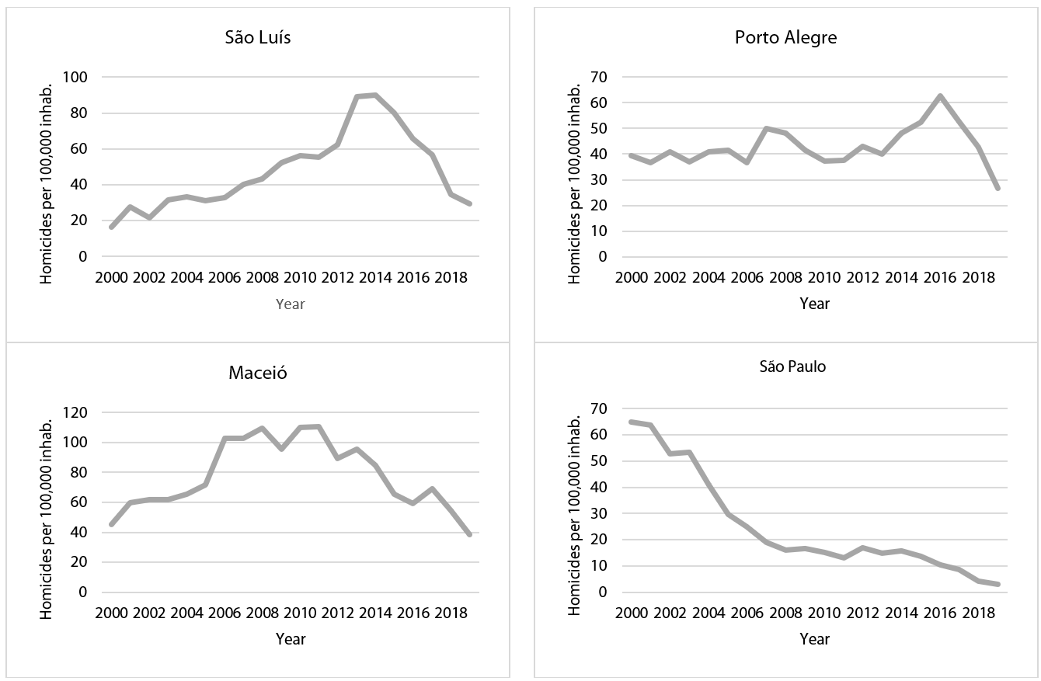
Source: Developed by the authors, using the Datasus homicide database, CID10 x85-y09 and Y35-36 groups, and population data of the Brazilian Institute of Geography and Statistics (IBGE), table 2093.

How can we explain the variations in the aggregate homicide rates in these four states and across Brazil, when they reflect a phenomenon that displays a markedly consistent victim profile? We answer this question based on the construction of an analytical framework consisting of: 1) a set of theoretical assumptions; 2) proposing quali-quantitative research methods; and 3) a specific categorisation of homicide cases, detailed in our final considerations. Through this framework, we turn in particular to the causal understanding of the strong variation in homicide rates in Brazil over the last two decades. We are not interested, therefore, in explaining the (stable or dynamic, higher or lower) levels of existing rates in each location. These levels respond to the patterns of local conflict in each region, including structural dimensions of social and urban conflict. Our focus in this text is on explaining the cyclical variations in these rates.
Our framework of analysis has been inductively and collectively constructed from the systematic comparison of ethnographic experiences of the authors in the universe of criminal groups of four state capital cities: Porto Alegre, São Luís, Maceió, and São Paulo. In this framework, we propose two relatively simple procedures: 1) the qualitative and synoptic reconstitution of the always unique history of conflicts between factions at the local level, and 2) the breakdown of quantitative historical series of homicides, in the particular space and according to the different socio-demographic profiles of the victims. We then articulate the two chronologies by examining whether there is any overlap between the dynamics of local criminal violence and the marked conjunctures of rising or falling aggregate homicide rates. In the cases studied, we find this this overlap to be evident.

Literature review

The debate regarding homicides in Brazil has brought important new considerations to the literature. It has already been found that in practically all contexts where there has been a significant rise in homicide rates (such as Rio de Janeiro in the 1980s, São Paulo in the 1990s and the states of the Northeast in the last decade) there were highly profitable illegal markets being established and disputed by armed groups (MANSO and GODOY, 2014; RATTON and DAUDELIN, 2018; MANSO and DIAS, 2018; FELTRAN, 2018, 2019; KAHN, 2021; RODRIGUES, 2019a, 2020a). Recent quali-quantitative studies into homicide and urban territories show that homicides are not concentrated in the most precarious areas of cities, but rather on the borders between marginalised neighbourhoods and affluent areas (CORDEIRO, 2022, in press; FELTRAN, 2022), as well as in rural territories with historical conflicts or in expanding extractive economic zones (RODRIGUES, 2017; RODRIGUES et al., 2022). Much lower rates are found in less vulnerable regions (TAVARES et al., 2016), even when these regions have the same illegal markets in operation, as well as in the case of drug trafficking among middle-class and elite groups (GRILLO, 2008).
Different inclinations in the Brazilian literature have referred, more or less directly, to the theme of homicides. Environmental, institutional and population characteristics capable of inducing or preventing crime and lethal violence have been related to structural problems, such as inequality, poverty and stigmatisation (BEATO et al., 2004; RATTON et al., 2011; ADORNO, 1993b; RIBEIRO and CANO, 2016; SOARES, 2009; MELLO and SCHNEIDER, 2011). In explaining the homicidal phenomenon, others have emphasised the economic and political rationales intrinsically tied into illegal markets and protection rackets (MISSE, 2006, 2017; DAUDELIN and RATTON 2017; DURÁN-MARTINEZ, 2015; OSORIO and NORMAN 2016; RODRIGUES 2019; FELTRAN, 2021). Approaches with a more institutional focus have tended to demonstrate that police strategies designed to demonstrate force end up exacerbating lethal violence (COSTA et al., 2014; CANO and DUARTE, 2010; MARINHO et al., 2016; SILVEIRA et al., 2010), as well as studying the ways in which legal truth is constructed, and how fluctuations in the justice system and the role of security forces affect homicidal dynamics (PLATERO and VARGAS, 2017). Finally, there is an approach to social conflict focused on the relations between criminal groups and state forces, bringing in power, politics and even the question of sovereignty to understand the issue of homicides (see, for example, MISSE, 2006; FELTRAN, 2011; ARIAS, 2018; BARNES, 2017; RODRIGUES, 2021).
Qualitative—and especially ethnographic—research has allowed for the understanding of homicidal mechanisms in contemporary criminal dynamics, but has neither concentrated on understanding trends in the quantitative homicide curves in the country, nor broken them down according to the analytical findings. Despite the lack of dialogue with the area of public security, these studies have proposed that, contrary to what is claimed in the press and in part of the literature, a strict repertoire of urban practices governs lethal violence in Brazil through a partition among different armed actors: criminal factions, groups linked to the police acting illegally and law enforcement (HIRATA and GRILLO, 2019a, 2019b; FELTRAN, 2020; JARA, 2021; CARVALHO, 2021; RODRIGUES, 2021a). However, there remain few comparative studies between cities and regions of the country (SAPORI, 2020) and even less frequent are those that link quali-quantitative methodologies in the theme of homicides (PLATERO and VARGAS, 2017; CORDEIRO, 2018; FELTRAN, 2021).
In response to these gaps, we argue that the dynamics of conflict among factions—conditioned by wars and pacifications between national and regional factions, and between them and gangs and the police—is by far the main cause of the remarkable variation in aggregate homicide rates in Brazil over the last two decades. Such variation is qualitatively described and quantitatively demonstrated from the upward and downward curves of homicide rates of young black men. We also suggest that the other hypotheses put forward by the specialized literature to explain the variation in homicide rates (changes of federal or state government or in public security policies, demographic transitions, income transfer policies, or even transformations in the situation of economic inequalities, besides other structural causes) may produce some widespread effect on these rates, but would not hold up as an explanation for the specific, and irregular, variations that we find in the aggregate state and national homicide rates.

The dynamics of criminal factions

In the last two decades, the Primeiro Comando da Capital (First Capital Command – PCC) and the Comando Vermelho (Red Command – CV), factions born in the prisons in the Southeast, have spread nationwide and taken on a central role in regulating illegal markets throughout Brazil. Even where there are no “baptised” members of these groups in the everyday retail trade, their presence in the regulation of wholesale drug markets has contributed to redefining relations between local armed groups and the security forces, as well as producing rivalries and regulating conflicts in numerous poverty-stricken neighbourhoods of Brazilian cities. Various criminal traditions have been reconfigured at the local level through the unprecedented extension of criminal networks related to the PCC and CV in Brazil, and there are still few systematic answers to the question about the effects of this expansion on variations in homicide rates in the country.
When authors with quantitative experience have presented factions as an explanatory hypothesis (PERES et al., 2011; BIDERMAN et al., 2014), the works have lacked knowledge about the history of local dynamics among criminal factions. When the histories of these factions and their consequences for state and municipal homicide rates have been presented in detail (FELTRAN, 2011a, 2011b; CIPRIANI, 2021b; RODRIGUES, 2021b), the work has lacked both a systematic comparison that would allow inferences to be extended to the national level, and a breakdown of the quantitative rates according to different victim profiles. Such a breakdown would demonstrate that it is the acute variations in the victimization of young black men that drive the variations in aggregate rates.

Conceptual and methodological clarifications

The specialised literature on homicide has made little differentiation between the very distinct criminal formations operating in the country today. Categories such as ‘faction’ or ‘organised crime’ have been used generically to designate groups as empirically diverse as local gangs and illicit cartels or national criminal networks such as the CV and PCC. To contribute to this literature, we have constructed synopses of the armed conflict in São Paulo, Porto Alegre, São Luís and Maceió, referring to the small, local groups as gangs, similar to those that the international literature addresses using the same term (RODGERS, 2020). We have reserved the notion of regional faction for criminal groups that, while regulating gang activity in several neighbouring municipalities and even states, do not have a national presence. For the purposes of this text, the CV and PCC are considered national factions that influence, regulate or control the actions of all local criminal groups. We avoid confusing the dynamics of the factions with those of the Rio de Janeiro militias, which in our opinion, although they have a direct impact on homicide rates in the city, constitute a type of armed group very distinct from gangs and factions.
Regarding the methodological operation, we propose a quali-quantitative approach. Firstly, we qualitatively reconstruct synopses of conflict among factions in each of the cities studied, based on the authors’ previous experiences in these cities. In-depth interviews and observation of routine activities were conducted in the respective empirical settings, followed by field diary entries, and searches for formal and informal documentation. Our main interlocutors were people directly involved in conflict among factions: residents in the poor urban outskirts. Some police officers, interviewed for previous studies, also helped shed light on the phenomenon. These are subjects with whom we obtained contacts via intermediaries in order to gain the trust required for the field exchanges. The settings seem better constructed when we take seriously what our interlocutors say about their experiences, which does not mean “buying into their line of reasoning”, but rather taking it as an epistemologically valid perspective. The literature still lacks the development of an obvious qualitative path, which can be narrated by those who have lived through conflict, and which narrative will be put into perspective in the analysis.
The qualitative synopses of the four municipalities analysed were reconstructed as follows: 1) revisiting field material; 2) re-engaging with research subjects in the event of any doubts; 3) reconstructing the timeline of the conflicts among factions at the local level; and 4) seeking mechanisms through which, within that timeline, conflicts intensified or became locally pacified. In each of the cases it became evident that our characters were intertwined, first and foremost, with lethal conflicts contextually linked to illegal markets in poor urban neighbourhoods. In other words, we were working with the main victims of homicide in Brazil: low-level agents in the criminalised markets.
From the quantitative point of view, it was then necessary to break down the historical series of homicide rates in the particular space—homicide dynamics vary greatly from territory to territory—and in relation to the primary victim profiles which, following our qualitative finding, reflect the primary profiles of low-level workers in illegal markets. We know from quantitative studies that the vast majority of homicide victims in Brazil are young, poor and male. We know from qualitative studies that participating in the dynamics of criminal factions represents a very strong risk factor predicting homicide, even stronger than gender, age and colour/race. Initially, we thought that one variable that may work as a proxy to hone in on the profile of these precarious and criminalised workers would be the level of schooling, as different studies have already shown that young offenders have a substantial lack of schooling (BITTAR, 2012). Unfortunately, however, data on the education of homicide victims was ignored in almost 32% of the homicides recorded in DataSUS for the four cities between 2000 and 2019, while the variable “race” was only ignored in 3.4% of the recorded homicides. Several tests were performed before we chose to define the ways of braking down the data based on four profiles: “young, black men”, “young non-black men”, “total population without young black men” and “total population”.
This article is divided, from this introduction onwards, into two more parts. In the first, we demonstrate our argument empirically by systematically correlating variations in homicide rates in the municipalities under analysis with synopses of the conflicts among factions at the local level, in the following way: 1) comparing periods of notable increases in these rates in each of the cities and 2) comparing periods of notable reductions in these rates in each of the cities. There is a clear correspondence between periods of open conflict between armed groups and large increases in homicide rates among young men, especially those who are also black. Similarly, the qualitatively verified pacifications of dynamics among factions at the local level have led to marked falls in homicide rates amongst these young men, affecting the aggregate rates and corroborating our explanatory hypothesis. In short, analysed qualitatively, the variation in homicide rates among young black men is explained at a local level by the dynamics of conflict among factions; and quantitatively, we demonstrate how these specific rates clearly follow the example of the aggregate rates, thus explaining the latter's variations.
This demonstration is followed by the conclusions, in which we present the three dimensions of our explanatory framework: methodological, analytical and theoretical. We suggest that this framework, induced beginning with ethnographic research and arriving at multi-methodological formulations, may be useful for understanding the intense variations in homicide rates in Brazil in recent decades. Our interpretative framework for understanding the developments in São Luís, Maceió, Porto Alegre and São Paulo would allow tests in any other national context, aiding understanding of the variations in aggregate state and national rates. As relational, complex and multi-causal phenomena, homicides should be studied based on a theoretical protocol that conceives of them as social actions and by a set of methods that include the qualitative search for local causal mechanisms, associated with systematic studies of the aggregate effects of the phenomenon on specific sectors of the population, described based on quantitative data broken down in terms of location and victim profile.

Variations in homicide rates and the dynamics of conflict among factions

Below we will analyse the ranges of important variations—rises and falls—in the homicide rates for Porto Alegre, São Luís, Maceió and São Paulo. The graphs presented on the following pages are accompanied by qualitative synopses outlining the trajectories of armed conflict in the dynamics among factions of the respective state capitals between 2000 and 2019. Graph 2 illustrates the historical series of these homicides broken down according to victim profile. Clearly, in the four capitals, the extremely high rates among young black men stand out; these rates also vary more rapidly than those of other profiles.

Graph 2: Homicide rates by victim profile: Porto Alegre, São Luís, Maceió, São Paulo, between 2000 and 2019
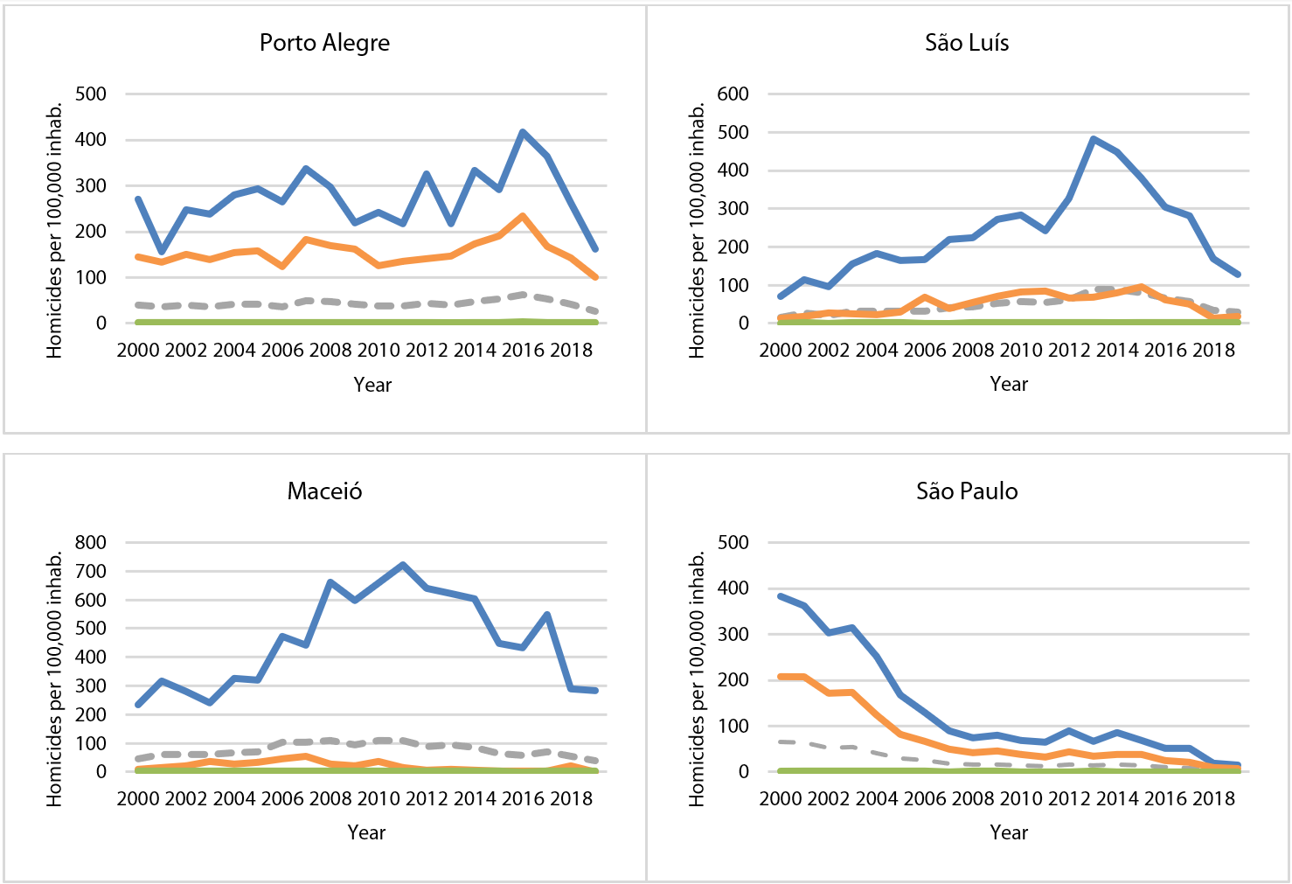
Source: Developed by the authors, using the Datasus homicide database, CID10 x85-y09 and Y35-36 groups and population data of the IBGE, table 2093.

It is clear that homicide rates, both aggregate and broken down by victim profile, are characterized by heterogeneous curves and levels in the four municipalities studied. In Porto Alegre, the aggregate homicide rates remained relatively stable in the 2000s, approaching 40 cases per 100,000 inhabitants—39.2 in 2000 and 41.6 in 2009, with a level between 200 and 350/100,000 among young, black men. In São Luís, the aggregate rates tripled: they grew from 16 to over 52/100,000 inhabitants in 2009, the highest in the decade. Timid downward oscillations alternated with significant increases which eventually prevailed, driven by the rise in the homicide rates of young black men from a level below 100 to almost 300 per 100,000. In Maceió, the 2000s paint an even more dramatic picture: homicide rates rocketed, reaching 100/100,000 for the population as a whole and over 600/100,000 among young black men. An inverse variation pattern occurred in São Paulo: during that same period, rates for the entire population fell progressively from 64 to 16.7 occurrences, with a drop from almost 400 to less than 100 among young black men. In all cases, it is quite evident from the graphs that the rises and falls in aggregate rates were driven by trends in the homicide rates for young black men.
In the following decade, Porto Alegre experienced significant fluctuations and its rates peaked in 2016, followed by a sharp fall. In São Luís the trends are similar, but the peak occurred earlier, in 2014. Violent and intentional killing in Maceió continued to surpass the other Brazilian capitals studied, peaking at 110/100,000 inhabitants in 2011, but there has been a strong downward trend in the past decade, as in the other capital cities studied. São Paulo is again a case apart: the city already entered the 2010s with lower rates than the others and throughout the past decade has maintained rates lower than those recorded in Porto Alegre, São Luís and Maceió. In all cases, the regularity observed in the 2000s remains valid: homicide rates among young black men are strikingly higher than the others, and clearly more sensitive to upward and downward trends in each period.
Working from this analytical regularity, we shall henceforth drill down into specific situations—defined times and spaces—in each of the capital cities studied. We will therefore delve into local contexts to understand what was happening in terms of dynamics among factions during each period analysed. Then we will conduct a comparative analysis of the processes behind elevations in the homicide rates in each municipality studied. Finally, we will analyse the conspicuous falls that occurred in the period. Our focus on variations, rather than the same time period in each city, allows us to identify the relational mechanisms of conflict among factions in each city.

Rising rates: a detailed explanation

In 2005, a small gang called Bala na Cara (BNC) emerged in a poor suburban neighbourhood of Porto Alegre. In the following years, the group promptly engaged in violently eliminating the other gangs in the surrounding areas. This movement was reflected, already in 2008, by the conquest of a wing of its own in the largest prison in the state—an advantage previously obtained only by the biggest criminal groups, due to the limited number of wings and the need to separate members of the main regional factions, placing each group in its own space in the prison (CIPRIANI, 2021b).
In mid-2013, members of some gangs claimed that the BNC gangsters were destabilising the crime dynamics in certain regions of the capital by encompassing smaller groups, suspending agreements they had made with neighbouring gangs and stimulating violent competition where, hitherto, a division of territories and markets had been agreed. In the following years, voluntary and forced alliances, as well as countless takings of drug-dealing spots followed by the extermination of their former employees, were systematically led by the Bala members.
The period from 2013 to 2016, illustrated in Graph 3 below, was marked by a progressive increase in violent and intentional murders in the capital. The curves indicate a sharp rise, contrary to the stability of the previous decade. In this three-year window, the aggregate homicide rate for the total population rose from 39.9 to 62.7/100,000 inhabitants, while the rate for young non-black men went from 147.4 to 233.5, and the homicide rate for young black men jumped from 217.9 to 417.3/100,000.
The build-up of the BNC’s reprehensible practices in the criminal universe, from the perspective of several gangs that also operated in Porto Alegre’s criminal markets, became a key factor for the creation of the Antibala group in 2015. This was a coalition that, in the name of what is right in crime, intended to curb the BNC and react to its acts of oppression. At that time, the BNC and Antibala became fronts for criminal alliances, known as embolamentos (clusters) in street parlance, agreed between groups of varying sizes (Idem, 2021a). This polarization ended up encompassing practically all the actors of the city’s criminal world. The BNC and Antibala were becoming, in analytical terms, rival regional factions.
The conflict between the rivals intensified and, in unprecedented fashion, the total number of murders in Porto Alegre reached 700 in 2015, foretelling the arrangements that were being forged in the local criminal world, and that would become evident in early January 2016, when the clash between Antibala and BNC was openly declared and the war among factions began in the city’s poor outskirts (Idem, 2021b). The now veteran BNC went to battle with the newly created Antibala and, in the most brutal year in Porto Alegre’s history, the total number of homicides reached 903. Among young black men, the rate exceeded 400/100,000. In the same period, as demonstrated in Graph 3, the homicide rate pertaining to the population group without young men—and therefore not involved in war among factions—remained at European levels: 3.2 per 100,000.

Graph 3: Porto Alegre: Homicide rate by racial and age groups between 2013 and 2016
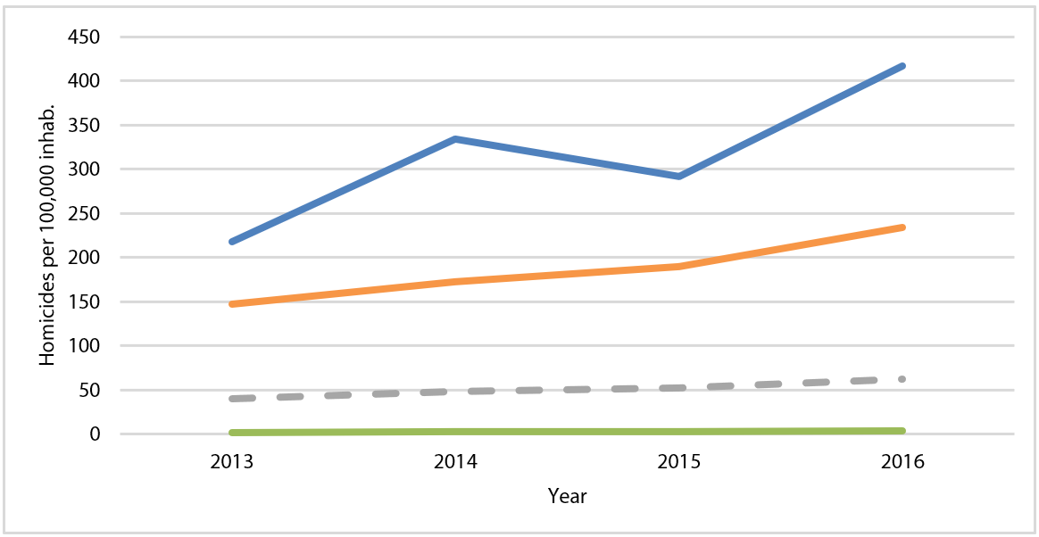
Source: Developed by the authors, using the Datasus homicide database, CID10 x85-y09 and Y35-36 groups and population data of the IBGE, table 2093.

Considering the socio-spatial distribution of homicides during the war in Porto Alegre is as instructive as the breakdown of rates by racial and age groups. In the most extreme case, that of the Vila Jardim neighbourhood, occurrences increased fivefold between 2013 and 2016, with the rate for the local population rising from 53 to 265/100,000 inhabitants. The figures for other vilas, as the capital’s poor suburban neighbourhoods are called, also doubled or trebled. Neighbourhoods more distant from the region where the conflicts between BNC and Antibala were concentrated showed little or no change in their rates, although they participated in the disputes through the declaration of alliances and support, involving the sending of guns and people.
In the regions of concentrated conflict, 2016 was marked by drive-by shootings, a tactic introduced with the war which did not target particular victims for murder, but rather involved a generalized violent assault with the intention of striking any individuals considered enemies (the contras). These drive-by shootings were committed by the teams targeting whoever was in the vicinity of rival drug dealing spots. The aim of these attacks was not to take the drug-dealing spots, which would require more robust logistics and remaining in those places, but rather to challenge the authority of the contras in their own areas. Such dynamics led to a vendetta-type situation characterised by cyclical violence, whereby revenge killings between embolamentos multiplied.
In São Luís, we focus our analysis on the most express increase noted in the last two decades, which occurred between 2011 and 2014 (Graph 4). Those four years witnessed a 65.9% increase in the total number of homicides in the capital, with aggregate rates varying from 55.2 to 89.95/100,000 inhabitants. With regard to young black men, the rates jumped from 243.3 to 481.7/100,000 in 2013, with a downward swing the following year, but remaining very high. Comparing the evolution of the lines in Graph 4, despite the homicide rate among young black men peaking in 2013 and the aggregate population rate peaking in 2014, one can observe not only that young black men were the prime homicide victims—which we already know—but also that in the four selected years, the rise in these rates was considerably greater for this population group. Whereas the rates fell from 2.0 to 1.99 in the group represented by the green line, which corresponds to the total population without young men, for young black men it practically doubled (between 2011 and 2013)—a 97.9% increase.

Graph 4: São Luís: Homicide rate by racial and age groups, 2011-2014
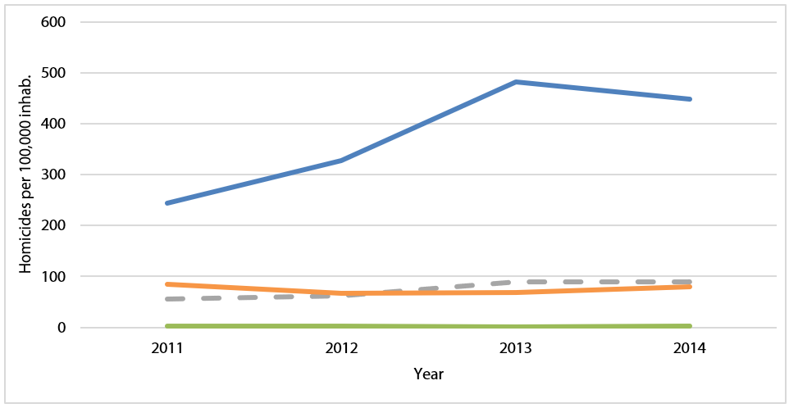
Source: Developed by the authors, using the Datasus homicide database, CID10 x85-y09 and Y35-36 groups and population data of the IBGE, table 2093.

Two regional criminal alliances had been forming in the Maranhão prison system, strengthened by the hyper-concentration of inmates in the then Pedrinhas Penitentiary Complex (PACHECO, 2015; COSTA, 2014; PEDROSA, 2014). Within the prison context, these were protection networks that encapsulated a series of ties of belonging that, until then, had been territorially spread around the poor neighbourhoods of Maranhão. On the streets, the forms of identification in crime tended not to cross the borders of each quebrada (poor neighbourhood or shanty town); however, the prevalent conflict within the prisons did not replicate the antagonism between São Luís neighbourhoods. Alliances and feuds emerged from a violent rivalry that developed between prisoners from the interior of the state—who organised themselves as the Primeiro Comando do Maranhão (PCM)—and prisoners from the capital, who gave rise to the Bonde dos 40 Ladrão (B.40).
Following a violent rebellion in late 2010 at the Pedrinhas Penitentiary Complex and driven by the confrontation between the two groups, this new way of organising criminal relations definitively spilled over into the poor outskirts of São Luís, developing from an intricate dialectic between prison and favela (SILVA, 2020, 2021). Two types of confrontational dynamics overlapped, producing the cycle of deaths that is illustrated in the graph by the rapid rise in the homicide curve of young black men between 2011 and 2013, and which remained very high in 2014. The world of crime in the city was being reconfigured, characterised by the rapid transition from the previous scenario dominated by gangs, which had formed according to the micro-local identity of the quebradas, to the new reality, centred on the two large, regional, prison-born factions.
As in the case of Porto Alegre, during this transition towards a faction-dominated dynamic, smaller groupings of youths involved in illegal markets were progressively swallowed up, voluntarily or under duress, by larger factions. In some cases, regional factions even absorbed entire cadres of local gangs that controlled drugs-dealing spots in São Luís. This was not a peaceful process. On the one hand, power was concentrated in regional factions that led to the extermination of numerous gangs, smaller groups and individuals that refused to join the PCM or B.40; on the other hand, there was the warfare between these factions that led a violent race for territorial expansion and consolidation of power in the poor city outskirts. In both cases, the use of lethal violence was the standard form of dispute resolution (SILVA, 2020; SILVA and BEZERRA, 2021). In a city with a large black population, the striking variation in homicides is evident by the line that corresponds to the group of young black men, the significantly lower line corresponding to young non-black men and the line that is practically indistinguishable from zero when one considers the rest of the population.
Although armed conflicts had been recorded in São Luís since the early 2000s (these conflicts contributed to the progressive rise in homicide rates in the following years), such clashes took on new dimensions in light of the dynamics among factions that stemmed from the prisons. From within the prisons, crime had become better structured, enhancing its fire-power, manpower and ability to organise actions on the streets. In the period referred to in Graph 4, the arrangements within the prison system, led by the two regional factions, ignited and accelerated confrontations that occurred in the outside world, and vice-versa. Up to that point, the national factions had only acted behind the scenes in alliance with the PCM (SILVA, 2020).
The case of Maceió is equally relevant to the construction of our argument. From 2002 onwards, treaties agreed between the Federal Government and the state of Alagoas in the field of public security led to a growing movement of prisoners through the federal and state system, intensifying their relations. From these relations emerged new criminal dynamics between the poor outskirts of small, medium-sized and large cities, which had previously been scarcely connected from the point of view of crime. This process was followed by the expansion of factions throughout the prisons of Alagoas, as well as in the outskirts of the capital and inner-state towns. Since that time, the PCC has been identified as being only marginally present in Alagoas prisons. It was the CV that, in 2005, introduced crack into the local market and engaged in more and more disputes for drug-dealing spots, including the involvement of low-ranking police officers (RODRIGUES, 2017b, 2019a, 2020a, 2021a, 2021b; CARVALHO, 2021).
Although its presence was known in the state since the 1980s, the CV had been active on a small scale and mainly in inner-state marijuana production. It was in the mid-2000s, with the temporary incarceration of Fernandinho Beira-Mar at the Federal Police jail in Alagoas, that this relationship would be transformed. Since then, the sprawling of the CV through the urban peripheries of Alagoas became clear and intertwined with previous rivalries, among different groups—families, popular culture groups, football fan bases, gangs and posses—also engaged in informal and illegal markets. The role of low-ranking police officers and union leaders as urban terrorists formed part of the landscape of urban conflict in Maceió, which relies on the widespread use of firearms and explains the high levels of violent murders in the municipality.
Not by chance, 2005 was marked by a surge in homicides registered in the city (a 45% increase in the rates in the space of a year). As can be seen in Figure 5, violent murder was particularly high for young black males. The curves are quite clear: between 2005 and 2011, a period in which the homicide rate for young black men more than doubled, the rate for young non-black men fell to less than half.

Graph 5: Maceió: Rise in homicide rate by racial and age groups between 2005 and 2011
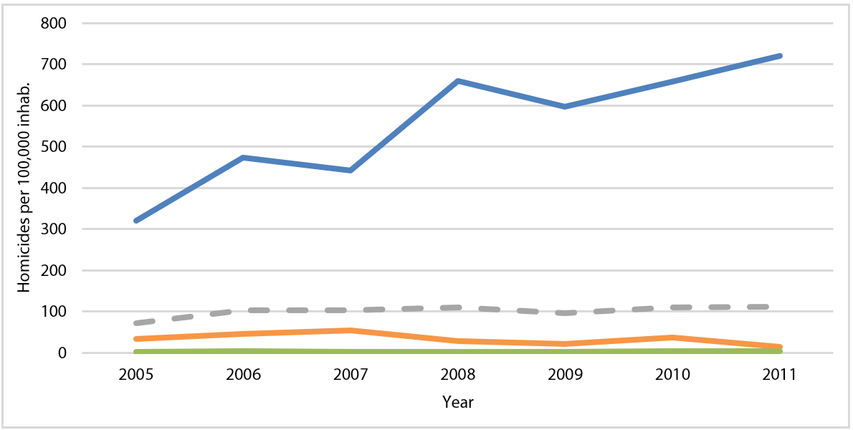
Source: Developed by the authors, using the Datasus homicide database, CID10 x85-y09 and Y35-36 groups and population data of the IBGE, table 2093.

Between 2005 and 2011 the forms of governance over illegal markets in Maceió underwent a transition. The shift in rule over local civil order was marked by violent disputes. Once controlled by other types of leadership, including low-ranking police officers who acted as criminal terrorists, the poor neighbourhoods of Maceió began to coexist with the non-hegemonic rise of the main national factions, the CV and the PCC, whose rivalry was growing inside the prison. At the time nationwide allies, these factions came to represent a benchmark for the protection of drug dealers and thieves who had initially been in prison. They came out as criminal actors who would progressively occupy positions of power in the poor urban peripheries. This reconfiguration of faction practices was accompanied by the extermination of older leaders, as well as an unprecedented process of the juvenilization of crime.
These movements were in line with the significant growth in the homicide rate in the municipality, witnessed especially among young black men in the period. The variation in these rates for this victim profile was characterised, between 2005 and 2011, by one or two years of intense rise, followed by a year of modest fall, although still higher than the previous levels. This pattern reflects the rapid alternation between episodes of destabilisation and a precarious balance of power relations between the groups that previously regulated the illegal markets and the factions waging war against them. This conflict permeates myriad regions and actors in the poor suburban neighbourhoods of Maceió, reconfiguring power in those territories.
The first part of our argument—the explanation of upward variations in the rates—is finally completed in São Paulo. The 2000s are the decade of the white flag established by the PCC (BIONDI, 2009; HIRATA, 2018; MANSO and DIAS, 2018). The 1990s had been known in the peripheries as the “time of wars”, which saw an explosion in homicide rates caused by confrontations between thieves and dealers from those poor outskirts and vigilantes and extermination groups linked to the police and elites. In 1999, the rate reached 66.7 homicides per 100,000 inhabitants (SALLA, 2007), and DataSUS data shows that for young black men, the figure reached the 400/100,000 mark. At the same time, the PCC's hegemony was developing in the prisons. This hegemony would become notable in the urban peripheries in the following decade (FELTRAN, 2011).
Once this hegemony was consolidated, there was a steep drop in homicides among young people involved in the local criminal world, as analysed in the next section. Because of this strong trend, we chose to focus on 2006, which was marked by a significant increase in homicide rates when compared with the previous and subsequent years. As can be seen in Graph 6, broken down by months of the year, there was a visible increase in the number of killings in May, especially among young black males. For this group, the homicide rate increased by 70% from one month to the next. Although less significantly, the rate also oscillated in the case of young non-black men, for which group there was a 40% increase.

Graph 6: São Paulo: Monthly homicide rate by racial and age groups in 2006
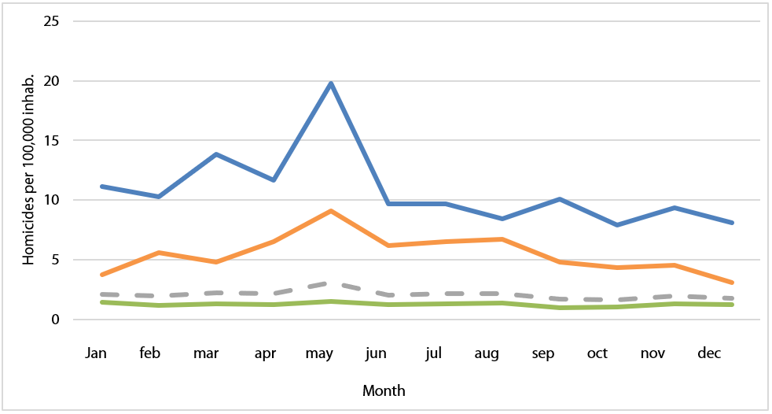
Source: Developed by the authors, using the Datasus homicide database, CID10 x85-y09 and Y35-36 groups and population data of the IBGE, table 2093.
What explains this rapid rise in homicide rates and the biggest public security crisis in the history of São Paulo state? On 12 May 2006, a local war was sparked by a public demonstration of force by the PCC, which was already setting up hegemonic control inside the prisons and completing its expansion process to establish rule over the criminal world. The police reaction to the PCC attacks resulted in 564 murders in just two weeks (JUSTICE GLOBAL et al., 2011; SALLA, 2007), in episodes that became known as the “May Crimes”.
The PCC’s lethal actions were a response to the transfer of several prisoners who belonged to the faction, considered ‘PCC leaders’, to the Presidente Venceslau Maximum Security Prison—under the Differentiated Disciplinary Regime (RDD). The transfer was justified after wiretaps revealed that a supposed rebellion inside the state prisons had been arranged for Mother’s Day of that year, 14 May 2006. In response to the state action, the prisoners upturned the jails and urban peripheries, that is, they organised a coordinated simultaneous riot at 74 state penitentiaries and 12 juvenile detention centres. At the same time, on Friday 12 May 2006, the biggest offensive against the public security forces in the history of São Paulo was executed.
Police stations, cars, police vehicles, Military Police bases, police checkpoints on the state’s highways and various Civil and Military Police garrisons in several locations in the state came under simultaneous attack with assault rifle fire. On Saturday (13 May), an initial death toll of 20 state officers was reported. For the next 15 days, a third of the municipality’s bus fleet did not take to the streets. The city of São Paulo came to a halt at the precise moment that the representation of the PCC as the great national enemy was consolidated. Data regarding the attacks show that police officers were killed primarily between 12 and 13 May (JUSTICE GLOBAL et al., 2011). The Military Police killed one person on the 12th, 18 on the 13th, 42 more on the 14th and 37 more on the 15th of May (FELTRAN, 2011, p. 177). In the days that followed until 26 May, 505 civilians and 59 public security officers were killed (AMADEO et al., 2018). The data were released much later, following pressure from human rights organisations. For every police officer killed during those days, on average ten civilians were killed in response. The profile of those killed by the police forces in that period was 91% male, 74.5% between 15 and 29 years old. Graph 6, above, helps us understand the intensity of these events.
Other periods of upward swings in homicide rates in São Paulo followed similar patterns of conflict. In 2012, for example, we witnessed a 28% increase in the aggregate rates (which rose from 13.15 in 2011 to 16.84 in 2012). 2012 was marked by a series of open conflicts between the military police and the PCC in São Paulo, with a record number of police officers murdered in the state—more than a hundred, according to data from the São Paulo Public Security Office (SSP/SP)—and several executions committed by police officers and groups of hooded men in the city’s poor outskirts, linked to the modus operandi of extermination groups.
Over the last two decades, although the profiles of the curves observed in the four municipalities are very distinct, our analysis identifies a striking sociological regularity. In all four cases, consistent increases in aggregate homicide rates have been caused by armed conflict over the establishment of the dynamics among factions that control the local criminal universes. The synopses of this conflict, analysed in Porto Alegre between 2013 and 2016, in São Luís between 2011 and 2014 and in Maceió between 2005 and 2011, clearly indicate a process towards domination by factions, first inside the prisons and then manifesting itself in the streets, that absorbed gangs and other small groups, bringing them into line with an overarching government of the criminal universe.
In all the cases, we know that regional factions were also responding to important changes in the national governance of the criminal universe, given the then two-decade long alliance between the CV and PCC. In São Paulo, this alliance dates back to the 1990s, and it was forged in Maceió in the 2000s and in Porto Alegre and São Luís in the 2010s. In all four cases, however, the correlated process of consistently rising homicide rates was established during this alliance, entirely linked to conflicts over the high profitability of transnational illegal markets, especially cocaine trafficking.
The short period analysed in São Paulo in 2006 is only intended to demonstrate our argument in a far more time-specific situation. Sharp variations in homicide rates in strict localities—such as this 70% rise in a single month—almost always indicate conflicts over dynamics among factions. We shall now look at how the falls in homicide rates seem to be equally related to this same dynamic.

Falling rates: a detailed explanation

In Porto Alegre, homicide rates plummeted with the end of the war between the BNC and Antibala in 2018, returning to a level of 40 cases per 100,000 inhabitants, around which mark the rates fluctuated throughout virtually the entire historical series. Some relevant events contributed to the end of the clash, which had already become costly for both embolamentos. Before the war, the group that led the Antibala was unknown outside the city, but it took over two wings in the state’s largest prison in 2017, considerably strengthening its ability to participate in the illegal markets. From then on, the dynamics of the vendettas hindered rather than contributed to its new intentions and capabilities. The BNC, on the other hand, was more interested in directing its efforts towards the interior of the state in order to fight for control of the merchandise routes and territorial expansion through strategic cities—a strategy already being executed by the largest regional faction in Rio Grande do Sul, the Manos.

Graph 7: Porto Alegre: Homicide rate by racial and age groups between 2016 and 2019
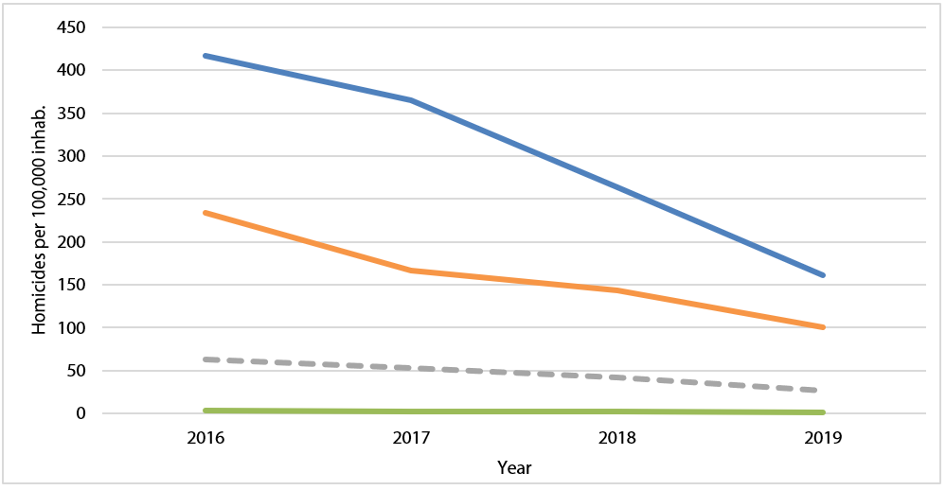
Source: Developed by the authors, using the Datasus homicide database, CID10 x85-y09 and Y35-36 groups and population data of the IBGE, table 2093.

Thus, although the war in words and occasional clashes between the Antibala and the BNC continue to this day, a relative ceasefire was signed in Porto Alegre, mainly with regard to the type of negative reciprocity imbued in the logic of the drive-by shootings. Since 2018, other conflicts have persisted, now between the Manos and the BNC, and in inner-state towns. Unlike the war in Porto Alegre, which was markedly local, national factions have a greater involvement in this new dispute. Although the PCC and CV do not participate directly in the confrontations, the collectives have signed alliances with the Manos and BNC, respectively. The Manos and BNC, furthermore, have grown progressively stronger since 2016.
In Maceió, in the years following 2011, when a faction-linked order was established in the city under the control of groups linked to the CV and the PCC, we observe a consistent decline in homicide rates, intensified in 2014 and interrupted only between 2016 and 2017. In a period spanning just five years, the municipality’s aggregate rates consistently fall from 111/100,000 in 2011 to 59/100,000 in 2016. The drop observed in Graph 8 is even more drastic when observed among black men between 15 and 29 years’ old, dropping from 721/100,000 inhabitants in 2011 to 284/100,000 inhabitants in 2019.

Graph 8: Maceió: Homicide rate by racial and age groups 2011-2019
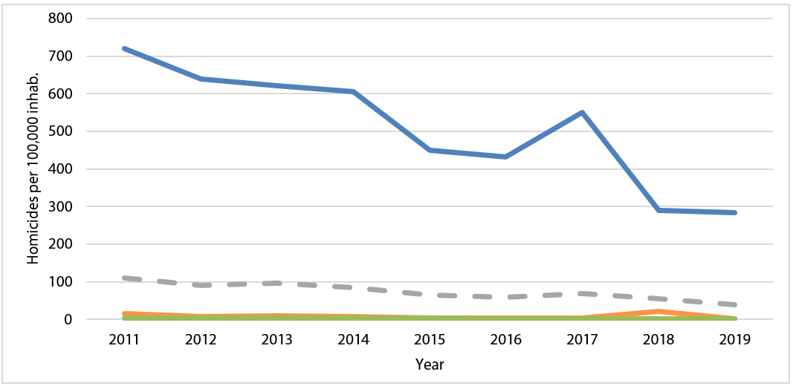
Source: Developed by the authors, using the Datasus homicide database, CID10 x85-y09 and Y35-36 groups and population data of the IBGE, table 2093.

Ethnographic research conducted in the municipality reveals that the fall in these rates is directly associated with the increased amount of areas of Maceió controlled by CV and PCC networks. As in the other capital cities studied, the dynamics of the prison system are fundamental to the expansion of the faction influence. The police, who were dominant in the grotas and poor outskirts until the early 2000s, lost an important part of their control over the inmates. Thus, the Alagoas prisons became subject to a form of co-government between, on the one hand, a prison bureaucracy made up of civil servants and contractors and, on the other, the faction-affiliated criminal leaderships—which, in turn, modify how the minority non-faction-affiliated leaderships operate. Meanwhile, inter-regional mobility supported by the kinship and alliances forged behind bars between traffickers from the north-east and the mid-south of Brazil, intensified movements among families, work places, prisons and factions. The stories of all four cities studied here bear out the harmony between the prisons and the quebradas, which structures the consolidation of faction repertoires in our ethnographic settings.
In Alagoas, the repertoire for controlling violence in conflict resolution associated with the PCC has gained it a progressively larger share of prison buildings and detention units, with repercussions in the quebradas. The way in which CV allies have developed their own criminal discipline in the state is very much marked by the PCC. Links between allies of both groups, through family or neighbourhood, also manifest themselves in faction discipline. Faction-linked ideas and norms of “peace between us and war on the system” have found acceptance among the younger generation. Whereas many of the older criminals and traffickers experienced the arrival of national factions as rivals and external forces, the younger generations have tended to embrace the novelty. Hence, many of the old criminals have been murdered in police operations or in conflicts with power-hungry youths.
These deaths did not, thus, lead to power vacuums in the drug-trafficking world or in the local rule over the shanty towns. Newer and more faction-affiliated thieves and drug traffickers have come to regulate order in the criminal world of Maceió. This process connected local conflicts to those in other states in the country, paving the way for greater inter-regional integration of the criminal circuit between the lower ranks and enabling peace agreements between national factions to have repercussions in the shanty towns of Alagoas. After the rebalancing of territorial power in 2016 in the Lagoa Mundaú region, in the Reginaldo Valley and in different areas of Benedito Bentes, a drastic reduction in homicide rates is observed between 2017 and 2018, with stability maintained between 2018 and 2019. The presence of national factions even impacts the shaping of regional faction disciplines.
In São Luís, there was only a timid fall in the homicide rates in 2015, which continued consistently until 2019. Graph 9 helps us describe this drop in the aggregate rates in São Luís, from 89.95 in 2014 to 29.4/100,000 inhabitants in 2019. Considering the rates by racial and age groups, once again the homicide curve among young black men is the one that pushes the general downward trend, followed by the rate among young non-black men. The curve that excludes this population of young men, as shown in the graph below, shows practically no variation.

Graph 9: São Luís: Homicide rate by racial and age groups, 2014-2019
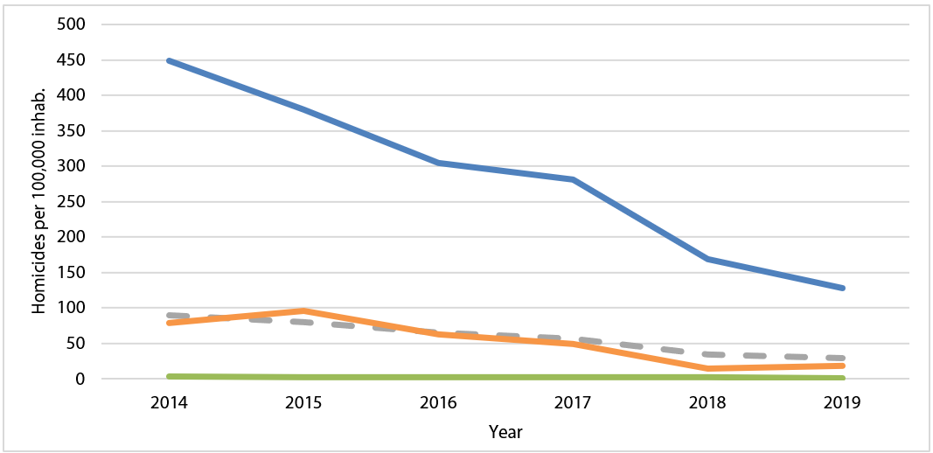
Source: Developed by the authors, using the Datasus homicide database, CID10 x85-y09 and Y35-36 groups and population data of the IBGE, table 2093

The ethnographic data produced for this period (2014 to 2019) reveals that in late 2014, the internal fights of the PCM began in the Cidade Olímpica region, which would culminate in the creation of the Comando Organizado do Maranhão (Organised Command of Maranhão – COM) in 2015. Although these internal conflicts already assumed a faction-like configuration aimed at reducing homicides, they also contribute to maintaining the still very high homicide rates. In late 2016, this scenario among factions became even more fragmented with the dissolution of the PCM, stemming from its members joining either the CV or the PCC. The national factions once again demonstrate their over local criminal conflicts. The split of former PCM members into the CV and PCC resulted from the end of the historical alliance until then maintained between the national factions.
The national war between the CV and PCC had local consequences in São Luís, curtailing the downward trend in homicides in 2016. From 2017 onwards, however, the pacification of the quebradas was actively stimulated by the regional factions, as the hegemony of the B.40 spread through the capital’s poor outskirts. The power of the factions was already consolidated in the capital’s shanty towns, with the B.40 taking control of most of the day-to-day discipline. The domination exercised by this faction in its territories deepened to the point of establishing the “ban on theft in the quebradas” law, enforced with severe punishments for any transgressors. The B.40 has actively pacified previously existing rivalries in the criminal universe, in a process similar to that described in literature specific to the PCC in São Paulo. A new normative regime emerged in São Luís and the faction asserted itself as a mediator in the world of crime, blocking widespread conflicts and establishing an ethical, aesthetic and political paradigm in that universe (SILVA, 2019, 2020). The hegemony of the B.40 means that few areas of the city remain in faction-related conflict; these are the areas that have the highest incidence of homicides, such as Cidade Olímpica, Coroadinho and Bairro de Fátima, or border areas such as that between Camboa and Liberdade. Here, two blocs have emerged: the alliance between the CV and COM on the one hand, and between the PCC and B.40 on the other. Once this hegemony and the opposition territories were established, the homicide rates continued to drop significantly, even in regions that had once been among the most violent in the city such as Anjo da Guarda and other areas of the Itaqui-Bacanga region.
The remarkable fall in homicide rates in São Paulo—an 80% drop in the aggregate rates over the course of the 2000s—has already been discussed at length in the literature (FELTRAN, 2010, 2011, 2012; MANSO, 2014; BIDERMAN et al., 2018). Currently, it is difficult to find academic work that negates the decisive participation of faction dynamics in this reduction. In Sapopemba, a district in the East Zone of São Paulo where we concentrated our ethnographic work in the city, the rates fell progressively between 2001 and 2008, from 73.1/100,000 in 2000 to 8.78/100,000 in 2008 (PRO-AIM, 2012). The same trend repeated in practically all of the city's peripheral neighbourhoods, where retail drug dealing and robberies are concentrated (FELTRAN, 2022). As in the other cases analysed in this article, the rates did not change significantly in the middle/upper class districts, where they were already very low.
Graph 10 illustrates how the aggregate homicide curve for São Paulo fell consistently, clearly pulled down by the significant reduction in homicides of young black men, which dropped from 383 to 74/100mil between 2000 and 2008, the biggest fall in the cities analysed. Similar curves can be found in many other municipalities in São Paulo state and in cities in regions where the criminal world is under the consolidated hegemonic control of the PCC, such as in the states of Paraná and Mato Grosso do Sul.

Graph 10: São Paulo: Homicide rate by racial and age groups between 2000 and 2008
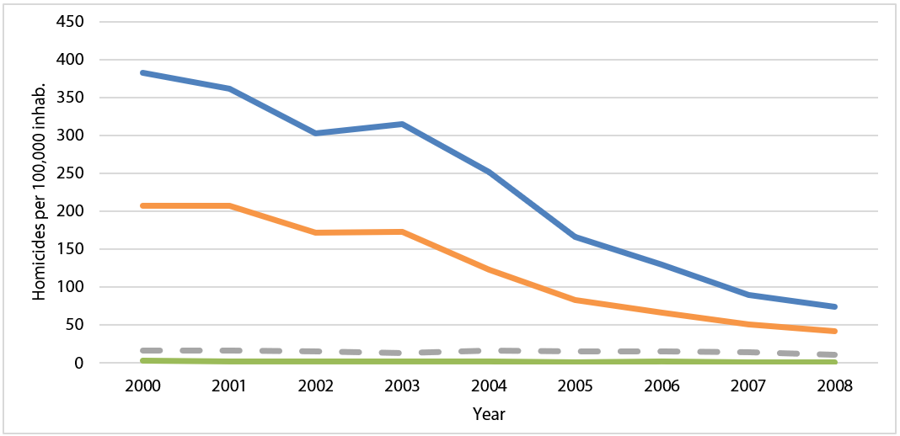
Source: Developed by the authors, using the Datasus homicide database, CID10 x85-y09 and Y35-36 groups and population data of the IBGE, table 2093.

The striking downward trend in São Paulo produces a remarkable similarity between the homicide rates of young black men and the general population rates, the latter also plummeting from 63.7/100,000 in 2001 to 13.2/100,000 in 2011 and remaining at these levels to date. While homicides fell, expressions such as “procedure” and “debate” were heard more frequently in São Paulo’s poor outskirts, as part of a homicide control device regulated by the faction universe (MARQUES, 2007a, 2007b; BIONDI, 2010; FELTRAN, 2010; HIRATA, 2018). The PCC’s institutionalisation of faction policies on clarifying homicides, third-party conflict mediation, victim reparation and the accountability of aggressors, together with strict gun control, enabled those excluded from the formal justice system feel there was an effective security policy in the peripheral neighborhoods. The PCC implemented all of this in São Paulo, as a criminal organization, instrumentalising state policies on incarceration and proactive policing. It is these very policies that constitute state public security policy, with the difference that the latter has the possibilty of being effectively democratic. The fact is that after the war of the 1990s and the occasional crises in 2001 and 2006, the PCC's hegemony established peace in the drug, weapons, vehicles and contraband markets and in the associated legal markets (fuel, cars, transportation, hotels, etc.). This faction-led peace channelled even more money into the criminal world, and protection rackets formed ties with illegal economies, as Michel Misse has taught us (2002, 1997). There was, therefore, a consistent fall in the homicide rates within the world of crime for two decades, as expressed by the aggregate or disaggregate curves that we have correlated to our ethnographic synopses.

Final considerations

In this article we have presented and analysed the variations in the historical homicide figures in four Brazilian capitals between 2000 and 2019, demonstrating the analytical hypothesis that these variations were primarily due to the dynamics of local conflict among factions—which of course includes the conflict of these armed groups with state forces of repression. Our analysis was inductively constructed, starting from the qualitative study of the dynamics of this conflict to arrive at causal inferences on aggregate rates, supported by a breakdown of the quantitative data. We also detail the methodological, analytical and theoretical principles and procedures we used, suggesting that this same framework of analysis could be used to understand variations in homicide rates in other local contexts, and similarly produce inferences about aggregate state and national rates.
In conclusion, our final considerations are as follows: 1) Factions are formed and expand within state and federal prison systems in all the municipalities studied; 2) in all four settings studied, there is a recurrent spread of faction-associated discipline within the criminal universe via connections between prisons and poor neighborhoods; 3) the installation of such discipline and faction rule tends to produce local conflicts and even wars that consistently increase homicide rates, at a faster or slower pace depending on the context; 4) the construction of hegemonies within the universe of factions, as well as pacification agreements between distinct groups, produces consistent reductions in homicide rates; and 5) the hegemony of the PCC in particular, due to its specific organisational characteristics that have been well studied in the literature—especially the fact that the faction does not exercise armed territorial control and has a framework that regulates illegal markets—tends to produce consistently lower homicide rates compared to other factions.
These five analytical findings respond to the study of local socio-historical processes that, although unique and dependent on their empirical contexts, allow formal cross-sectional analysis and therefore causal inference. The combination of such elements makes a key contribution to the consistent rise in aggregate state and national rates, where there has been a process of the establishment of faction dynamics and a consistent fall in the homicide rates in recent years (2017-2021), as noted by our interlocutors in each of the ethnographic contexts studied.
Although some authors consider that the phenomenon of downward-trending homicide rates is an indication of the success of public security policies or of other factors for which a statistical correlation (albeit spurious) can be found, it seems evident that the articulation between coexisting power regimes in the poor outskirts, materialised in disputes for the control of illegal markets and the rule over daily conflicts between drug factions, has been by far the main cause of the remarkable variations in homicide rates in Brazil in recent decades. From this sociological interpretation we propose that further work may also test an analytical framework that preserves some of the methodological, analytical and theoretical principles summarised below.
Methodologically, our model proposes, firstly, the construction of local synopses of the conflict among factions in order to understand it in each locality. In the municipalities studied, these synopses were based on the ethnographic surveys conducted by the authors in recent years. We were able to finely analyse the intra-urban dynamics of the armed conflict, taking seriously what our interlocutors directly involved in the armed conflict had to tell us. “Taking seriously what the natives say”, a well-known expression in anthropology, does not imply blindly believing what the interlocutors say, but rather considering them as actors able to produce knowledge about the social dynamics in which they live. This knowledge, subjected to methodological rigour, can be translated into academic knowledge.
Thus, the reports obtained in the field are first subjected to systematic observation of similar contexts and cases, of medium or long duration, and to triangulation—fundamental data validation procedures in any qualitative research. Formulating as data the synopses presented above, therefore, are distillations of that which we observed and heard in the field repeatedly in different contexts of ethnographic work, and not repetitions of what was heard in an isolated account or interview. The authors’ experience in their field settings was the basis for formulating data, which is fundamental for systematic comparison and qualitative-quantitative analysis. This data formulation enables the analysis of the historical series of homicide rates in each municipality. Their breakdown by victim profile, as demonstrated above, clearly signals the strength of conflicts among factions as an explanatory factor for the trends in variation.
We consider the analysis of historical series to be essential for contextualizing the variations studied; therefore, the DataSUS data proved to be more adequate for the task at hand. As the data from the state Secretaries of Public Security have been harmonised since 2007, they would also certainly offer interpretations of rising and falling local and aggregate trends in the country. The DataSUS series as well as those of the Ipea and FBSP today support a systematic study of the variations of aggregate state and national rates, to the precise extent that they also allow for a breakdown of the data by victim profile and territory. The municipal breakdown offered by DataSUS helps understanding of local conflicts by qualitative research, although the literature on multisite and even transnational ethnographies shows that we can, qualitatively, propose causal hypotheses that are broader than the local level.
The potential of this interpretation is exemplified by the qualitative construction of an explanatory hypothesis for the upward variation in national homicide rates between 2016 and 2017, reaching a national record in 2017, based on peaks in the historical series of 15 of the 27 states. As we know, in 2016 the two national factions, the CV and PCC, broke away from a peaceful understanding that had lasted 23 years. This rupture generated bloody conflicts throughout the Brazilian faction universe, which in turn were reflected in the increasing homicide rates of young illegal market agents, especially in states where these markets were emerging. Localised and intense conflicts among actors with this social profile would have pulled state aggregate rates up to such an extent that rising trends were noted in the national rates. Testing this hypothesis, however, would require the construction of state-wide synopses of conflicts among factions, as well as the breakdown of state data on homicides by victim profile.
Analytically, our explanatory framework is centred on comprehensive sociology. We consider homicide to be a social action: an analytical unit that, in this sociological tradition, is thought of as being composed of a multicausal set, a defined course of action and discernible social effects (WEBER, 2019). The empirical study of the effects and course of homicidal action, based on the observation of situations and intentions expressed by the agents in their representations, allows us to access, through interpretation, dimensions of social relations and legitimate orders. Our ethnographic work in the municipalities studied, and especially in the poor outskirts of these municipalities, allows us to access representations, senses of justice, values, beliefs and norms of the subjects involved in the dynamics of lethal violence. These faction-influenced representations, formally very regular in different Brazilian states, have war as a way of life (SILVA, 2020, 2021) and the elimination of the enemy as a requirement for emancipation—constituted by peace, justice, freedom, equality and unity that all factions preach internally.
Theoretically, our interpretative framework suggests that studies of homicides in Brazil assume that the majority of victims are low-level agents of illegal markets, involved in conflicts among factions at the local level. These young people can be captured quantitatively based on their social, age, racial, work or schooling profile. Testing these different ways of characterising them would advance the literature and greatly assist in the construction of robust models for interpreting murders in Brazil. In this regard, studies on hybrid sovereignties (ARIAS and BARNES, 2017), governmental landscapes (STEPPUTAT, 2018), coexisting legitimate authority (SILVA, 2004) and normative regimes (FELTRAN, 2020; MALDONADO, 2020; BERALDO, 2020) may point to clues for theoretical development to counter the theoretically state-centred analyses that currently dominate the literature on homicide in the country. We will progress yet further if we start from the assumption that homicides in Brazil are mostly related to armed conflicts by the government of illegal markets, conditioned locally and nationally by national and regional conflicts among factions, gangs and the police.

References

ADORNO, Sérgio. “A criminalidade urbana violenta no Brasil: Um recorte temático”. BIB: Boletim Bibliográfico e Informativo em Ciências Sociais, São Paulo, vol. 35, pp. 3-24, 1993a.
ADORNO, Sérgio. “Violência urbana e justiça criminal: Desafio do crime organizado ainda sem resposta adequada”. Carta Política, São Paulo, vol. 43, p. 6, 1993b.
AGAMBEN, Giorgio. Homo Sacer: O poder soberano e a vida nua. Belo Horizonte: Editora UFMG, 2002.
ALVES, José Cláudio Souza. Dos barões ao extermínio: Uma história da violência na Baixada Fluminense. Rio de Janeiro: Consequência, 2020.
AMADEO, Javier et al. (coords). Violência de Estado no Brasil: Uma análise dos Crimes de Maio de 2006 na perspectiva da antropologia forense e da justiça de transição. Relatório Final. Unifesp, 2018. Disponível em https://www.unifesp.br/reitoria/caaf/images/Relatorio_final_2.pdf
AQUINO, Jânia Perla Diógenes de. “Pioneiros: O PCC e a especialização no mercado dos grandes roubos”. Journal of Illicit Markets and Development, vol. 2, pp. 80-100, 2019.
ARENDT, Hannah. As origens do totalitarismo. São Paulo: Companhia das Letras, 2012.
ARIAS, Desmond; BARNES, Enrique. “Crime and Plural Orders in Rio de Janeiro, Brazil”. Current Sociology, vol. 65, n. 3, pp. 448-465, 2017.
ARIAS, Desmond. Criminal Enterprises and Governance in Latin America and the Caribbean. Cambridge: Cambridge University Press, 2018.
BARNES, Nicholas. “Criminal Politics: An Integrated Approach to the Study of Organized Crime, Politics, and Violence”. Perspectives on Politics, vol. 15, n. 4, 2017.
BEATO, Claudio Chaves Filho et al. “Crime, oportunidade e vitimização”. RBCS, vol. 19, n. 55, pp. 73-89, 2004.
BEAUD, Stéphane; WEBER, Florence. Guia para a pesquisa de campo: Produzir e analisar dados etnográficos. Petrópolis: Vozes, 2007.
BERALDO, Ana. Negociando a Vida e a Morte: Estado, igreja e crime em uma favela de Belo Horizonte. Tese (Doutorado em Sociologia) – Universidade Federal de São Carlos, São Carlos, 2020.
BIDERMAN, Ciro et al. Pax monopolista and crime: the case of the emergence of the Primeiro Comando da capital in São Paulo. Corporación Andina de Fomento, 2014. CAF Working paper, n. 2014/03.
BIDERMAN, Ciro et al. “Pax Monopolista and Crime: The Case of the Emergence of the Primeiro Comando da Capital in São Paulo”. Journal of Quantitative Criminology, vol. 35, pp. 573-605, 2018.
BIONDI, Karina. Junto e Misturado: Imanência e transcendência no PCC. Dissertação (Mestrado em Antropologia Social) – Universidade de São Paulo, São Paulo, 2009.
BITTAR, Mariana. Trajetórias educacionais dos jovens residentes num distrito com elevada vulnerabilidade juvenil. Tese (Doutorado em Ciência Política) – Universidade de São Paulo, São Paulo, 2012.
CANDOTTI, Fábio Magalhães; CUNHA, Flávia Melo da; SIQUEIRA, Ítalo Barbosa Lima. “A grande narrativa do Norte: considerações na fronteira entre crime e Estado”. In: MALLART, Fábio; GODOI, Rafael (orgs). BR 111: As rotas das prisões brasileiras. São Paulo: Veneta, 2017, pp. 35-47.
CANO, Ignacio; DUARTE, Thais Lemos. “A mensuração da impunidade no sistema de justiça criminal do Rio de Janeiro”. Segurança, Justiça e Cidadania: Pesquisas Aplicadas em Segurança Pública, pp. 9-44, 2010.
CARVALHO, Ada Rizia Barbosa de. Cadeias de tensão: Repertórios disciplinares de facções e do sistema em unidades de internação alagoanas. Dissertação (Mestrado em Sociologia) –Universidade Federal de Alagoas, Maceió, 2021.
CIPRIANI, Marcelli. Do global ao local: A emergência das “facções criminais” no Brasil e sua manifestação em Porto Alegre, Manuscrito (Bacharelado em Direito) – Pontifícia Universidade Católica do Rio Grande do Sul, Porto Alegre, 2016.
CIPRIANI, Marcelli. “Embolamento”. In: PERONDI, Maurício et al. (orgs). Juventudes entre A & Z. Porto Alegre: CirKula, 2021a.
CIPRIANI, Marcelli. Os coletivos criminais de Porto Alegre entre a “paz” na prisão e a guerra na rua. São Paulo: Hucitec, 2021b.
CLASTRES, Pierre. Society Against the State: Essays in Political Anthropology. Zone Books, 1987[1974].
CORDEIRO, Ricardo (org). Morte matada. 2022 (no prelo).
CORDEIRO, Ricardo. Trabalho, violência e morte: Miséria da existência humana. Curitiba: Appris, 2018.
COSTA, Wagner. “Pedrinhas $.A.: A violência do negócio e o negócio da violência”. Revista Catirina, n. 0, pp. 09-53, 2014.
COSTA, Arthur et al. “Avaliação dos homicídios na Área Metropolitana de Brasília”. Pensando a Segurança Pública, vol. 4, pp. 93-121, 2014.
DAUDELIN, Jean; RATTON, José Luiz. “Mercados de drogas, guerra e paz no Recife”. Tempo Social, São Paulo, vol. 29, pp. 115-132, 2017.
DIAS, Camila Caldeira Nunes. PCC: Hegemonia nas prisões e monopólio da violência. São Paulo: Saraiva, 2013.
DUARTE, Thais Lemos; ARAUJO, Isabela Cristina. “PCC em pauta: Narrativas jornalísticas sobre a expansão do grupo pelo Brasil”. Dilemas, Rev. Estud. Conflito Controle Soc., Rio de Janeiro, vol. 13, pp. 505-532, 2020.
DUARTE, Thais Lemos; MELO, Juliana. “É guerra? Narrativas judiciais sobre a ação do PCC e do SDC”. Revista Tomo, n. 40, pp. 243-276, 2022.
DURÁN-MARTINEZ, Angelica. “Drugs Around the Corner: Domestic Drug Markets and Violence in Colombia and Mexico”. Latin American Politics and Society, vol. 57, n. 3, pp. 122-146, 2015.
FELTRAN, Gabriel de Santis. The Entangled City: Crime as Urban Fabric in São Paulo. Manchester: Manchester University Press, 2020.
FELTRAN, Gabriel de Santis. “Crime e castigo na cidade: Os repertórios da justiça e a questão do homicídio nas periferias de São Paulo”. Caderno CRH (UFBA), vol. 23, pp. 59-73, 2010.
FELTRAN, Gabriel de Santis. “Debates no ‘mundo do crime’, repertórios da justiça nas periferias de São Paulo”. In: CABANES, Robert; GEORGES, Isabel; RIZEK, Cibele; TELLES, Vera da Silva (orgs). Saídas de Emergência: Ganhar/perder a vida na periferia de São Paulo. São Paulo: Boitempo, 2011, pp. 215-237.
FELTRAN, Gabriel de Santis. “Economias (i)lícitas no Brasil: Uma perspectiva etnográfica”. Journal of Illicit Economies and Development, vol. 1, p. 36, 2019.
FELTRAN, Gabriel de Santis. Fronteiras de tensão: Política e violência nas periferias de São Paulo. São Paulo: Edunesp/CEM, 2011.
FELTRAN, Gabriel de Santis. “Governo que produz crime, crime que produz governo: o dispositivo de gestão do homicídio em São Paulo (1992-2011)”. Revista Brasileira de Segurança Pública, vol. 6, pp. 232-255, 2012.
FELTRAN, Gabriel de Santis. “Illegal realities in the lyrics by Racionais MC’s”. In: Bradellero, Sara; Pardue, Derek; Wink, Georg (orgs). Living (Il)legalities in Brazil Practices, Narratives and Institutions in a Country on the Edge. Abingdon, UK: Routledge, 2020, v. 1, p. 70-90.
FELTRAN, Gabriel de Santis. Irmãos: Uma história do PCC. São Paulo: Companhia das Letras, 2018.
FELTRAN, Gabriel de Santis. “Sobre lutos e lutas: Violência de estado, humanidade e morte em dois contextos etnográficos”. Ciência e Cultura, vol. 67, pp. 40-45, 2015.
FELTRAN, Gabriel de Santis. “State Reaction”. In: FELTRAN, Gabriel et al. Stolen Cars: A Journey Through São Paulo’s Urban Conflict. Nova York: Hoboken, 2022.
FELTRAN, Gabriel de Santis. “Unequal Violence Illicit Markets and the Relational Distribution of Lethal Force in São Paulo”. Lo Squaderno: Explorations in Space and Society, vol. 59, pp. 35-38, 2021.
FERNANDES, Leandro da Silva. O território da violência: Análise espacial 2015-2018 dos Crimes Violentos Letais Intencionais em São Luís/MA. Dissertação (Mestrado em Geografia) – Universidade Federal do Maranhão, São Luís, 2021.
GALDEANO, Ana Paula; ALMEIDA, Ronaldo; FROMM, Deborah; LOTTA, Gabriela; DINIZ, Gregório; MALVASI, Paulo. Tráfico de drogas entre as piores formas de trabalho infantil: Mercados, famílias e rede de proteção social. São Paulo: Cebrap, 2018.
GRILLO, Carolina Christoph. “O ‘morro’ e a ‘pista’?: Um estudo comparado de dinâmicas do comércio ilegal de drogas”. Dilemas, Rev. Estud. Conflito Controle Soc., Rio de Janeiro, vol. 1, pp. 127-148, 2008.
HIRATA, Daniel. Sobreviver na adversidade: Mercados e formas de vida. São Carlos: EdUFSCar, 2018.
HIRATA, Daniel Veloso; GRILLO, Carolina Christoph. “Crime, guerra e paz: dissenso político-cognitivo em tempos de extermínio”. Novos Estudos Cebrap, vol. 38, pp. 553-571, 2019a.
HIRATA, Daniel Veloso; GRILLO, Carolina Christoph. “Movement and Death: Illicit Drug Markets in the Cities of São Paulo and Rio De Janeiro”. Journal of Illicit Economies and Development, vol. 1, n. 2, pp. 122-133, 2019b.
JARA, Simon Rodrigo da Costa. A cobrança: Os sensos de justiça das facções do Maranhão. Dissertação (Mestrado em Sociologia) – Universidade Federal de São Carlos, São Carlos, 2021.
JUSTIÇA GLOBAL et al. São Paulo sob achaque: Corrupção, crime organizado e violência institucional em Maio de 2006. Rio de Janeiro: IHRC; Justiça Global, 2011.
JUSTOS, Marcelo; KAHN, Tulio; CERQUEIRA, Daniel. O “Mistério de São Paulo” e o Papel do PCC na redução de homicídios nos anos 2000. Texto para discussão, Instituto de Economia, Unicamp, ago. 2016.
KAHN, Tulio. “What Does the Evidence Tell Us about Drug-Related Violence in Brazil”. UN Commission on Narcotic Drugs, vol. 13, 2021.
LERO, Cecília; FELTRAN, Gabriel; KOCH-NOGUEIRA, Paulo Cesar. Um modelo quali-quantitativo para a análise de homicídios. 2022 (no prelo).
LIEM, Marieke.; PRIDEMORE, Willian Alex. Handbook of European Homicide Research: Patterns, Explanations, and Country Studies. Nova York: Springer, 2012.
LINES, Odilza; PAES-MACHADO, Eduardo. “Processos sociais de vitimização prisional”. Tempo Social, São Paulo, vol. 25, n. 1, pp. 257-286, 2013.
LOPES, Cleber da Silva; FERREIRA, Anderson Alexandre. “O efeito gangue sobre a dinâmica dos homicídios: um estudo sobre o caso de Cambé/PR”. Revista USP, n. 129, pp. 29-46, 2021.
MACHADO DA SILVA, Luiz Antonio. “Violência urbana: Representação de uma ordem social”. In: NASCIMENTO, Elimar Pinheiro do; BARREIRA, Irlys Alencar F. (orgs). Brasil urbano: Cenários da ordem e da desordem. Rio de Janeiro: Notrya, 1993, pp. 131-142.
MACHADO DA SILVA, Luiz Antonio. “A perda do protagonismo histórico do trabalho e as favelas”. Cadernos Metrópole, n. 21, pp. 21-28, 2019.
MALDONADO, Janaína. Jogando meu corpo no mundo: Relações entre marcadores sociais da diferença e conflito urbano. Dissertação (Mestrado em Sociologia) – Universidade Federal de São Carlos, São Carlos, 2020.
MANSO, Bruno Paes. Crescimento e queda dos homicídios em SP entre os anos de 1960 e 2010: Uma análise dos mecanismos da escolha homicida e das carreiras no crime. Tese (Doutorado em Ciência Política) – Universidade de São Paulo, São Paulo, 2012.
MANSO, Bruno Paes; GODOY, Marcelo. “20 anos de PCC: o efeito colateral da política de segurança”. Interesse Nacional, vol. 1, pp. 5-15, 2014.
MANSO, Bruno Paes; DIAS, Camila Nunes. A guerra: Ascensão do PCC e o mundo do crime no Brasil. São Paulo: Todavia, 2018.
MANSO, Bruno Paes. A república das milícias: Dos esquadrões da morte à Era Bolsonaro. São Paulo: Todavia, 2020.
MARINHO, Frederico Couto; ROCHA, Rafael Lacerda Silveira; BARROS, Cinita; SILVEIRA, Andrea Maria. “A contribuição dos indicadores de desempenho na consolidação dos Projetos Mulheres da Paz e Protejo na Prevenção e Redução da Violência”. In: Pensando a Segurança Pública: Investigação criminal e avaliação de políticas de segurança pública, vol. 7, Brasília, DF: Ministério da Justiça, 2016, pp. 155-178.
MARQUES, Adalton. “Dar um psicológico”: Estratégias de produção de verdade no tribunal do crime. Trabalho apresentado na VII RAM: Reunião de Antropologia do Mercosul, Porto Alegre, 2007a.
MARQUES, Adalton. “Da ‘bola de meia’ ao triunfo do ‘Partido’: Dois relatos sobre o ‘proceder’. Ponto Urbe (USP), vol. 1, 2007b.
MELLO, João M. P. de; SCHNEIDER, Alexandre. “Mudança demográfica e a dinâmica dos homicídios no estado de São Paulo”. Revista Brasileira de Epidemiologia, vol. 14, n. 4, p. 709-21, 2011.
MELO, Juliana; PAIVA, Luiz Fábio S. “Violências em territórios faccionados do Nordeste do Brasil: Notas sobre as situações do Rio Grande do Norte e do Ceará”. Revista USP, vol. 1, n. 129, pp. 47-62, 2021.
MISSE, Michel. “As ligações perigosas: Mercado informal ilegal, narcotráfico e violência no Rio”. Contemporaneidade e Educação, Rio de Janeiro, vol. 1, pp. 93-116, 1997.
MISSE, Michel. “O Rio como um bazar: A conversão da ilegalidade em mercadoria política”. Insight Inteligência, Rio de Janeiro, vol. 5, n. 18, pp. 68-79, 2002.
MISSE, Michel. Crime e violência no Brasil contemporâneo: Estudos de sociologia do crime e da violência urbana. Rio de Janeiro: Lumen Juris, 2006.
MISSE, Michel. “The Social Accumulation of Violence in Brazil”. Sociology International Journal, vol. 1, n. 2, pp. 1-12, 2017.
NASCIMENTO, Emerson Oliveira do; GAUDÊNCIO, Júlio César. “Homicídios em Alagoas: Desafios e evidências empíricas”. Latitude, vol. 7, n. 2, pp. 109-132, 2013.
NASCIMENTO, Emerson Oliveira. “Acumulação social da violência e sujeição criminal em Alagoas”. Sociedade e Estado, vol. 3, n. 2, pp. 465-485, 2017
NIVETTE, Amy; PERES, Maria Fernanda Tourinho. “Social Disorganization and Urban Homicide Rates: A Spatial-Temporal Analysis in São Paulo, Brazil 2000 to 2015”. Homicide Studies, v. 0, n. 0, pp. 1-25, 2021.
OSORIO, Javier; NORMAN, Susan. Multi-Actor Conflict and Violence in Colombia. Manuscrito não publicado, pp. 1-53, 2016.
PACHECO, Keise Regina Costa. Desigualdade e justiça: O sistema penitenciário brasileiro e o contexto penitenciário maranhense. Monografia (Bacharelado em Ciências Sociais) – Universidade Federal do Maranhão, São Luís, 2015.
PAIVA, Luiz Fabio Silva; BARROS, João Paulo Pereira; CAVALCANTE, Ricardo Moura Braga. “Violência no Ceará: As chacinas como expressão da política e do conflito entre facções”. O público e o Privado, vol. 33, pp. 73-98, 2019.
PAIVA, Luiz Guilherme Mendes de; FELTRAN, Gabriel de Santis; CARLOS, Juliana de Oliveira (orgs). “Special Issue: Brazil”. Journal of Illicit Economies and Development, vol. 1, n. 2, 2019.
PEDROSA, Luís. “Complexo Penitenciário de Pedrinhas: Do seletivismo penal ao cadafalso”. SMDH em Defesa da Vida, n. 0, pp. 93-107, 2014.
PERES, Maria Fernanda Tourinho; VICENTIN, Diego; NERY, Marcelo Batista; LIMA, Renato Sérgio de; SOUZA, Edinilsa Ramos de; CERDA, Magdalena; CARDIA, Nancy; ADORNO, Sérgio. “Queda dos homicídios em São Paulo, Brasil: Uma análise descritiva”. Revista Panam Salud Publica, vol. 29, n. 1, pp. 17-26, 2011.
PLATERO, Klarissa Almeida Silva; VARGAS, Joana Domingues. “Homicídio, suicídio, morte acidental... ‘O que foi que aconteceu?’”. Dilemas, Rev. Estud. Conflito Controle Soc., Rio de Janeiro, vol. 10, n. 3, pp. 621-641, 2017.
PRO-AIM. Mortalidade no Município de São Paulo. Prefeitura Municipal de São Paulo/Sempla, São Paulo, 2012. Disponível em: http://www.nossasaopaulo.org.br/obser-vatorio/analises_distritos.php
RATTON, José Luiz et al. “Configurações de Homicídios em Recife: Um estudo de caso”. Segurança, Justiça e Cidadania: Pesquisas Aplicadas em Segurança Pública, vol. 6, pp. 73-90, 2011.
RATTON, José Luiz; DAUDELIN, Jean. “Construction and Deconstruction of a Homicide Reduction Policy: The Case of Pact for Life in Pernambuco, Brazil”. International Journal of Criminology and Sociology, vol. 7, pp. 173-183, 2018.
RIBEIRO, Eduardo; CANO, Ignacio. “Vitimização letal e desigualdade no Brasil: evidências em nível municipal”. Civitas: Revista de Ciências Sociais, Porto Alegre, vol. 16, n. 2, p. 285-305, 2016.
RODGERS, Dennis. “Drug Trafficking, Gang Members and Positive Cultural Capital in Nicaragua”. Estudios Socio-Juridicos, Bogotá, vol. 22, n. 2, p. 1, 2020.
RODRIGUES, Fernando de Jesus et al. “Políticas, Mercados e Violência no Norte e Nordeste do Brasil”. Revista Tomo, n. 40, pp. 8-39, 2022.
RODRIGUES, Fernando de Jesus. “‘Corro com o PCC’, ‘Corro com o CV’, ‘Sou do crime’: facções, sistema socioeducativo e os governos do ilícito em Alagoas”. RBCS, vol. 35, n. 103, pp. 1-21, 2020a.
RODRIGUES, Fernando de Jesus. “‘Necessidade’ de ‘polícia’ e a ‘paz’ das ‘facções’: Desejos de ‘ordem’ e efeitos de ‘desordem’ nas periferias de Maceió, AL”. In: BITTENCOURT, João Batista de Menezes (org). Juventudes contemporâneas: Desafios e expectativas em transformação. Rio de Janeiro: Telha, 2020b, pp. 126-142.
RODRIGUES, Fernando de Jesus. A rua, a grota e o meio: A balança polícia-crime “antes” e “depois” das facções em uma periferia de Maceió. Trabalho apresentado no GT23 do 45° Encontro Anual da Anpocs, Caxambu, 2021a.
RODRIGUES, Fernando de Jesus. “Mercados ilícitos, ambivalências e agressividade: Condições estatais e mercantis de um circuito de bailes de reggae em ‘periferias’ de Maceió, AL”. Contemporânea, vol. 9, n. 1, pp. 199-227, 2019.
RODRIGUES, Fernando de Jesus. “Mercados musicais-dançantes e periferias: Trajetórias individuais e de circuitos de diversão em Salvador e Maceió”. Ciências Sociais Unisinos, vol. 53, n. 1, pp. 86-99, 2017a.
RODRIGUES, Fernando de Jesus. “Neutros: Novos atores criminais, o combate local às facções nacionais e os homicídios em Maceió, Alagoas”. Blog da SBS, 2021b.
RODRIGUES, Fernando de Jesus. “Tradições de agressividade, disciplina e sistema de internação de jovens em Alagoas (1980-2015)”. Intersecções, vol. 19, n. 02, pp. 483-513, 2017b.
RODRIGUES, Fernando de Jesus; CARVALHO, Ada Rízia Barbosa de; SANTOS, Alana Barros. “Notas sobre redes de proteção: Facção, família e crime em periferias urbanas de Alagoas”. Diversitas Journal, vol. 5, n. 3, pp. 2297-2316, 2020.
SÁ, Leonardo. “A condição de ‘bichão da favela’ e a busca por ‘consideração’: uma etnografia de jovens armados em favelas à beira-mar”. Dilemas, Rev. Estud. Conflito Controle Soc., Rio de Janeiro, v. 4, n. 2, p. 339–355, 2011.
SALLA, Fernando. “De Montoro a Lembo: As políticas penitenciárias de São Paulo”. Revista Brasileira de Segurança Pública, vol. 1, pp. 72-90, 2007.
SANTOS, Alana Barros Santos. Afetos marginais e tramas no crime: Trajetórias sentimentais e experiências de encarceramento entre adolescentes mulheres em Alagoas. Dissertação (Mestrado em Sociologia) – Universidade Federal de Alagoas, Maceió, 2021.
SANTOS, Nido Farias dos; CARVALHO, Ada Rízia Barbosa de; NASCIMENTO, Rangel Ferreira Fidéles do. “Entre terreiros, unidades de internação e grupos de internet: Etnografando mobilidades nas fronteiras do (i)lícito e do (in)formal em Alagoas”. Revista Tomo, n. 40, pp. 351-382, 2022.
SANTOS, Nido Farias dos; RODRIGUES, Fernando de Jesus. “Paredão na calçada, polícia na porta: Conflitos vicinais e transformação da diversão nas periferias de São Miguel dos Campos, Alagoas”. Mediações: Revista de Ciências Sociais, vol. 24, n. 2, pp. 278-306, 2019.
SAPORI, Luís Flávio. “Mercado das drogas ilícitas e homicídios no Brasil: Um estudo comparativo das Cidades de Belo Horizonte (MG) e Maceió (AL)”. Dados, vol. 63, n. 4, pp. 1-36, 2020.
SILVA, Luiz Eduardo Lopes; BEZERRA, Vinicius. “‘Comando Organizado do Maranhão’ (C.O.M) e a guerra de facções na periferia maranhense”. História Revista, vol. 25, pp. 111-132, 2020.
SILVA, Luiz Eduardo Lopes. “Desentoca o arsenal!: A estrutura de sentimento na guerra de facções, analisada a partir do proibidão”. Leitura: Teoria e Prática, vol. 37, pp. 93-110, 2019.
SILVA, Luiz Eduardo Lopes. Trilha sonora da guerra: Análise das facções maranhenses e da formação da sensibilidade da juventude faccionada a partir do proibidão. Tese (Doutorado em Educação) – Universidade Federal Fluminense, Niterói, 2020.
SILVA, Luiz Eduardo Lopes. “O novo ‘mundo do crime’: O ‘fazer-se’ da juventude faccionada forjada na guerra de classes”. In: SANTOS, Jean Isídio dos Santos et al. (orgs). Educação em perspectiva: Análises contemporâneas. São Paulo: Pimenta Cultural, 2021.
SILVEIRA, Andréa Maria et al. “Impacto do Programa Fica Vivo na redução dos homicídios em comunidade de Belo Horizonte.” Revista de Saúde Pública vol. 44, n. 3, pp. 496-502, 2010.
SILVÉRIO, Valter Roberto; SILVA, Petronilha Beatriz Gonçalves; BARBOSA, Lúcia M.A (orgs). De preto a afrodescendente: Trajetos de pesquisa sobre relações étnico-raciais no Brasil. São Carlos: EdUFSCar, 2010.
SOARES, Gláucio Ary Dillon. “Subdesenvolvimento Econômico e Social e Homicídios no Distrito Federal, 1995 a 1998”. Coleção Segurança com Cidadania [Vol. III] Homicídios: Políticas de Prevenção e Controle, pp. 69-89, 2009.
STEPPUTAT, Finn. “Pragmatic Peace in Emerging Governscapes”. International Affairs, vol. 94, n. 2, pp. 399-416, 2018.
TAVARES, Ricardo et al. “Homicídios e vulnerabilidade social”. Ciência & Saúde Coletiva, vol. 21, pp. 923-934, 2016.
TILLY, Charles. Coercion, Capital, and European States, AD 990-1990. Nova Jersey: Wiley, 1990.
UNODC. Global Study on Homicide. United Nations Office on Drugs and Crime (UNODC), 2019. Disponível em: https://www.unodc.org/unodc/en/data-and-analysis/global-study-on-homicide.html
WEBER, Max. Conceitos sociológicos fundamentais. Amadora: LeYa, 2019.
ZALUAR, Alba. A máquina e a revolta: As organizações vicinais e o significado da pobreza. Tese (Doutorado em Antropologia) – Universidade de São Paulo, São Paulo, 1984.
ZILLI, Luís Felipe; VARGAS, Joana Domingues. “O trabalho da polícia investigativa face aos homicídios de jovens em Belo Horizonte”. Ciência & Saúde Coletiva, vol. 18, n. 3, pp. 621-632, 2013.
ZILLI, Luís Felipe; BEATO FILHO, Cláudio Chaves. “Gangues juvenis, Grupos Armados e estruturação de atividades criminosas na Região Metropolitana de Belo Horizonte”. Dilemas, Rev. Estud. Conflito Controle Soc., Rio de Janeiro, Especial 1, pp. 73-110, 2015.

GABRIEL FELTRAN (gabrielfeltran@gmail.com) é pesquisador do Núcleo de Etnografias Urbanas do Centro Brasileiro de Análise e Planejamento (Cebrap, São Paulo, Brasil) e professor do Departamento de Sociologia da Universidade Federal de São Carlos (UFSCar, Brasil). Tem doutorado pelo Programa de Pós-Graduação em Ciências Sociais (PPGCS) da Universidade Estadual de Campinas (Unicamp, Brasil), com estágio doutoral na École des Hautes Études en Sciences Sociales (EHESS, Paris, França), e mestrado pelo Programa de Pós-Graduação em Ciência Política (PPGCP) da Unicamp. Agradece à FAPESP (processos 2020/07160-7 e 2019/25686-9).

https://orcid.org/0000-0003-3424-0822

CECÍLIA LERO (cecilia.lero@gmail.com) é pesquisadora do Centro Brasileiro de Análise e Planejamento. É doutora e mestre em ciência política pela University of Notre Dame (UND, South Bend, IN, EUA) e graduada em política pela New York University (NYU, EUA). Agradece o Centro de Estudos da Metrópole (CEM) e a Fundação de Amparo à Pesquisa do Estado de São Paulo (Fapesp) pelo apoio financeiro para a realização desta pesquisa (Processo no 2019/14105-5).

https://orcid.org/0000-0002-6950-8641

MARCELLI CIPRIANI (marcellicipriani@hotmail.com) é doutoranda do Programa de Pós-Graduação em Sociologia (PPGS) da Universidade Federal do Rio Grande do Sul (UFRGS, Porto Alegre, Brasil) e tem graduação em ciências sociais pela mesma Universidade. Tem mestrado em ciências sociais e graduação em direito, ambos pela Pontifícia Universidade Católica do Rio Grande do Sul (PUCRS, Porto Alegre, Brasil).

https://orcid.org/0000-0003-1562-0395

JANAINA MALDONADO (janamaldonado40@gmail.com) é doutoranda na Escola de Graduação “Democratising security in turbulent times” da Universität Hamburg (UH, Alemanha). É pesquisadora do Instituto de Estudos Latino Americanos (ILAS) do German Institute of Global and Area Studies (GIGA). Tem mestrado pelo PPGS/UFSCar em sociologia e graduação em ciências sociais pela mesma universidade.

https://orcid.org/0000-0002-2300-1458

FERNANDO DE JESUS RODRIGUES (ferssa@gmail.com) é professor e pesquisador do Instituto de Ciências Sociais e do Programa de Pós-Graduação em Sociologia (PPGS) da Universidade Federal de Alagoas (UFAL, Maceió, Brasil). É líder do Grupo de Pesquisa Periferias, Afetos e Economia das Simbolizações (GruPPAES). Tem mestrado e doutorado pelo Programa de Pós-Graduação em Sociologia (PPGSol) da Universidade de Brasília (UnB, Brasil) e graduação em direito pela Universidade Federal da Bahia (UFBA, Salvador, Brasil).

https://orcid.org/0000-0001-8842-856X

LUIZ EDUARDO LOPES SILVA (edu88silva@gmail.com) é professor da Universidade Federal do Maranhão (UFMA, Pinheiro, Brasil) e professor efetivo da rede pública estadual do Maranhão (EJA PRISIONAL). É coordenador da Rede de Estudos Periféricos da Baixada Maranhense (REP da Baixada) e vice-coordenador da Rede de Estudos Periféricos (REP). É também coordenador do Observatório da Segurança do Maranhão ligado a Rede de Observatórios da Segurança. É membro da Sociedade Maranhense de Direitos Humanos (SMDH). Tem doutorado pelo Programa de Pós-Graduação em Educação (PPGE) da Universidade Federal Fluminense (UFF, Niterói, Brasil), mestrado pelo Programa de Pós-Graduação em História Social (PPGHIS) da UFMA e licenciatura em história pela mesma universidade.

https://orcid.org/0000-0003-1486-6158

NIDO FARIAS (nidofarias@yahoo.com.br) é doutorando do Programa de Pós-Graduação em Sociologia (PPGS) da Universidade Federal do Pernambuco (UFPE, Recife, Brasil). É membro do GruPPAES/Ufal e do grupo de estudos Macondo: Artes, Culturas Contemporâneas e Outras Epistemologias, da Universidade Federal Rural do Pernambuco (UFRPE, Brasil).

https://orcid.org/0000-0003-2478-6805

Colaboradores

GF trabalhou na concepção, delineamento, análise e interpretação dos dados; na redação, edição e revisão crítica do texto; e na revisão e aprovação da versão final. CL trabalhou na concepção, delineamento e interpretação dos dados e na redação do texto. MC trabalhou na concepção, delineamento, análise e interpretação dos dados, na redação do manuscrito e na revisão crítica e final do texto. JM trabalhou na concepção, delineamento, análise e interpretação dos dados, na redação e na revisão final do texto. FJR trabalhou na concepção, no delineamento, na análise e interpretação dos dados e na redação do texto. LES trabalhou na concepção, delineamento, análise e interpretação dos dados e na redação do texto. NF trabalhou na concepção, delineamento, análise e interpretação dos dados e na revisão do texto.

Recebido em: 07/10/2021
Aprovado em: 25/02/2022

Notes The notion of violence here is also pragmatic and restricted: it is the use of force or explicit threat to use it that produces a similar effect (MACHADO DA SILVA, 1993; MISSE, 2006). In Brazil, acronyms such as CVLI, referring to lethal and intentional violent crimes, are used by the security forces and in portions of the literature to designate the set of state headings in the classification of homicides (robbery aggravated by death, bodily injury followed by death, etc.). Playing a key role in national debate, these acronyms were responsible for standardising and harmonising the statistical data produced by the Public Security ministries of all Brazilian states, which each classify these deaths in their own way. We return to the category of homicide, however, for three main reasons: 1) because we have primarily used data from DataSUS, which uses the category of homicide in a similar sense; 2) to dialogue with the international literature on homicides, which is not in line with Brazilian acronyms; and 3) to restore the common meaning of the intentional killing of a peer, a participant in the political community known as humanity, in accordance with the historical notion of homicide.
Ethnic-racial classifications have been changing rapidly in Brazil, especially over the last two decades, during which time the anti-racist struggle has been consolidated in everyday life. We consider the category “black” to be a socioculturally constructed classification from processes of racialisation. For the articulation between qualitative and quantitative data, we considered “black” as the sum of “black people” and “brown people” (pardo in Portuguese), categories used in the IBGE demographic censuses. "Brown people" in this context refers to those of Afro-Brazilian ancestry mixed with other races.
Our qualitative work demonstrates that the group mainly composed of young black men, precisely because of the structural racism, elitism and sexism that exist in the country, occupies the lowest positions in illegal markets. Young men with this profile should be protected by labour or compensatory policies (Galdeano et al., 2018), yet they are further criminalised and killed. Based on this analytical construction, we broke down the homicide rates, considering the rates among men, youths and blacks as a better indicator of local factional dynamics than the rates of other profiles. This delicate correlation indicates that factional dynamics kill more young black men, but would never suggest that a young person fitting this profile would be more prone to factional activity than young people with a different profile. We are talking about a population group subjected to profoundly unequal, sexist and racist social structures.
The topic of homicide levels in the 27 Brazilian states is being addressed by Lero, Feltran and Koch-Nogueira (2022, in press).
Regarding the CV and the PCC, we are interested in critically engaging not with the literature on gangs, which seems to address a distinct empirical phenomenon (ZILLI and BEATO, 2015), but with that which addresses “organised crime”. Internationally, the concept has been used for dichotomous and state-centric, normative and empirically fragile analyses, taking a legal notion as an analytical category. The conceptual division between gangs, regional factions and national factions, on the other hand, seems to favour our national engagement with works that also dialogue with the international literature on gangs or organised crime, such as Lines and Paes-Machado (2013), Adorno (1993a, 1993b), Beato et al. (2004), Ribeiro and Cano (2016).
In previous studies, the team has followed the trajectories of families who have suffered youth homicide (SILVA, 2019; FELTRAN, 2020; MALDONADO, 2020). Qualitatively, it is clear both that black families are victimised much more, and that in these families the victims are primarily the young men engaged as low-level agents in the illegal markets. Other young people from the same family—also men and black, like the victims—but without a recent criminal record are much less at risk (MALDONADO, 2020).
This time frame contains the main rises and falls in the homicide curves of the four cities, except for São Paulo, where the most significant rise occurred in the 1990s and has been well described in specialised literature. To study the rises and falls the period analysed in all the capital cities, we analytically highlight the rise in homicide rates that occurred in São Paulo in 2006.
Among the municipalities studied, São Luís has reported the most significant variation in homicide rates considering the two-decade period. Just between 2000 and 2014, when homicides reach their peak in the Maranhão capital, there is a 545% increase in the rates, which corresponded to a 6.7-fold increase in homicides.
The increase in the rates in Porto Alegre was not constant among young black men throughout the period, with a general growth trend, but periods of downward fluctuations (2014-2015). This curve demonstrates two important things: 1) similar to the findings throughout Brazil, young black men continue to be the primary victims and 2) in Porto Alegre the profile of young non-black men also presented very high rates, which occurs far less intensely in the other capital cities with a proportionally more black population, primarily in São Luís and Maceió. In Porto Alegre, which has a proportionally smaller black population than the other capitals studied, the low-level agents in the illegal markets continue to be young and poor men, but proportionally more white than in the other capitals studied. Consequently, and reinforcing our analytical hypothesis that homicides are concentrated among low-level agents in criminalised illegal markets regulated by factions, the homicide rates of these non-black young men in Porto Alegre are relatively higher than in the other capital cities.
The researcher Luiz Eduardo Lopes Silva thanks the support of the Foundation for the Support of Research and Scientific and Technological Development of Maranhão (Fapema).
Grota is the popular term for informal neighbourhoods in narrow ravines in Maceió.
The research of geographer Leandro Fernandes (2021) on the spatial distribution of the CVLI in São Luís between 2015 and 2019 corroborates the arguments presented here and confirms that these crimes were concentrated in these areas of disputes. It also demonstrates, with data obtained from the Maranhão Public Security Office (SSP/MA), in relation to 2017 and 2018, that these crimes are overwhelmingly motivated by disputes between factions and involvement with criminal activities.

