Dear Editor-in-Chief Dr. Natalie Olifiers,

We are pleased to submit our manuscript "Impacts of Climate Change on Rare Amphibians of the Northern Atlantic Forest", by B. Vilela, F.A. Nascimento, and M.V.C. Vital, for consideration for publication in Oecologia Australis as an ‘original article’ in the special edition on “Macroecology and Geographical Ecology”. We all agree with the contents and its submission to Oecologia Australis. We also assure that this is an original research carried out by all authors. This article has not been previously submitted to this journal and it is not under submission in any other. All the research not carried out by us is fully acknowledged as well as all the sources of funding.
Our manuscript is the first attempt to show how simple models can be used to investigate the effects of climate change on species with very few occurrence records that are normally neglected in climate change studies. We specifically test the impact of climate change on shifts in environmental similarity in rare amphibians of the Northern portion of the Atlantic Forest. Our main finding indicate that future climatic conditions will be less favorable for the evaluated species under all tested greenhouse gases concentration scenarios. We discuss how species could react to such changes from the ecological and evolutionary point of view. We believe that the methodological framework applied in our research can be used anywhere in the world to address questions concerning the impacts of climate change on rare species.
We recommend the following referees for our paper given their interest in species distribution modelling, climate change and/or herpetology:
- Matheus Ribeiro (UFG): mslima.ribeiro@gmail.com
- Levi Carina Terribile (UFG): levicarina@gmail.com
- Priscilla Lemes (USP): priscila.lemes.azevedo@gmail.com
- Sidney Gouveia (UFS): sidfgouveia@gmail.com
- Diogo Borges Provette (UFSC): dbprovete@gmail.com
We hope this manuscript proves valuable for publication in Oecologia Australis. If you have any queries regarding the manuscript, please do not hesitate to contact us. Looking forward to hearing from you.

Sincerely,

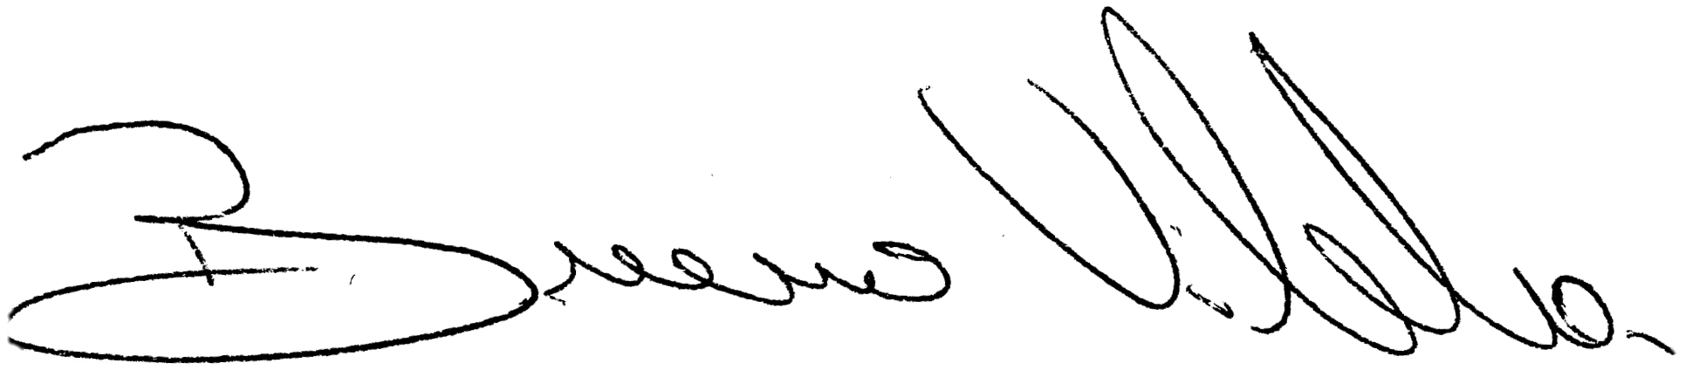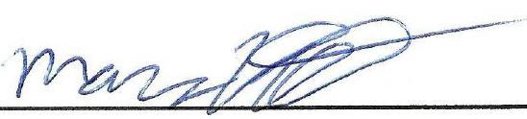
Bruno Vilela, PhD Marcos V. C. Vital, PhD Filipe A. Nascimento, Msc
Postdoctoral Researcher, WUSTL Adjunct Professor, UFAL PhD student, UFMG
(bvilela@wuslt.edu) (marcosvital@gmail.com) (filipe.bio@gmail.com)

