## July 17th, 2017

## Dear EDITOR Dr. Hugo Bornatowski

ASSOCIATED Editor

Oecologia australis

I am submitting the manuscript “Ecology of habitat choice by *Macrobrachium brasiliense* (Heller, 1862) (Crustacea, Decapoda, Palaemonidae) on different substrates and microhabitats”, by Caio dos Santos Nogueira, Tânia Marcia Costa and Ariádine Cristine Almeida, to be considered for publishing in **Oecologia Australis**. All authors have agreed to the submitted version of the manuscript.

This research and its results were not published in other journals and were not submitted simultaneously in another journal.

We should notice you that the correction of the English and suggestion about of the MS was made by “Ana Clara Monte Teixeira (Editor, Portuguese – English Translator, English Consultant)”.

Additionally, I am suggesting the names of five referees and their respective email address:

1. Dra. Laura Lopez Greco

University of Buenos Aires · Department of Biodiversity and Experimental Biology

Email: laura@bg.fcen.uba.ar

2. Dr. Klaus Anger

Alfred Wegener Institute for Polar and Marine Research · Abteilung

Email: [Klaus.Anger@awi.de](mailto:Klaus.Anger@awi.de)

3. Dr Fabiano Gazzi Taddei

Universidade do Estado do Amazonas · Centro de Estudos Superiores de Parintins

Email: fgtaddei@hotmail.com

4. Dr Fulvio Aurelio de Morais Freire

Departamento de Botânica, Ecologia e Zoologia - DBEZ  
Universidade Federal do Rio Grande do Norte

fulvio@cb.ufrn.br

5. Dra Cibele Soares Pontes

Universidade Federal do Rio Grande do Norte, Centro de Tecnologia, Unidade Acadêmica Especializada em Ciências Agrárias - Campus Macaíba.

cibelepontes.ufrn@yahoo.com.br

I look forward to hearing your response to our submission.

Sincerely,

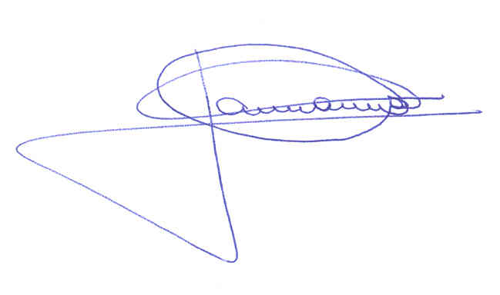

Ariádine Cristine de Almeida Tânia Marcia Costa

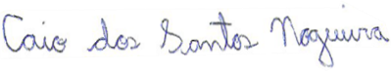

Caio dos Santos Nogueira

Faculdade de Ciências - Universidade Estadual Paulista

Av. Eng. Luís Edmundo Carrijo Coube, 2085, Bauru, 17033-360, São Paulo, Brazil

Telephone number: 55 (17) 99198-4143. Email: caiosnogueira@hotmail.com