Dear editor-in-chief,
We are writing to submit our manuscript entitled, “Protection mutualism: an overview of ant-plant interactions mediated by extrafloral nectaries”, for consideration in the special volume "Ecology and Evolution of Interactions" of Oecologia Australis.
This study provides and improves the knowledge about protection mutualism considering ant-plant interactions and can provide new ideas and perspectives for studies that will help in a better understanding of the ecological interactions and the ecosystem as a whole. Thank you for receiving our manuscript and considering it for review. All authors agree on the publication, which has not been published or submitted to any other journal.
Bellow, we have included the name of 5 independent referees:
Referee 1:
Name: Vanessa Stefani Sul Moreira
Affiliation: Universidade Federal de Uberlândia, Brazil
E-mail: vastefani@hotmail.com

Referee 2:
Name: Jean Carlos Santos
Affiliation: Universidade Federal de Uberlândia, Brazil
E-mail: jcsantos@inbio.ufu.br

Referee 3:
Name: Suzanne Koptur
Affiliation: Florida International University, USA
E-mail: kopturs@fiu.edu

Referee 4:
Name: Armando Aguirre Jaimes
Affiliation: Instituto de Ecología, A.C. – INECOL, Mexico
E-mail: armando.aguirre@inecol.mx

Referee 5:
Name: Helena Maura Torezan Silingardi
Affiliation: Universidade Federal de Uberlândia, Brazil
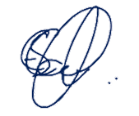
E-mail: hmtsilingardi@gmail.com
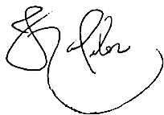

Eduardo Soares Calixto Denise Lange Kleber Del-Claro

