College of Sciences and Mathematics
Department of Biological Sciences

7 December 2016

Dear Dr. Natalie Olifiers,

My co-authors and I are submitting a short communication entitled “The effects of artificial crab spiders (Misumenops spp.) on Piper pollinator behaviour in Costa Rica: differences between insect orders” for exclusive consideration of publication as an article in Oecologia Australis. This short communication investigates the influence of artificial spider models, in an open field setting, on pollination of Piper plants.

We certify that this manuscript has never been published and has not been submitted to any other journal. All authors declare no conflicts of interests. Five potential reviewers (all of which are cited in our short communication) are indicated below.

Potential Reviewers:
- Astrid M. Heiling, Department of Biological Sciences, Macquarie University
  - Email: astrid.heiling@univie.ac.at
- Reuven Dukas, Department of Psychology, McMaster University
  - Email: dukas@mcmaster.ca
- Gustavo Q. Romero, Department of Zoology and Botany, Sao Paulo State University
  - Email: gq_romero@yahoo.com.br
- Thiago Goncalves-Souza, Department of Biology, Federal Rural University of Pernambuco
  - Email: tgoncalves.souza@gmail.com
- Lars Chittka, Research Centre for Psychology at Queen Mary, University of London
  - Email: l.chittka@qmul.ac.uk

Thank you for considering our manuscript. Please contact me if you have any questions regarding the submission.

Sincerely,
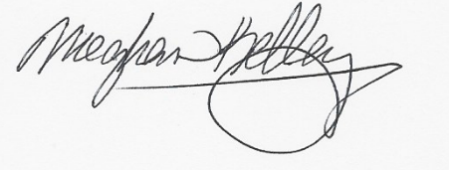
Meghan D. Kelley, M.S.
Department of Biological Sciences
Auburn University
+1 734.731.4048 mdk0014@auburn.edu
Markus Creachbaum, B.S.
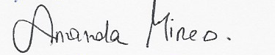
Amanda Mineo, B.S.

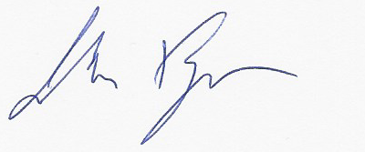
John W. Finger Jr., Ph.D.

