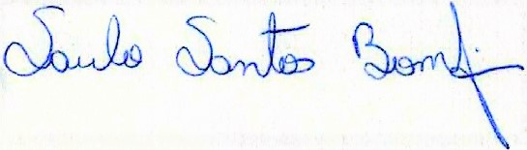
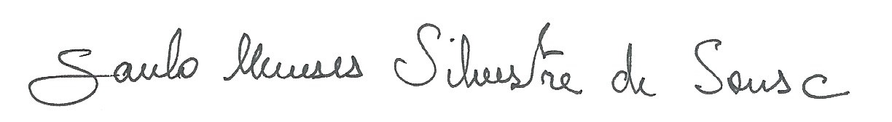
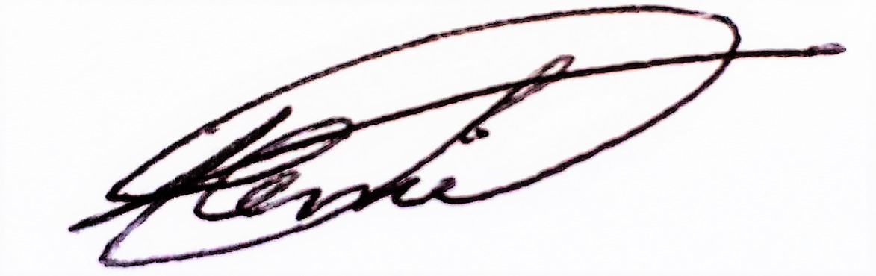
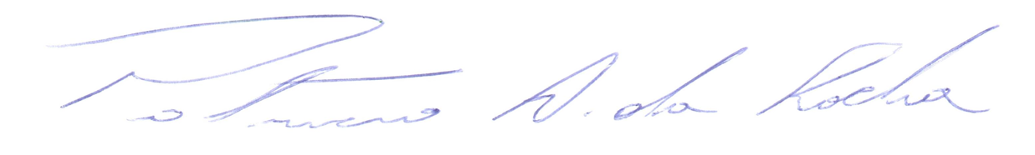
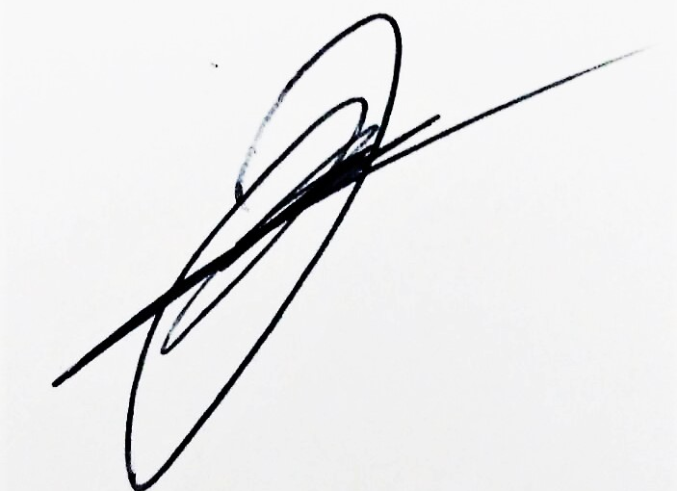
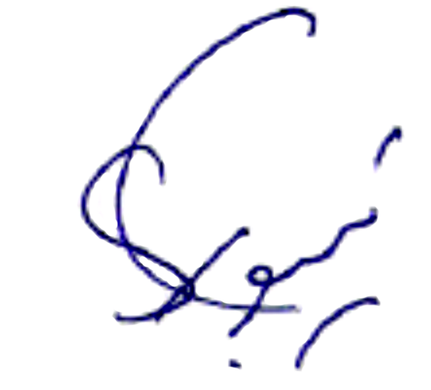
Dear editor,

Please find attached a copy of our manuscript entitled “Phylloderma stenops Peters, 1865 (Chiroptera, Phyllostomidae): first record for the state of Sergipe”, which we hope you will consider for publication in Oecologia Australis.
We, the authors, declare that we are in agreement with the publication of the submited article. Furthemore, we declare that the followinng article has not been published elsewhere, nor has it been simutaneously submitted in other journal.
We suggest the following referees:
- Marcelo Nogueira, Universidade Estadual do Norte Fluminense, nogueiramr@gmail.com
- Marlon Zortéa, Universidade Federal de Goiás, mzortea@uol.com.br
- Renato Gregorin, Universidade Federal de Lavras, rgregorin@dbi.ufla.br
- Anderson Feijó, Universidade Federal da Paraíba, andekson@gmail.com
- Fabio Soares, Universidade Federal da Bahia, fabiosoares9@gmail.com
Yours faithfully,

Saulo S. Bomfim
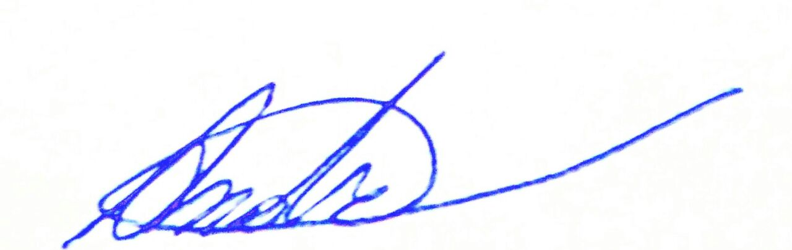

André R. Criscoulo

Juan M. Ruiz-Esparza

Stephen F. Ferrari

Saulo M. Silvestre de Sousa

Isadora C. Hamsi

Patrício A. Rocha

