Helio Secco
Universidade Federal do Rio de Janeiro
Núcleo em Ecologia e Desenvolvimento Sócio-Ambiental de Macaé
CEP 27965-045 Macaé, RJ, Brazil.
September 16, 2016
To the Editor-in-Chief,

As invitation letter received by editor Alexandra M. R. Bezerra, please find enclosed a manuscript entitled ROAD AND LANDSCAPE FEATURES THAT AFFECT BAT ROADKILLS IN SOUTHEASTERN BRAZILIAN ROAD that we would like to submit for publication to Oecologia Australis as an Original Article, in special issue edition “Environmental impacts: case studies in South America”.

The submitted work has not been published or accepted for publication elsewhere, this is the first submission of the manuscript. The document has 13 printed pages (including title page, figures and references), 4 figures, and 3 tables. All authors agree to its submission. Finally, all appropriate ethics and other approvals were obtained for the research.

The death of animals by roadkills is the most studied impact on road ecology, but some potentially susceptible faunal groups still lack information about the relationship between the species and the disturbances caused by roads, as well as the dynamics of mortality. This is a pioneer work in Brazil since it aimed to: 1) list the roadkill species of bats; 2) evaluate the existence of temporal variation of the roadkill rate; 3) to evaluate the existence of specific road portions with higher incidence of roadkill; 4) identify the road/landscape characteristics which are decisive on roadkill occurrence. Our results show that the increase in vehicle traffic combined with the reduction of pastures and forests associated to road margins intensify the occurrence of roadkills. We believe that the results found in this study contribute to the definition of mitigation measures of the road impacts on bats.

Yours sincerely,
Helio Secco Luis Augusto Gomes Hudson Lemos
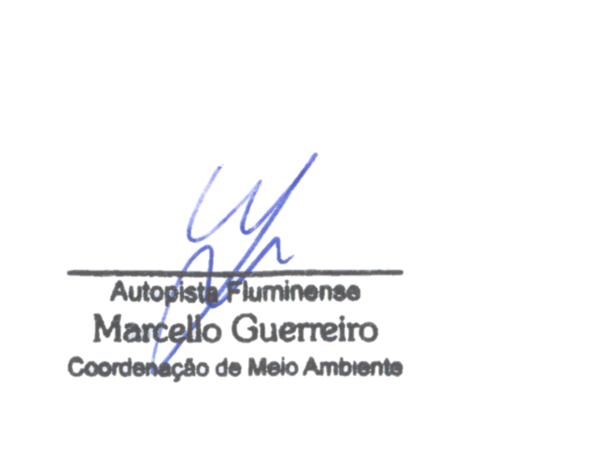
Felipe Mayer Thiago Machado Marcello Guerreiro

Renato Gregorin

