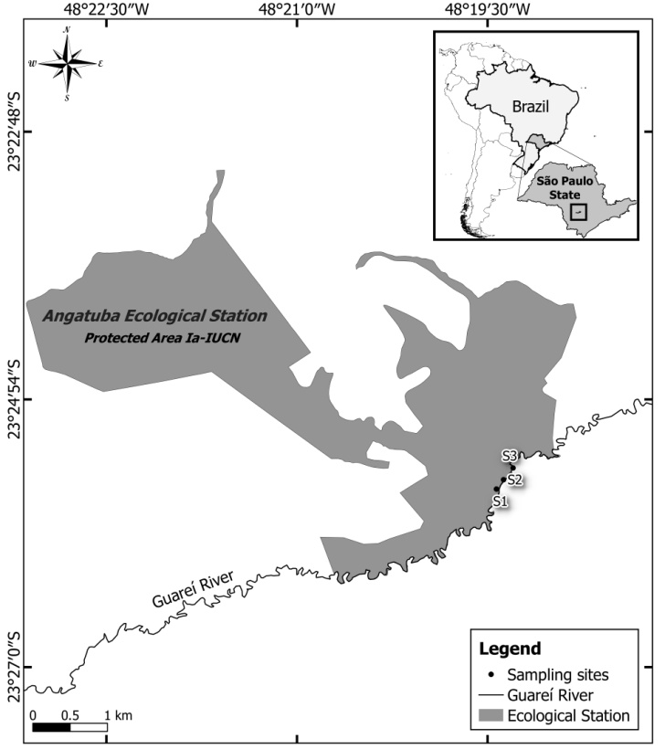

**Figure 1.** Study area: Angatuba Ecological Station (São Paulo, Brazil) and the three sampling sites on a stretch of Middle Guareí River.

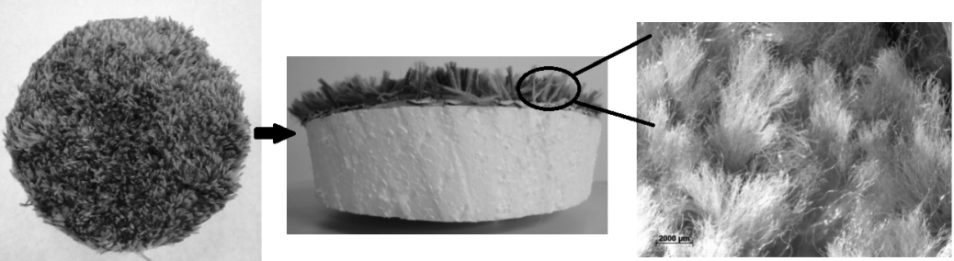

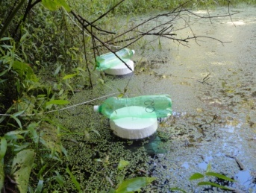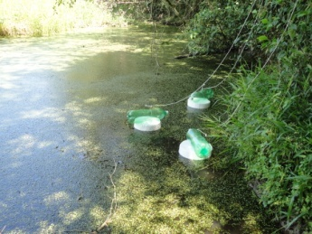

**Figure 2.** Artificial substrate sampler made of polyester carpet and experimental design with the position of artificial substrate samplers on the margin of Guareí River.



**Figure 3.** Daily precipitation (mm) at Angatuba Ecological Station from December 2012 to January 2013 (Note the difference in scales; the arrows indicate the sampling days).







**Figure 4.** Means ± SD (N=3) of water temperature (A), dissolved oxygen and percent saturation (B), pH (C), organic and inorganic suspended matter (D), electrical conductivity (E) and transparency (F) on the plain lateral to the Guareí River on successive sampling days from December 2012 to January 2013 (Note the difference in scales).



**Figure 5.** Means ± SD (N=3) of total pigments from water samples (A) and dry biomass of *R. natans* and *S. intermedia* (B) on the plain lateral to the Guareí River on successive sampling days from December 2012 to January 2013.







**Figure 6.** Mean ± SD (N=3) of the total density of macroinvertebrates associated with macrophytes (ind.m-2) (A) and on the artificial substrate (B), daily rates of variation of abundance (ind.day-1) (C), and richness of macroinvertebrates (taxa.day-1) colonizing the artificial substrate (D); total taxonomic richness of fauna associated with macrophytes (E) and on the artificial substrate (F) on the plain lateral to the Guareí River in successive sampling days from December 2012 to January 2013 (note the difference in scales).







**Figure 7.** Mean (N=3) of the total density (ind.m-2) of macroinvertebrate taxa in macrophytes (A) and on the artificial substrate (B) on the plain lateral to the Guareí River on successive sampling days from December 2012 to January 2013 (note the difference in scales).





**Figure 8.** Mean (N=3) of total density (ind.m-2) of the different orders of Insecta associated with macrophytes (A) and with the artificial substrate (B) on the plain lateral to the Guareí River on successive sampling days from December 2012 to January 2013 (note the difference in scales).







**Figure 9.** Means (N=3) of relative abundance (%), total abundance and standard-deviation (±) of macroinvertebrates associated with macrophytes (A) and on the artificial substrate (B) on the plain lateral to the Guareí River on successive sampling days from December 2012 to January 2013.

**Table 1.** Correlation of environmental variables and photosynthetic total pigments measured on successive sampling days on the plain lateral to the Guareí River between December 2012 and January 2013 from the Principal Component Analysis (PCA) with two first axes (PC1 and PC2).

|  |  |  |
| --- | --- | --- |
| **Abiotic variables** | **PC1** | **PC2** |
| Water pH (pH) | 0.469 | -0.205 |
| Water electrical conductivity (K) | 0.395 | 0.615 |
| Dissolved oxygen (DO) | -0.04 | -0.226 |
| Water temperature (TEMP) | 0.704 | 0 |
| Total suspended matter (TSM) | 0.135 | -0.342 |
| Organic suspended matter (OM) | 0.192 | 0.015 |
| Inorganic suspended matter (IM) | 0.075 | -0.44 |
| Total pigments (TPigm) | 0.104 | 0.197 |
| Transparency (Transp) | -0.236 | 0.423 |

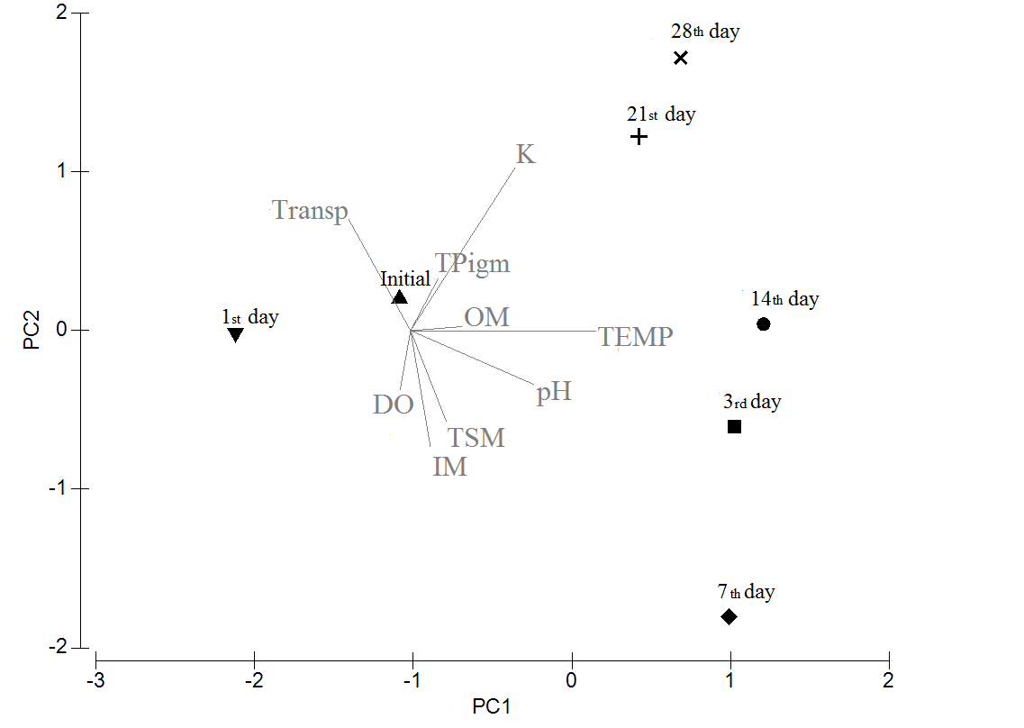

**Figure 10.** Ordination of the successive sampling days (December 2012 to January 2013) by Principal Component Analysis (PCA – axes 1 and 2) for the environmental variables and photosynthetic total pigments measured on the plain lateral to the Guareí River.

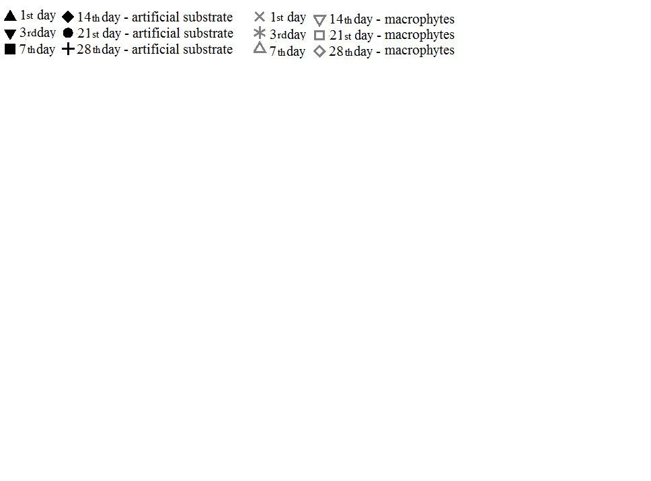

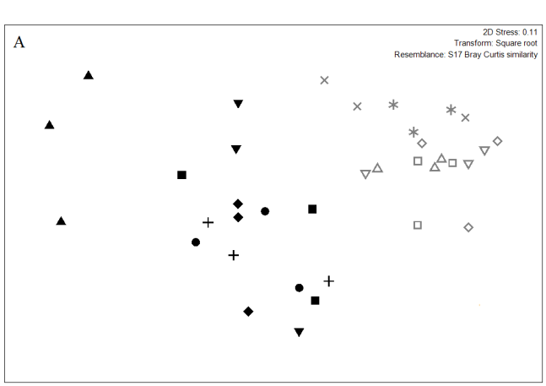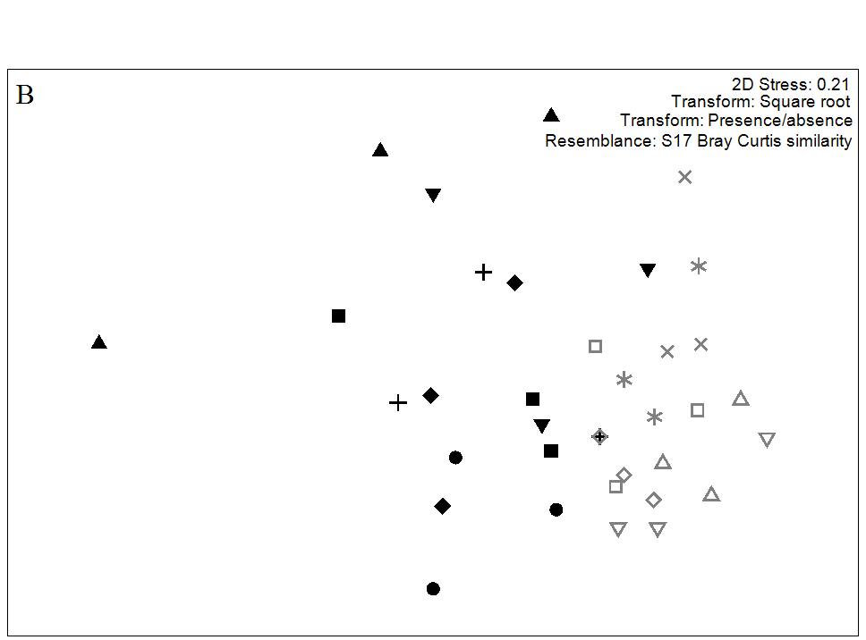

**Figure 11.** NMDS analysis of density (ind.m-2) (A) and composition (B) of macroinvertebrates associated with the artificial substrate and the macrophytes on the plain lateral to the Guareí River on successive sampling days from December 2012 to January 2013.