Dr. Natalie Olifiers, Chief Editor February 1st, 2017

Oecologia Australis

Dear Dr. Natalie Olifiers,

Please find enclosed a manuscript entitled: "Climate-driven variation in the use of space of the neotropical marsupial Metachirus nudicaudatus" which we are submitting for exclusive consideration of publication as a short communication in Oecologia Australis.
In the present study, we show that climatic seasonality drives marsupial's space use in tropical forests. We used 6-year dataset of a long-term ecological study initiated in 1997, to monitor small mammal populations, to test several hypotheses regarding the effects of climate, reproductive season, and population size on the daily home range area and the intensity of habitat use of the neotropical marsupial Metachirus nudicaudatus. As expected, individuals of Metachirus nudicaudatus explored larger areas in the dry season, probably in search for food resources. We detected no effect of population size on M. nudicaudatus spatial arrangement, corroborating previous results of the long-term study - intraspecific competition for food is the main regulatory mechanism of M. nudicaudatus population.
As such this paper should be of interest to a broad readership of this journal including those interested in space use, population dynamics and regulation, climatic seasonality, and mammals.

Knowledgeable referees for this paper might include*:
- Clarisse R. Rocha - Universidade de Brasília, Brazil (rocha.clarisse@gmail.com)
- Alex J. de Almeida - Pontifícia Universidade Católica de Minas Gerais, Brazil (alexjosebio@gmail.com)
- Sonia Aparecida Talamoni - Pontifícia Universidade Católica de Minas Gerais, Brazil (talamoni@pucminas.br)
- Ricardo Augusto Serpa Cerboncini - Universidade Federal de Lavras, Brazil (ricardocerboncini@gmail.com)
*All reviewers have published papers on mammal/marsupial space use.

This manuscript was not published before or accepted for publication, nor is under consideration for publication elsewhere. All authors agree on the content and were properly named on this submission.

Thank you for your consideration.

Sincerely,

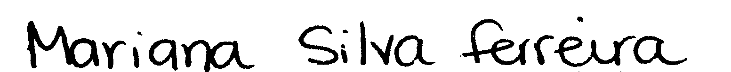

Mariana Silva Ferreira

PLEASE SEND CORRESPONDENCE TO:
Mariana Silva Ferreira
Universidade Veiga de Almeida
Rua Ibituruna, 108, Maracanã, Rio de Janeiro, RJ, CEP 20271-901, Brazil
E-mail: msferreira84@gmail.com

