Table 1. Total of individuals collected at Fora Beach and Urca Beach With trample (Tr) and Without Trample (Wt), Rio de Janeiro, 2012.

 | Urca |  | Fora |  | Urca |  | Fora |  | Urca |  | Fora |  | Urca |  | Fora
 | June |  |  |  | August |  |  |  | October |  |  |  | December
Treatment | Wt | Tr | Wt | Tr | Wt | Tr | Wt | Tr | Wt | Tr | Wt | Tr | Wt | Tr | Wt | Tr
POLYCHAETA
Capitella jonesi | 1 | 2 | 0 | 0 | 8 | 8 | 0 | 0 | 2 | 1 | 2 | 2 | 0 | 0 | 2 | 1
Opheliidae | 0 | 0 | 0 | 0 | 0 | 0 | 0 | 0 | 0 | 0 | 0 | 1 | 0 | 0 | 0 | 0
Syllidae n.id. | 0 | 0 | 0 | 0 | 0 | 3 | 0 | 0 | 1 | 0 | 0 | 0 | 4 | 5 | 0 | 0
Saccocirrus pussicus | 0 | 0 | 0 | 0 | 208 | 307 | 0 | 0 | 1454 | 3302 | 1 | 1 | 165 | 28 | 0 | 0
CRUSTACEA
Amphipoda n.id. | 1 | 12 | 2 | 0 | 11 | 0 | 0 | 0 | 0 | 18 | 0 | 0 | 1 | 1 | 0 | 0
TURBELLARIA n.id. | 0 | 0 | 4 | 3 | 0 | 0 | 0 | 2 | 0 | 0 | 4 | 5 | 0 | 1 | 0 | 0
NEMATODA n.id. | 52 | 167 | 41 | 31 | 35 | 42 | 5 | 7 | 41 | 29 | 12 | 15 | 74 | 64 | 72 | 22

Table 2. Total of individuals collected at Fora Beach and Urca Beach during Week days (DW) and on Weekend (WE), Rio de Janeiro, 2012.
 |  | Urca |  | Fora |  | Urca |  | Fora
 |  | Winter |  |  |  | Summer
Treatment |  | DW | WE | DW | WE | DW | WE | DW | WE
POLYCHAETA
Syllidae n.id. |  | 2 | 0 | 0 | 0 | 0 | 1 | 0 | 0
Saccocirrus pussicus |  | 546 | 0 | 0 | 0 | 593 | 17 | 0 | 0
CRUSTACEA
Amphipoda n.id. |  | 0 | 24 | 0 | 0 | 0 | 11 | 0 | 0
Emerita brasiliensis (Decapoda) |  | 0 | 0 | 4 | 0 | 0 | 0 | 0 | 1
Macrochiridothea sp. (Isopoda) |  | 0 | 0 | 1 | 1 | 2 | 0 | 0 | 0
TURBELLARIA n.id. |  | 0 | 0 | 1 | 5 | 0 | 0 | 0 | 4
NEMATODA |  | 130 | 289 | 13 | 42 | 15 | 77 | 22 | 35

Table 3. Mean density of benthic fauna during June to December/2012 at Fora and Urca Beaches (Wt: Without trample; Tr: With trample).
 | Fora Beach |  | Urca Beach
Month | Wt | Tr | Wt | Tr
June | 10,8 | 7,4 | 10,8 | 34,2
August | 1,2 | 1,8 | 52,4 | 72
October | 4,2 | 5,3 | 299 | 670
December | 15 | 4,6 | 48,8 | 24,2

Table 4. People passing by amostral area, Urca Beach and Fora Beach. Rio de Janeiro, 2012 (DW: During the Week; WE: Weekend).
 | Urca Beach |  | Fora Beach
 | DW | WE | DW | WE
Winter | 8 | 54 | 12 | 0
Summer | 0 | 437 | 0 | 10

Table 5. Mean density of benthic fauna during Winter and Summer/2012 at Urca and Fora beaches (DW: During the Week; WE: Weekend).
 | Urca Beach
 | DW | WE
Winter | 143 | 70,2
Summer | 122,6 | 21,8
 | Fora Beach
 | DW | WE
Winter | 4 | 10,7
Summer | 4,6 | 8,2

Table 6. Richness of benthic fauna at Urca and Fora beaches, in the samples during Winter and Summer/2012 (DW: During the Week; WE: Weekend).
Season | Winter |  | Summer
 | DW | WE | DW | WE
Urca Beach | 5 | 4 | 3 | 4
Fora Beach | 4 | 3 | 1 | 3

Table 7. Richness of benthic fauna at Urca Beach and Fora Beach, during June to December/2012 (Wt: Without trample; Tr: With trample).
Month | June |  | August |  | October |  | December
 | Wt | Tr | Wt | Tr | Wt | Tr | Wt | Tr
Urca Beach | 3 | 3 | 4 | 4 | 4 | 4 | 4 | 5
Fora Beach | 4 | 3 | 2 | 2 | 5 | 5 | 3 | 2

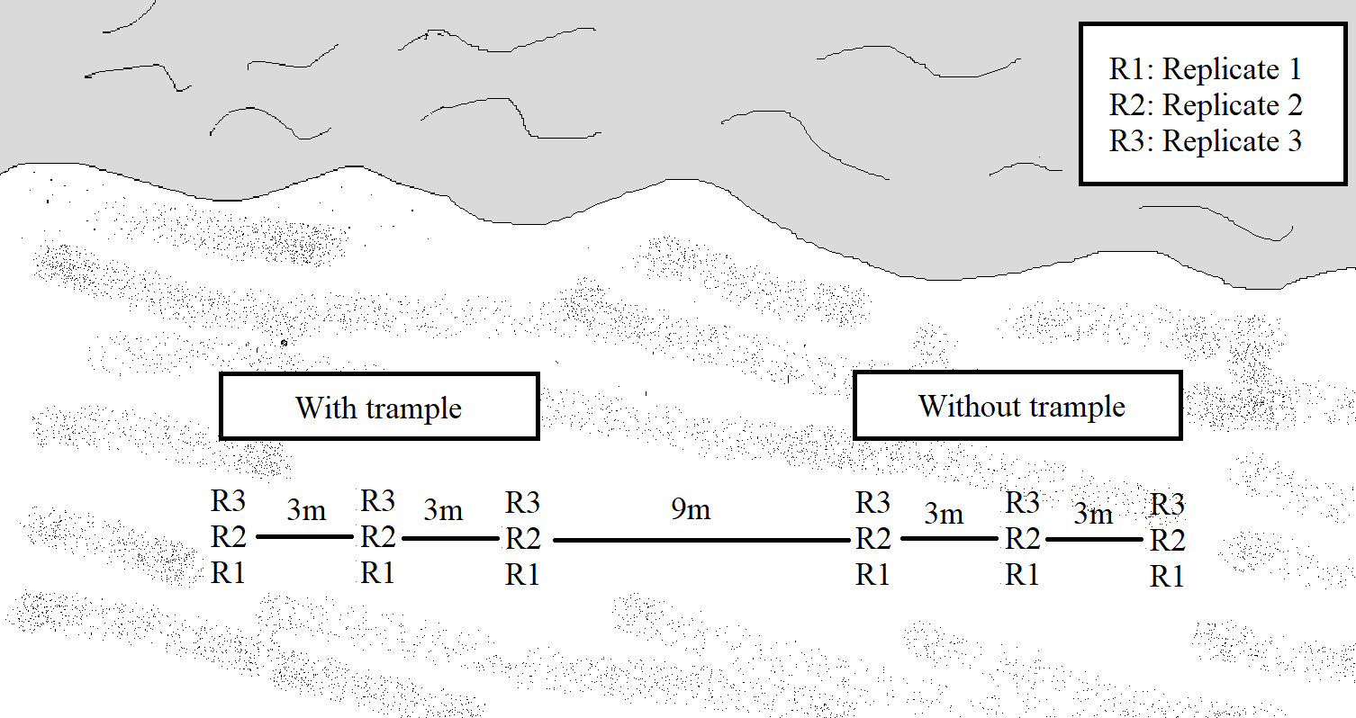
Figure 1. Sampling design organized by treatments: With Trample (Tr) and Without Trample (Wt).
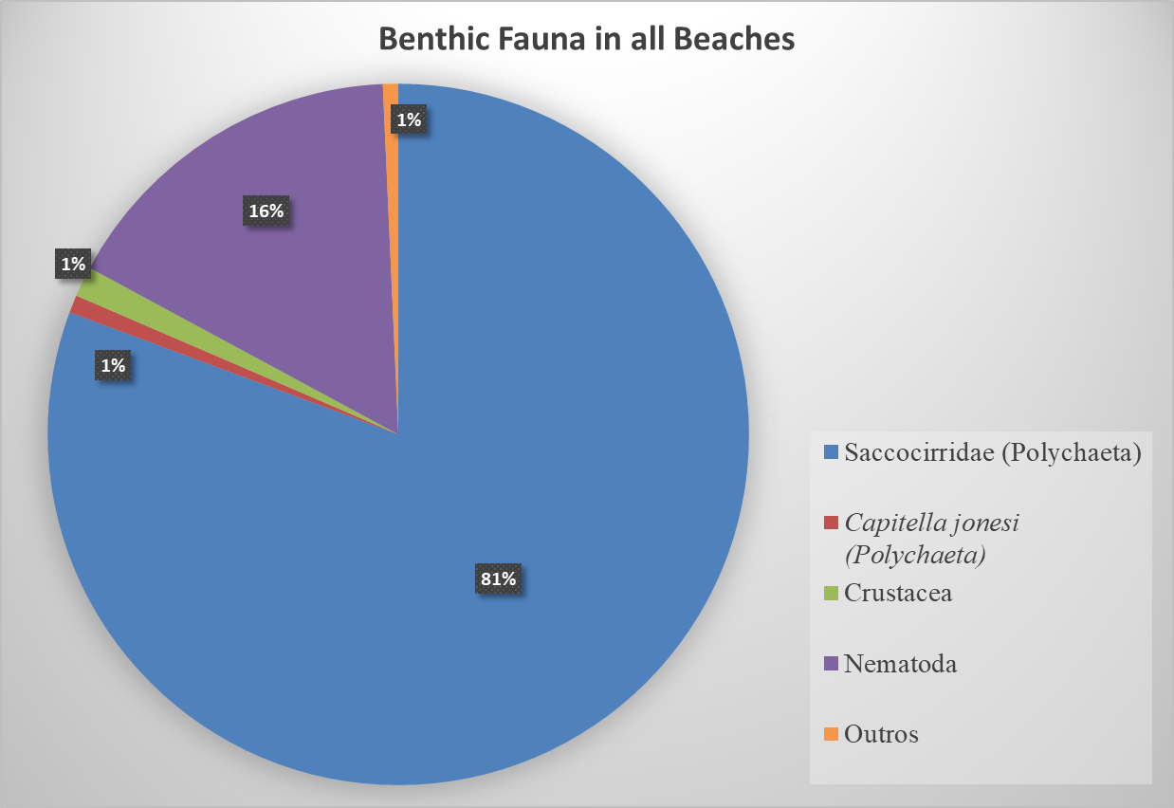
Figure 2. Percentage contribution of the benthic fauna found at Urca and Fora beaches in all treatments (Rio de Janeiro, Brazil).
Figure 3. Mean differences between Week X Weekend seasonal treatment in Urca and Fora beaches (Rio de Janeiro, Brazil).

Figure 4. Mean differences between Without trample X Trample treatment in Urca and Fora beaches (Rio de Janeiro, Brazil).

