

December 16, 2018

Dear Editor:

Please, consider the manuscript, “Abiotic factors affect the organization of spider communities in an Atlantic Forest fragment”, for publication in Oecologia Austalis as an original article. In this manuscript, a survey of spiders in a Mixed Ombrophilous Forest fragment (Araucárias Municipal Park, Guarapuava, Paraná state, Brazil) was carried out. A total of 5,285 spiders were obtained, distributed in 138 morphospecies, belonging to 23 families. The Araneidae family was the most abundant (N = 524) and Theridiidae was the richest (31 spp.). The richness estimates varied between 165 species for Chao 1 and 166.8 for Chao 2. The number of species recorded was relatively high compared to other surveys in subtropical regions, however none of the estimators exhibited a tendency to reach the asymptote. The greatest abundance of adult individuals and the greatest richness were recorded in the hot and rainy season, with the temperature being one of the factors responsible for this pattern. Although these results point out that there are seasonal periods in the diversity and abundance of the spiders, new studies could clarify if other factors also influence the araneofauna of this region. We hope you find our study suitable for publication in Oecologia Australis.
This manuscript is not under consideration for publication elsewhere, wasn’t sent simultaneously to another journal and has not been made publically available online. All authors have approved its submission, and all persons entitled to authorship are listed and contributed directly to the preparation of the manuscript.
Sincerely,

Prof. Msc Renan de Brito Pitilin
Instituto de Biologia, Universidade Federal de Uberlândia (MG), Brazil. E-mail pitilin_tj@hotmail.com

Prof. Dr Antonio domingos Brescovit

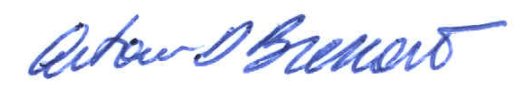

Prof. Drª Maria Luisa Tunes Buschini

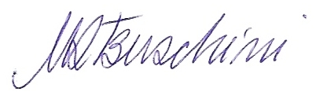

Indication of referees

(1) Everton Nei Lopes Rodrigues - enlrodrigues@yahoo.com.br
Universidade do Vale do Rio dos Sinos, Centro de Ciências da Saúde, Programa de Pós-Graduação em Biologia.

(2) Adalberto José dos Santos - oxyopes@yahoo.com
Universidade Federal de Minas Gerais, Instituto de Ciências Biológicas, Departamento de Zoologia.

(3) Jimmy Jair Cabra García - jimjacag@gmail.com
Universidade de São Paulo, Instituto de Biociências.

(4) Leonardo Souza Carvalho - carvalho@ufpi.edu.br
Universidade Federal do Piauí, Campus Amílcar Ferreira Sobral.

(5) João Vasconsellos Neto - jvascont@unicamp.br
Universidade Estadual de Campinas, Instituto de Biologia, Departamento de Zoologia.

