Dear Editor Dra. Ana Claudia Delciellos,

We are submitting our manuscript “Report of injuries in batoids caught in small-scale fisheries: implications for management plans” for consideration as article in Journal Oecologia Australis. It describes original work, intellectual property of the authors, all authors are in agreement about its release, and it is not being considered for publication elsewhere.
The evaluation of physical and physiological conditions is imperative for a better understanding of the impacts caused by fishing, as a way to improve management plans and reduce the impacts of bycatch. This study was a first attempt to identify injuries in elasmobranchs caused by shrimp trawling fisheries in Brazil.
Based on our results, we registered three threatened endemic ray-species caught by shrimp-fisheries (Pseudobatos horkelli, Zapteryx brevirostris and Narcine brasiliensis), with several injuries in body, being the P. horkelii listed as critically endangered in the IUCN red list. In a recent paper, Davidson & Dulvy (2017 – Nature Ecology & Evolution, n.40) considered the Brazil as an international hotspot, and among the top ten chondrichthyan fishing countries in the world. In addition, Brazil has high conservation value based on high number of chondrichthyan endemism.
Therefore, based on our results and in the importance of Brazil, we strongly encourage and recommend a greater care is taken in the management of captured bats, encouraging the immediate release of these animals regardless of the level of injury, as a way to reduce the impacts of bycatch on elasmobranch populations by small scale fisheries in Southeastern Brazil.

Thanks for the attention,
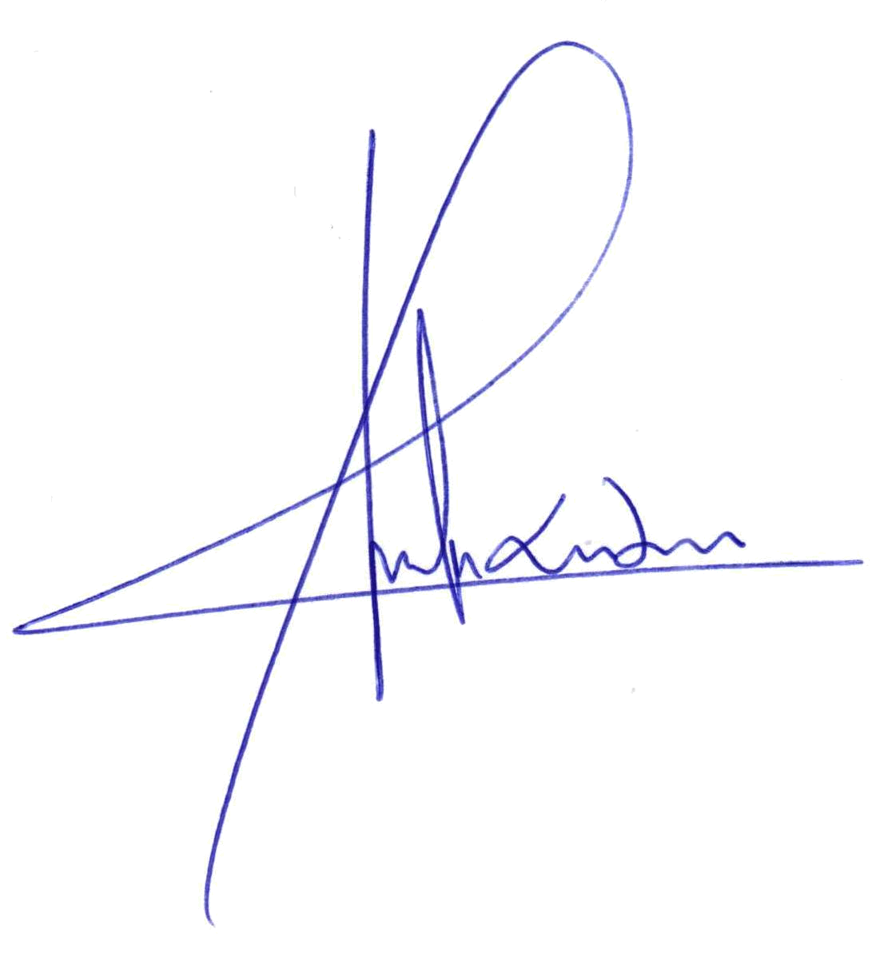
Sincerely,

Alexandre Rodrigues

Bianca de Sousa Rangel, NataschaWosnick, Hugo Bornatowski, Jorge Luís Santos, Renata Guimarães Moreira, Alberto Ferreira de Amorim.

Indication of five independent referees:

- Jones Santander Neto
jones.santander@ifes.edu.br
Engenharia de Pesca, Instituto Federal de Ciência e Tecnologia do Espírito Santo, Campus Piúma.

- Maria Lúcia Góes de Araújo
malugaraujo@gmail.com
Departamento de Pesca e Aquicultura, Universidade federal de Sergipe

- Rosangela Lessa
rptlessa@gmail.com
DIMAR-Departamento de Pesca e Aquicultura, Universidade Federal Rural de Pernambuco

- Fabio dos Santos Motta
limbatus@gmail.com
Laboratório de Ecologia e Conservação Marinha (LABECMAR), Departamento de Ciências do Mar, Universidade Federal de São Paulo - UNIFESP

- Roberto da Graça Lopes
robgralopes@pesca.sp.gov.br
Centro Avançado de Pesquisa Tecnológica do Agronegócio do Pescado Marinho, Instituto de Pesca, SAA.

