Cover Letter

By the Editorial Board Oecologia Australis

Dear Sirs (a):

We are submitting the manuscript entitled: "POPULATION DYNAMICS AND RECRUITMENT OF ODONTOSTILBE PARAGUAYENSIS (CHARACIFORMES: CHARACIDAE) IN THE PARAGUAY RIVER, PANTANAL, BRAZIL" for reviewing and possible publication in the journal Oecologia Australis in the special issue on "ECOLOGY OF WETLANDS". The paper was submitted on the journal`s website. The authors have seen and are in agreement and attest that the manuscript is original and has not been published or submitted for publication in any other journal or scientific journal.

Referees:
- Lúcia Aparecida de Fátima Mateus, UFMT, lafmateus@gmail.com
- Éder André Gubiani, UNIOESTE, egubiani@yahoo.com.br
- Luzia da Silva Lourenço, Faculdade São Rolim de Moura, bioluzia@gmail.com
- Alexandro Cezar Florentino, UNIFAP, alexandrocezar@gmail.com
- Ursulla Pereira Souza, Unisanta, upsouza@gmail.com

With kind regards,

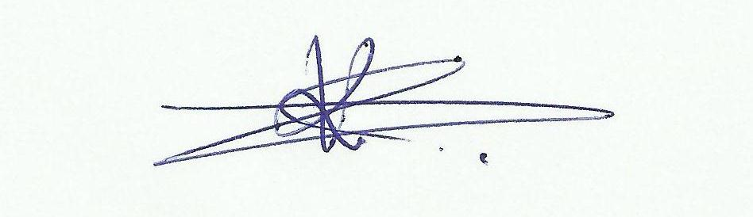
Karina Keyla Tondato

