Supplementary Material 1. Anamaria heterophylla (Plantaginaceae). Details of the aquatic habit, heterophily, acrodrome venation and thirsoid inflorescence with ramifications in dicasio. Photos by Siqueira- Filho, J. A. (2009), available in Herbarium of the Universidade Federal do Vale do São Francisco (HVASF) http://www.hvasf.univasf.edu.br/index.php?page=dados
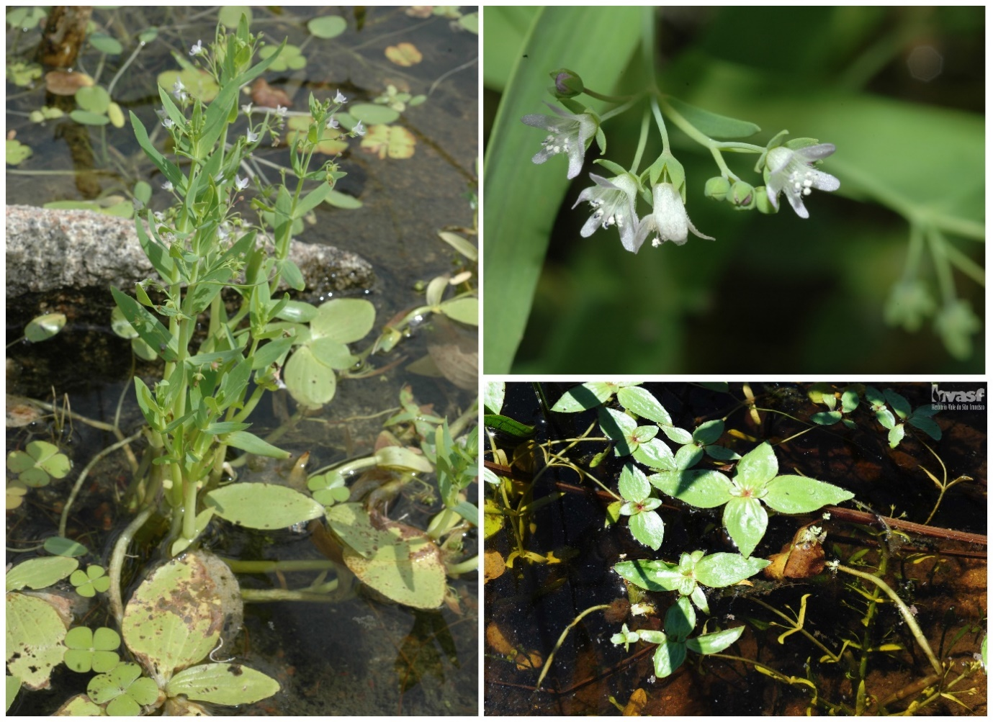

Supplementary Material 2. Records of Anamaria heterophylla accurate and without influence of spatial autocorrelation bias.
Records | Herbarium | Coordinates in decimal degrees (DD) |  | City/State
 |  | Longitude | Latitude
1 | BAH | -43,361944 | -13,403889 | Bom Jesus da Lapa/BA
2 | MOBOT_BR | -43,21666 | -13,16666 | Bom Jesus da Lapa/BA
3 | MBM | -42,781398 | -14,22329 | Guanambi/BA
4 | HVASF | -41,344 | -4,980055556 | Buriti dos Montes/PI
5 | HTSA | -41,235833 | -9,533611 | Casa Nova/BA
6 | HUEFS | -41,185833 | -9,26 | Casa Nova/BA
7 | HUEFS | -40,821111 | -9,482222 | Sobradinho/BA
8 | HTSA | -40,603056 | -9,285278 | Petrolina/PE
9 | IAC | -40,577778 | -9,531667 | Juazeiro/BA
10 | HVASF | -40,54963889 | -9,331583333 | Petrolina/PE
11 | ESA | -40,533333 | -4,816667 | Nova Russas/CE
12 | HVASF | -40,447361 | -9,207917 | Petrolina/PE
13 | HVASF | -40,367917 | -9,198528 | Petrolina/PE
14 | NYBG_BR | -40,21 | -12,76 | Iaçu/BA
15 | HTSA | -40,201944 | -8,035278 | Ouricuri/PE
16 | ESA | -40,15 | -6,183333 | Arneiroz/CE
17 | HTSA | -40,115 | -9,524722 | Juazeiro/BA
18 | HVASF | -39,596667 | -8,144167 | Parnamirim/PE
19 | NYBG_BR | -39,3856 | -11,8069 | Riachão do Jacuípe/BA
20 | ESA | -38,2983 | -7,99194 | Serra Talhada/PE
21 | HVASF | -37,78322222 | -8,334472222 | Custódia/PE
22 | HVASF | -37,715306 | -8,255694 | Custódia/PE
23 | HUEFS | -37,561389 | -9,699167 | Pão de Açúcar/AL
24 | EAC | -37,357222 | -6,221944 | São José do Brejo do Cruz/PB
25 | EAC | -37,169444 | -6,683333 | São João do Sabugi/RN
26 | HUEFS | -36,588611 | -5,905556 | Santana do Matos/RN

Supplementary Material 3. Eigenvalues of the variables for the significant axes of PCA.
Variables |  | Axis 1 | Axis 2 | Axis 3 | Axis 4
ai | Aridity index | 0.0913 | 0.3626 | 0.3064 | 0.1169
alt | Elevation | 0.2177 | 0.1293 | 0.3108 | 0.1335
bio1 | Annual Mean Temperature | 0.2898 | 0.0384 | 0.1468 | 0.0998
bio2 | Mean Diurnal Range (Mean of monthly (max temp - min temp | 0.0508 | 0.3488 | 0.2846 | 0.2958
bio3 | Isothermality (bio2/bio7) (* 100) | 0.2093 | 0.1071 | 0.0976 | 0.1842
bio4 | Temperature Seasonality (standard deviation *100) | 0.2327 | 0.0032 | 0.1929 | 0.2184
bio5 | Max Temperature of Warmest Month | 0.2651 | 0.1397 | 0.0378 | 0.2566
bio6 | Min Temperature of Coldest Month | 0.2619 | 0.1309 | 0.2456 | 0.074
bio7 | Temperature Annual Range (bio5-bio6) | 0.0312 | 0.3235 | 0.2676 | 0.3838
bio8 | Mean Temperature of Wettest Quarter | 0.2511 | 0.138 | 0.1922 | 0.0983
bio9 | Mean Temperature of Driest Quarter | 0.2816 | 0.0813 | 0.163 | 0.0401
bio10 | Mean Temperature of Warmest Quarter | 0.2777 | 0.029 | 0.1875 | 0.154
bio11 | Mean Temperature of Coldest Quarter | 0.2996 | 0.0212 | 0.0682 | 0.0415
bio12 | Annual Precipitation | 0.1496 | 0.283 | 0.3332 | 0.1924
bio13 | Precipitation of Wettest Month | 0.2164 | 0.2046 | 0.2966 | 0.0476
bio14 | Precipitation of Driest Month | 0.1602 | 0.2966 | 0.1224 | 0.3079
bio15 | Precipitation Seasonality (Coefficient of Variation) | 0.21 | 0.1133 | 0.1575 | 0.3886
bio16 | Precipitation of Wettest Quarter | 0.2102 | 0.2128 | 0.3219 | 0.0247
bio17 | Precipitation of Driest Quarter | 0.1583 | 0.2934 | 0.1268 | 0.3346
bio18 | Precipitation of Warmest Quarter | 0.2061 | 0.0961 | 0.1149 | 0.1588
bio19 | Precipitation of Coldest Quarter | 0.1205 | 0.3172 | 0.0773 | 0.1355
decliv | Slope | 0.0716 | 0.0864 | 0.1765 | 0.12
pet | Evapotranspiration | 0.2008 | 0.2784 | 0.1213 | 0.2802
Bold values show selected variables.

Supplementary Material 4. Correlation circle of the first two axes of the Principal Component Analysis - PCA. Legends: bio1 = Annual Mean Temperature; bio2 = Mean Diurnal Range (Mean of monthly (max temp - min temp)); bio3 = Isothermality (bio2/bio7) (* 100); bio4 = Temperature Seasonality (standard deviation *100); bio5 = Max Temperature of Warmest Month; bio6 = Min Temperature of Coldest Month; bio7 = Temperature Annual Range (bio5-bio6); bio8 = Mean Temperature of Wettest Quarter; bio9 = Mean Temperature of Driest Quarter; bio10 = Mean Temperature of Warmest Quarter; bio11 = Mean Temperature of Coldest Quarter; bio12 = Annual Precipitation; bio13 = Precipitation of Wettest Month; bio14 = Precipitation of Driest Month; bio15 = Precipitation Seasonality (Coefficient of Variation); bio16 = Precipitation of Wettest Quarter; bio17 = Precipitation of Driest Quarter; bio18 = Precipitation of Warmest Quarter; bio19 = Precipitation of Coldest Quarter; ai = aridity index; alt = elevation; decliv = slope; pet = evapotranspiration.
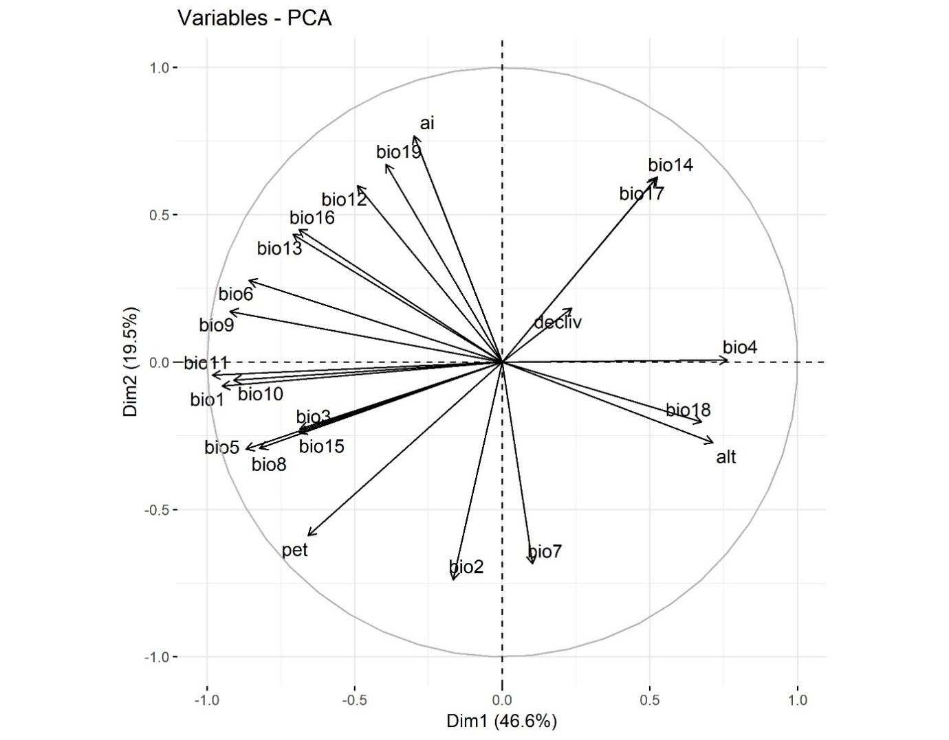

Supplementary Material 5. Values of the contribution of the ten optimization procedures and the final average model.
Replicates | AUC | Threshold (MTP) | TSS | Predicted area (Km²) | Predicted area (%)
Run 1 | 0.861 | 0.192 | 0.564 | 467,567.267 | 56.52
Run 2 | 0.813 | 0.331 | 0.784 | 499,626.673 | 60.4
Run 3 | 0.859 | 0.185 | 0.510 | 468,746.351 | 56.66
Run 4 | 0.835 | 0.258 | 0.597 | 490,312.444 | 59.27
Run 5 | 0.863 | 0.044 | 0.520 | 581,281.997 | 70.27
Run 6 | 0.836 | 0.106 | 0.594 | 437,401.439 | 52.87
Run 7 | 0.842 | 0.070 | 0.545 | 557,520.504 | 67.39
Run 8 | 0.821 | 0.280 | 0.659 | 563,383.770 | 68.1
Run 9 | 0.878 | 0.216 | 0.509 | 408,594.381 | 49.39
Run 10 | 0.866 | 0.311 | 0.550 | 450,040.631 | 54.4
Average | 0.8474 | 0.1993 | 0.5832 | 492,447.5459 | 59.53
SD* | 0.0212 | 0.0999 | 0.0844 | 57,979.54 | 7.009
SD* - Standard Deviation

