Figure 1. Prediction curves and percentage contribution of the best set of predictive variables in SDM. In figures a-d the black lines represent the ten optimization procedures and the red line the average model. (a) Aridity Index; (b) Mean Temperature of Coldest Quarter; (c) Annual Precipitation; (d) Precipitation Seasonality; (e) Percentage contribution of each variable.
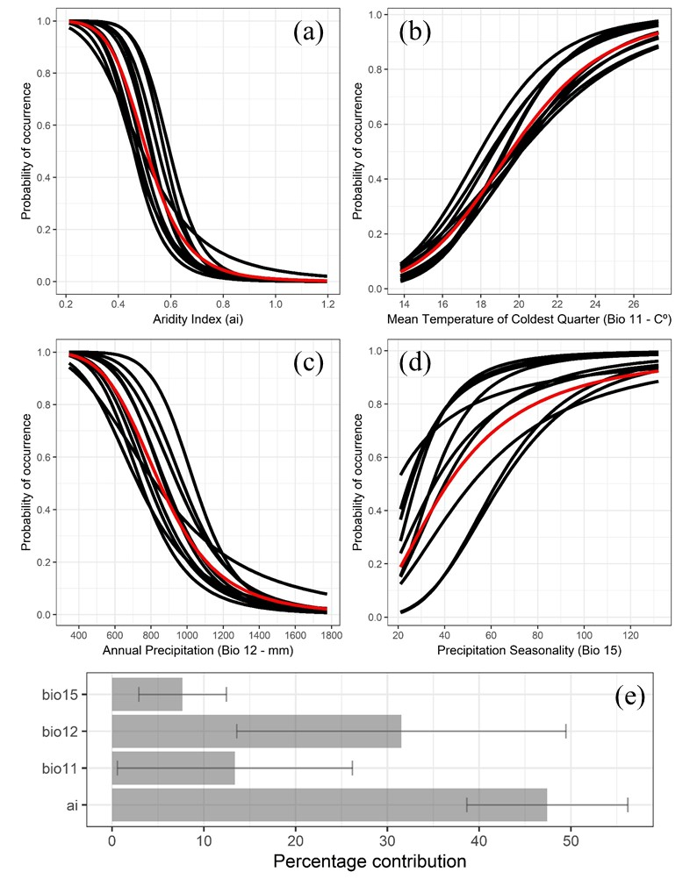
Figure 2. Species Distribution Modeling (SDM) of Anamaria heterophylla for the Caatinga. (a) The boundaries of the Brazilian Federative Units. Al - Alagoas; BA - Bahia; CE - Ceará; DF - Distrito Federal; GO - Goiás; MA - Maranhão; MG - Minas Gerais; PB - Paraíba; PE - Pernambuco; PI - Piauí; RN - Rio Grande do Norte; SE - Sergipe; TO - Tocantins. (b) Protected Areas (PAs) and Priority areas for the conservation of the Caatinga (PACCs) indicated by SDM with high environmental suitability (≥0.8) in the Caatinga. 1 - PA Pond of Sobradinho (BA); 2 - PACC Juazeiro Sul (BA); 3 - PACC Petrolina (PE/BA); 4 - PA Riacho Pontal (PE); 5 - PA Serra of Areal (PE); 6 - PA Tatu-Bola (PE); 7 - PACC Parambú/Cococi (CE); 8 - PA Aiuaba; 9 - PACC Serra de Santa Luzia (PB/RN).
