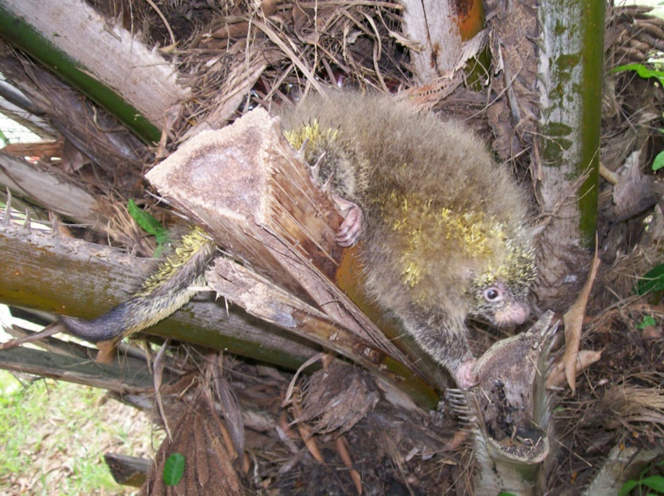
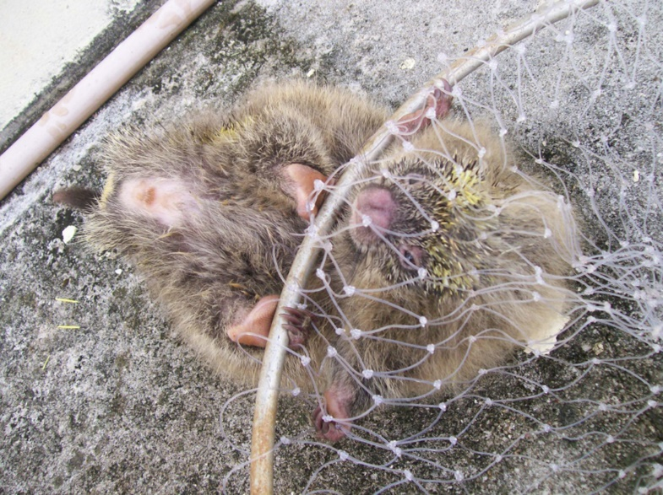
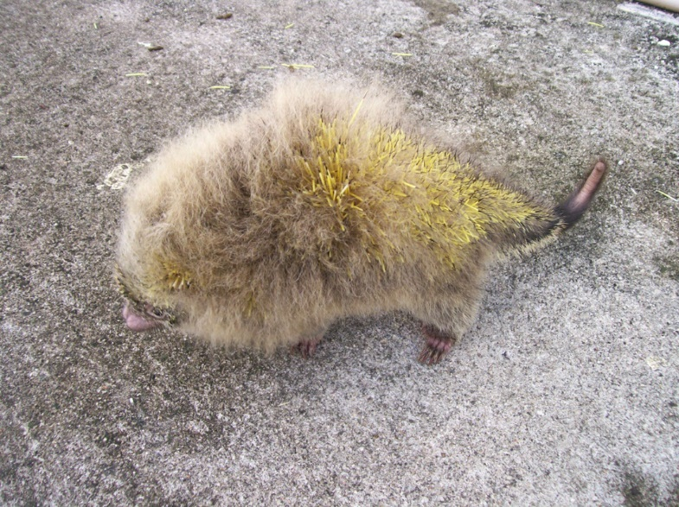
Figure 1: Coendou spinosus on the tree of Elaeis guineensis (A); capture for removing hair samples (B), and release of the individual (C).

