Supplementary material

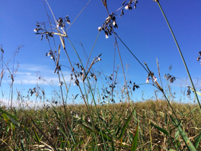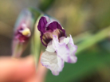

Figure 1. *Thalia geniculata* L. (Marantaceae). **A.** Plants in the Pantanal growing in an area of open swamp . Inflorescences bloom massively with at least 50 flowers and look like gramineous spikes from a distance**.** The main peduncle of the inflorescence is ca. 2m long, extends from the rhizome submerged in the water (swamp), and is ebracteate for most of its length until the location where it branches into enriched panicles of pseudanthium. **B**. The two flowers in the pseudanthium are structurally organized so they look like a single flower. These reproductive units are distributed throughout the long inflorescences.