I, Emerson Machado de Carvalho, hereby certify that they are authors of the manuscript entitled “Characterization of Pantanal ponds under the influence of the Miranda river flood” seen and approved the submitted manuscript.

The manuscript has not been published and has not been submitted simultaneously in other journal(s).

Names along with institutional affiliation and contact details of independent referees:
- Maria Helena Silva Andrade, Universidade Federal do Mato Grosso do Sul (UFMS) – helenaandrade@ufms.br
- Yzel Rondon Súarez, Universidade Estadual do Mato Grosso do Sul (UEMS)– yzel@uems.br
- Sidnei Eduardo Lima Junior, Universidade Estadual do Mato Grosso do Sul (UEMS) – sidnei@uems.br
- Anderson Ferreira, Universidade Federal da Grande Dourados (UFGD) – andersonferreira@ufgd.edu.br
- Virginia Sanches Uieda, Universidade Estadual Paulista (UNESP) campus de Botucatu - vsuieda@ibb.unesp.br

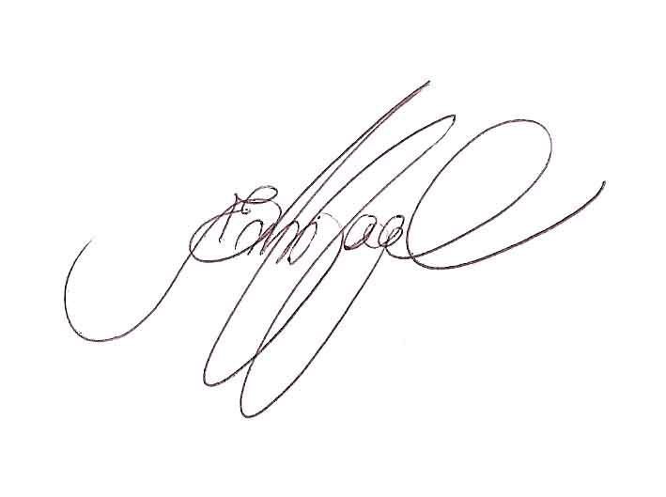

_________________________________
Emerson Machado de Carvalho
09/15/2018

