SPATIO–TEMPORAL PATTERNS OF MAMMAL ROAD MORTALITY IN MIDDLE MAGDALENA VALLEY, COLOMBIA

Fabio Leonardo Meza-Joya^{1,2*}, Eliana Ramos^{1,2} & Diana Cardona¹
¹ Colombia Endémica, Asociación para el Estudio y la Conservación de los Recursos Naturales, Calle 35 # 24–28, Bucaramanga, Santander, Colombia. CEP: 680002
^{b} Grupo de Investigación en Biotecnología Industrial y Biología Molecular, Escuela de Biología, Universidad Industrial de Santander, Parque Tecnológico Guatiguará, Km 2 vía al Refugio. Piedecuesta, Santander, Colombia. CEP: 681011
E–mails: fabio.meza@correo.uis.edu.co; elianr86@gmail.com; dianicardoni@gmail.com

Running title: Mammal Roadkill in Middle Magdalena Valley, Colombia

Table S1. General description of the surveyed route segments, landscape, management, anthropogenic features (urbanization level), and wildlife roadkill management measures.

Route | Segment description | Length | Landscape description | Urbanization  level | Management measures
DR01 | 2–lane paved road; narrow to absent shoulder, some roadside ditches; speed limit 80 km/h | 26 km | Smooth hills dominated by oil exploration and extraction areas, pastures, herbaceous and shrubby vegetation | Suburban | Warning signs
NR45 | 2–lane paved road; wide shoulder; discontinuous roadside ditches; speed limit 100 km/h | 18 km | Smooth hills and plains dominated by pastures, heterogeneous agricultural areas, herbaceous and shrubby vegetation, and forest patches | Rural | None
NR66 | 2–lane paved road; wide to absent shoulder, intermittent roadside ditches; speed limit 100 km/h | 31 km | Smooth hills dominated by pastures, heterogeneous agricultural areas, small forest patches, and dump and construction sites | Rural | None

Table S2. Resistance values assigned to different landscape features in the study area.

Group | Corine Land Cover (CLC) class | Resistance Value |  | Fragmentation index |  | Resistance Value
Artificial surfaces | Continuous urban fabric | 100 |  | Less Fragmentation | 0–9 | 1–10
 | Discontinuous urban | 90 |  |  | 9–15 | 10–20
 | Industrial or commercial units | 100 |  |  | 15–21 | 20–30
 | Road network | 100 |  |  | 21–26 | 30–40
 | Airports | 100 |  |  | 26–32 | 40–50
 | Mineral extraction sites | 70 |  |  | 32–39 | 50–60
 | Green urban areas | 90 |  |  | 39–46 | 60–70
 | Sport and leisure facilities | 90 |  |  | 46–54 | 70–80
Agricultural areas | Permanent arboreal crops | 10 |  |  | 54–75 | 80–90
 | Grassland prevailingly without trees and shrubs | 40 |  | More Fragmentation | 75–101 | 90–100
 | Grassland with trees and shrubs | 20
 | Crops mosaic | 30 |  | Proximity to rivers (m) |  | Resistance Value
 | Grassland and Crops mosaic | 30 |  | Closer to river | 0–21.46 | 1–10
 | Crops, Grassland and natural vegetation mosaic | 10 |  |  | 21.46–64.37 | 10–20
 | Grassland and natural vegetation mosaic | 10 |  |  | 64.37–107.29 | 20–30
 | Crops and natural vegetation mosaic | 10 |  |  | 107.29–171.66 | 30–40
Forest and semi–natural areas | Forest | 1 |  |  | 171.66–236.03 | 40–50
 | Gallery forest and riparian formations | 1 |  |  | 236.03–300.40 | 50–60
 | Agroforestry | 10 |  |  | 300.40–386.23 | 60–70
 | Herbaceous vegetation associations | 30 |  |  | 386.23–514.10 | 70–80
 | Shrub areas | 10 |  |  | 514.10–793.92 | 80–90
 | Secondary vegetation | 1 |  | Further from river | 793.92–5,471.61 | 90–100
Water bodies | River | 40
 | Inland wetlands | 50
 | Large water bodies | 90
NDVI |  | Resistance Value |  | Proximity to roads (m) |  | Resistance Value
More greenness | 0.53–0.67 | 1–10 |  | Far from roads | 10,000–6,313.67 | 1–10
 | 0.49–0.53 | 10–20 |  |  | 6,313.67–4,745.05 | 10–20
 | 0.44–0.49 | 20–30 |  |  | 4,745.05–3,686.24 | 20–30
 | 0.39–0.44 | 30–40 |  |  | 3,686.24–2,823.50 | 30–40
 | 0.32–0.39 | 40–50 |  |  | 2,823.50–2,078.41 | 40–50
 | 0.23–0.32 | 50–60 |  |  | 2,078.41–1,529.40 | 50–60
 | 0.12–0.23 | 60–70 |  |  | 1,529.40–1,098.03 | 60–70
 | -0.01–0.12 | 70–80 |  |  | 1,098.03–745.10 | 70–80
 | -0.19––0.01 | 80–90 |  |  | 745.10–156.86 | 80–90
Less greenness | -0.28––0.18 | 90 –100 |  | Closer to roads | 156.86–0.00 | 90 –100
Surface temperature (ºC) |  | Resistance Value
Less temperature | 19.96–23.81 | 1–10
 | 23.81–24.18 | 10–20
 | 24.18–24.55 | 20–30
 | 24.55–24.91 | 30–40
 | 24.91–25.22 | 40–50
 | 25.22–25.59 | 50–60
 | 25.59–26.01 | 60–70
 | 26.01–26.57 | 70–80
 | 26.57–27.42 | 80–90
More temperature | 27.42–35.56 | 90–100

Table S3. Current density statistics from 100-m circular buffers around each roadkill location. Low landscape connectivity (< 0.50 amperes), high landscape connectivity (> 0.50, gray highlighted). *Mortality events associated to roadkill hotspots.

Roadkill ID | Current density values (amperes)
 | Minimum | Maximum | Range | Mean | SE
1* | 0.32 | 0.35 | 0.03 | 0.33 | 0.01
2* | 0.31 | 0.34 | 0.03 | 0.32 | 0.01
3* | 0.33 | 0.35 | 0.02 | 0.34 | 0.01
4 | 0.43 | 0.45 | 0.02 | 0.44 | 0.00
5 | 0.48 | 0.74 | 0.32 | 0.57 | 0.07
6 | 0.46 | 0.55 | 0.09 | 0.50 | 0.02
7 | 0.55 | 0.58 | 0.03 | 0.56 | 0.01
8 | 0.44 | 0.45 | 0.01 | 0.45 | 0.00
9 | 0.44 | 0.50 | 0.06 | 0.47 | 0.02
10 | 0.45 | 0.48 | 0.03 | 0.47 | 0.01
11 | 0.41 | 0.45 | 0.04 | 0.42 | 0.01
12 | 0.49 | 0.53 | 0.05 | 0.51 | 0.01
13 | 0.41 | 0.49 | 0.08 | 0.44 | 0.02
14 | 0.32 | 0.33 | 0.01 | 0.33 | 0.00
15* | 0.35 | 0.40 | 0.05 | 0.38 | 0.01
16 | 0.41 | 0.53 | 0.13 | 0.47 | 0.03
17 | 0.51 | 0.57 | 0.06 | 0.55 | 0.02
18* | 0.37 | 0.38 | 0.01 | 0.37 | 0.00
19* | 0.39 | 0.39 | 0.00 | 0.39 | 0.00
20 | 0.42 | 0.43 | 0.02 | 0.43 | 0.00
21 | 0.42 | 0.42 | 0.00 | 0.42 | 0.00
22 | 0.52 | 0.58 | 0.06 | 0.55 | 0.01
23 | 0.44 | 0.45 | 0.01 | 0.45 | 0.00
24 | 0.30 | 0.34 | 0.03 | 0.32 | 0.01
25 | 0.62 | 0.68 | 0.06 | 0.64 | 0.01
26 | 0.62 | 0.65 | 0.03 | 0.64 | 0.01
27 | 0.61 | 0.67 | 0.06 | 0.63 | 0.01
28 | 0.47 | 0.52 | 0.04 | 0.49 | 0.01
29 | 0.44 | 0.47 | 0.03 | 0.45 | 0.01
30 | 0.32 | 0.39 | 0.06 | 0.34 | 0.01
31 | 0.38 | 0.44 | 0.06 | 0.40 | 0.02
32 | 0.37 | 0.38 | 0.02 | 0.37 | 0.01
33 | 0.50 | 0.65 | 0.15 | 0.57 | 0.04
34* | 0.34 | 0.37 | 0.03 | 0.35 | 0.01
35* | 0.33 | 0.35 | 0.02 | 0.34 | 0.01
36* | 0.31 | 0.33 | 0.02 | 0.32 | 0.01
37* | 0.31 | 0.33 | 0.02 | 0.32 | 0.00
38 | 0.40 | 0.47 | 0.07 | 0.43 | 0.02
39* | 0.31 | 0.34 | 0.03 | 0.32 | 0.01
40* | 0.32 | 0.33 | 0.01 | 0.33 | 0.00
41 | 0.38 | 0.50 | 0.13 | 0.41 | 0.03
42 | 0.31 | 0.33 | 0.01 | 0.31 | 0.00
43 | 0.42 | 0.46 | 0.04 | 0.43 | 0.01
44 | 0.53 | 0.57 | 0.04 | 0.55 | 0.01
45 | 0.57 | 0.64 | 0.07 | 0.61 | 0.02
46 | 0.49 | 0.49 | 0.00 | 0.49 | 0.00
47* | 0.34 | 0.37 | 0.03 | 0.35 | 0.01
48 | 0.45 | 0.64 | 0.20 | 0.51 | 0.04
49 | 0.31 | 0.32 | 0.01 | 0.32 | 0.00
50 | 0.38 | 0.40 | 0.02 | 0.38 | 0.01
51 | 0.41 | 0.43 | 0.02 | 0.42 | 0.01
52 | 0.38 | 0.41 | 0.02 | 0.39 | 0.01
53 | 0.46 | 0.46 | 0.00 | 0.46 | 0.00
54 | 0.42 | 0.46 | 0.03 | 0.44 | 0.01
55 | 0.49 | 0.60 | 0.10 | 0.56 | 0.03
56 | 0.46 | 0.54 | 0.08 | 0.49 | 0.02
57 | 0.53 | 0.57 | 0.03 | 0.55 | 0.01
58 | 0.50 | 0.55 | 0.06 | 0.53 | 0.02
59 | 0.40 | 0.66 | 0.26 | 0.49 | 0.08
60 | 0.49 | 0.56 | 0.07 | 0.52 | 0.02
61 | 0.56 | 0.83 | 0.26 | 0.72 | 0.06
62 | 0.42 | 0.46 | 0.03 | 0.44 | 0.01
63* | 0.33 | 0.35 | 0.02 | 0.34 | 0.01
64* | 0.31 | 0.36 | 0.04 | 0.33 | 0.01
65 | 0.57 | 0.59 | 0.02 | 0.58 | 0.00
66 | 0.61 | 0.67 | 0.06 | 0.63 | 0.01
67 | 0.49 | 0.55 | 0.06 | 0.51 | 0.02
68 | 0.41 | 0.44 | 0.03 | 0.43 | 0.01
69 | 0.30 | 0.33 | 0.03 | 0.31 | 0.01
70* | 0.33 | 0.35 | 0.03 | 0.34 | 0.01
71* | 0.33 | 0.33 | 0.01 | 0.33 | 0.00
72 | 0.31 | 0.33 | 0.02 | 0.32 | 0.00
73 | 0.48 | 0.48 | 0.00 | 0.48 | 0.00
74 | 0.53 | 0.71 | 0.18 | 0.58 | 0.04
75 | 0.31 | 0.41 | 0.09 | 0.37 | 0.02
76 | 0.31 | 0.33 | 0.02 | 0.32 | 0.00
77 | 0.39 | 0.44 | 0.05 | 0.41 | 0.01
78 | 0.63 | 0.80 | 0.18 | 0.70 | 0.06
79 | 0.43 | 0.51 | 0.07 | 0.45 | 0.02
80 | 0.47 | 0.50 | 0.02 | 0.49 | 0.01
81 | 0.49 | 0.65 | 0.16 | 0.56 | 0.04
82 | 0.24 | 0.30 | 0.03 | 0.28 | 0.01
83 | 0.40 | 0.46 | 0.06 | 0.43 | 0.02
84 | 0.34 | 0.45 | 0.10 | 0.38 | 0.02
85 | 0.36 | 0.39 | 0.03 | 0.37 | 0.01
86 | 0.46 | 0.52 | 0.06 | 0.50 | 0.02
87* | 0.31 | 0.33 | 0.02 | 0.32 | 0.01
88* | 0.32 | 0.35 | 0.02 | 0.33 | 0.01
89* | 0.33 | 0.34 | 0.01 | 0.33 | 0.00
90 | 0.43 | 0.47 | 0.04 | 0.46 | 0.01
91 | 0.43 | 0.47 | 0.04 | 0.45 | 0.01
92* | 0.31 | 0.33 | 0.02 | 0.32 | 0.00
93* | 0.38 | 0.44 | 0.06 | 0.42 | 0.01
94 | 0.38 | 0.42 | 0.04 | 0.40 | 0.01
95 | 0.40 | 0.86 | 0.46 | 0.59 | 0.10
96 | 0.62 | 0.63 | 0.02 | 0.62 | 0.01
97 | 0.46 | 0.52 | 0.06 | 0.50 | 0.02
98 | 0.42 | 0.44 | 0.02 | 0.43 | 0.00
99 | 0.64 | 0.64 | 0.00 | 0.64 | 0.00
100 | 0.77 | 1.34 | 0.57 | 0.94 | 0.13
101 | 0.45 | 0.48 | 0.03 | 0.46 | 0.01
102 | 0.54 | 0.56 | 0.02 | 0.55 | 0.01
103 | 0.47 | 0.50 | 0.03 | 0.49 | 0.01
104 | 0.58 | 0.63 | 0.06 | 0.60 | 0.01
105 | 0.43 | 0.46 | 0.03 | 0.44 | 0.01
106 | 0.47 | 0.57 | 0.10 | 0.51 | 0.00
107 | 0.39 | 0.43 | 0.04 | 0.41 | 0.01
108* | 0.32 | 0.32 | 0.01 | 0.32 | 0.00
109 | 0.37 | 0.58 | 0.21 | 0.45 | 0.01
110 | 0.43 | 0.52 | 0.10 | 0.48 | 0.03
111 | 0.43 | 0.45 | 0.02 | 0.44 | 0.01
112 | 0.54 | 0.57 | 0.03 | 0.55 | 0.01

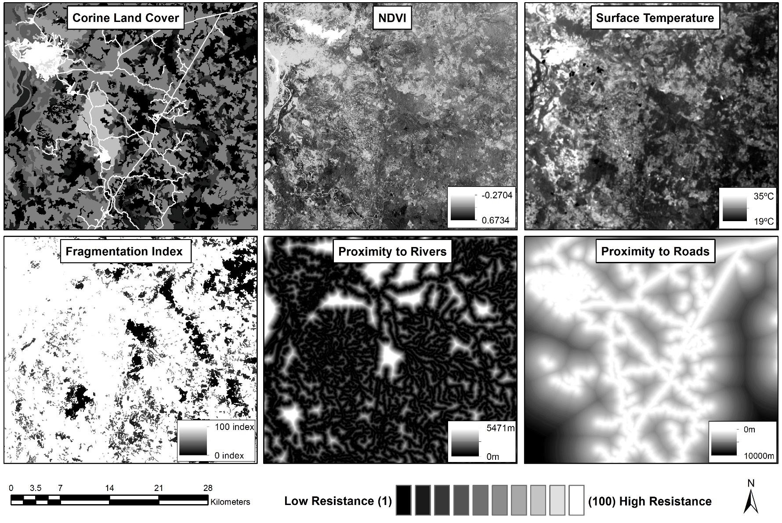
Figure S1. Landscape features used for createating a resistance surface of the study area. Spatial resolution of 30 m.

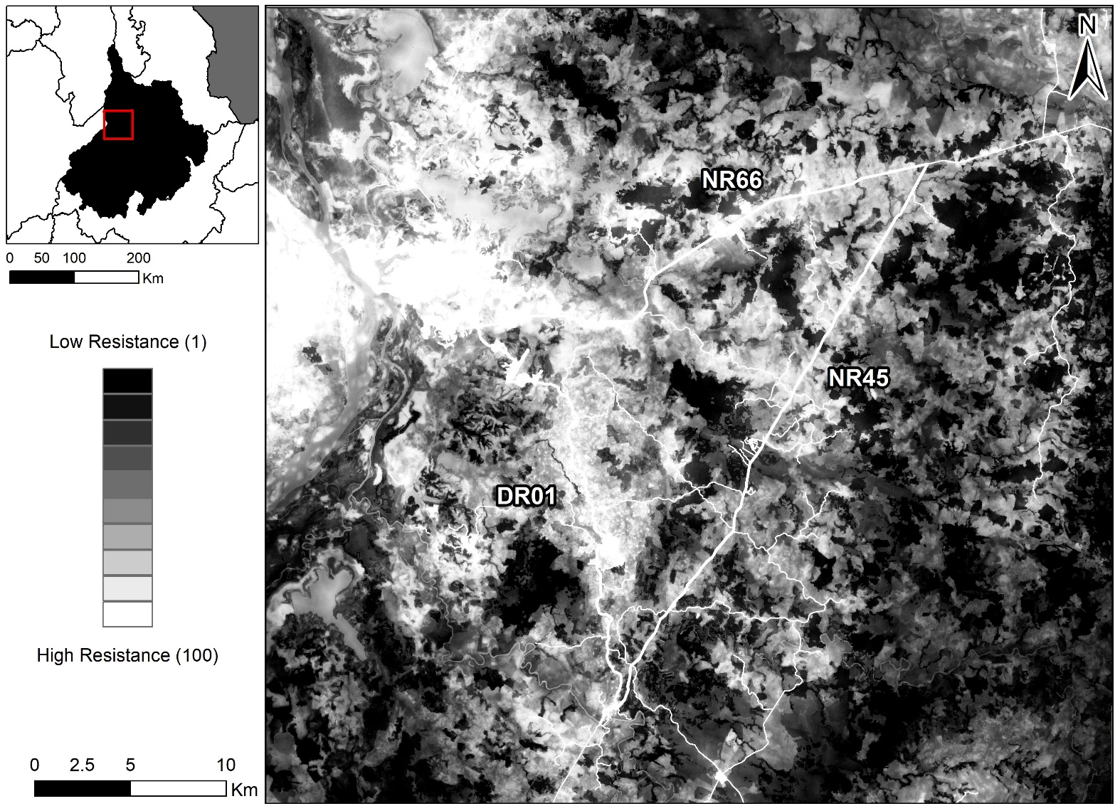
Figure S2. Resistance surfaces of the study area representing the hypothesized relationships between environmental features and multi–scale structural connectivity. Spatial resolution of 30 m.

