Figure 1: Study area in the Northern Pantanal wetland. Many savannic grasslands can be found along parkland road Transpantaneira .

Opcional: fotos
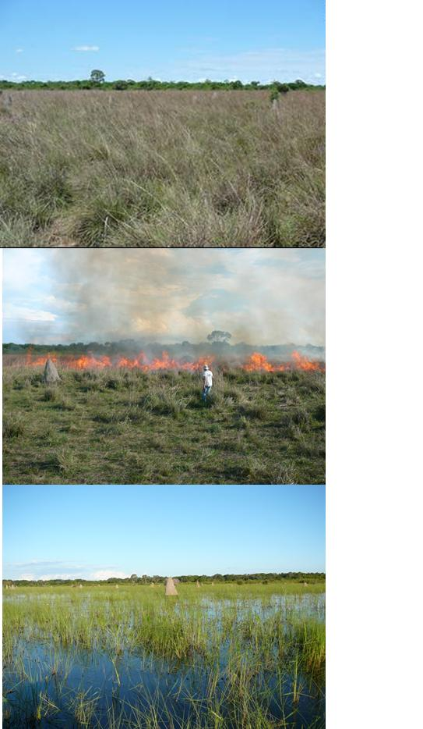

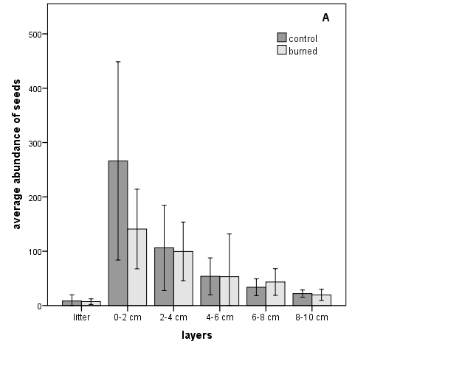

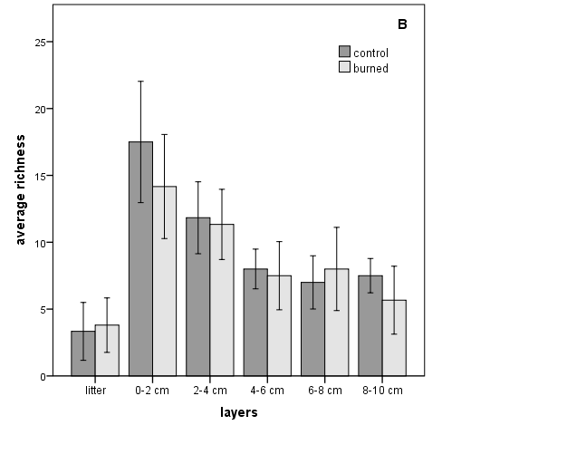

Figure 2: Soil seed bank ecological parameters according to soil depth obtained by seedling emergence method in a greenhouse. Soil samples came from unburned (control) and burned sites from flood-prone savannic grassland in the Pantanal wetland. A) Abundance; B) Richness. Rods represent 95% of confidence interval.

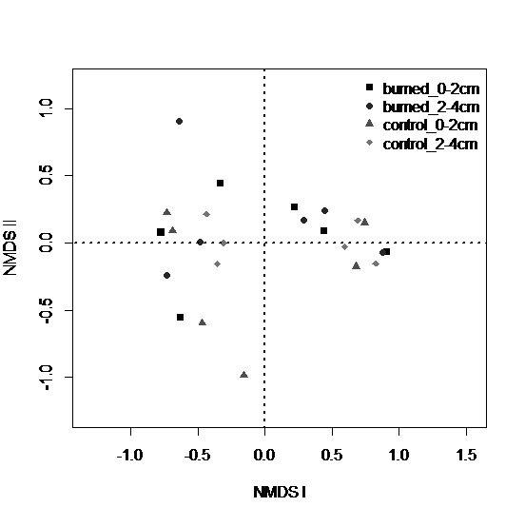

Figure 3: Non-metric multidimensional scaling (NMDS) ordination reflecting species composition of soil seed banks from flood-prone savannic grassland in Pantanal wetland. Soil samples were taken before (control) and after prescribed fire (burned). This NMDS takes in account samples from two first layers : 0-2 and 2-4 cm.

