FIGURES
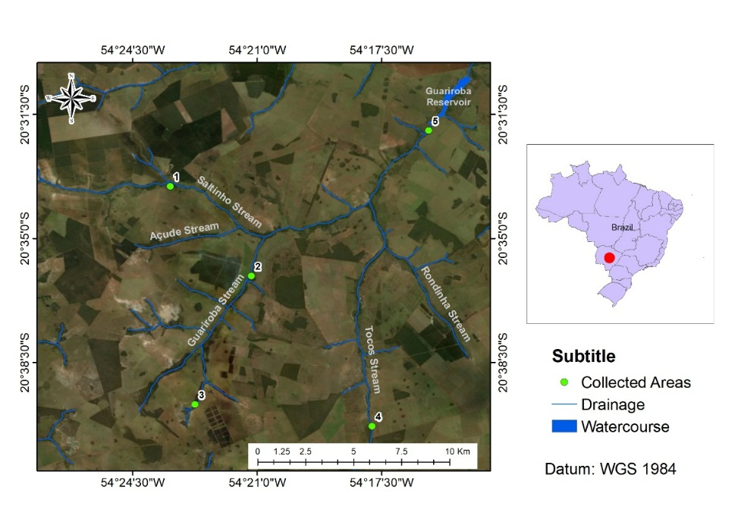

Figure 1: Study area with location of sampled points along streams in veredas and the reservoir in the APA do Guariroba, Campo Grande, MS.
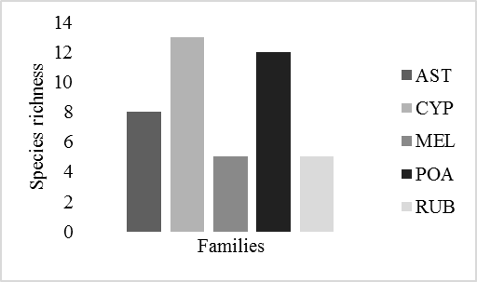
Figure 2: Species richest families in the dry season in veredas of APA do Guariroba, Campo Grande, MS Ast: Asteraceae; Cyp: Cyperaceae; Mel: Melastomataceae; Poa: Poaceae; Rub: Rubiaceae.
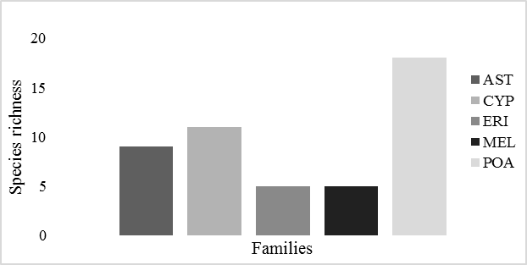
Figure 3: Richest families in the rainy season in veredas of APA do Guariroba in Campo Grande, MS. Ast: Asteraceae; Cyp: Cyperaceae; Eri: Eriocaulaceae; Mel: Melastomataceae; Poa: Poaceae.
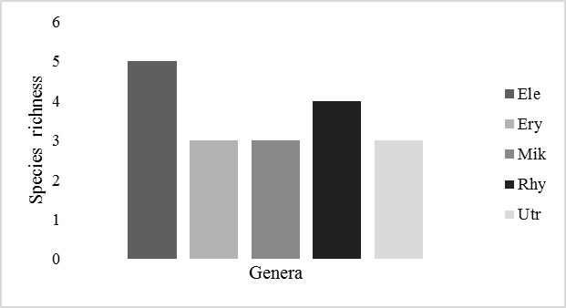
Figure 4: Species richest genera in the dry season of veredas of APA do Guariroba, Campo Grande, MS. Ele: Eleocharis; Ery: Eryngium; Mik: Mikania; Rhy: Rhynchospora; Utr: Utricularia.
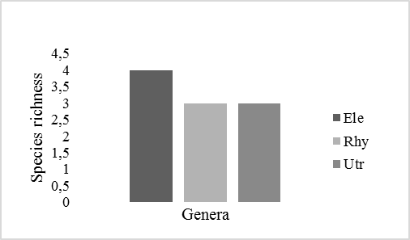
Figure 5: Species richest genera in the rainy season in veredas of the APA do Guariroba, Campo Grande, MS. Ele: Eleocharis; Rhy: Rhynchospora; Utr: Utricularia.

Subtitle figure 6: Figure 6: Principal Coordinate Analysis, with Bray Curtis distance, performed using the species percentage cover matrix in dry and wet seasons in veredas of the APA do Guariroba, Campo Grande, MS.

