Figure 1. Distribution of the sites in the Aripuanã River basin, state of Mato Grosso

Figure 2. Streams of first, second and third order in the Aripuanã River basin, state of Mato Grosso. A - First order stream, B - Second order stream and C - Third order stream.
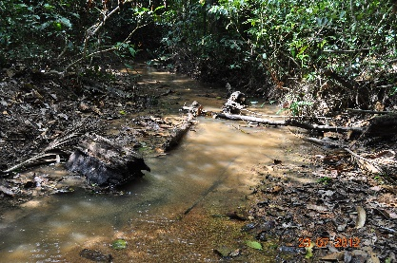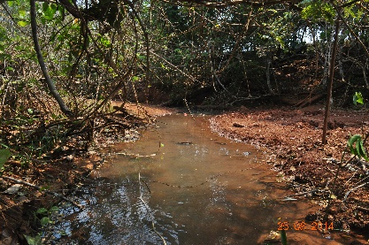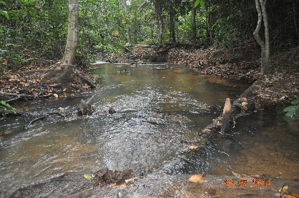
C
B
A

Figure 3. Fishing equipment used in the streams. A - sieve and B - hand net.
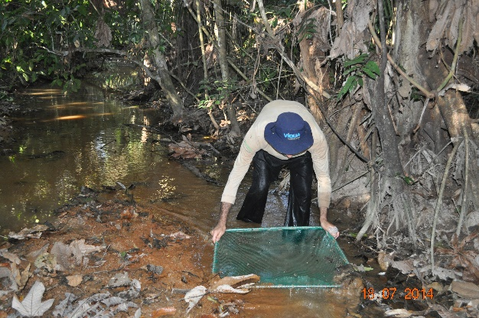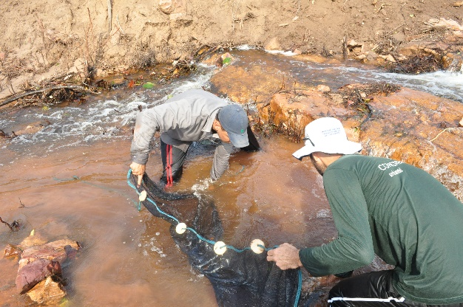
B
A
Figure 4. Some species registered in the Aripuanã River basin, state of Mato Grosso, Brazil. A. I. kerri, B. Knodus sp. C. Hyphessobrycon sp. D. Ancistrus spp. E. Hyphessobrycon vilmae F. Moenkhausia oligolepis

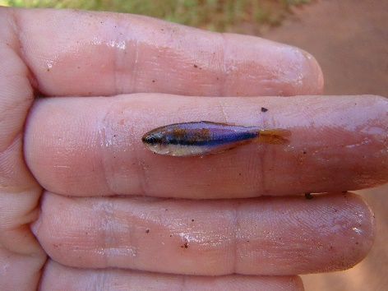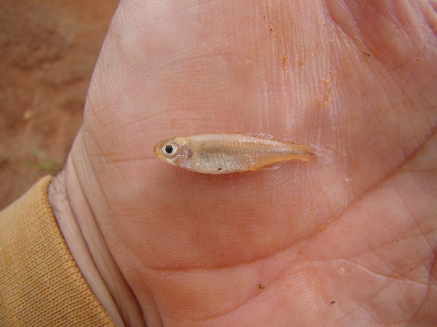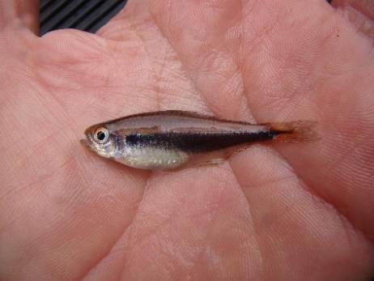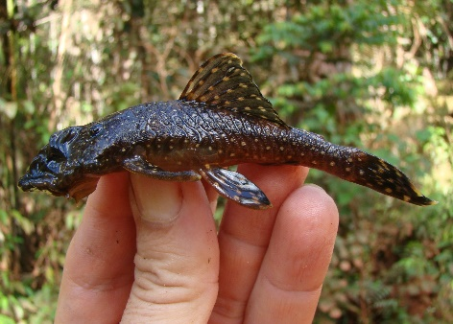
D
C
B
A
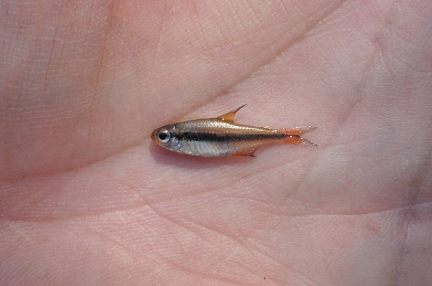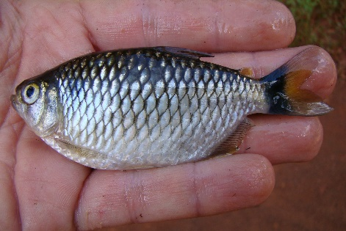
F
E

