Dra. Ana Claudia Delciellos
Editor in Chief
Oecologia Australis

This letter is in order to stated that that all authors have approved to submit the manuscript to the Oecologia Australis Journal. The manuscript has not been publish or send it to other journal. Above I provided a list of five (5) potential referees for the review process.
- Pier Cacciali, Instituto de Investigación Biológica del Paraguay, piercantropus@gmail.com
- Henrique Caldeira Costa, Universidade Federal de Viçosa, ccostah@gmail.com
- Santiago Carreira, Universidad de la Republica de Uruguay, santiago.carreira@gmail.com
- Gustavo Scrocchi, Instituto de Herpetologia, Fundación Miguel Lillo, gustavo.scrocchi@gmail.com
- Nicolas Pelegrin, Universidad Nacional de Cordoba, nicolas.pelegrin@conicet.gov.ar.

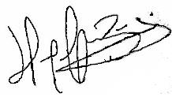
Hugo Cabral

