Dear Editor of Oecologia Australis
June 29, 2019

I am pleased to submit the manuscript "Environmental effects of the unsustainable capture of live bait for sport fishing in the Pantanal wetland" for publication in Oecologia Australis, as an article.
I inform that:
- I have seen and approved the submitted manuscript in accordance with the editorial rules of Oecologia Australis;
- the manuscript has not been published;
- the manuscript has not been submitted simultaneously in other journal;
- the manuscript's content matches the objectives of Oecologia Australis

My suggestions for independent referees are:
- Humberto C. Gonçalves – Superintendent of ANA – Agência Nacional de Águas – humberto.goncalves@ana.gov.br
- Herbert Shubart – former director of INPA – Instituto Nacional de Pesquisa da Amazônia – herbert.shubart@gmail.com
- Thomas Lacher Jr. – Texas A&M University – lacher@tamu.edu
- Marcelo L. Reis – ICMBio – Instituto Chico Mendes – marcelomukira@gmail.com
- Rosa M.L. Sá – FUNBIO – rosa.lemos@funbio.org.br

With my best wishes,

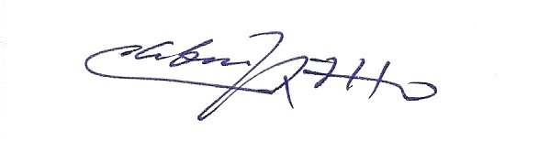

Cleber J. R. Alho, Ph.D.
Conservação da Biodiversidade
Ecologia e Meio Ambiente; ORCID: 0000-0003-4569-5312
Lattes: http://lattes.cnpq.br/3871915319484773

