03 March, 2020

Dear Editor-in-chief of Oecologia australis,

We are submitting the scientific note titled "New record of the spider crab Mithrax tortugae Rathbun, 1920 in the Northeast Ecorregion of Brazil, first record on the coast of Rio Grande do Norte", written by Matheus Rocha, Sávio Moraes, Carlos Alencar and Fúlvio Freire for manuscript evaluation by the editorial board of Journal Oecologia australis.
We propose the first record of M. tortugae on the coast of the state of Rio Grande do Norte. This record stablishes a new northmost record for the distribution in the Southwest Tropical Province and Northeast Brazil Ecorregion (sensu Spalding et al. 2007 – World Marine Ecorregions). In addition to this new record, we presented an updated geographic distribution based on primary and secondary data. This manuscript has not been published and is not been in consideration by any other periodical/journal. This submission was authorized by our institution (UFRN), where this study was done. The authors of the present study declare that there is no conflict of interest. The corresponding author of the manuscript is Mr. Matheus Arthur Lúcio da Rocha (matheusarthurrocha@outlook.com).

Sincerely.

Matheus Arthur Lúcio da Rocha
Departamento de Botânica e Zoologia, Universidade Federal do Rio Grande do Norte UFRN; email: matheusarthurrocha@outlook.com; phone: +55(84) 999554316.
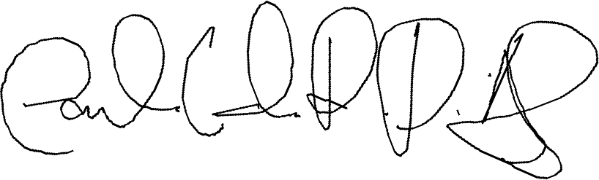

Carlos Eduardo Rocha Duarte Alencar
Departamento de Ciências Biológicas, Universidade do Estado do Rio Grande do Norte; email: carlosce2002@gmail.com
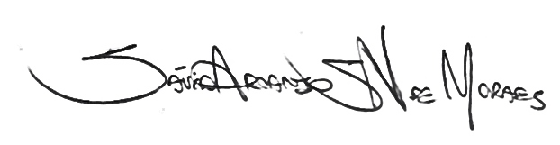

Sávio Arcanjo Santos Nascimento Moraes
Departamento de Botânica e Zoologia, Universidade Federal do Rio Grande do Norte UFRN; email: savioarcanjo@hotmail.com


Departamento de Botânica e Zoologia, Universidade Federal do Rio Grande do Norte UFRN; email: fulvio@cb.ufrn.br

