May 21, 2020
Dear Prof. Dra. Camila dos Santos de Barros

Editor in Chief of Oecologia Australis,

I am presenting the manuscript “Applicability of different seed bank methods in wetlands: advantagens and disadvantagens” (containing 5184 words), for evaluation by reviewers of Oecologia Australis. For this study, we compared three methods of seed bank evaluation in grasslands of Pantanal in two years. We have done everything in the drafting of the manuscript (data collection, analysis, discussion of results). Thus, we can state that there is no conflict of interest with any other researcher who collaborated in this study (species identification), and we do not have any financial support debt which could hinder our work.
It is necessary to consider how the plants establish themselves in a seasonally flooded environment and alters plant community and seed bank structure for future protocols of conservation and preservation of wetlands, motivating the need for studies that compare different methods to evaluation the aboveground vegetation with the seed reserves in the soil.
I hereby declare no conflict of interest and that all authors agree with this submission. The manuscript has never been published or is under review for publication elsewhere.
We suggest five referees below:
- Dra. Camila Aoki – Universidade Estadual de Mato Grosso do Sul (UEMS), e-mail: aokicamila@yahoo.com.br
- Dra. Gisele Catian – Universidade Federal de Mato Grosso (UFMT), e-mail: gcatian@gmail.com
- Dr. Evaldo Benedito Souza – Universidade Federal de Mato Grosso do Sul (UFMS), e-mail: bs.evaldo@gmail.com
- Dr. Luís Felipe Daibes – Universidade Estadual Paulista (UNESP), e-mail: luipedaibes@hotmail.com
- Ms. Mariane Dairel – Universidade Estadual Paulista (UNESP), e-mail: maridairel@gmail.com

Thank you for your attention.
Yours sincerely,

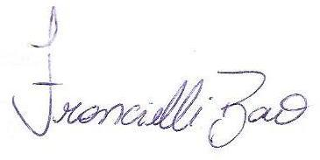
Dra.Francielli Bao
Autor and Correspondence author
Programa de Pós-Graduação em Ciências Biológicas (Biologia Vegetal)
Instituto de Biociências de Rio Claro
Universidade Estadual Paulista – UNESP
Phone: +55 (19) 3526 4219
E-mail: franbao@yahoo.com.br

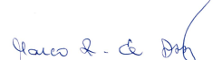
Dr. Marco Antonio Assis
Co-autor
Programa de Pós-Graduação em Ciências Biológicas (Biologia Vegetal)
Instituto de Biociências de Rio Claro
Universidade Estadual Paulista – UNESP
Phone: +55 (19) 3526 4219
E-mail: massis@rc.unesp.br

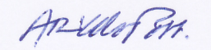
Dr. Arnildo Pott
Co-author
Programa de Pós-Graduação em Ciências Biológicas (Biologia Vegetal)
Departamento de Botânica
Universidade Federal de Mato Grosso do Sul – UFMS
Phone: +55 (67) 3345-7306
E-mail: arnildo.pott@gmail.com

