Cover letter to Oecologia Australis

Dear editor,
We sent for consideration as Short Communication in Oecologia Australis the manuscript entitled “Live bait trade as a pathway to introduction of non-native species in Brazilian freshwater ecosystems”. In this study, we presented cases of introductions of live baits in Brazilian freshwater ecosystems and recorded for the first time the occurrence of the crab Dilocarcinus pagei in the Paranapanema River basin. Actions aimed at avoiding new cases of introduction by this vector of non-native species still unknown in Brazil are discussed.

We state that:

1. All authors have seen and approved the submitted manuscript;
2. The manuscript has not been published;
3. The manuscript has not been submitted simultaneously in other journal;
4. No conflicts of interest exist in relation to this manuscript.

We provide five independent referees:

1. Dra. Vanessa Salete Daga - Universidade Federal do Paraná, Curitiba, Paraná - vanedaga@yahoo.com.br

2. Dr. Raffael Marcos Tófoli - Instituto Federal Catarinense, Videira, Santa Catarina - biotofoli@gmail.com

3. Dr. Dilermando Pereira Lima Junior - Universidade Federal de Mato Grosso, Pontal do Araguaia - dilermando.lima@gmail.com

4. Dr. Marcelo Fulgêncio Guedes Brito - Universidade Federal de Sergipe, Sergipe - marcelictio@gmail.com

5. Dr. Cleber Alho - Universidade Anhanguera-Uniderp, Campo Grande, Mato Grosso do Sul - alhocleber@gmail.com

Thank you for considering our manuscript for review. Please do not hesitate to contact us about any information.

Best regards,
The authors.

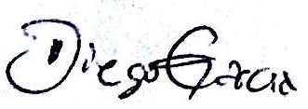
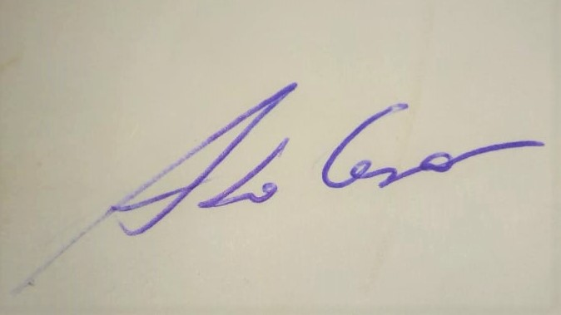
____________________________ ____________________________
Diego Azevedo Zoccal Garcia Armado César Rodrigues Casimiro

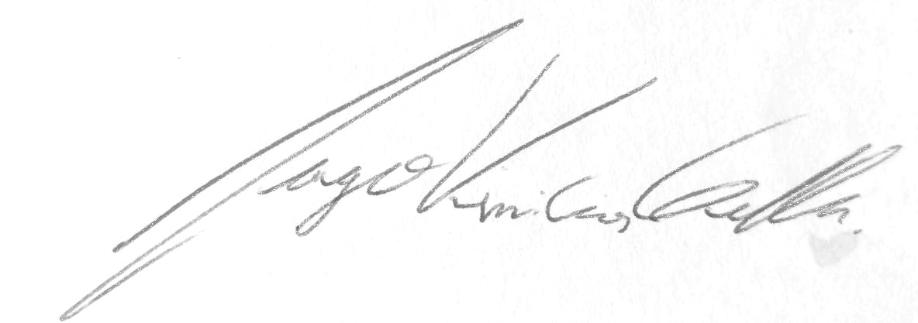
____________________________ ____________________________
Iago Vincios Geller João Daniel Ferraz

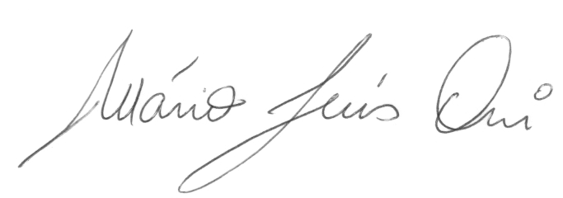
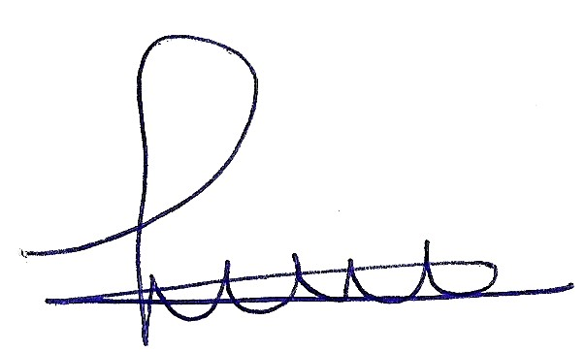
____________________________ ____________________________
Lucas Ribeiro Jarduli Mário Luís Orsi

