**Supplementary material**



**S1.** Sampling stations in the lower Doce basin. a. LO1 – Itapina, b. LO2 – Port of Linhares, c. LO3 – Povoação, d. LO4 – Port of Regência, e. LO5 – Guandu river (tributary).

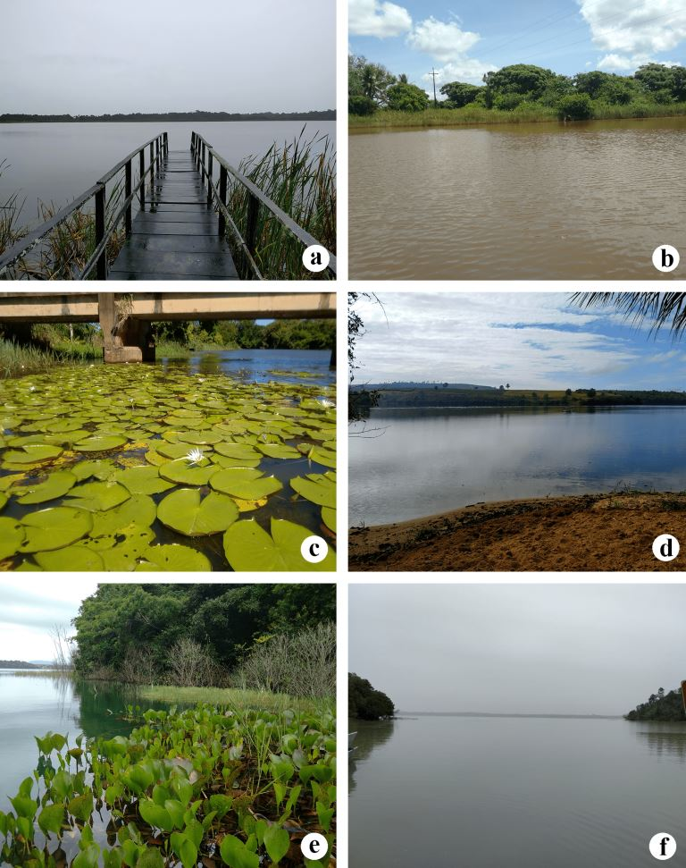

**S2.** Sampling stations in the lower Doce basin. a. LE1lag – Areão Lagoon, b. LE2lag – Areal Lagoon, c. LE3lag – Monsaras Lagoon, d. LE4lak – Limão Lake, e. LE5lak – Nova Lake, f. LE6lak – Juparanã Lake.

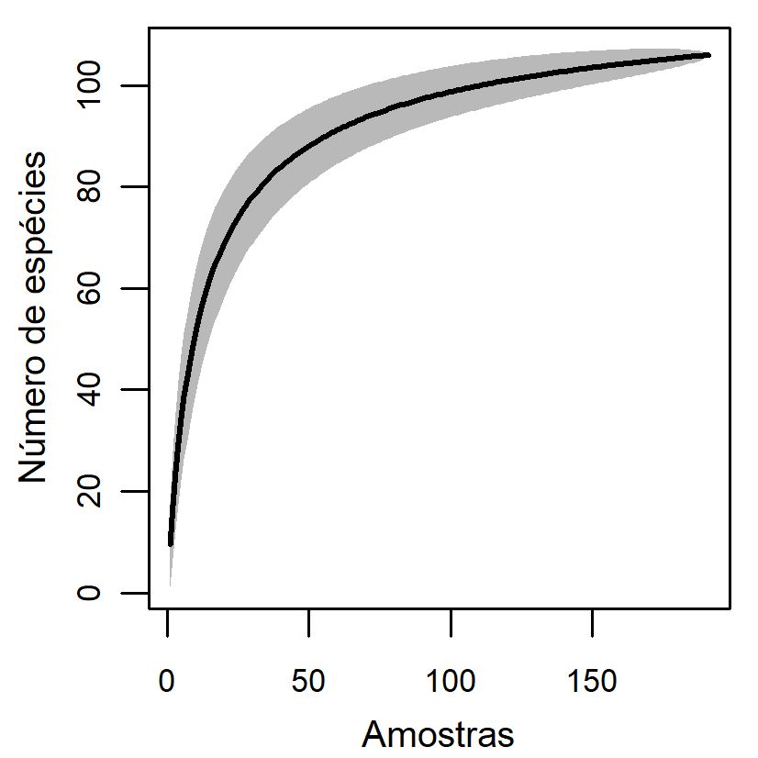

**S3.** Rarefaction curve.