Maria Silvina Bevilacqua
Laboratório Integrado de Ecologia Aquática,
Instituto de Biodiversidade e Sustentabilidade (NUPEM)
Universidade Federal do Rio de Janeiro (UFRJ)
Macaé, RJ, Brazil 27965-045
+55 22 2141-3976
mariasilvinabevilacqua@gmail.com

April 13st, 2021

Dear Editor-in-Chief,

I am writing to submit our manuscript entitled, “Determinant drivers for macroinvertebrates community structure in coastal lagoons from Restinga de Jurubatiba National Park, Rio de Janeiro, Brazil” for consideration as an Oecologia Australis research article for the special issue ‘Limnology in Brazil’.
This study aimed at the characterization of the benthic macroinvertebrate community in coastal lagoons and the environmental drivers for the community structure during the dry season. We used a set of coastal lagoons with distinct geophysical and physicochemical characteristics, located in the north of the state of Rio de Janeiro, within an integral protection conservation unit (CU), Restinga de Jurubatiba National Park. Using a simple macroinvertebrate community distribution sampling and spread throughout all the lagoons from the park, allowed a more holistic understanding of the factors that influence the benthic community as a whole along the lagoons belong to the park. This work highlighted that the benthic macroinvertebrates community distribution from coastal lagoons from PARNA Restinga de Jurubatiba are associated and subjugated to environmental factors such as salinity, pH, and grain size.
The Restinga is a biodiversity hotspot and some lagoons also are an important source of food and living support for the society around them. However, this conservation unit is under strong pressure of deforestation in the surroundings, exploration of the offshore industry on the continental shelf, and the possible construction of a large harbor facility adjacent to the CU. Therefore, studies that focus on the biotic communities’ assessment and the environmental drivers which shape them in natural environments are essential and could be helpful for the conservation of this ecosystem. Thus, we hope that this work could be considered for publication because it’s an important step to improve the knowledge of coastal lagoons from the Restinga de Jurubatiba National Park.
Each of the authors states that the manuscript has not been published or simultaneously submitted for publication in other journal(s). Also, all authors have seen and approved the submitted manuscript.

Thank you for your consideration
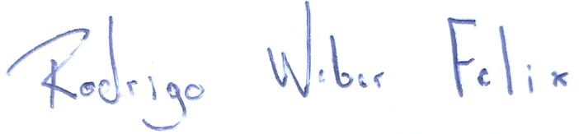
Maria Silvina Bevilacqua Rodrigo Weber Felix

Marcos Paulo Figueiredo de Barros Francisco de Assis Esteves

