May 03, 2021.

Dear Editor-in-chief of Oecologia Australis,

We are enclosed submitting the manuscript entitled “Pagurized gastropod shells in a northeast Brazilian coastal lagoon at the sea-estuary interface: temporal variation diversity and new ecological reports” written by Moraes, Vale, Alencar and Freire to be analyzed by the editorial board of this journal.
Coastal lagoons are considered biodiversity hotspots and relevant areas of recruitment in the sea-estuaries interface. In fact, besides this relevant arguments, coastal lagoon are scares in literature and aspects of biodiversity and ecology are virtually know for some taxonomic groups or ecological process. This manuscript aimed to checklist and seasonally analyze the pagurized shells from a coastal lagoon with seasonally connection with sea and estuary in Northeast Brazil, in terms of biodiversity and shells used for hermit crabs. Pagurized shells are relevant information for hermit crabs assemblage structure and a background for the gastropod assemblage structure. In addition, we discuss usage patterns of these biogenic remains and state the first record in the Brazilian Northeast of the hermit crab C. symmetricus, after its taxonomic resurgence.
This manuscript was not published anywhere and it is not under consideration in any other periodical. This submission was allowed by our institution (UFRN and URCA, Brazil), where this study was accomplished. All authors agree with the publication fee of Oecologia Australis. The corresponding author is Msc. Sávio Arcanjo Santos Nascimento Moraes.
We suggest the following referees:
- Elkênita Guedes Silva
Universidade Federal de Pernambuco, Laboratório de Carcinologia
Email: elkenitaguedes@gmail.com
- Patrícia Souza Santos
Universidade Federal de Pernambuco (UFPE), Campus Recife, Laboratório de Biologia de Crustáceos
Email: pssantosuesc@gmail.com
- Aderonke Lawal-Are
Department of Marine Sciences, Faculty of Science, University of Lagos, Akoka, Lagos State
Email: aolawalare@gmail.com
- Patricio De los Ríos
Laboratorio de Ecología Aplicada y Biodiversidad, Departamento de Ciencias Biológicas y Químicas, Facultad de Recursos Naturales, Universidad Católica de Temuco
Email: prios@uct.cl
- Allysson P. Pinheiro
Departamento de Ciências Biológicas, Universidade Regional do Cariri, Rua Cel. Antônio Luis,Crato, CE
Email: allysson.pinheiro@urca.br

We kindly ask you to acknowledge the receipt of this manuscript, please.

Sincerely,
Dr. Sávio Arcanjo Santos Nascimento Moraes
Departamento de Ciências Biologicas Universidade do Estado do Rio Grande do Norte, UERN, Brasil; email: savioarcanjo@hotmail.com

Author´s agreement
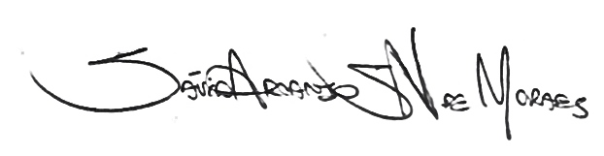
_________________________________________
Sávio A. S. N. Moraes
_________________________________________
Valéria F. Vale
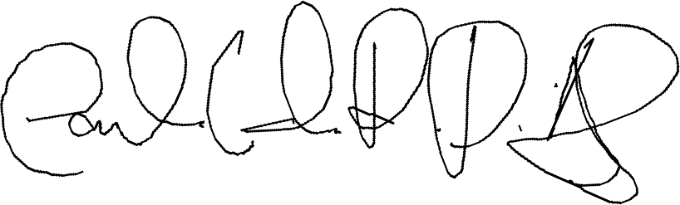
_________________________________________
Carlos E. R. D. Alencar

_________________________________________
Fúlvio A. M. Freire

